GODDARD SKI CLUB trip to AOSTA VALLEY, ITALY
Friday, February 25 to Saturday, March 5, 2011

Report by Harvey Walden, Trip Leader

Ciao! Friday evening, February 25, a group of 23 skiers and avid tourists in the NASA Goddard Ski Club departed Washington Dulles Airport on a KLM Royal Dutch Airlines flight to Milan, Italy via Amsterdam to join Eurofest 2011, which was sponsored by the Blue Ridge Ski Council. One graduate student member of our contingent of 24 joined us at the Milan Malpensa airport Saturday morning by travelling independently from Paris. There were seven Blue Ridge Council ski clubs with approximately 180 total participants on this Eurofest trip. Upon arrival at Milan, our group boarded a chartered bus for the approximately two-hour ride to Aosta, which is situated between Mont Blanc and the Matterhorn. After checking into the three-star Hotel Turin, located just outside the old city walls built by the Romans and close to the pedestrian town center, we attended an afternoon orientation meeting with our on-site Ski Europe agents, Dorothea and Richard, to discuss skiing and touring possibilities. Later, several of us went to a ski shop at the cableway connecting to the local Pila resort in Aosta to arrange rental ski equipment. Afterward, we explored the town of Aosta and enjoyed dinner on our own.

The following morning on Sunday, we had an extensive so-called continental breakfast at our hotel and then split into skiing and excursion groups, as was customary for each day. We went skiing at Pila, Aosta’s local area, or joined an afternoon guided walking tour of Aosta featuring the Augustan Roman and Medieval Age treasures in the town. In the evening, Blue Ridge sponsored a welcome party at the Hotel Cheval Blanc in Aosta. On Monday, skiing was at La Thuile and La Rosiere in France, via a special chartered bus which picked up at our hotel, as arranged by Blue Ridge each day during the week. Excursions went to tour two of the most famous fortified castles in the Aosta Valley, Fenis and Issogne Castles. In the evening, Blue Ridge sponsored an après-ski party at Restaurant Bataclan near the Roman Arch in Aosta with pizza cooked to order in unlimited quantities.

On Tuesday, skiers went to Monte Rosa (the complex of Champoluc-Gressoney-Alagne), while excursions went through the Mont Blanc tunnel to Chamonix, France, the host of the first Olympic Winter Games in 1924, and also to a wine tasting at the Cave du Vin Blanc at Morgex in the Aosta Valley. That evening, we enjoyed the first of three buffet dinners in the dining room on the mezzanine level of the Hotel Turin. Dinners generally consisted of four courses (salad or soup, pasta, a main entrée, and dessert) and were uniformly delicious with generous portions available.

On Wednesday, skiing was at Cervinia-Breuil with an option to ski at Zermatt in Switzerland. This venue turned out to be a favorite of several skiers on the trip. In the evening, we had our second buffet dinner at our hotel. On Thursday, a second day of skiing at the local Pila resort in Aosta was offered. Alternatively, some chose a full-day bus and walking guided tour of the city of Turin, a ride of less than two hours from Aosta. Turin was the host city to the 2006 Olympic Winter Games and the first capital of a unified Italy. Thursday evening was the Blue Ridge farewell party and dinner dance at the Hotel Cheval Blanc in Aosta. On our final full day on Friday, skiing was at Courmayeur. An option was a visit to the Spa Pre-Saint-Didier and its wellness center. A final buffet dinner that evening was at our hotel. We had a very early Saturday morning departure for the return flight from Milan with a lengthy layover on the flight connection in Amsterdam. This afforded us the possibility of perusing the extensive duty-free shopping areas at Schiphol Airport.

Our week in the Alps of northern Italy was notable for mild temperatures, often above freezing, in town in the valley, with not a trace of snow visible. In the mountains, the weather was decidely cooler, sometimes with slight snowfalls and occasional fog. The skiing conditions were excellent, and the numerous and varied daily excursions to nearby sights of interest were enjoyed by many. Grazie to all!

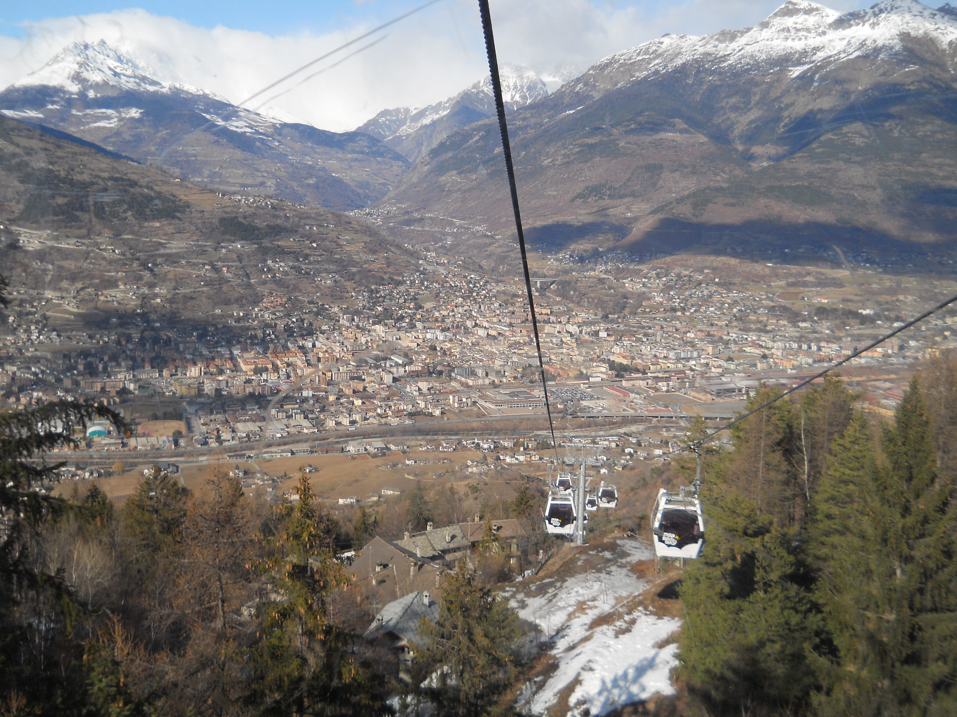
Pila in the Sky Gondola
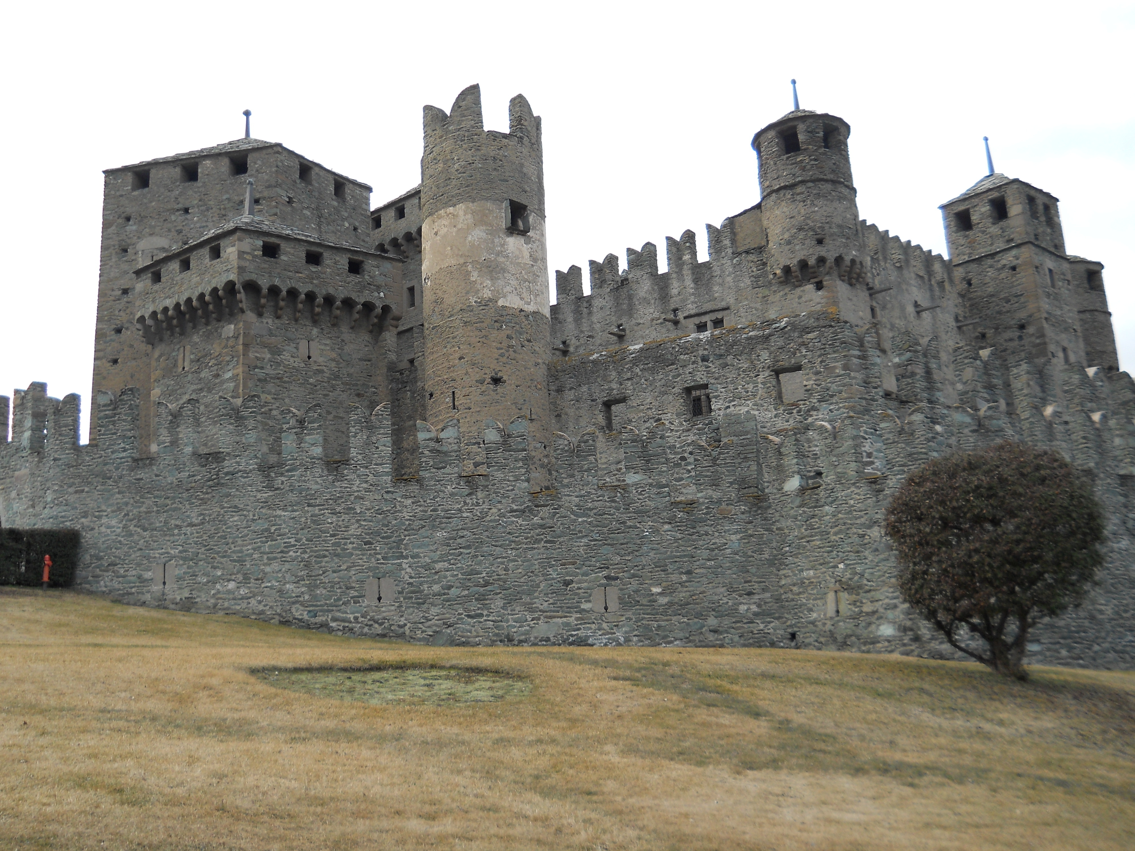
Castle Issogne - Aosta Valley

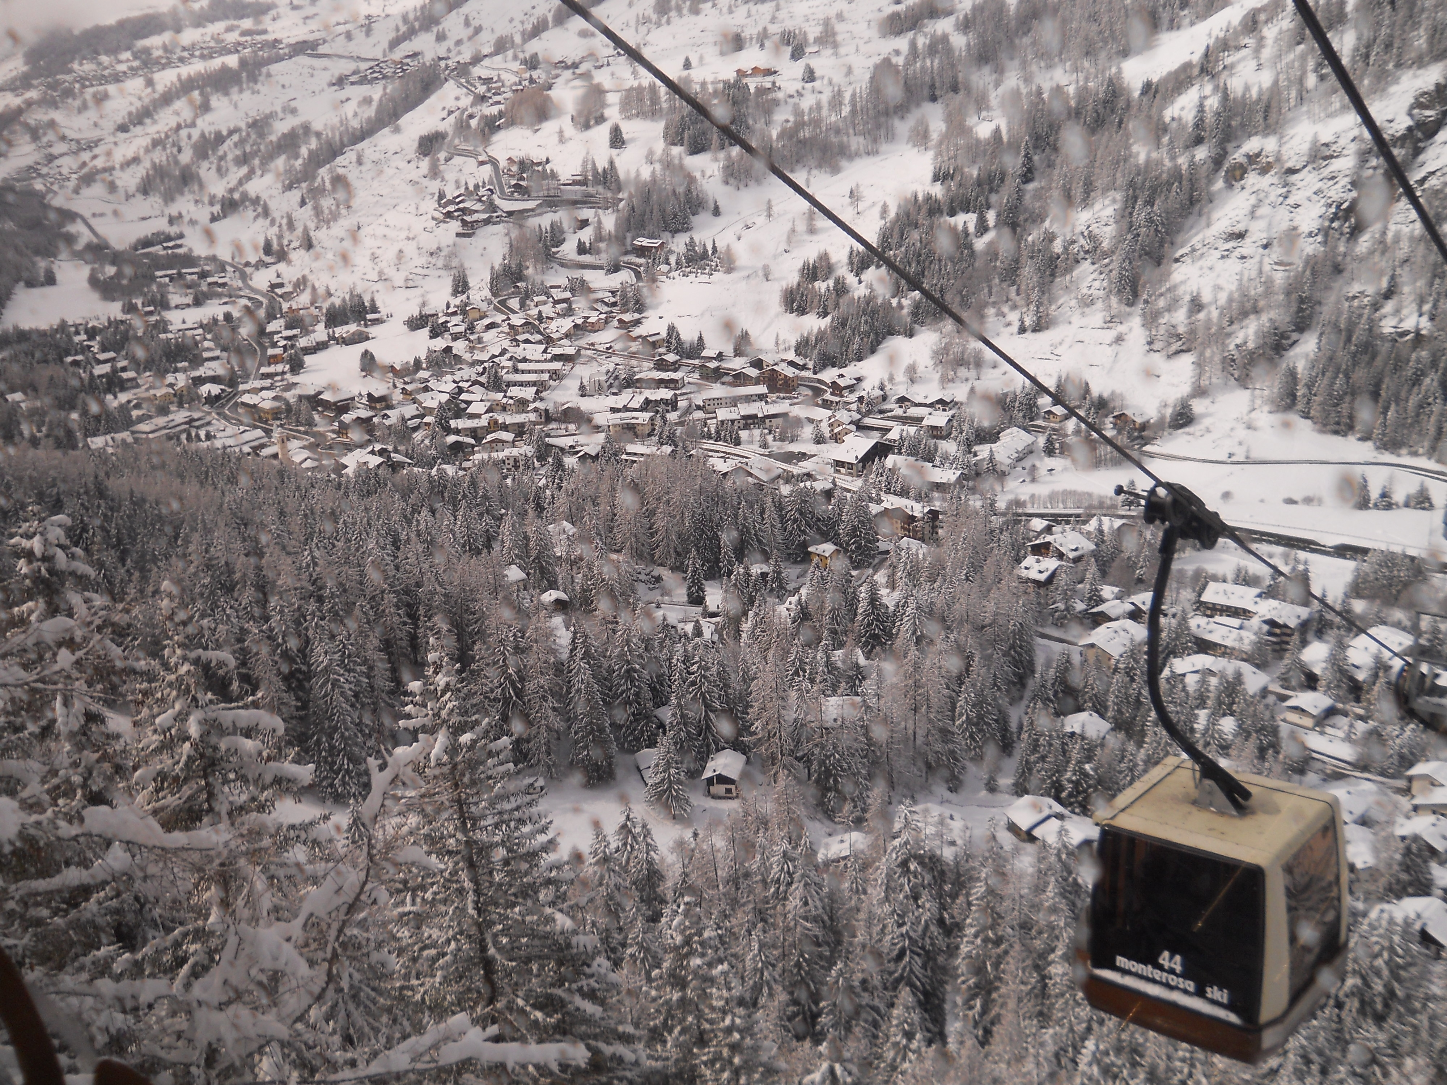
Monterosa Gondola
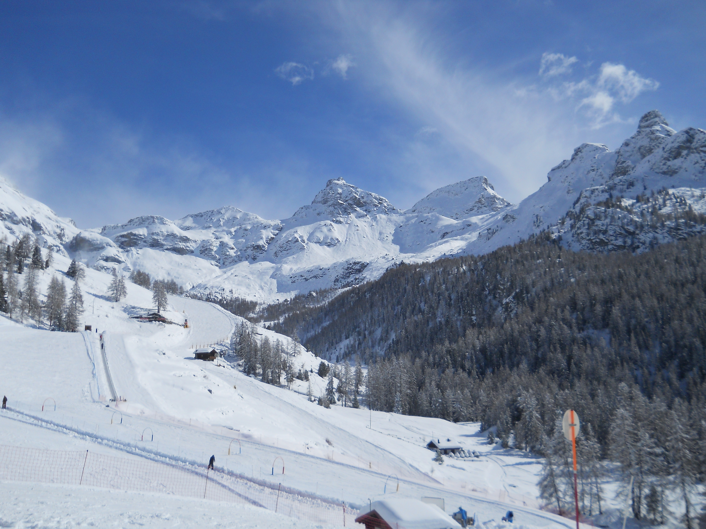
Monterosa Ski Scene

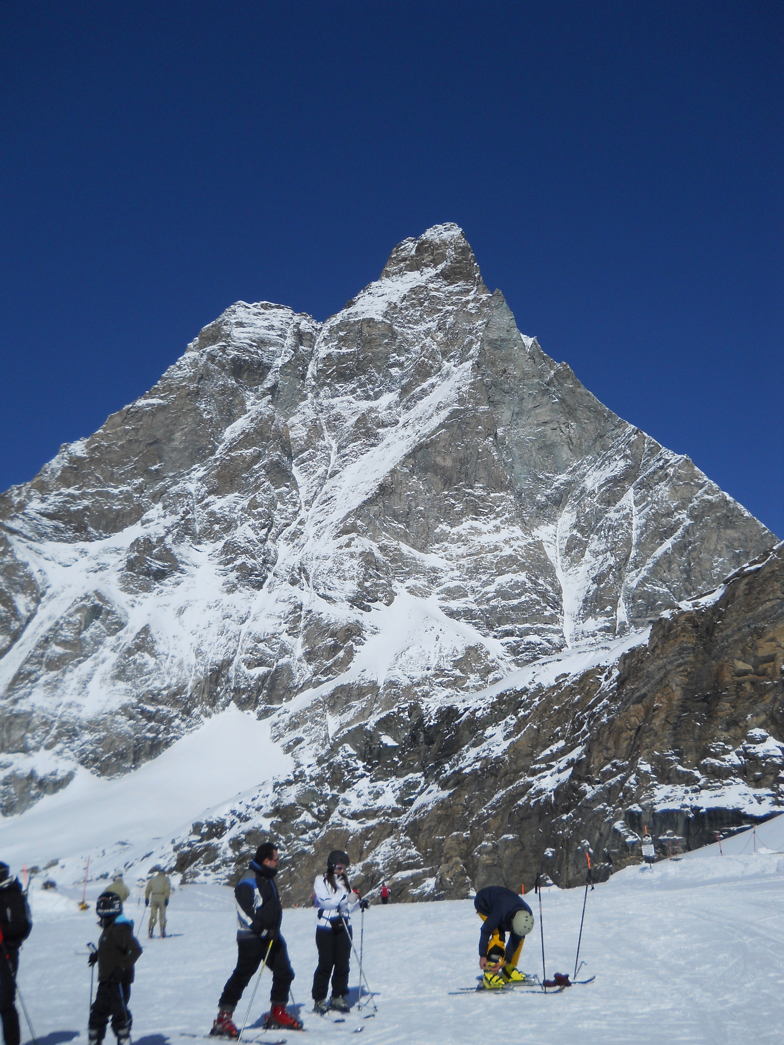
Cervinia - The Matterhorn
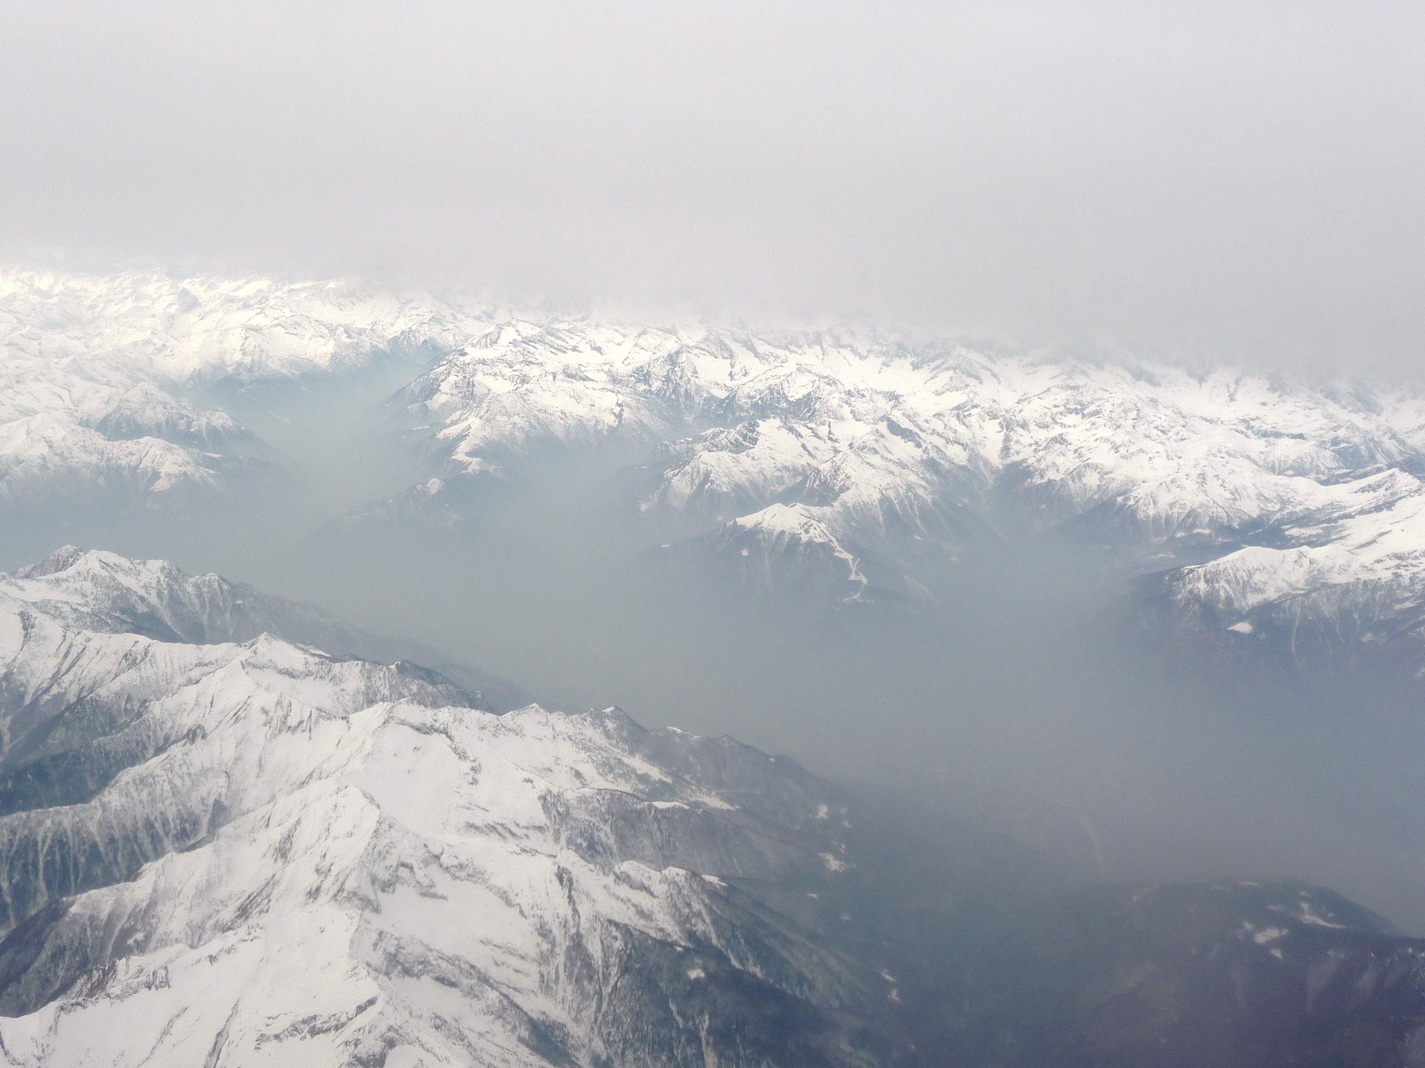
Italian Alps from the air

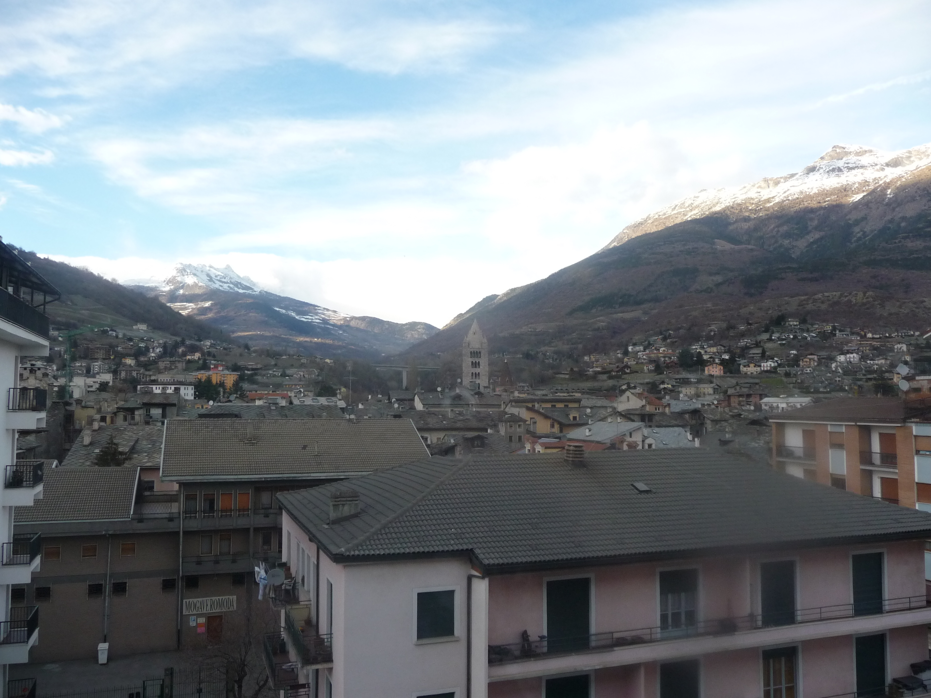
View of Aosta from Hotel Turin window
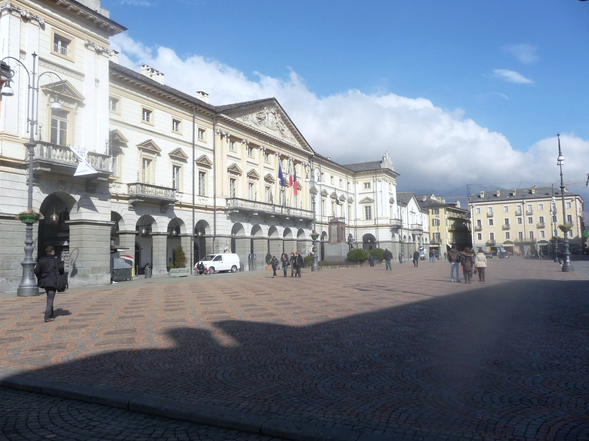
Hotel de Ville- Aosta Town Square

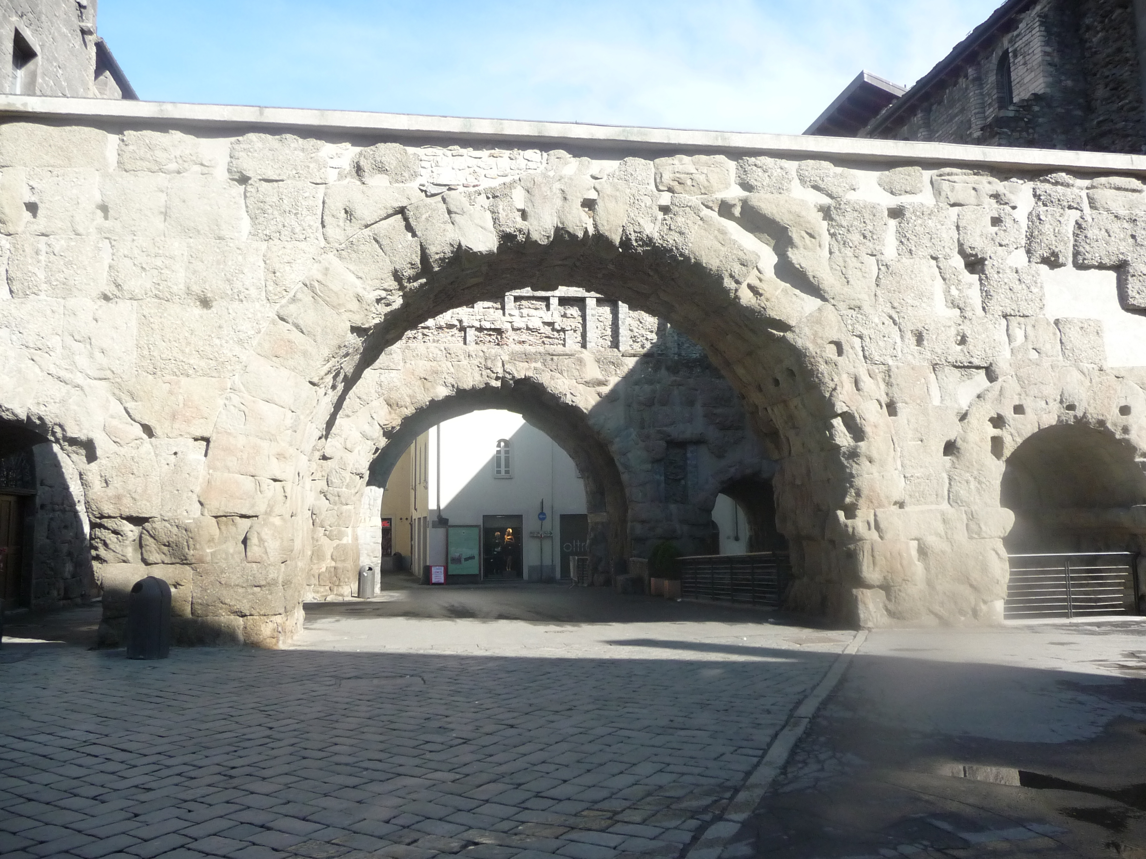
Roman Walls and Arches – Aosta
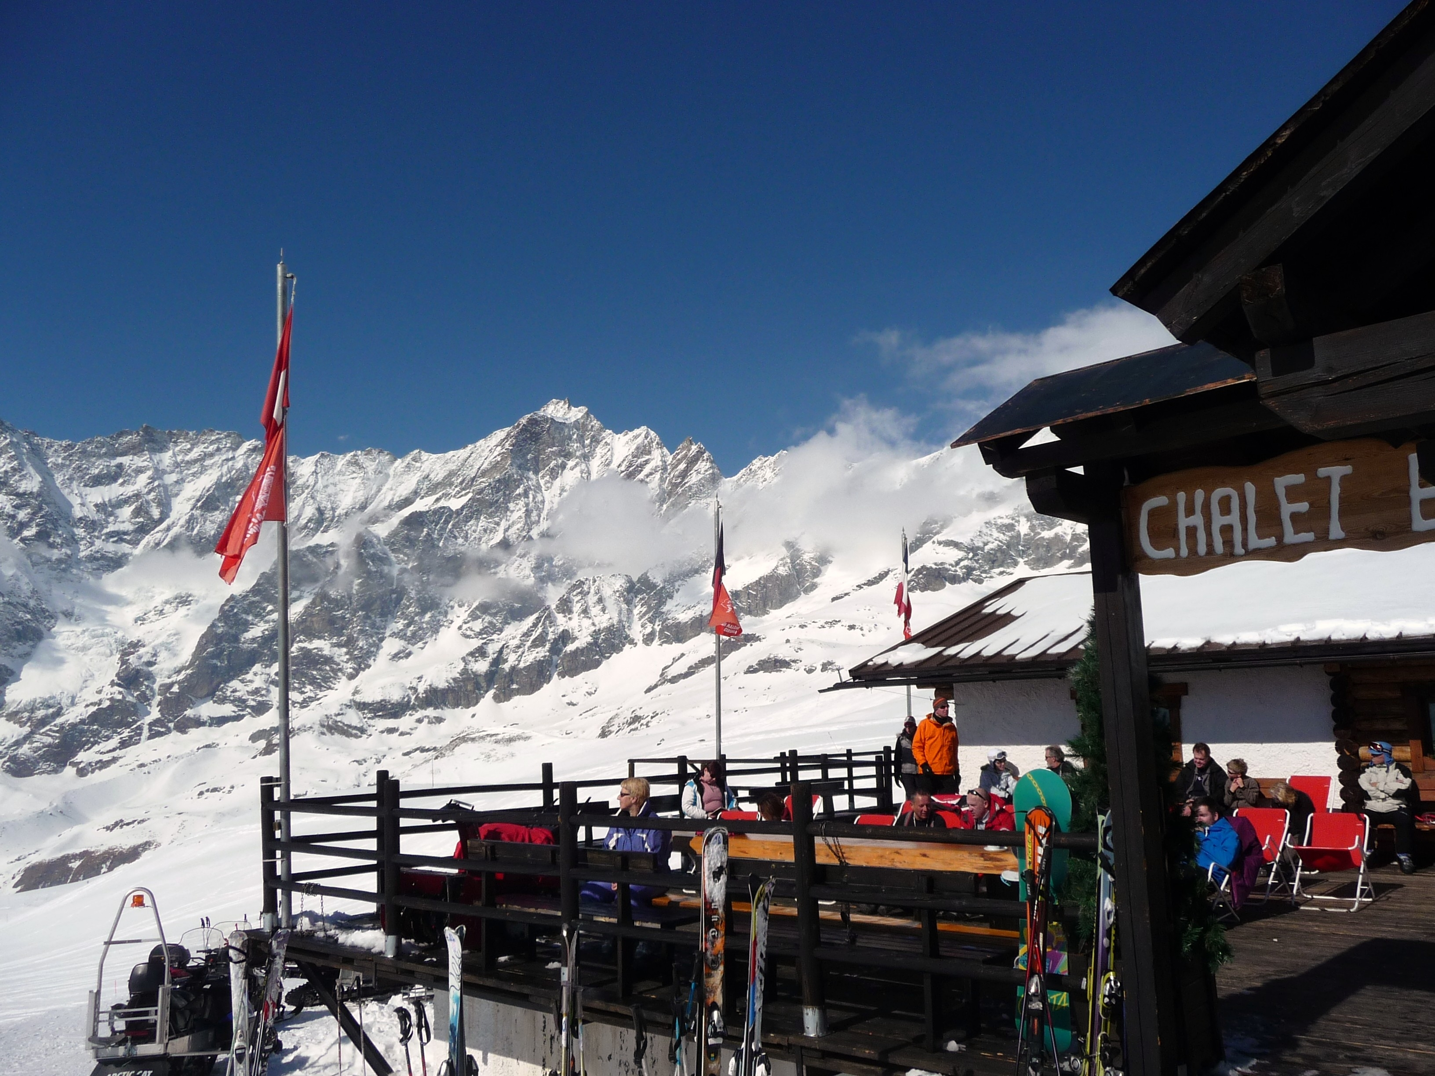
Chalet on the Slopes at Cervinia

