NASA GODDARD SKI CLUB TRIP
to BRIDES-LES-BAINS, TROIS VALLEES, FRANCE

March 10 to March 18, 2018

by Harvey Walden, Trip Leader
Photos by Steve Slojkowski

We departed Washington Dulles International Airport Saturday afternoon, March 10th on a United Airlines flight non-stop for Geneva, Switzerland. There were 39 of us in the group, making this one of the largest European contingents of the Goddard Ski Club in recent years. We arrived at the Geneva airport Sunday morning and met our chartered bus, after some initial confusion, for the approximately two-hour ride to the small Alpine spa town of Brides-les-Bains in the Trois Vallees region of Savoie, France. We arrived late morning at the three-star Hotel Amelie, where our large group was split between this hotel and the neighboring, just-renovated Hotel La Vanoise, where we were to spend the next seven nights with all breakfasts and dinners provided in the hotel’s dining room. We had lunch in town and then arranged ski equipment rentals. Before dinner, we enjoyed drinks and had an orientation on ski arrangements and touring attractions by our hotel manager and representatives from the local tourist information office and a ski school instructor. The hotels were centrally located across from the town’s main square and within walking distance up a short hill of the three-stage gondola “bubble” lift to Meribel.

Monday was the first day of skiing and though we experienced rain in town, it changed to snow on the ride up the bubble lift to Meribel (this phenomenon was to occur on following days as well). There were episodes of considerable fog on the slopes, but the weather was quite variable and not consistent for long. On Monday night, there was a celebration for newly-arrived guests in the Brides-les-Bains town square, offering free drinks of hot apple cider and hot chocolate. On Tuesday, the weather was similar, both in town and on the slopes. A free shuttle bus to Meribel village was available in the evening.

Wednesday was our first truly sunny day with blue skies and warm temperatures. Almost our entire group opted for a day tour by a previously-arranged chartered bus to the picturesque lakeside town of Annecy, some two hours away. Upon arrival at 10:30 am., we enjoyed a two-hour guided walking tour of Old Town Annecy with two English-speaking guides, Bianca and Aude, who each independently led half of our group. Afterward, there was ample time for lunch at one of the many restaurants in town, shopping, and strolling along the lakefront. Our chartered bus returned us to Brides-les-Bains in time for our usual excellent dinner at the hotel.

Thursday was another ski day and allowed an opportunity to visit either or both of the neighboring valleys of Courcheval and Les Menuires-Val Thorens that encompass the world’s largest interconnected ski area. Three of our group somehow managed to be marooned for three hours at a mid-mountain bar when the Saulire express lift unexpectedly stopped operation, but they survived the experience quite handily. Friday was our second bright and sunny day on the mountain with Saturday again snowy and foggy. Many of us met for lunch on our final ski day at Meribel village center.

Sunday morning, we had an early departure from the hotel in darkness at 6 a.m. to catch our departure flight from Geneva at 10:40 a.m. The hotel kindly provided us with breakfasts-to-go the night before for the two-hour bus ride. The United Airlines flight was non-stop to Washington/Dulles, where we arrived slightly ahead of schedule at 3:15 p.m. after a wonderful week in France’s Trois Vallees.

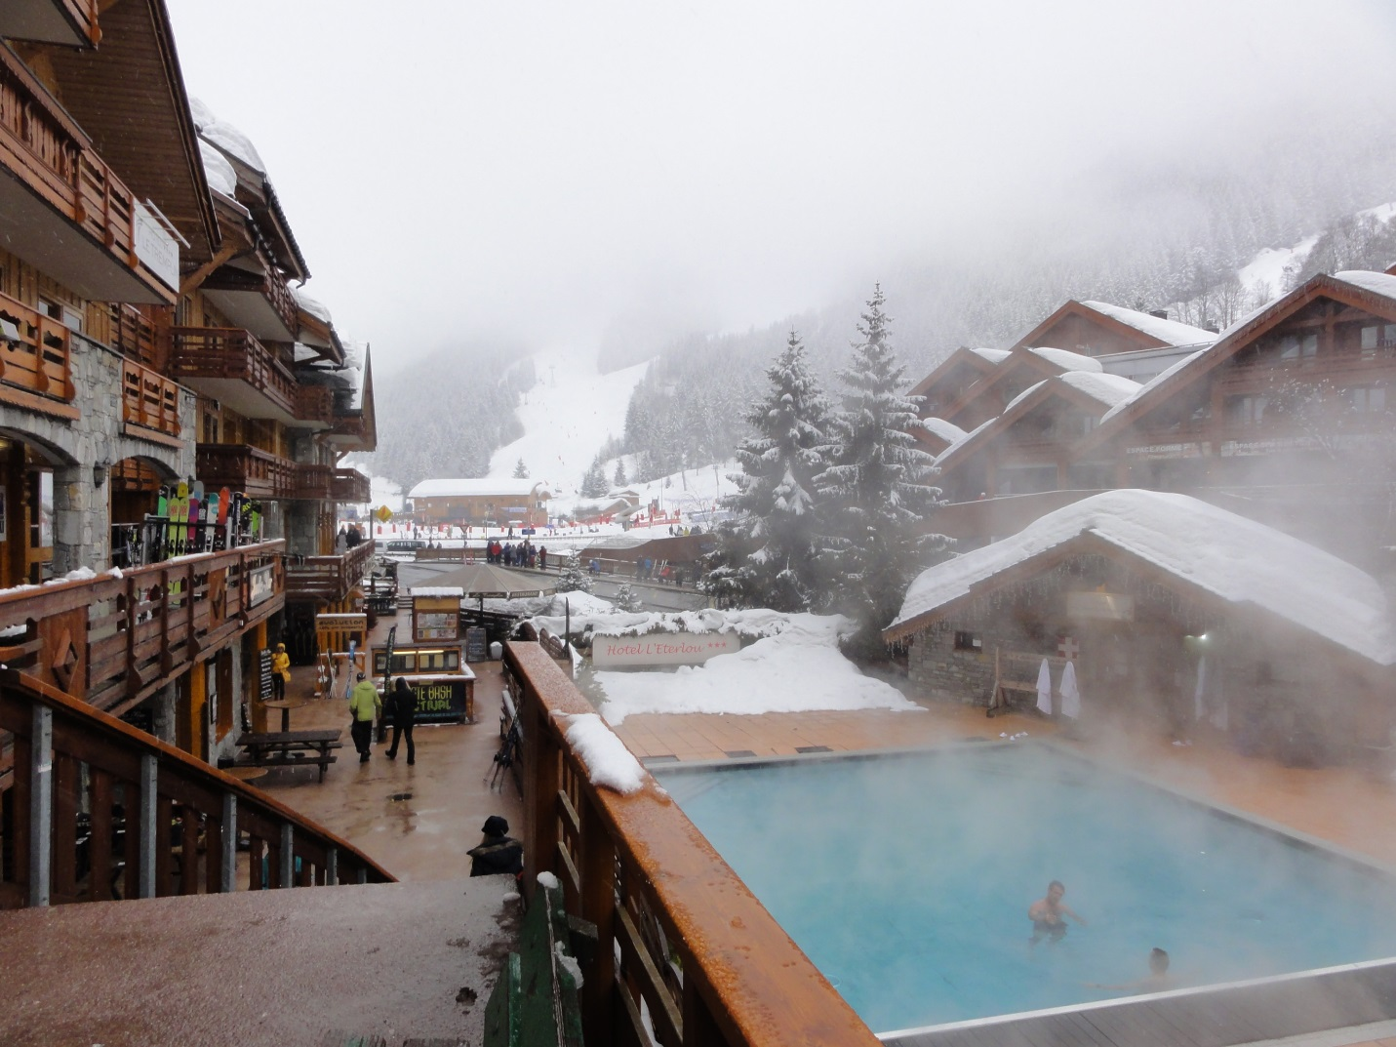

Outdoor spa in Meribel on a snowy day

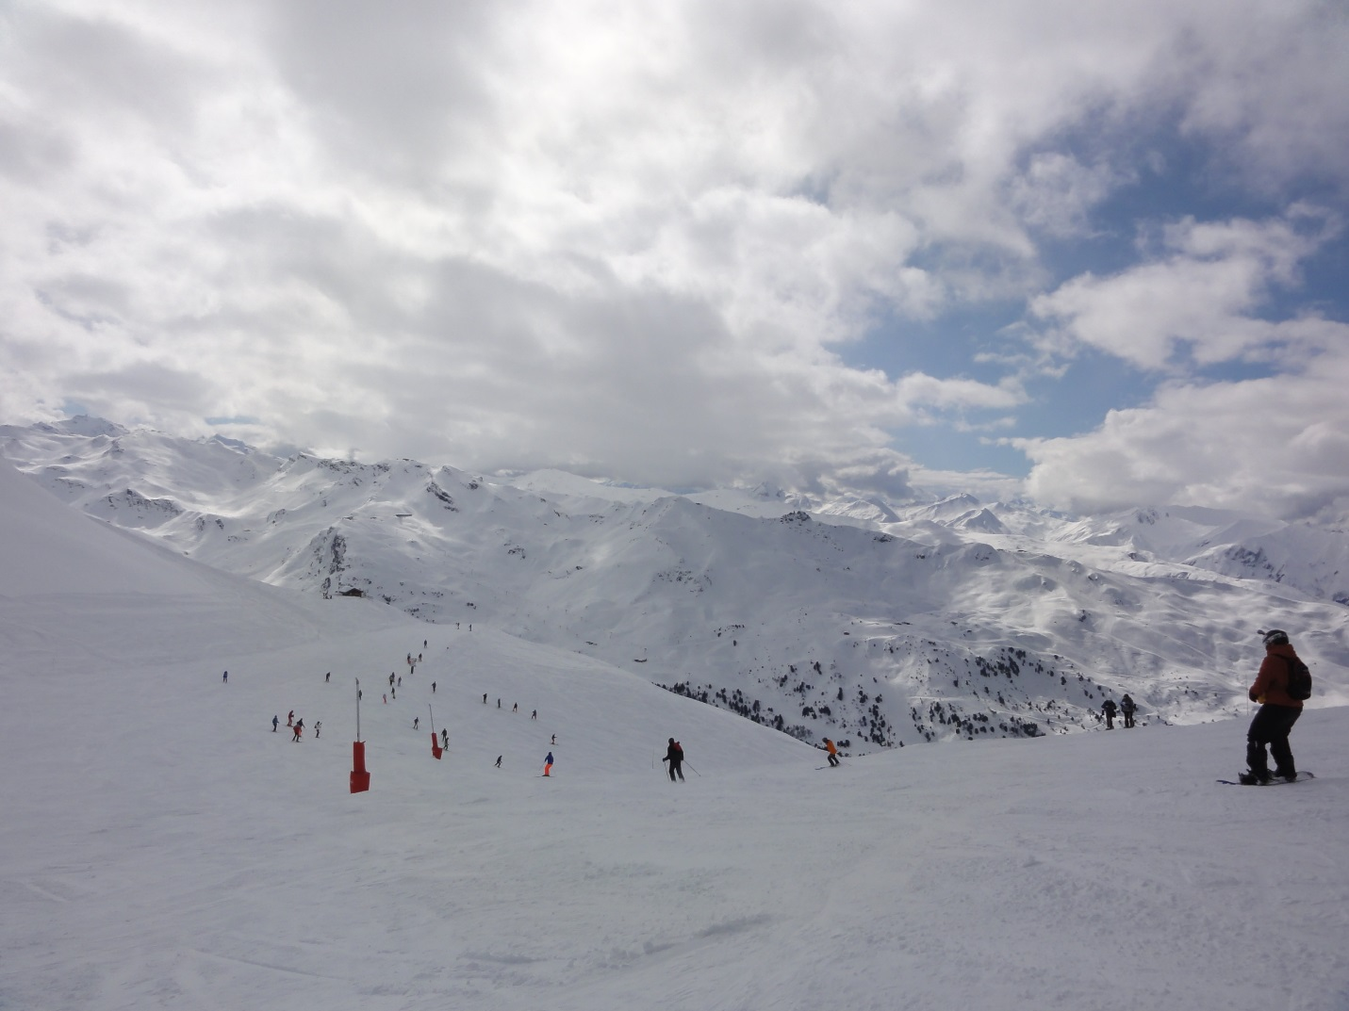

Skiing above the treeline
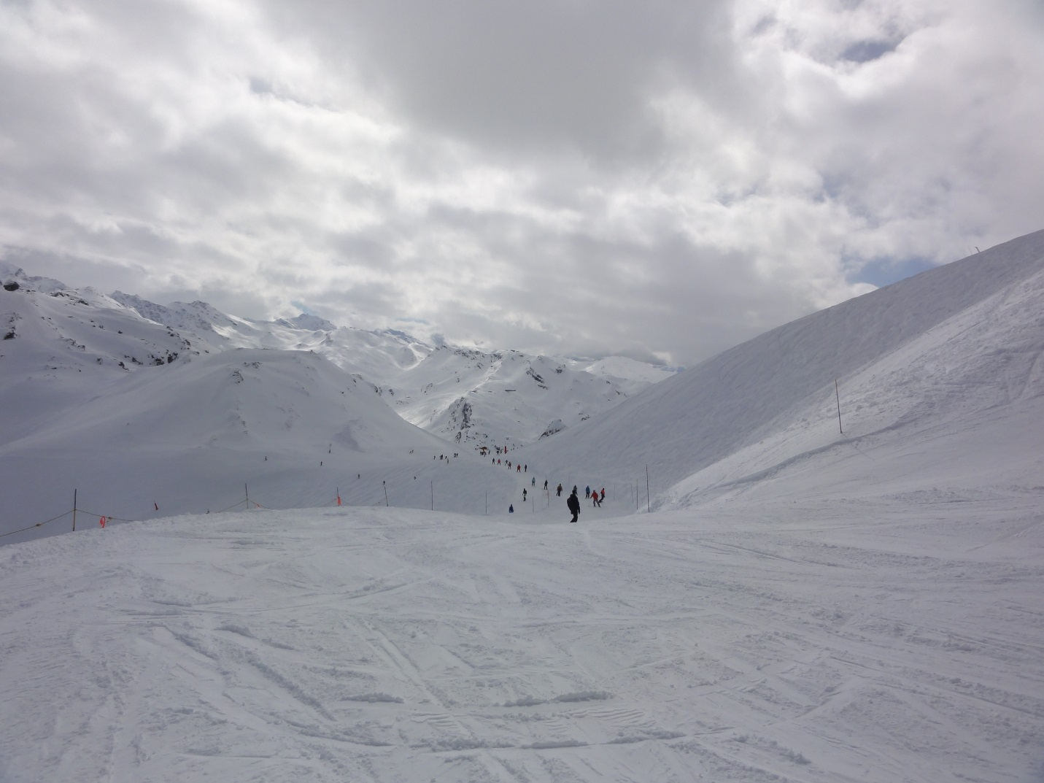

Heading down into the Courcheval valley
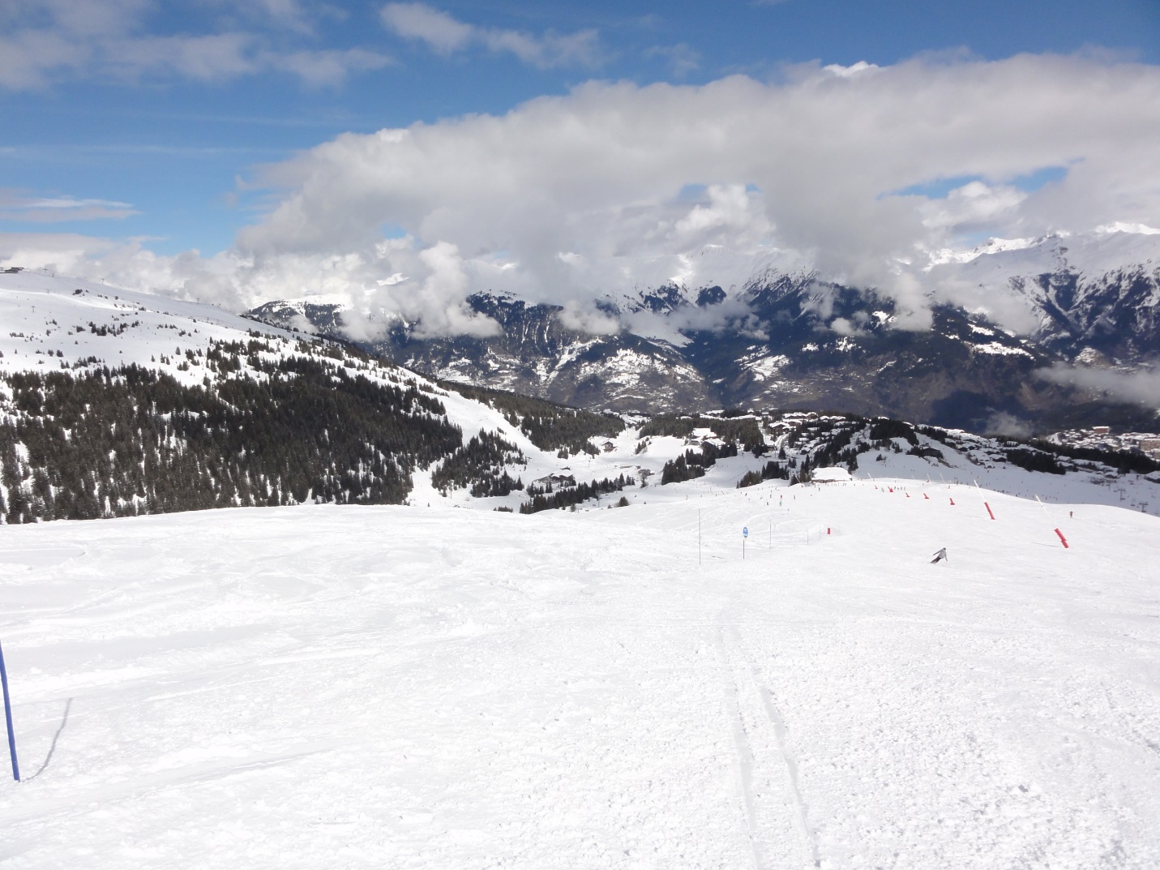

Follow

Blue runs in Courcheval
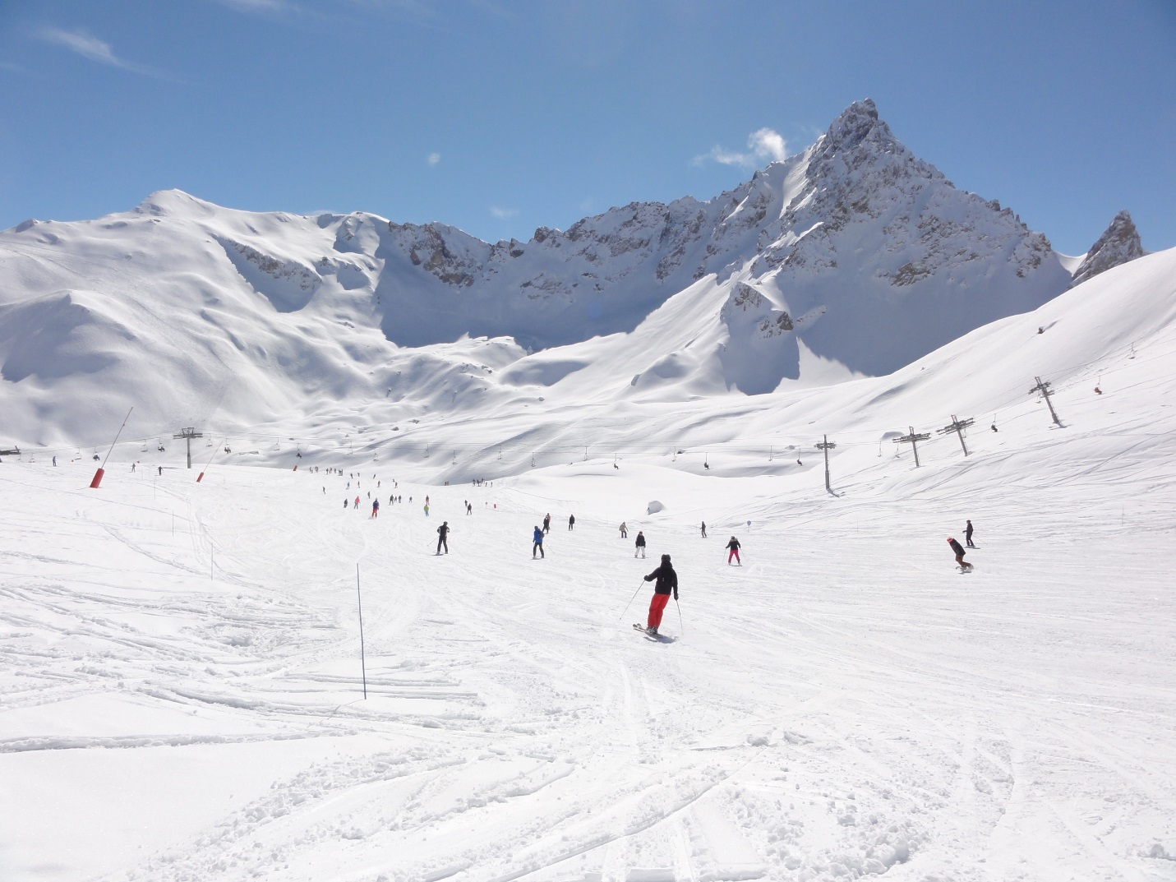

Sunny day skiing
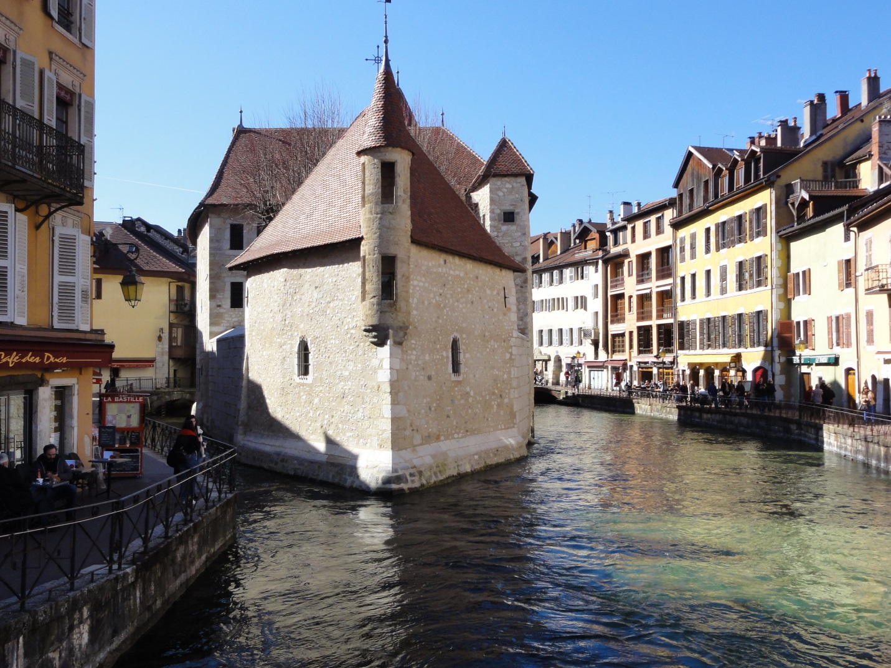

Follow

Annecy - view of the old jail

