NASA GODDARD SKI CLUB TRIP
to DAVOS, SWITZERLAND

February 28 to March 7, 2020
S. Slojkowski, Assistant Trip Lead

A group of 17 club members departed from Washington Dulles International Airport on time at 6:20 PM on February 28. Three attendees who originally planned to attended made the decision to cancel due to concerns over the COVID-19 pandemic which, at the time of departure, was just beginning to have serious impacts in northern Italy.

The flight landed a little early in Frankfurt, Germany and we managed to make an easy connection from Frankfurt to Zurich, arriving in Zurich at around 8 AM. In Zurich we met up with 4 other club members who had arranged independent flights, as well as with 6 additional non-club member trip attendees who were assigned to our group by the tour operator, making the total group size 27 people. At Zurich, we boarded a bus for an approximately 2-hour ride to Davos, arriving at our hotel at 1:30 PM on Saturday, February 29.

Our hotel was the Club Hotel Davos, located a short walk from the main lifts and downtown dining and shopping attractions. Hotel amenities included a bar and lounge area, indoor pool, and spa. The hotel provided discount vouchers for equipment rental at a very convenient location at the base of the main lift, which also provided equipment storage for an extra charge. Breakfasts and dinners were provided at our hotel by a very friendly English-speaking staff. Dinner was served as a full four-course meal, with each diner having the option of choosing from a small menu of main course items each night.

The very large Davos ski area consists of a number of different base sites, served by a number of busses and trains which provided access to local town and base areas. A special tourist ticket was provided by the hotel which allowed free access on all city busses to most destinations in the area. The local Davos Swissrail train station was easily accessible by foot from the hotel and provided rail access to further destinations in Switzerland. Many of the nearby ski areas were also accessible by trails and lifts in the upper mountains.

The first day of skiing on Sunday was an excellent sunny day, with warm weather, no wind and a few passing clouds. Unfortunately, while the rest of the week provided very beautiful winter weather conditions, skiing was challenging. Snow fell steadily throughout most of the week, with some days seeing a few inches accumulation. Most days the upper-mountain slopes were experiencing poor visibility due to clouds or flat light. Wednesday however, provided another excellent sunny and warm weather day for skiing, although Thursday through Friday saw a return of snow, clouds, and flat light. Throughout the week temperatures remained comfortable (around freezing on the upper mountain) with little wind.

Those on the trip who were not skiing were able to take advantage of a large downtown area with plenty of sightseeing and shopping, as well as day-trips from the local train station. Some attendees visited a nearby outdoor shopping center and the historic nearby town of Chur which is reached by a very scenic rail ride through the mountains. In addition, we held a group happy hour at a local restaurant called Teufi. The restaurant provided three horse-drawn carriages which picked the group up at the hotel and transported us through downtown Davos and up into a nearby mountain valley. We returned later to Davos by city bus.

The entire group departed Club Hotel at 8 AM on March 7, in the midst of still more heavy snowfall in Davos. Our return flight required a connection through Munich. We arrived on-time in Munich, but unfortunately suffered a delay of a few hours in departing Munich due to aircraft mechanical issues. After a change of gate, we finally departed Munich, and arrived home at Dulles at around 9:30 PM on Saturday, March 7. With good fortune, we returned just before major shutdowns in travel and business came to the US. We did not experience any delays or barriers in travel due to COVID-19 and none on the trip contracted any illness as a result of the travel.

Davos Upper Mountain Ski Area

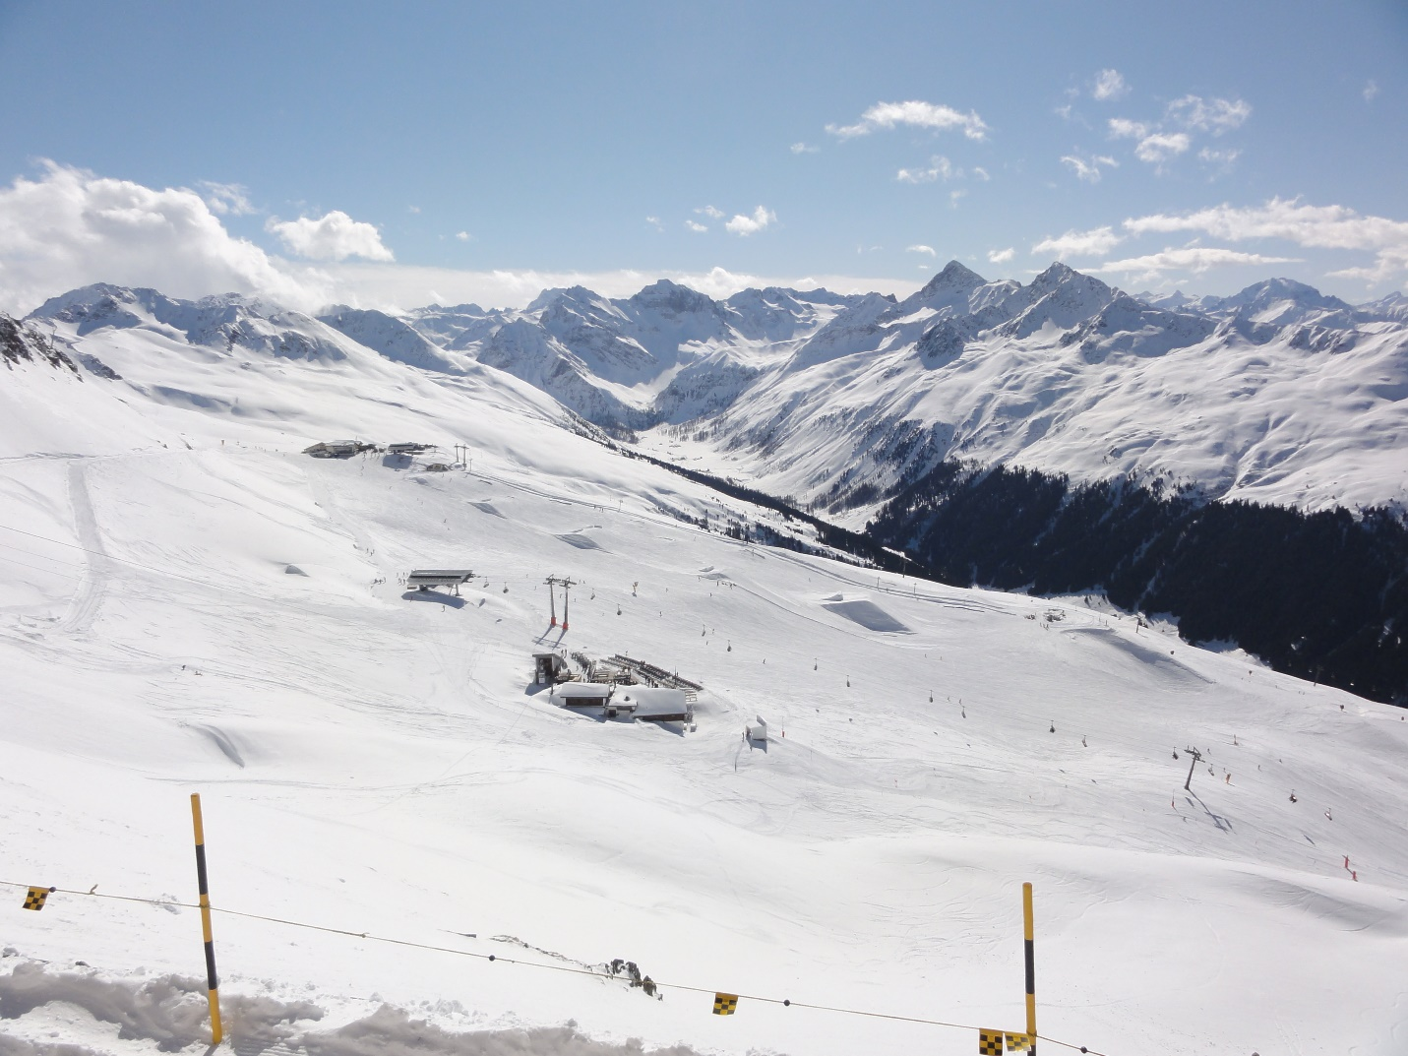

Town of Davos

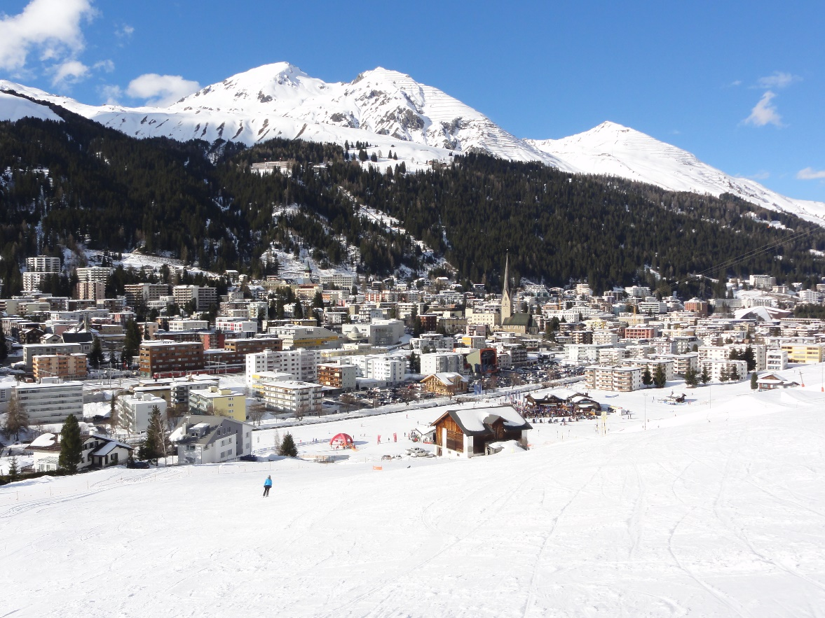

Club Hotel Davos

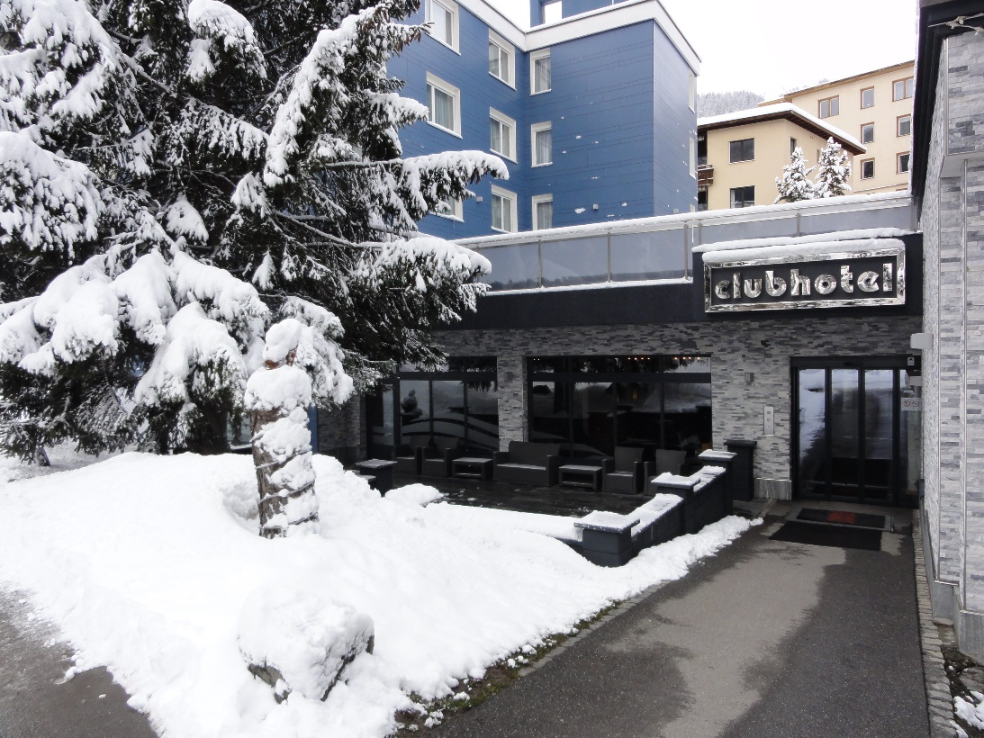
Town of Chur

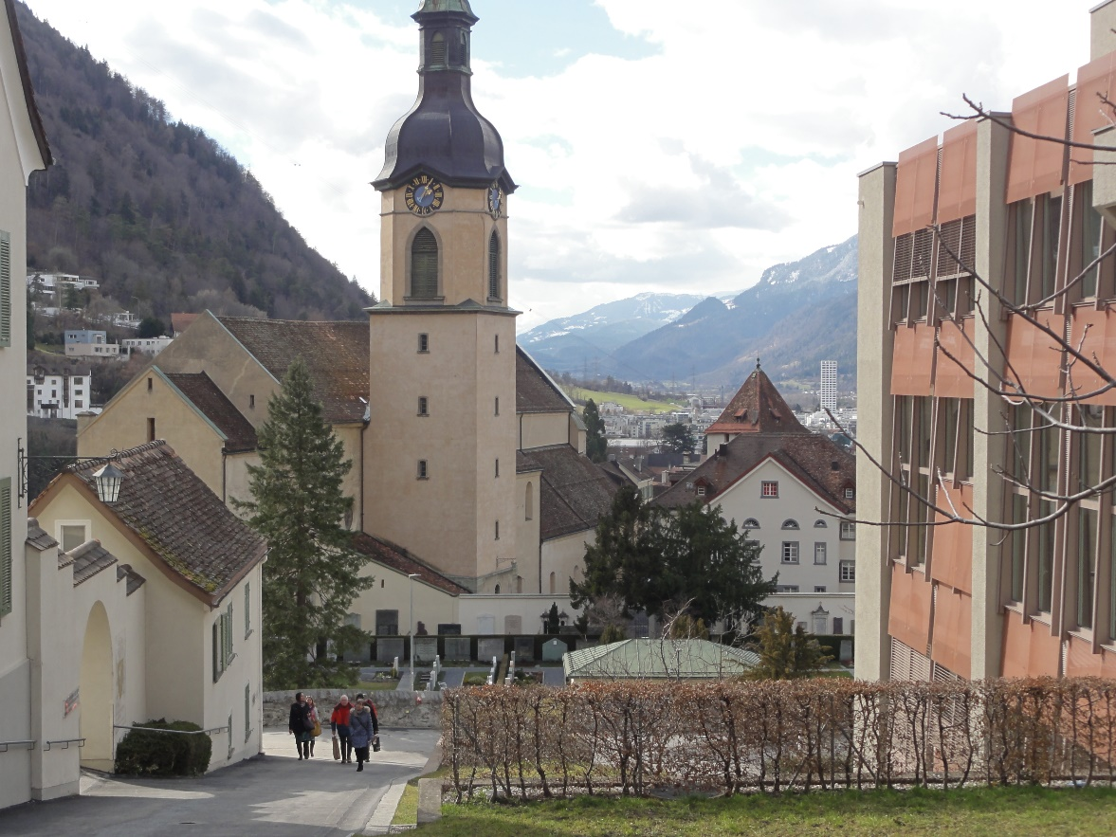

Carriage Ride to Restaurant Teufi

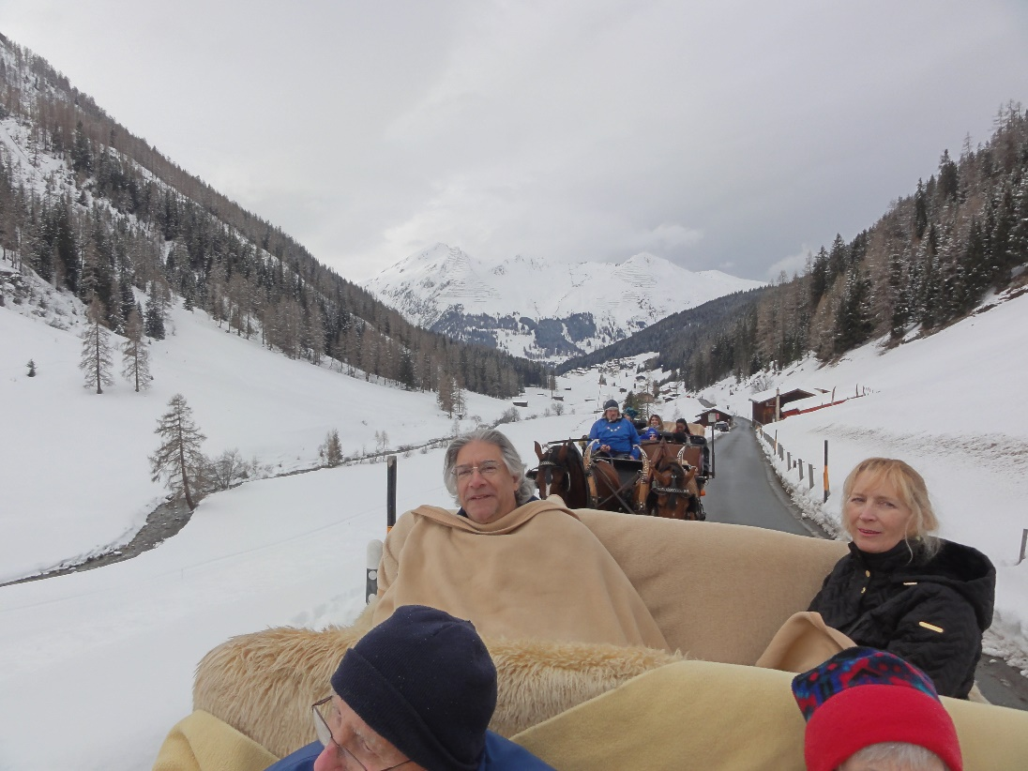

Downtown Snowfall

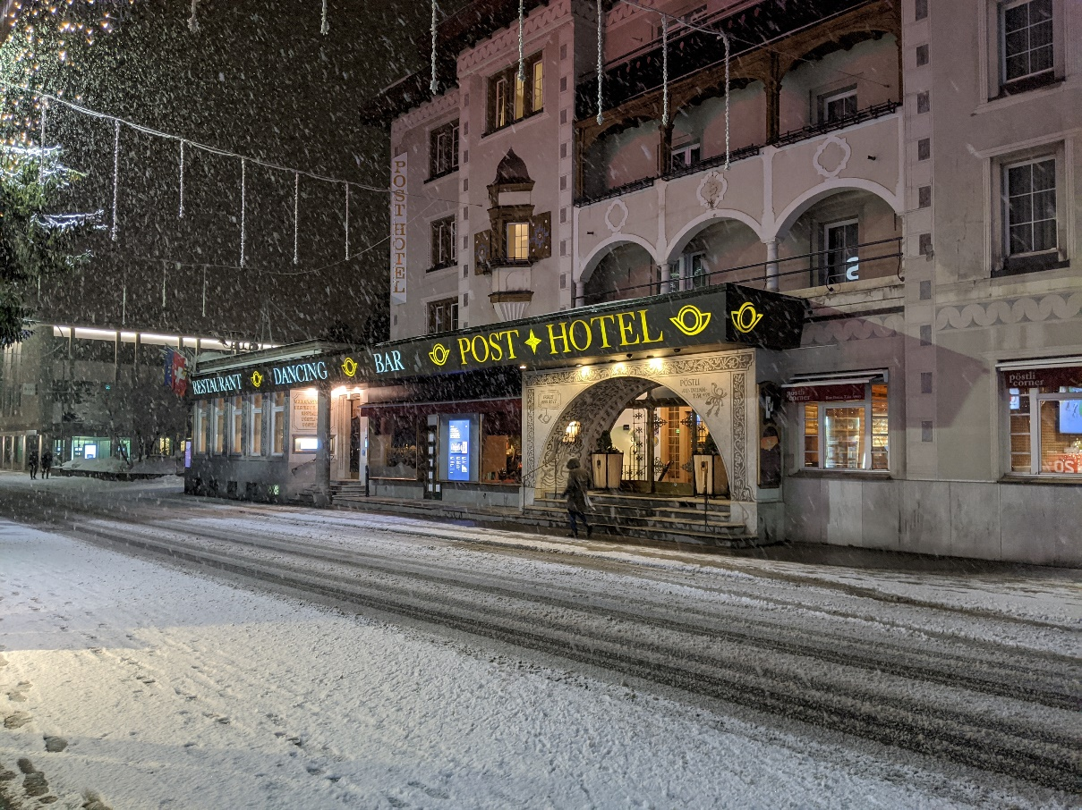

Sunny Ski Day Downtown

