NASA Goddard Ski Club

2015 Annual European trip

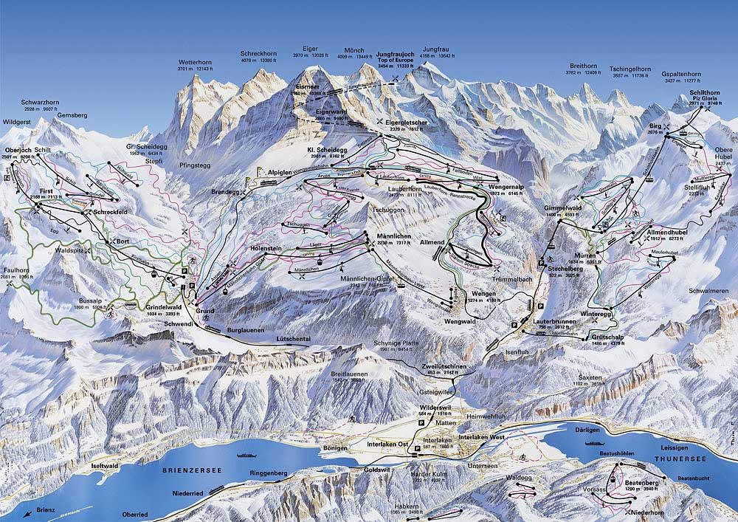INTERLAKEN, SWITZERLAND

only $2075*

Saturday, March 14 to Sunday, March 22
Interlaken is in the central Swiss Alps’ magnificent Jungfrau region. For skiing, it boasts an impressive 1372 m (4500 ft.) of vertical descent. There are 17 km (11 miles) of cross-country ski trails. For snowboarders, there are 3 terrain parks and 3 half-pipes. Interlaken also offers toboggan rides and miles of sledding tracks of varying difficulty. Optional day tour trips to Berne, Luzerne, and Zermatt. Enjoy skiing, sightseeing, shopping, and culture in Europe.

7 nights (dbl. occ./private bath) at City Hotel Oberland***. Single supplements available. Buffet breakfasts daily & 3-course dine-around dinner for 5 evenings at your choice of 3 restaurants within the hotel included. Round-trip air non-stop Dulles to Zurich via United, with ground transfers. $500 deposit to hold space (check to “Goddard Ski Club”).
*Price increases to $2150 for deposits received after November 1, 2014.

For information/reservations, contact:
Harvey Walden at (301) 286-9140 or Harvey.Walden@nasa.gov

