GODDARD SKI CLUB trip to INTERLAKEN, SWITZERLAND
Saturday, March 14 to Sunday, March 22, 2015

Report by Harvey Walden, Trip Leader
Photos by Jeff deLaBeaujardiere

Our trip began inauspiciously at Washington/Dulles Saturday afternoon, March 14 with the international airport experiencing an electrical power outage. Darkened hallways were lit only by a backup emergency power system, and airlines staff were reduced to using flashlights. Prior to departure, however, the power was restored, and 20 NASA Goddard Ski Club members boarded an overnight non-stop flight to Zurich, Switzerland on time. Upon landing early Sunday morning, we were joined by two additional Club members on separate itineraries. We all met our chartered bus at the airport for a scenic ride to the Jungfrau region of the central Swiss Alps. The ride was routine until our arrival in Interlaken, where our bus driver had considerable difficulty, despite the use of two GPS systems, in locating our 3-star City Hotel Oberland on the main street of town. We were rescued by a private citizen on a motorcycle, who personally escorted our bus to the hotel.

After checking in at the hotel, we had lunch in town. Then a ski rental shop picked us up at the hotel in a van for a short ride to arrange equipment rental for those who had not brought their own. At 6 p.m., we had a welcome orientation talk at the hotel to acquaint us with skiing, snowboarding, and touring possibilities in Switzerland. The hotel was quite comfortable, and the English-speaking staff were very accommodating and always friendly. Dinners were at either of two restaurants at the hotel, the Mercato and the Chalet, with a choice of either a daily special menu or a credit for any dinner a la carte. During the week, we had three-course dinners at either of these two fine restaurants within the hotel on five evenings, with the other two dinners on our own elsewhere in town. Breakfasts were all-you-can-eat buffet style each morning with a wide variety of hot and cold dishes available.

Each day, the group separated into skiing or snowboarding and touring groups. There were three large ski regions available: First/Grindelwald, Mannlichen/Kleine Scheidegg, and Murren/Schilthorn. A special free ski bus picked us up just across from our hotel for a short ride to the either of the first two regions, while the third was accessible by a combination of public bus and train to the base of the cable car. The touring group could readily walk to either of two rail stations at opposite ends of town, Interlaken Ost and Interlaken West. The First area has the easiest ski pistes for beginners and intermediates, Mannlichen has the greatest variety of terrain and is the largest area, while Schilthorn has more advanced runs. The latter is well known for the James Bond film, “On Her Majesty’s Secret Service,” which included a ski chase down the black (expert) run from the Piz Gloria restaurant at the summit. Posters in town shops still promote the 1969 film. Spectacular views of three distinctive peaks, the Eiger, the Monch, and the Jungfrau (highest at 4158 meters/13,642 feet elevation) were available to sightseers as well as skiers. The Jungfraujoch, or “Top of Europe” is accessible from Kleine Scheidegg by the highest rail station in Europe and includes the Sphinx Observatory, an Ice Palace, a 360-degree panorama, an outdoor plateau on the Aletsch glacier, as well as the omnipresent chocolate and watch shops and restaurants. Non-skiers in our group travelled from Interlaken by Swiss rail to Thun on the nearby lake, to Luzern (Lucerne), and to the capital city of Bern on various days during the week. On Friday, there was a partial solar eclipse in the morning of the first day of spring. It was also market day on the main street of Interlaken, which was closed for pedestrians and lined with tents, near our hotel. Paragliders were using the nearby main park in the center of Interlaken as a landing zone in late afternoon.

The week’s weather was mild and clear until our last ski day, Saturday, when it rained in town and snowed on the mountain. It was free demo. ski day at Mannlichen, where dense fog during the snowfall made visibility difficult on the slopes. Since it was relatively late in the ski season, the snow pack was quite firm each morning, especially at higher elevations. After the warmth of the day kicked in, allowing lunch at the open-air cafes on the slopes, conditions became spring-like by late afternoon. Ski runs were well groomed every overnight to a perfect combed surface. Some in our group went to ski Zermatt (a 2- to 3-hour trip by Swiss rail to the end of the line near the Italian border) on the final day for added variety.

On Sunday, the hotel arranged an early breakfast for our group at 6:30 to accommodate our 7 a.m. departure by chartered bus for Zurich airport, two hours distant. Some in our group had difficulty in arising at the early hour and missed breakfast, but barely managed to get aboard our bus just in time. We arrived at the gate at the airport with minutes to spare, but airline personnel expedited our processing as a group. The return flight was uneventful and capped a truly wonderful week in the beautiful Swiss Alps for all.

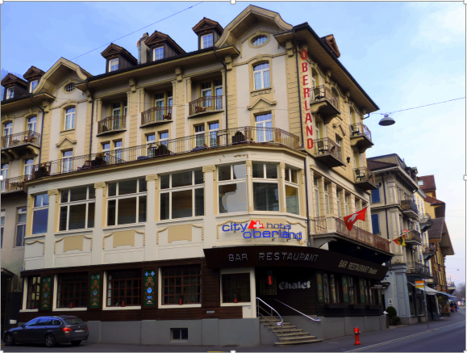
Our lodging in Interlaken at City Hotel Oberland

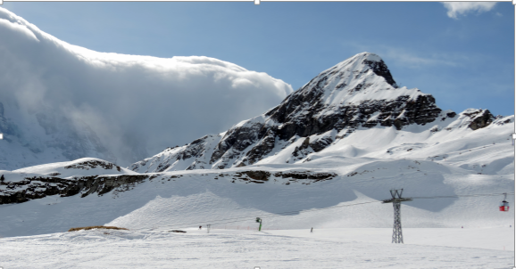
Männlichen Ski Area Switzerland

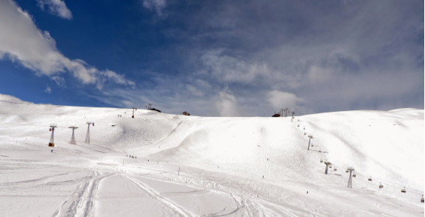
Männlichen Ski Area

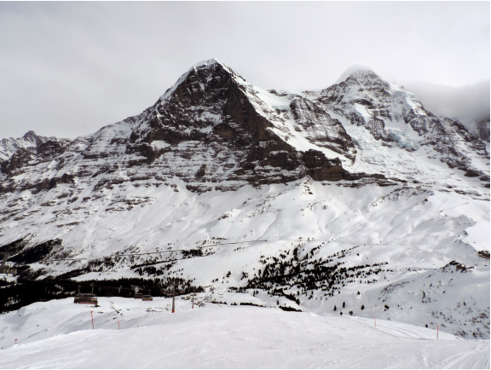
The Eiger and Mönch peaks from Kleine Scheidegg

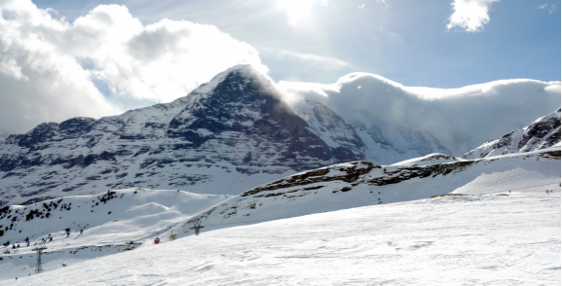
The Eiger as seen from Mannlichen Ski Area

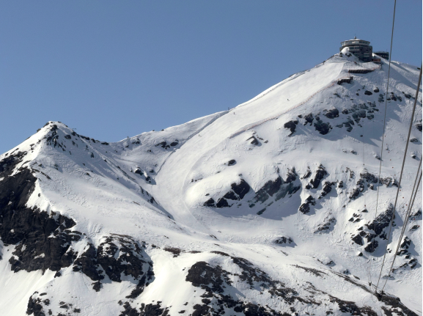
The villain's lair in the James Bond film, "From Russia with Love" (1969), now Piz Gloria restaurant at Schilthorn. The ski chase run is below.

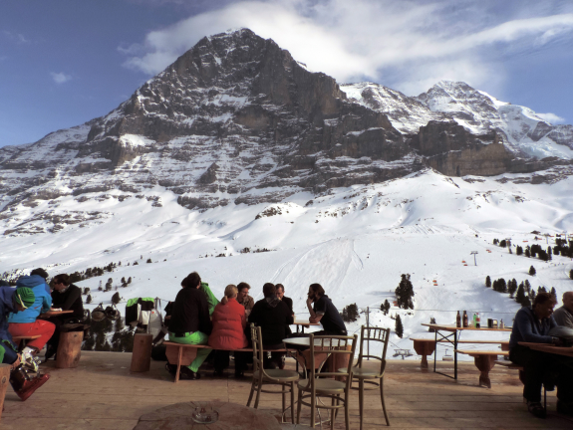
Après-ski terrace below the Eiger

