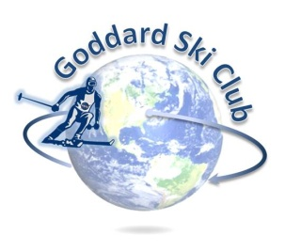
Killington Trip Report
Thursday, January 4 – Sunday, January 7, 2018

Location: Killington Ski Resort, Vermont
Participants: 22 adults, 1 teenager, 1 child
Trip Leader: Matt Ekinci (matthewekinci@gmail.com)
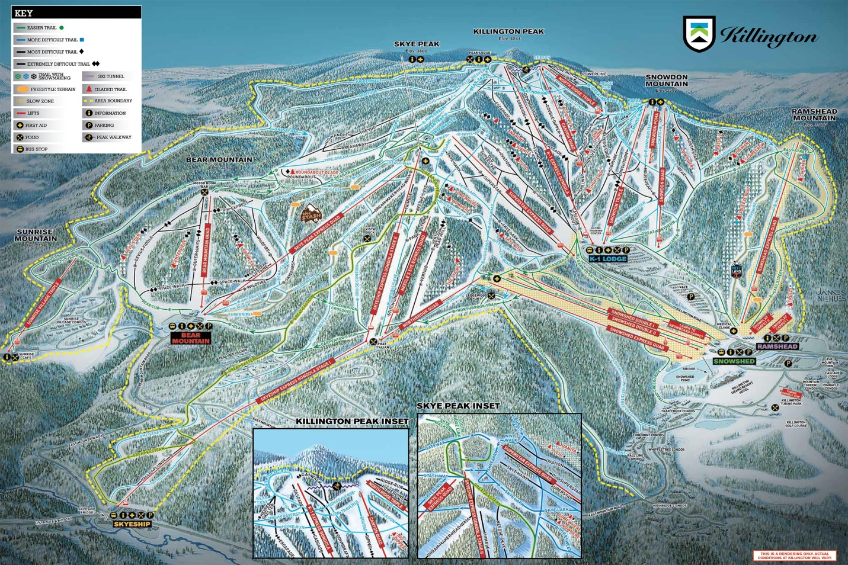

Lodging: Killington Mountain Lodge (http://killingtonmountainlodge.com/)
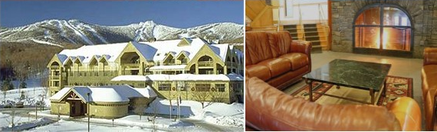

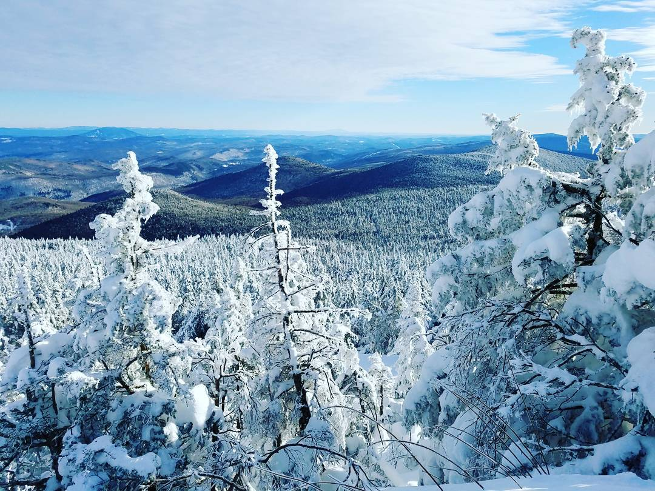
The club returned to Killington Mountain Lodge for the third time this year. While originally slated to be the largest Killington trip ever in terms of attendance with ~30 participants, weather led to some challenges and second thoughts that thinned the crowd – an ongoing theme for the weekend. While several inches of snow fell during an otherwise pleasant Thursday, offering a day full of endless refills on the trails for those that had come up early, many of the attendees were unfortunately caught in the storm during their drive up and had their travel time significantly extended. Temperatures plummeted overnight Thursday, setting up for a frigid (high of -11 F at the base!) day with a delayed opening and some lift closures due to the cold on Friday. Once lifts got turning, though, Friday was excellent if you layered properly, with patches of sun and lots of fresh snow to be had from the storm the day and night before.
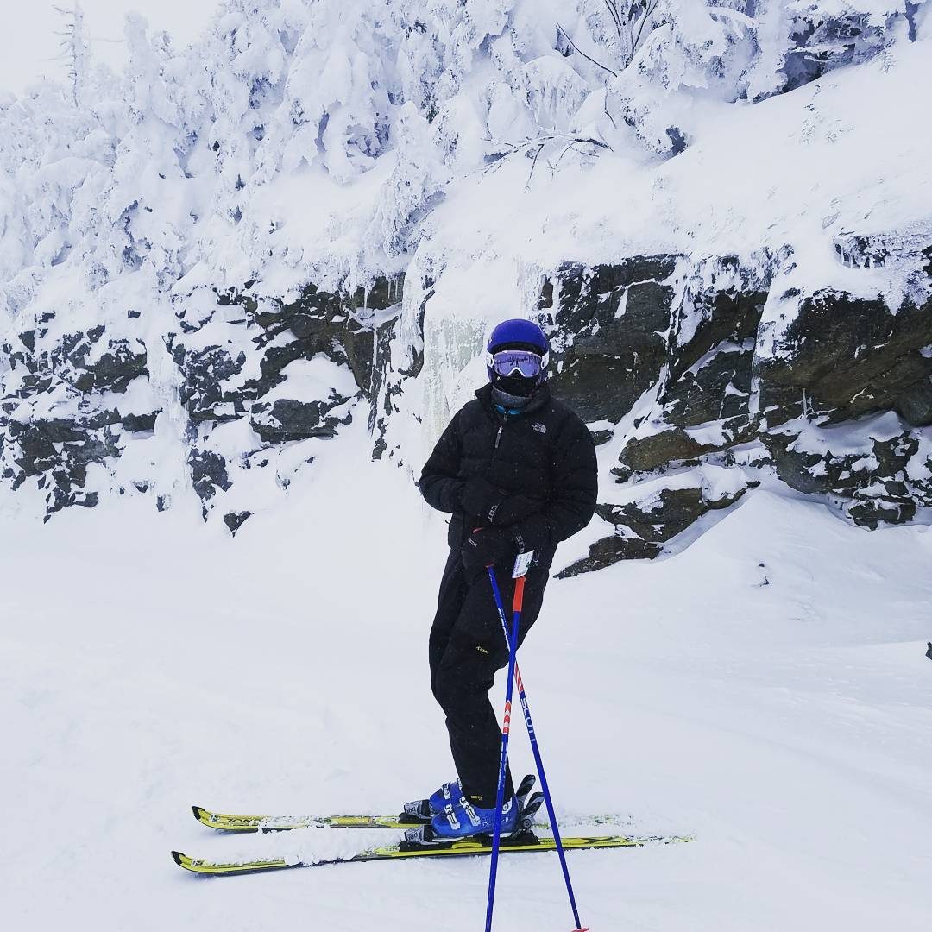
Friday night we gathered for happy hour at Outback Pizza, just a short walk down the road from KML. The club provided appetizers and drinks, and we had a great turn out with almost everyone on the trip stopping by (making it a convenient time to distribute swag – this year’s was SiliPint hot tub-safe pint glasses). It was a great chance for everyone to socialize and get to know new people on the trip, and with Saturday looking like a questionable-go day due to even colder temperatures moving in, many of us hung around well into the evening enjoying drinks and the live band. Labatt happened to be having a promotional event in support of USA Hockey at the bar that night, and with so few people on the mountain due to the weather quite a few of us ended up leaving with shirts, coozies, etc. They even raffled off a snowboard that we thought one of the group had won at first due to some confusion about names, but the person in question still got a hoodie as a consolation prize.
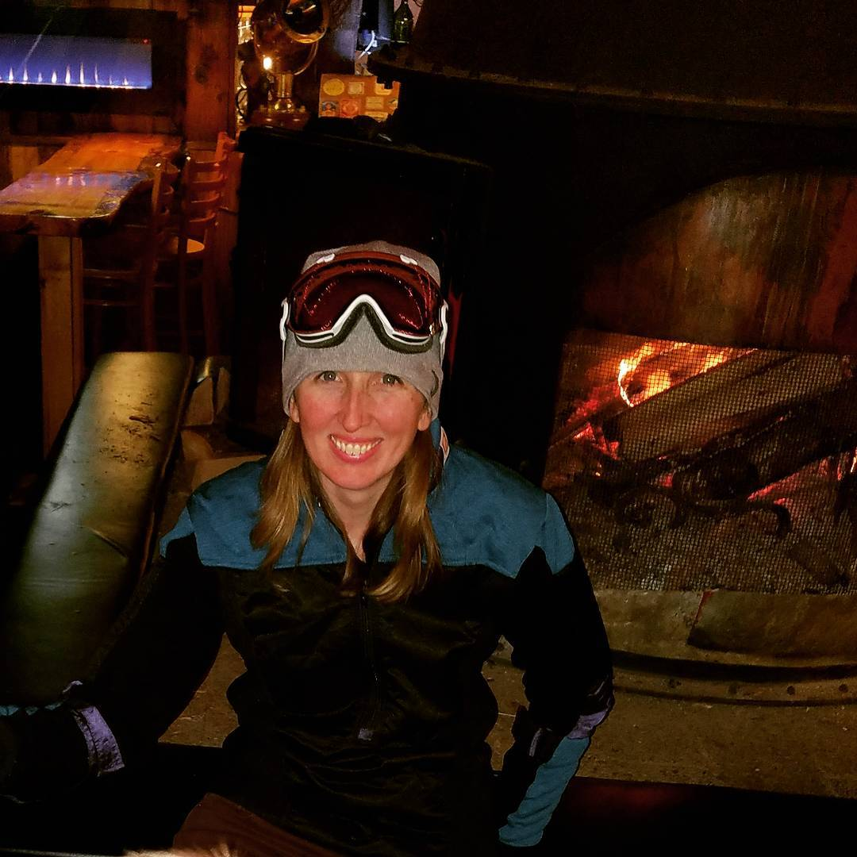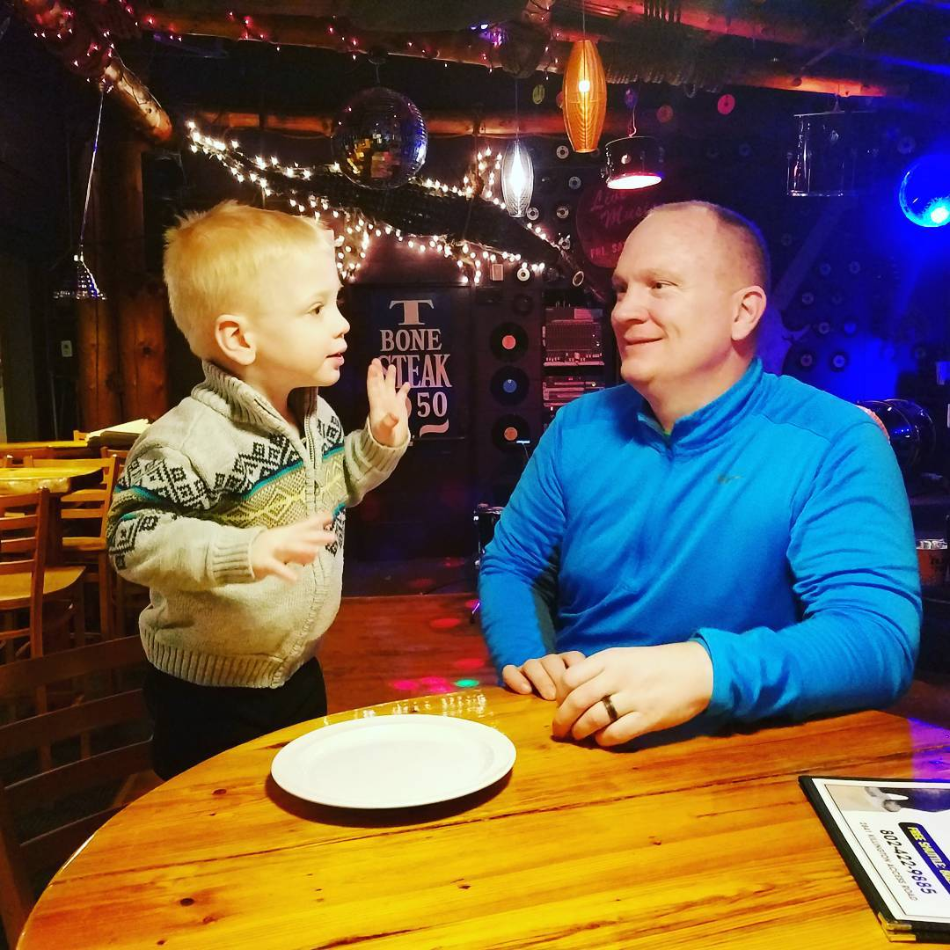
Saturday broke, as forecasted, with bone-chilling temperatures, with an overnight low in the -30s giving way to a daytime high at the base near -20. It was, in fact, so cold and windy that two hours into a morning lift delay, the mountain officially made the call to close for safety reasons for the day, for what I was told was the first time in at least 15 years. Everyone had to take a lift ticket voucher for the day, but not to let the day be wasted, about a dozen of us bundled up and drove down the road to nearby Long Trail Brewing (~20 minutes from KML) for lunch and their self-guided brewery tour. Saturday night a good portion of the group had dinner together at local standby The Wobbly Barn (something that’s becoming a bit of an annual tradition in and of itself), before returning to the hotel for a night of lazing by the fire and playing pool, giant Jenga, and other games in the lounge.
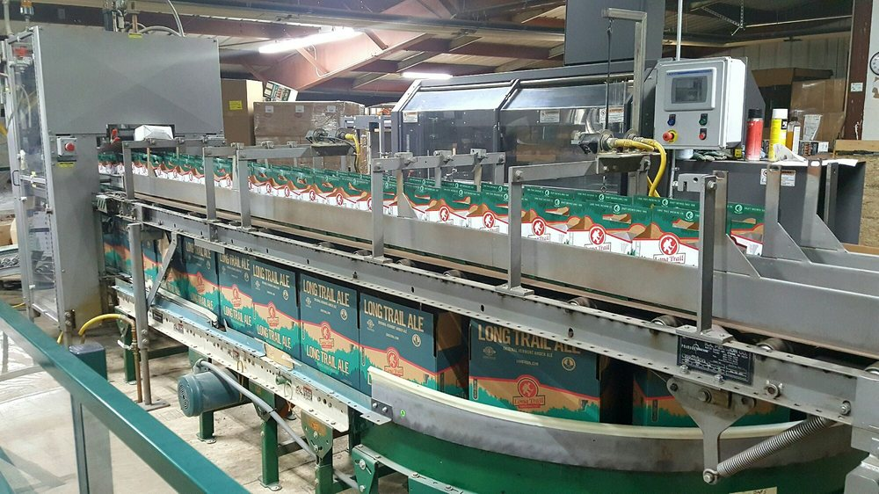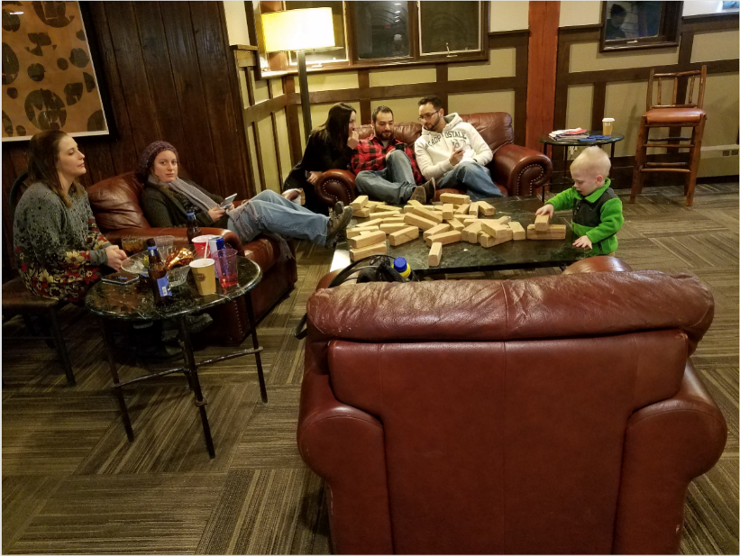

Things finally started warming up on Sunday, with subzero conditions in the early morning rapidly heading up into the mid-teens as part of a brilliant blue-sky day. With the warmer temps, sunshine, and the mountain having been closed the day before, those who put in some turns on Sunday were treated to generally awesome conditions before needing to bring the trip to a close.
