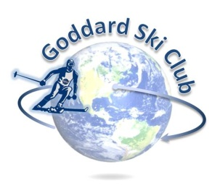
Killington Trip Report
Thursday, January 3 – Sunday, January 6, 2019

Location: Killington Ski Resort, Vermont
Participants: 32 adults, 2 children
Trip Leader: Matt Ekinci (matthewekinci@gmail.com)
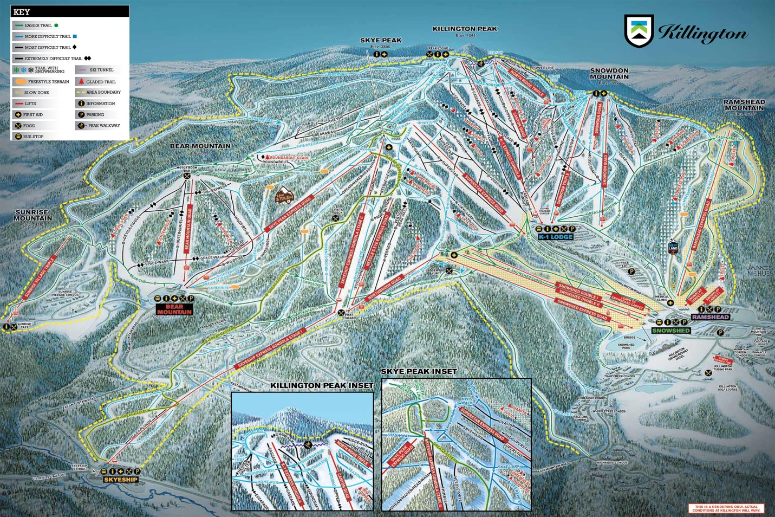

Lodging: Killington Mountain Lodge (http://killingtonmountainlodge.com/)
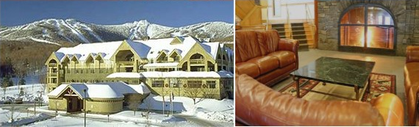

The club returned to Killington Mountain Lodge for the fourth time this year. With the club subsidizing part of the trip this year to up the activities included while dropping the price, we set a new record for trip attendance with 32 adults and 2 children, totally selling out our 15 room block in the process. In a reverse of the typical stats, this trip also had nearly 2:1 newcomers vs. returning trip attendees, affording ample opportunity to break in a new wave of club members that will hopefully push next year to an even higher attendance record when more of the “regulars” are in attendance.
While a freak 36 hour warm snap earlier in the week with temperatures in the mid-50s had set back the resort’s push to get some of the more challenging terrain open, 6” of fresh powder the day before we arrived and otherwise solid early season snowmaking conditions ensured that despite only running with ~100 of 155 trails open that what was open was in good shape and well-maintained. Friday gave us a solid day of cruising with temps in the 30s, with opportunity to explore some of the significant renovations K had made since the previous season – for example, the addition of an entirely new lift on the backside of Killington Peak servicing an area that previously required two whole-mountain descents and lift rides to lap and new cut-off trails on Bear Mountain that directly connected that pod back to the Snowshed area (other changes included the installation of a 6-person express bubble lift on Snowdon Peak, and the “tunnelization” of the arterial Great Northern run such that it no longer created cross traffic on most of the blues descending Snowdon). The group ended the day with apres drinks, food, and live music in the slopeside Long Trail Pub before dispersing for the night – though many of us ended up coincidentally meeting up in KML’s massive outdoor hot tub that evening.
Saturday and Sunday largely offered us more of the same, with temps in the 30s and patchy clouds and solid if not spectacular conditions across most of the resort on relatively unpacked slopes. While the famous double diamond bump runs on Bear Mountain and most other upper-level terrain in the Canyon unfortunately remained closed for the weekend, those looking to enjoy relaxed groomer cruising had a panoply of options throughout the trip. On Saturday evening the club descended on our old standby, Outback Pizza, for the 5th year in a row and were pleased as usual with the food, drinks, and unique sunken seating area reserved for us, and a fair number of the club again managed to find each other in the KML hot tub area before tucking in for the night.
