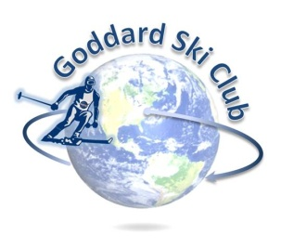
Killington Trip Report
Thursday, January 8 – Sunday, January 11, 2015

Location: Killington Ski Resort, Vermont
Participants: 24 Adults
Trip Leader: Matt Ekinci (matthewekinci@gmail.com ; 301-286-3217)
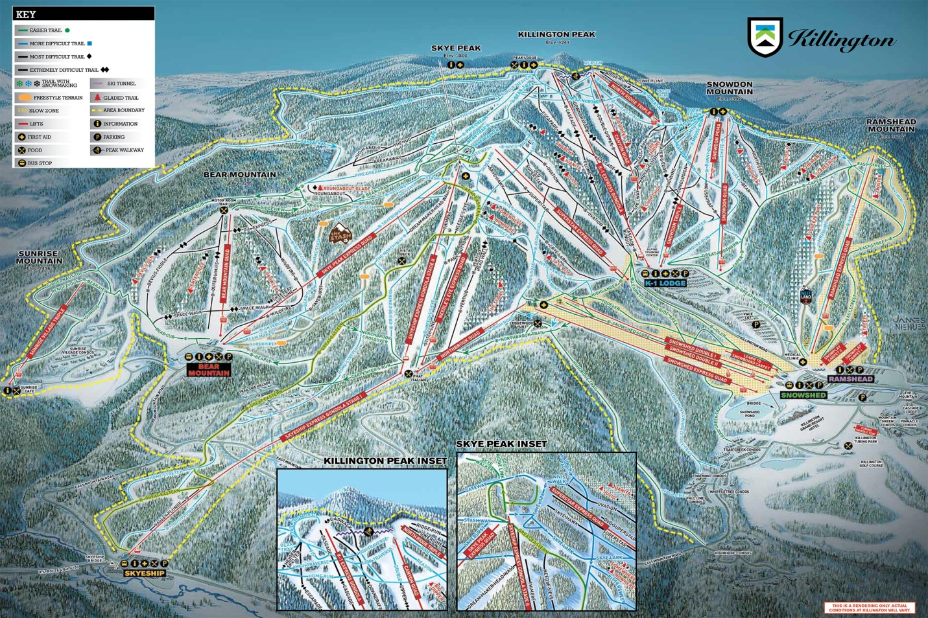

Lodging: The Cascades Lodge (http://cascadeslodge.com/)
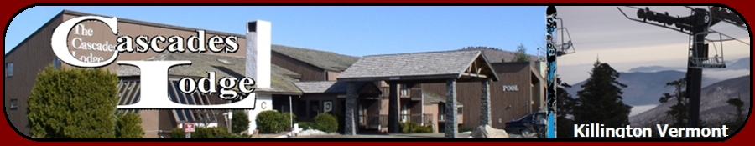
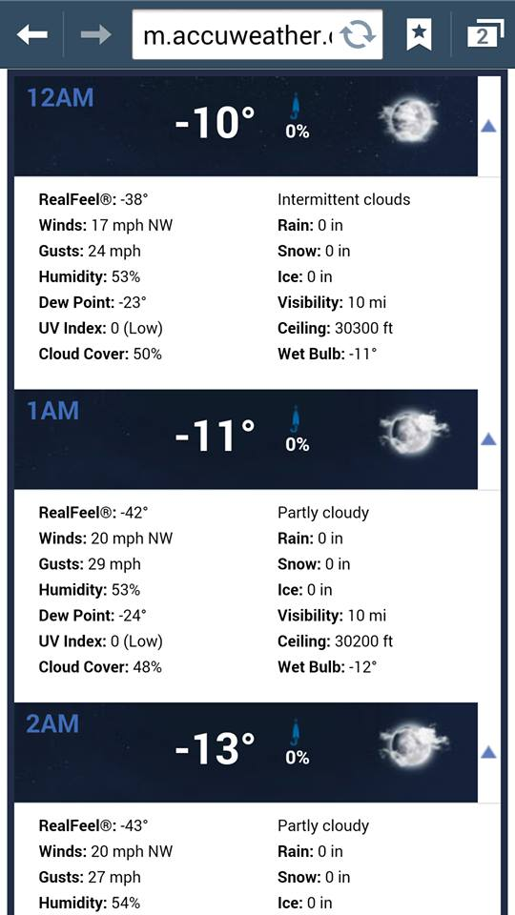
While officially a Thursday – Sunday trip, about half the attendees of this year’s trip opted to take advantage of midweek group rates and add at least one additional day to their stay, many to make use of lift vouchers left over from the 2014 GSFC Killington trip. Those driving up on Wednesday night arrived to find things just a little chilly on the mountain, with overnight temperatures plunging into the negative teens and strong winds bringing the wind chill down into the -40s. Thursday morning fared little better, bringing a clear-but-frigid day with temperatures still in the negative teens delaying certain lift openings and restricting the operation of others. Fortunately, no fingers, toes, or noses were lost to the cold, and those that stuck the day out enjoyed steadily improving conditions; temperatures rapidly rose into the high teens by the early afternoon, and Killington continued an intense snow-blowing effort that left many trails in as good -- or-better -- shape at mountain close as they had been at opening.
Friday morning brought with it the remainder of the club’s trip members as well as disappointment at what initially looked to be another lost morning,
as high winds, dense fog, and snow squalls threatened to make the mountain unskiable. Within an hour of lifts opening, though, the terrible weather quite literally vanished into thin air, giving way to partly cloudy skies, temperatures in the mid-20s, little wind, and – most importantly – phenomenal snow conditions on the slopes thanks to the combination of natural that had fallen overnight and continued round-the-clock snow gun work on the part of the resort. Small crowds and the mountain running almost full-open (including several runs I’d never seen un-roped before in the several times the club had previously been there) also contributed to an awesome day that was probably the best we’ve had in terms of weather and conditions in our three trips to Killington.
After lift close 8 or 10 of us enjoyed drinks in the Cascades Lodge hot tub, followed by almost everyone on the trip gathering for our apres ski party. With many new club members or first-time Killington trippers in attendance, this was a great opportunity for everyone to get to know each other. After about two hours of talk, food, and drinks, things slowly split up and most everyone did a low-key dinner and called a relatively early night.

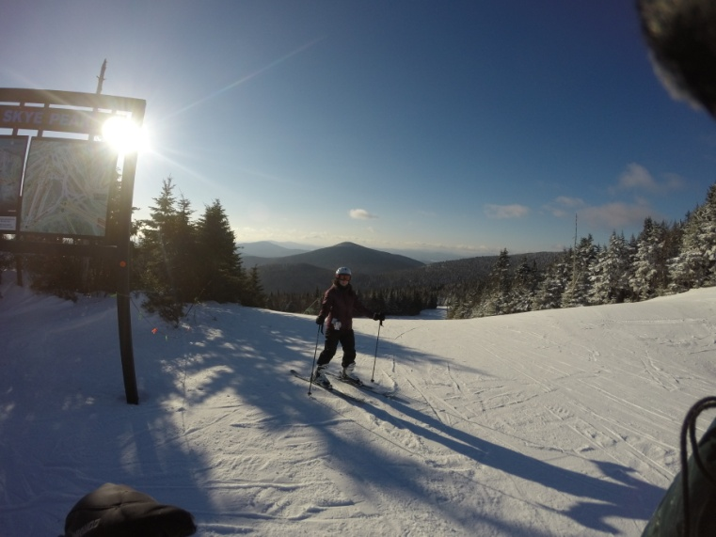
Saturday picked up right where Friday left off, with temperatures in the mid-20s and broken clouds occasionally giving way to a full-on bluebird day. Snow conditions before lunchtime were still good, with residual fresh left over from the day before and fresh manmade on many trails from the resort’s still-going-strong snow gun campaign. An excellent cruising day, though as one would expect, Saturday brought larger crowds, and by mid-afternoon many of the more popular runs and high-traffic areas began to get skied off and a bit icy. Many of the black diamonds remained forgiving if not pillowy, however, particularly Superstar, which had constant snowmaking throughout the day and developed a perfect set of soft, easy moguls away from the guns as the day went on.
Saturday after close was largely a repeat of the previous day, as most of the club group got together following a hot tub soak to kill off the food and wine leftover from the apres ski party the previous day while watching the NFL playoff games. Around 7 o’clock roughly a dozen of us made our way to Outback Pizza for dinner and drinks by commandeering the neighboring (and extremely crowded) Lookout Bar & Grill’s free shuttle – this led to a brief snafu arranging a ride back to Cascades later that night, but we had good food and drink and were seated in a nice semi-private fireside lounge area as a group, so it was worth the minor inconvenience.
Sunday was a nice close-out day, as a steady light snow fell on the mountain throughout the morning, leaving just enough fresh to give a nice feel to the trails without drastically cutting visibility. The scenic winter weather, combined with smaller Sunday crowds and the resort’s snow guns finally being turned off for the first time in days, made the last day really quite relaxing and a solid way to wrap things up before starting the drive home after lunch. All-in-all easily the best three days of skiing and boarding we’ve had on this trip since it started, and a nice blend of repeat customers and trip newcomers that we look forward to building on next year.
Pictures (all from Saturday):
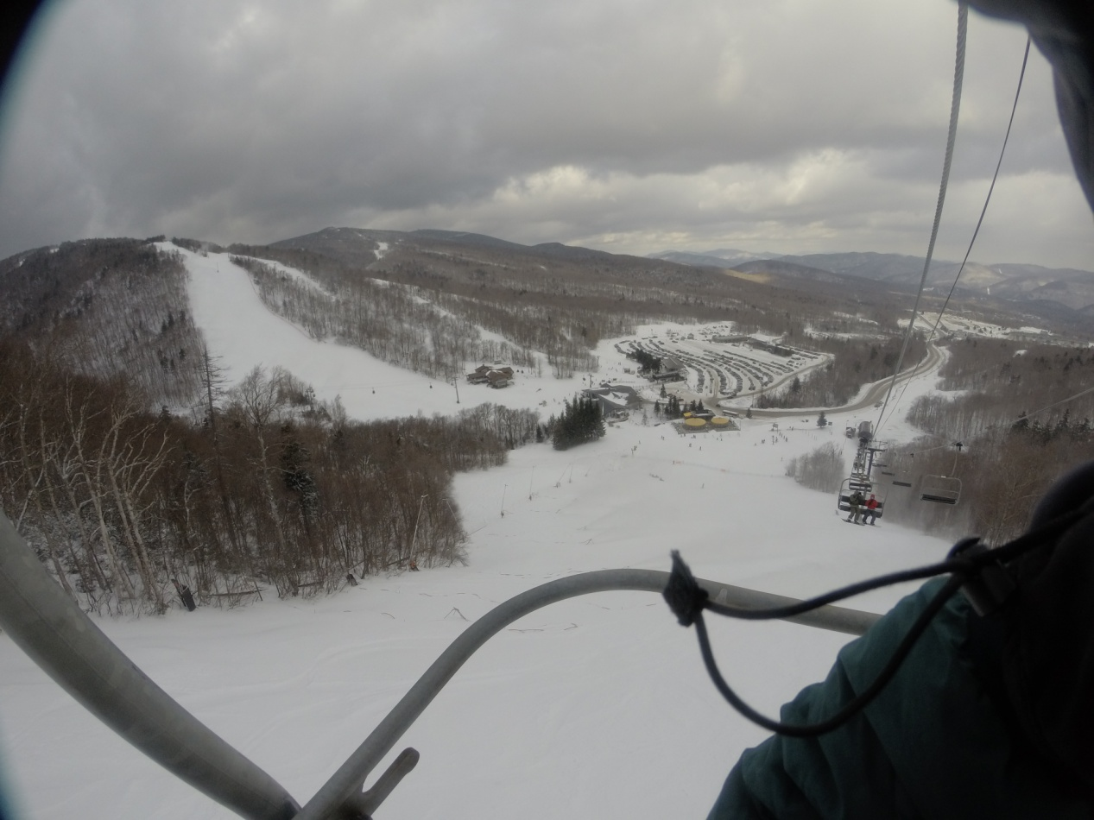
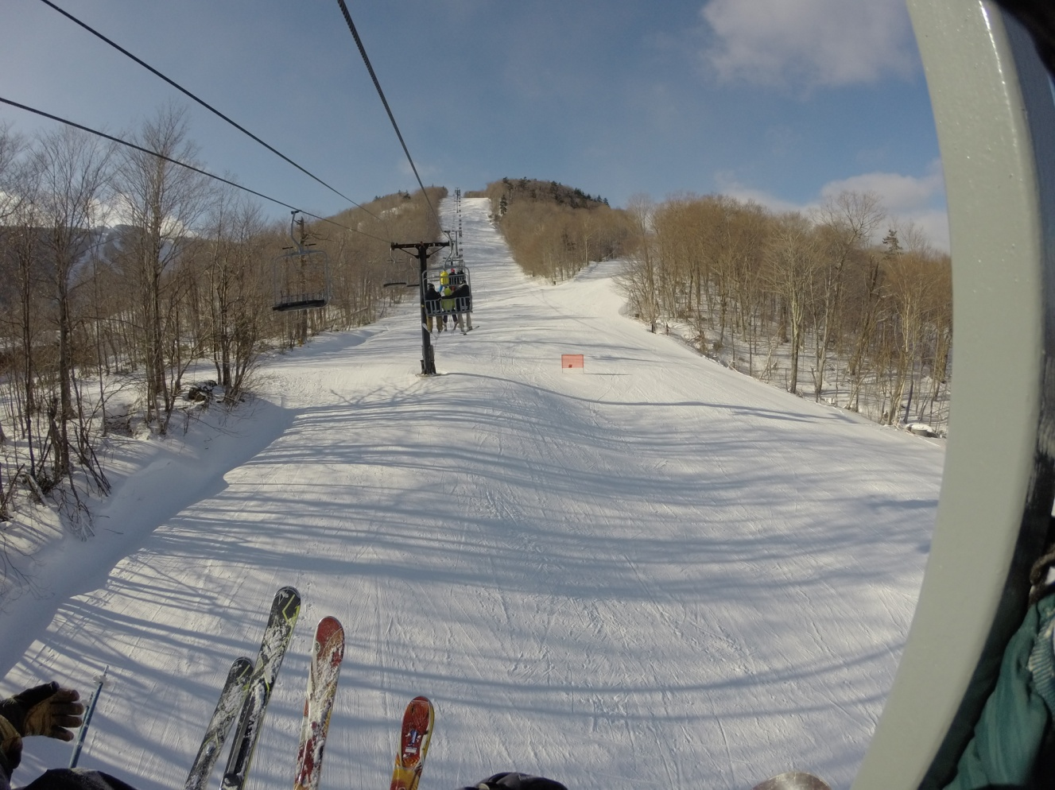
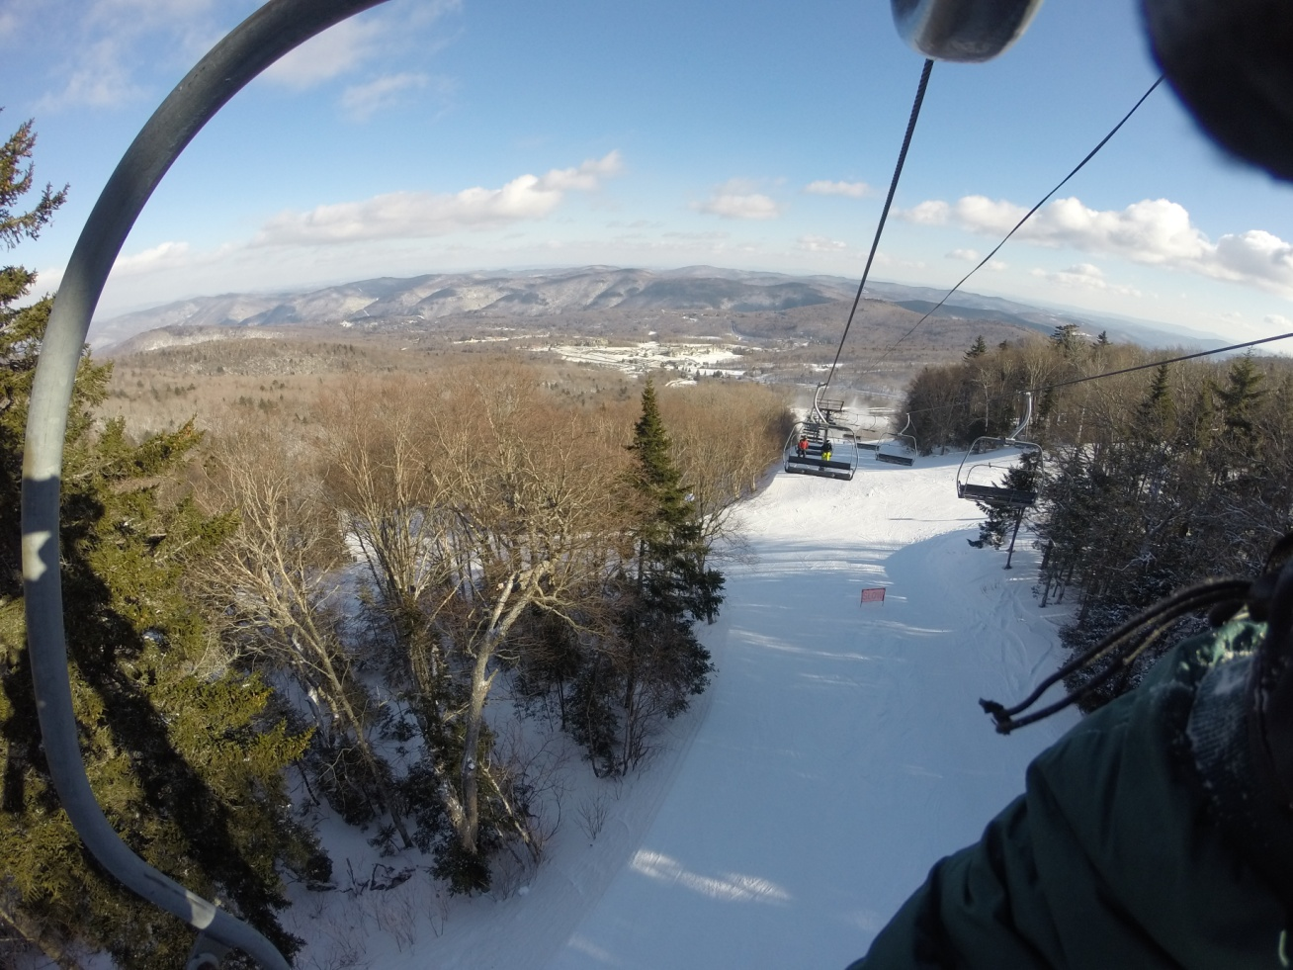
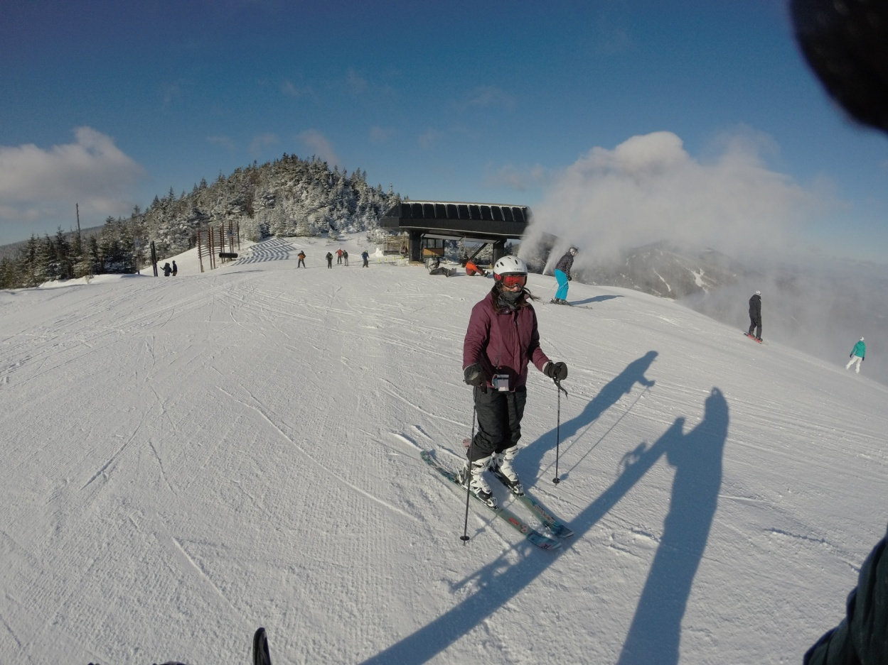
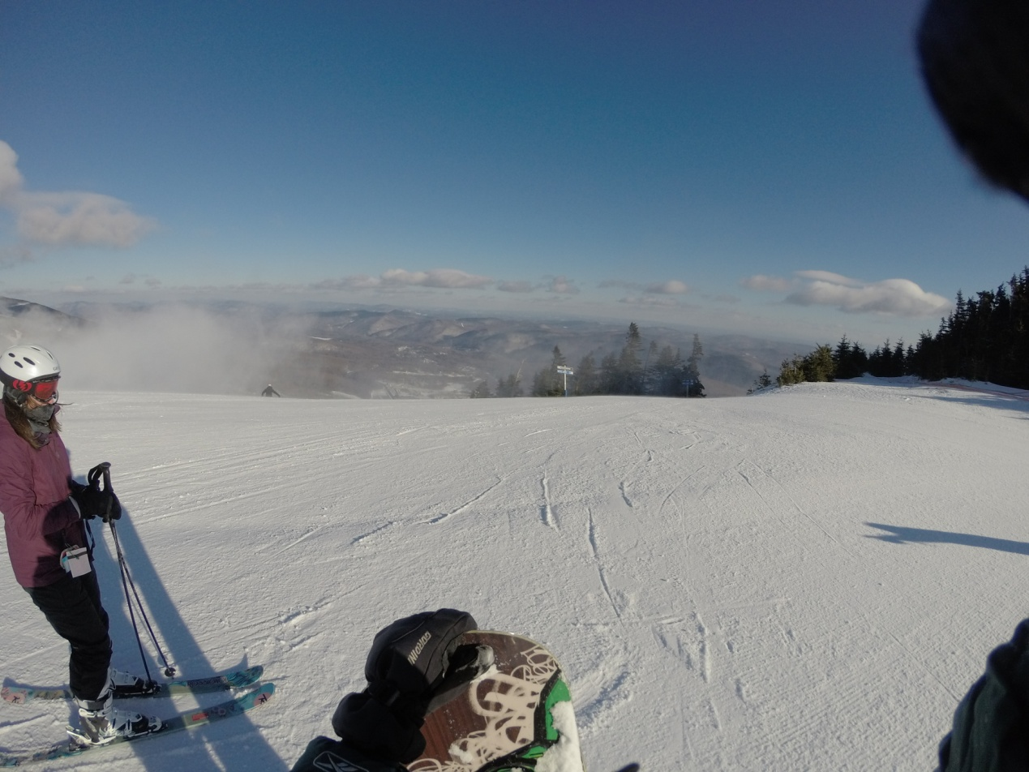
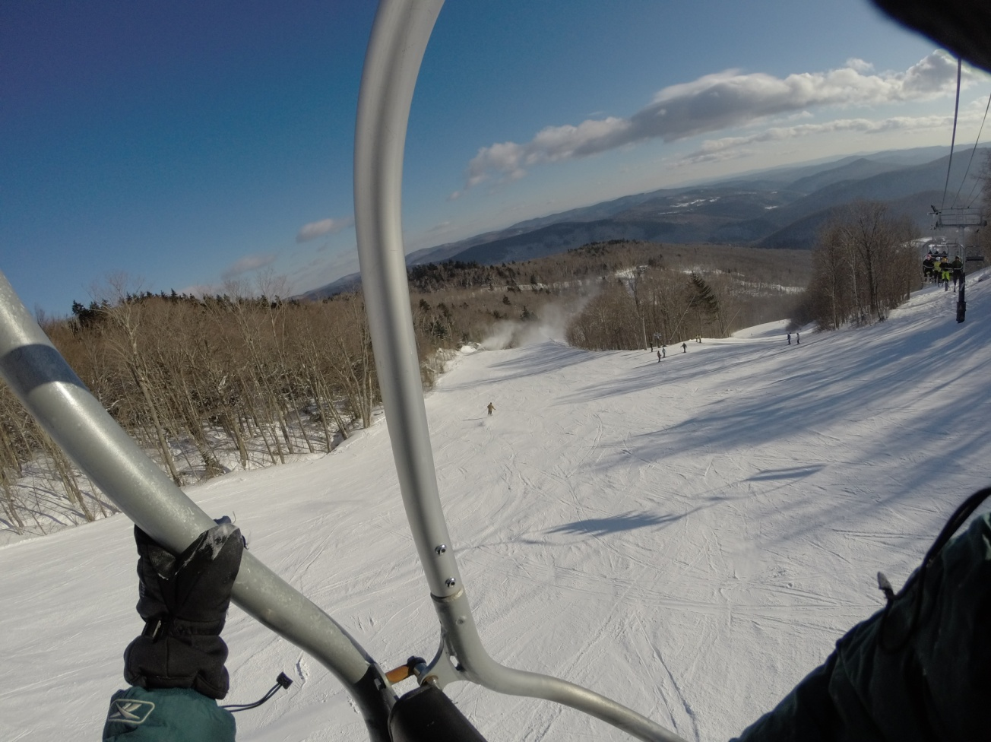
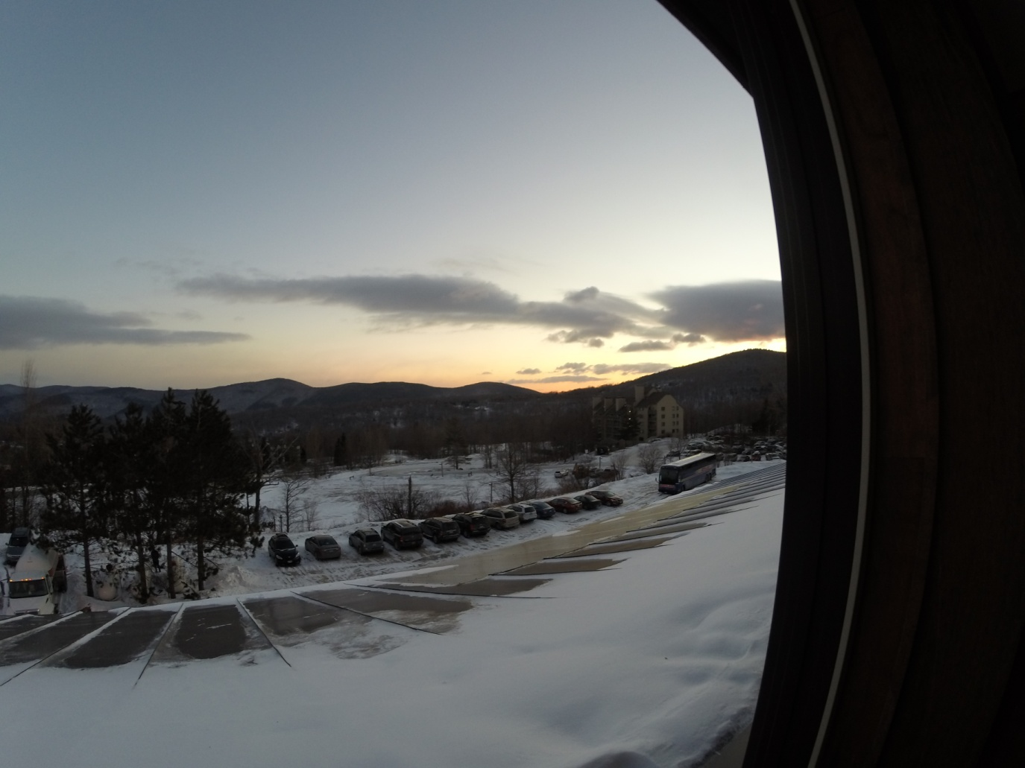
Videos:
https://www.youtube.com/watch?v=Zl3dBxgyDBM
https://www.youtube.com/watch?v=xLBwjC9GfKs

