NASA GODDARD SKI CLUB TRIP
to MADONNA di CAMPIGLIO and BOLOGNA, ITALY

March 15 to March 24, 2019

by Harvey Walden, Trip Leader
Photos by Steve Slojkowski

Our group of 19 was due to depart Washington Dulles International Airport Friday evening, March 15th on a Lufthansa Airlines flight bound for Milan, Italy with a connection in Frankfurt, Germany. We were to meet 10 others in Milan who had booked their flights independently, but were on the same Goddard Ski Club trip. However, due to a mechanical problem on the aircraft, never fully explained by the crew, we wound up waiting on the tarmac for two hours after our departure time. This resulted in missing our connection in Frankfurt. Two in our party managed to get on the next flight about noon to Milan from Frankfurt, but the rest of us had to wait for a late afternoon flight. We all joined forces at Malpensa Airport in Milan in early evening and boarded our chartered bus for the nearly four-hour ride, the latter portion along twisting mountain roads, to the small town of Madonna di Campiglio in the Dolomites. The good news was that, upon our late evening arrival at the four-star Savoia Palace Hotel, we were served a full-course dinner with all the trimmings by the hotel staff.

On our first full day, Sunday, we arranged ski equipment rentals at a nearby ski shop and purchased ski lift tickets, both at discounts offered by our hotel. The weather was cool and cloudy and the snow conditions good. That evening the hotel offered a party for our group with live music, hors d’oeuvres, and a complimentary drink. Dinner consisted of no fewer than six courses with choices from a menu, including elaborate and delicious desserts. This was true for all the following nights as well. With perfect timing, it snowed about 24 cm overnight just in time for our second day of skiing under sunny skies. Although there was no further snow, the weather was mild and partially sunny on all ski days, and snow conditions were good to excellent. On our second evening, we had a slide and video show in the hotel’s theatre which highlighted the Dolomites and Madonna di Campiglio in particular. Each afternoon after skiing, we had complimentary use of our hotel’s beautiful health center and spa, which included a Jacuzzi, sauna, Turkish bath, and a so-called “emotional shower.” Various types of body massages and beauty treatments were also available.

The hotel was centrally located in the town, and a nearby information center provided street maps with detailed hiking tours along local pathways for the non-skiers in our group. On Wednesday, one such contingent took a bus to the Groste cable car for a 20-minute ride to the Passo Groste peak with great views at 2444 meters elevation. In the evenings, several of us took short walks around Madonna di Campiglio under a full moon. One day some non-skiers took a bus to the nearby town of Pinzolo and enjoyed a self-guided walking tour. Thursday evening was the start of the tenth year of the Dolomites Fire Concert with a video on the stage just opposite our hotel. The following evening, our final night at the Savoia Palace, there were children’s games and a rock band and videos with live television on a large screen in the piazza. This was a fundraiser for the Dolomites Fire Concert.

On Saturday morning, we left Madonna by chartered bus for Bologna, a ride of about four hours. There was some confusion about our hotel booking, and the bus had difficulty in negotiating the narrow streets with low clearances in the Old City of Bologna. The closest approach to our hotel that was possible for a full-sized bus was to within about 750 meters. Our hotel, the Best Western San Donato, was centrally located and had a roof-top terrace with beautiful views over the Old City. We spent the late afternoon and evening of our final day strolling around Bologna’s many historical monuments and finding different locales for dinner. We were fortunate in that a Gastronomical Festival just happened to be underway that weekend. The next morning, we had breakfast on an outdoor patio at our hotel before checking out. We arranged for a van to take all our luggage from the hotel to a meeting point accessible to our bus, which then took us to the Bologna airport, only 20 minutes distant. We arrived very early, even before the security checkpoints were staffed, to check in for our flight to Munich on route back to Washington/Dulles. The flights were, thankfully, uneventful.

Follow
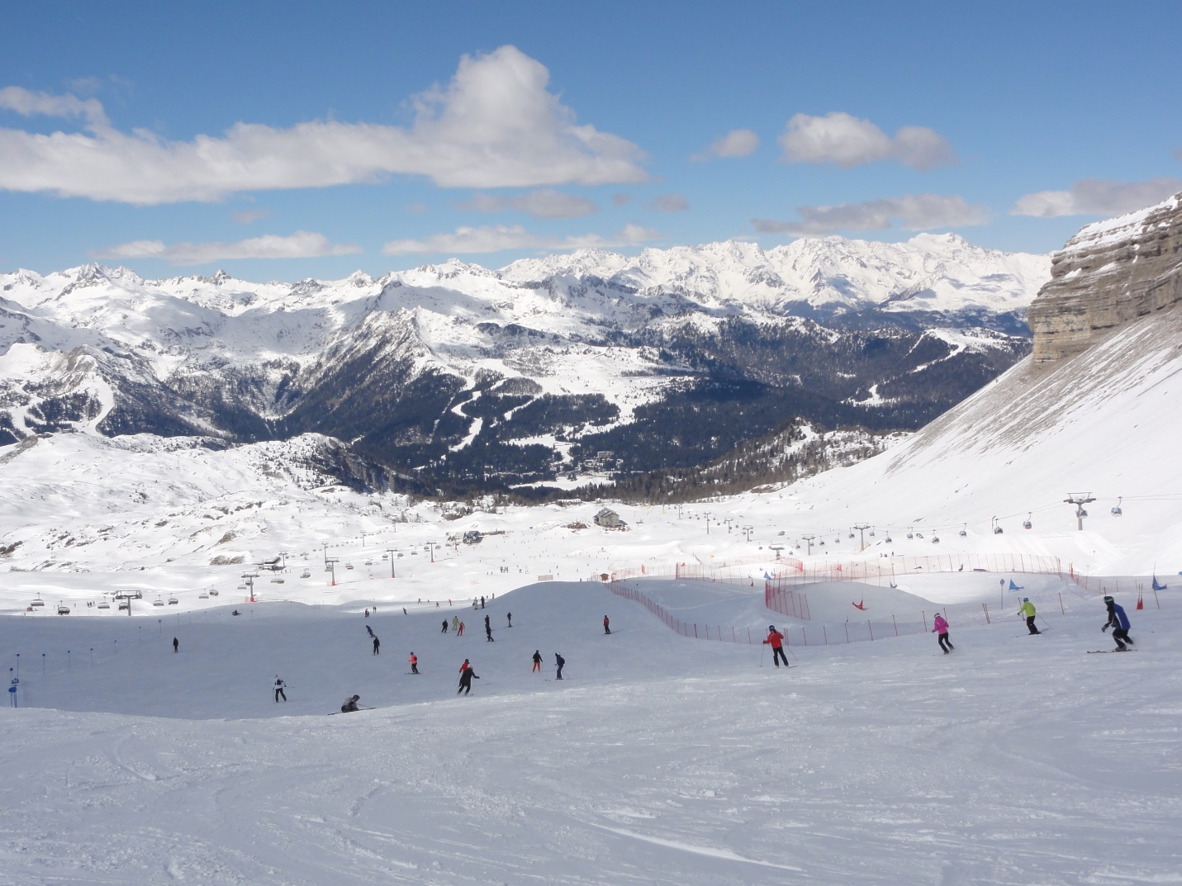

View from the top of Passo Groste
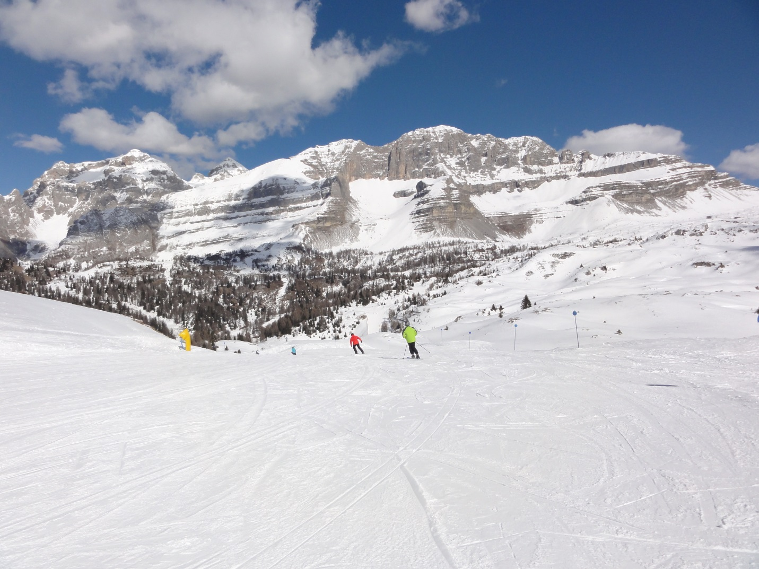

Descending from Monte Spinale
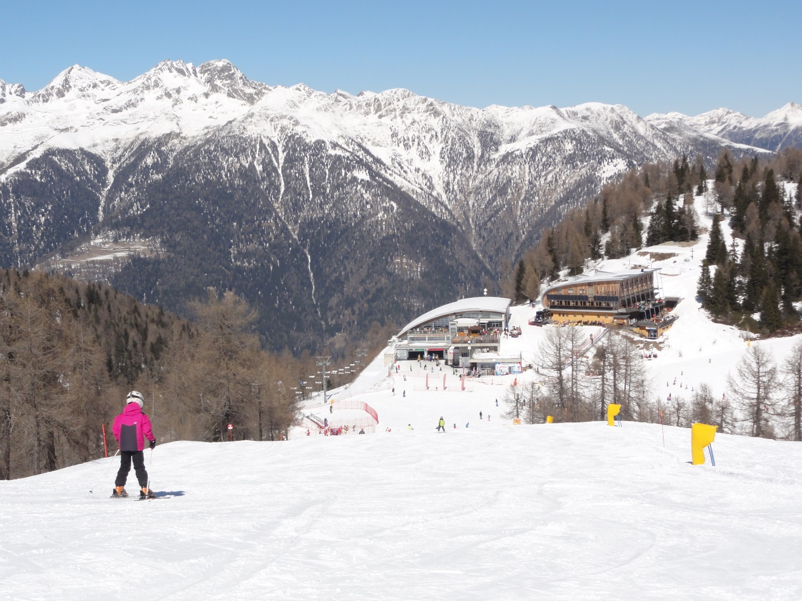

View of rest area atop Monte Spolverino
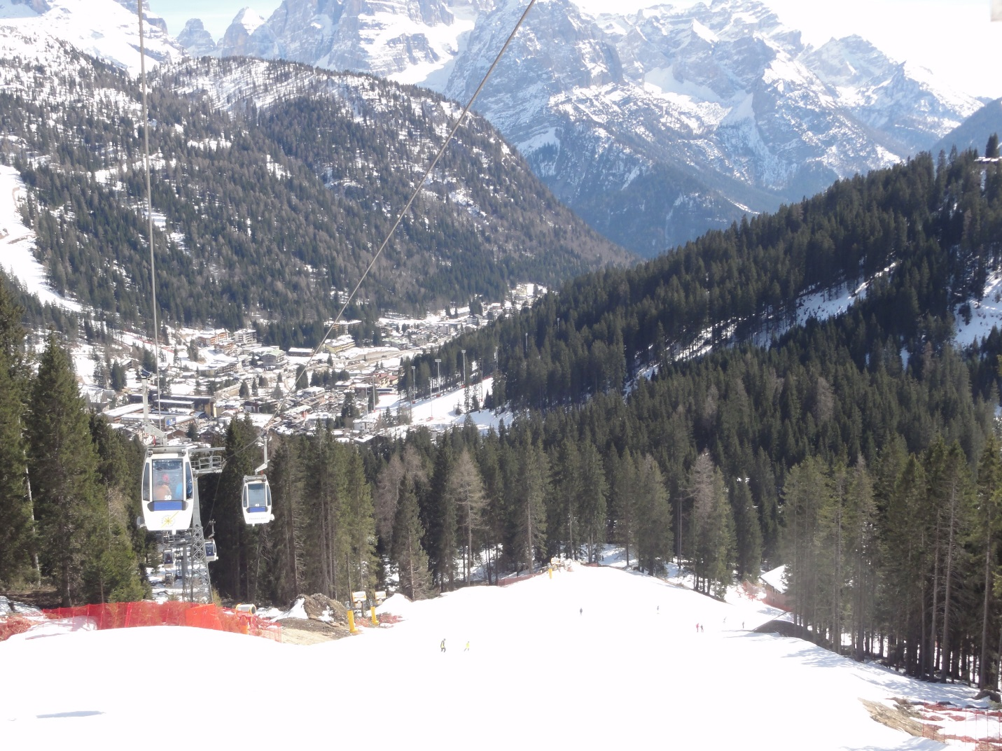

Gondola ascending from Madonna di Campiglio
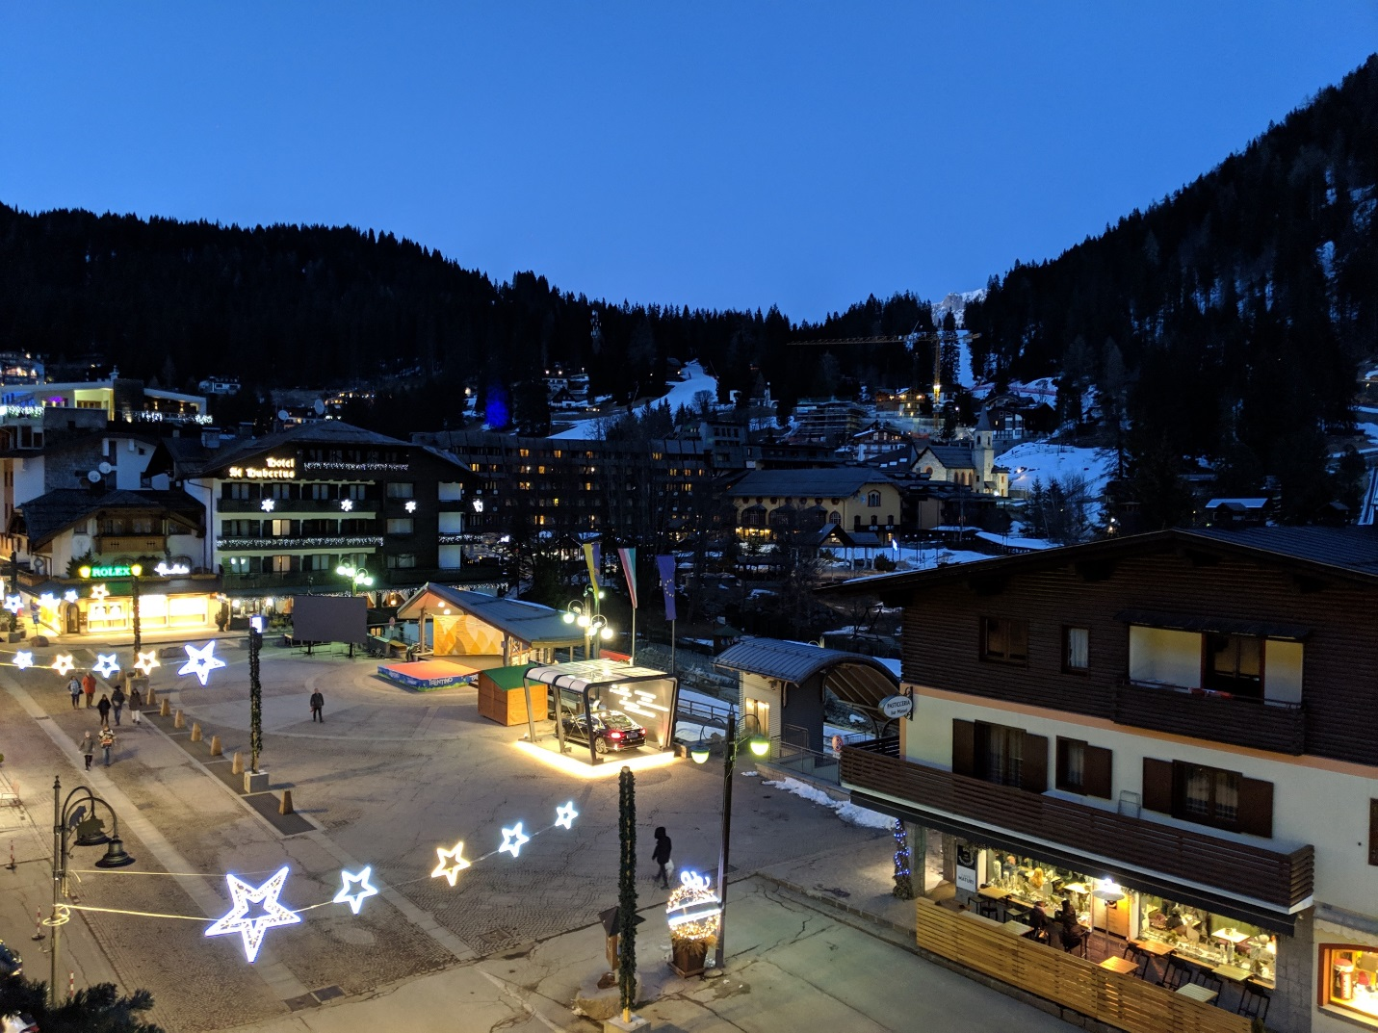

Madonna di Campiglio at night
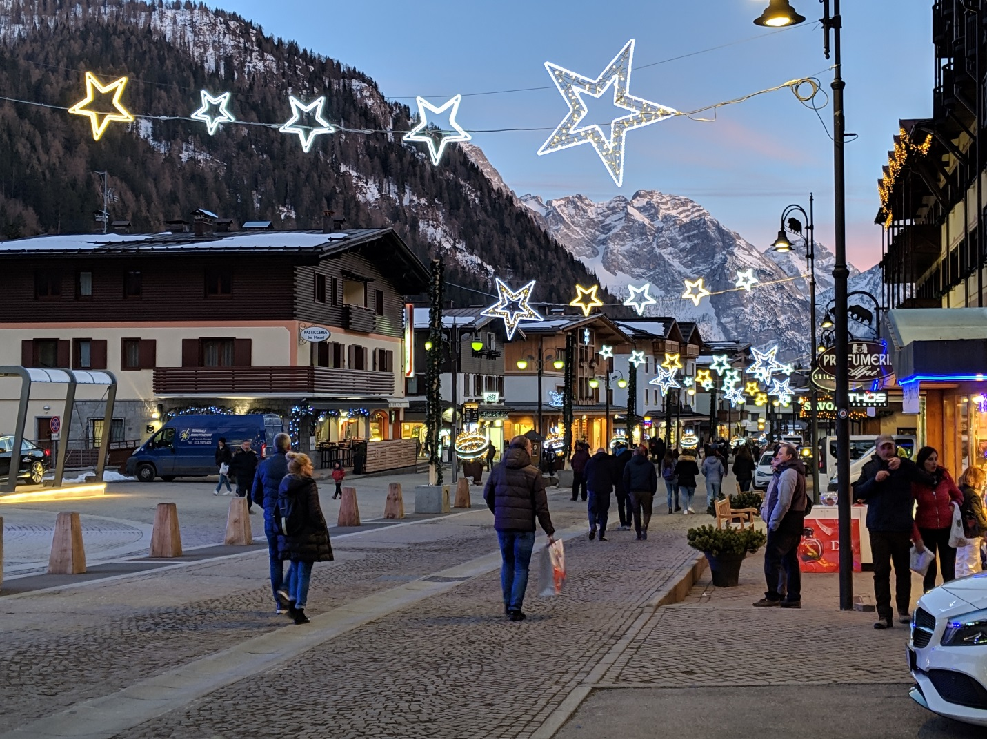

Streets of Madonna di Campiglio

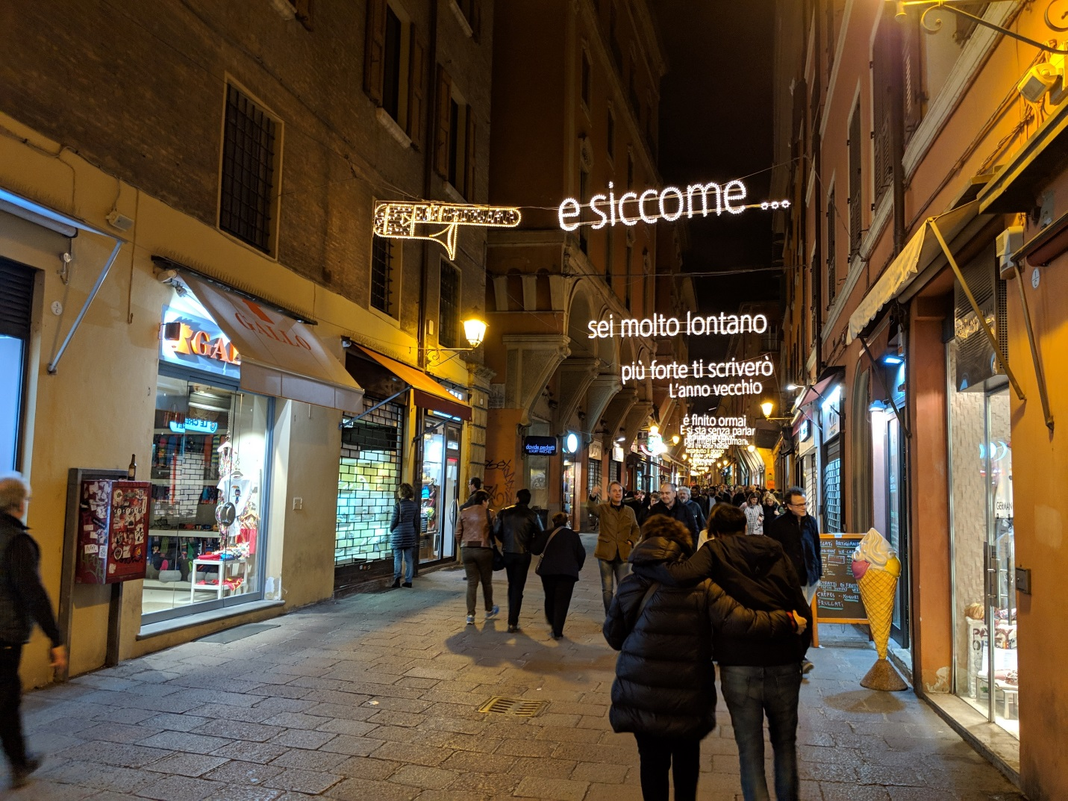

Side street of Bologna

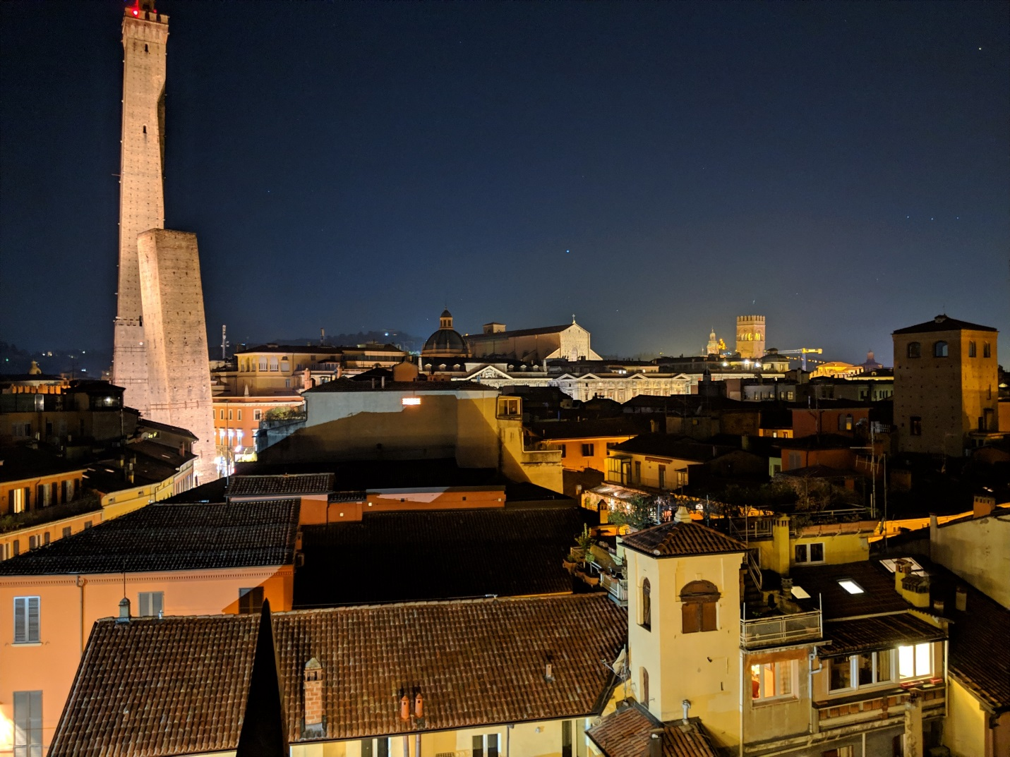

Bologna at night from the hotel rooftop patio

