Mt. Snow VT Trip February 21st – 26th, 2016
The Mt Snow Trip was a success with 20 participants. Of these, there was a mix of first timers and regulars who all had a good time. On a base of about 1.5 feet the conditions were ok for the 1st two days. Wednesday was a complete washout with rain. Thursday morning it was raining again but some folks skied anyway on & off as the rain would start & stop. Friday several folks skied & didn’t think the conditions were too bad. Overall these were the worst conditions I’ve ever seen at Mt. Snow but I can’t complain since this is the 1st time I’ve seen it like this. Our stay at the Mountaineer Lodge featured good food, a large hot tub, a warm atmosphere and of course a couple+ wine & cheese parties with some new and old friends.
This affordable trip has always delivered good skiing and is a particularly good value for families. Now for the pictures which I hope participants send me more:
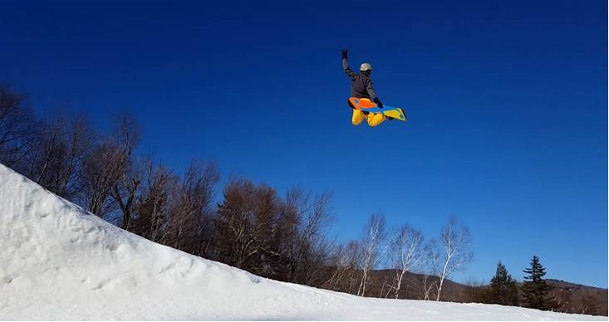
Andrew going large off the last jump in The Gulch on Monday. Oh yes, Carinthia is sweet….
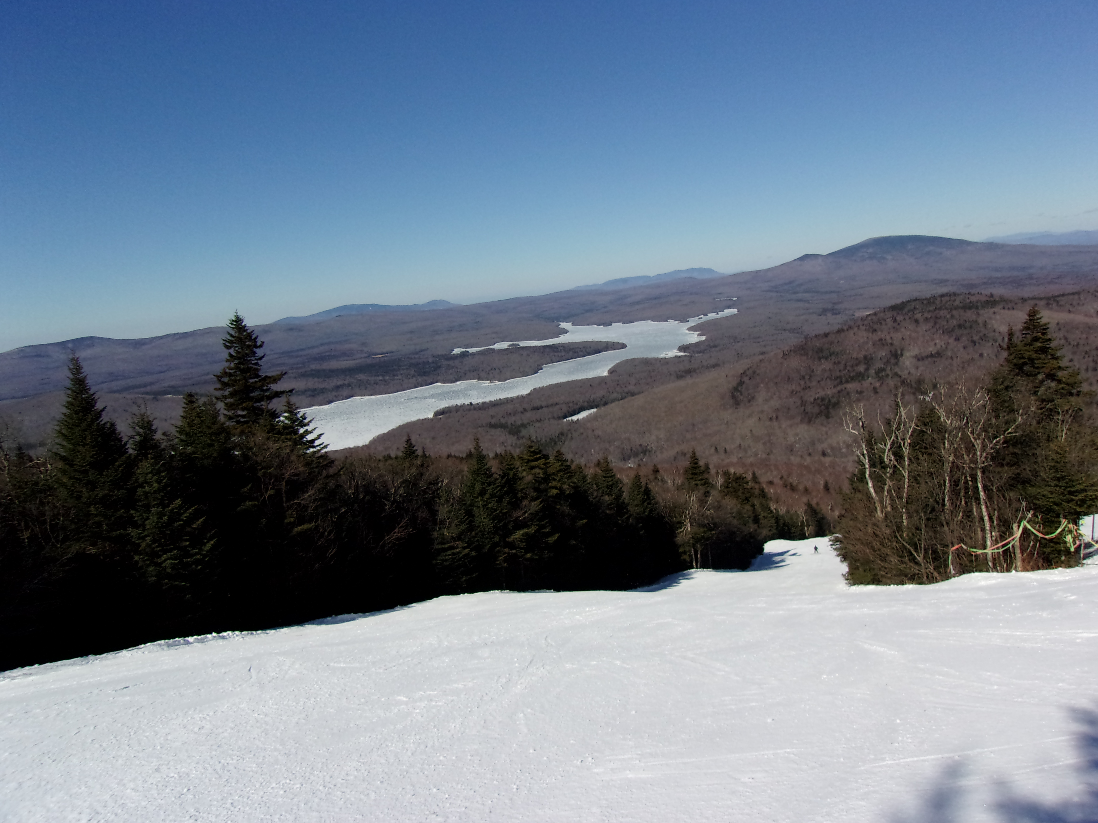
Top of Olympic.
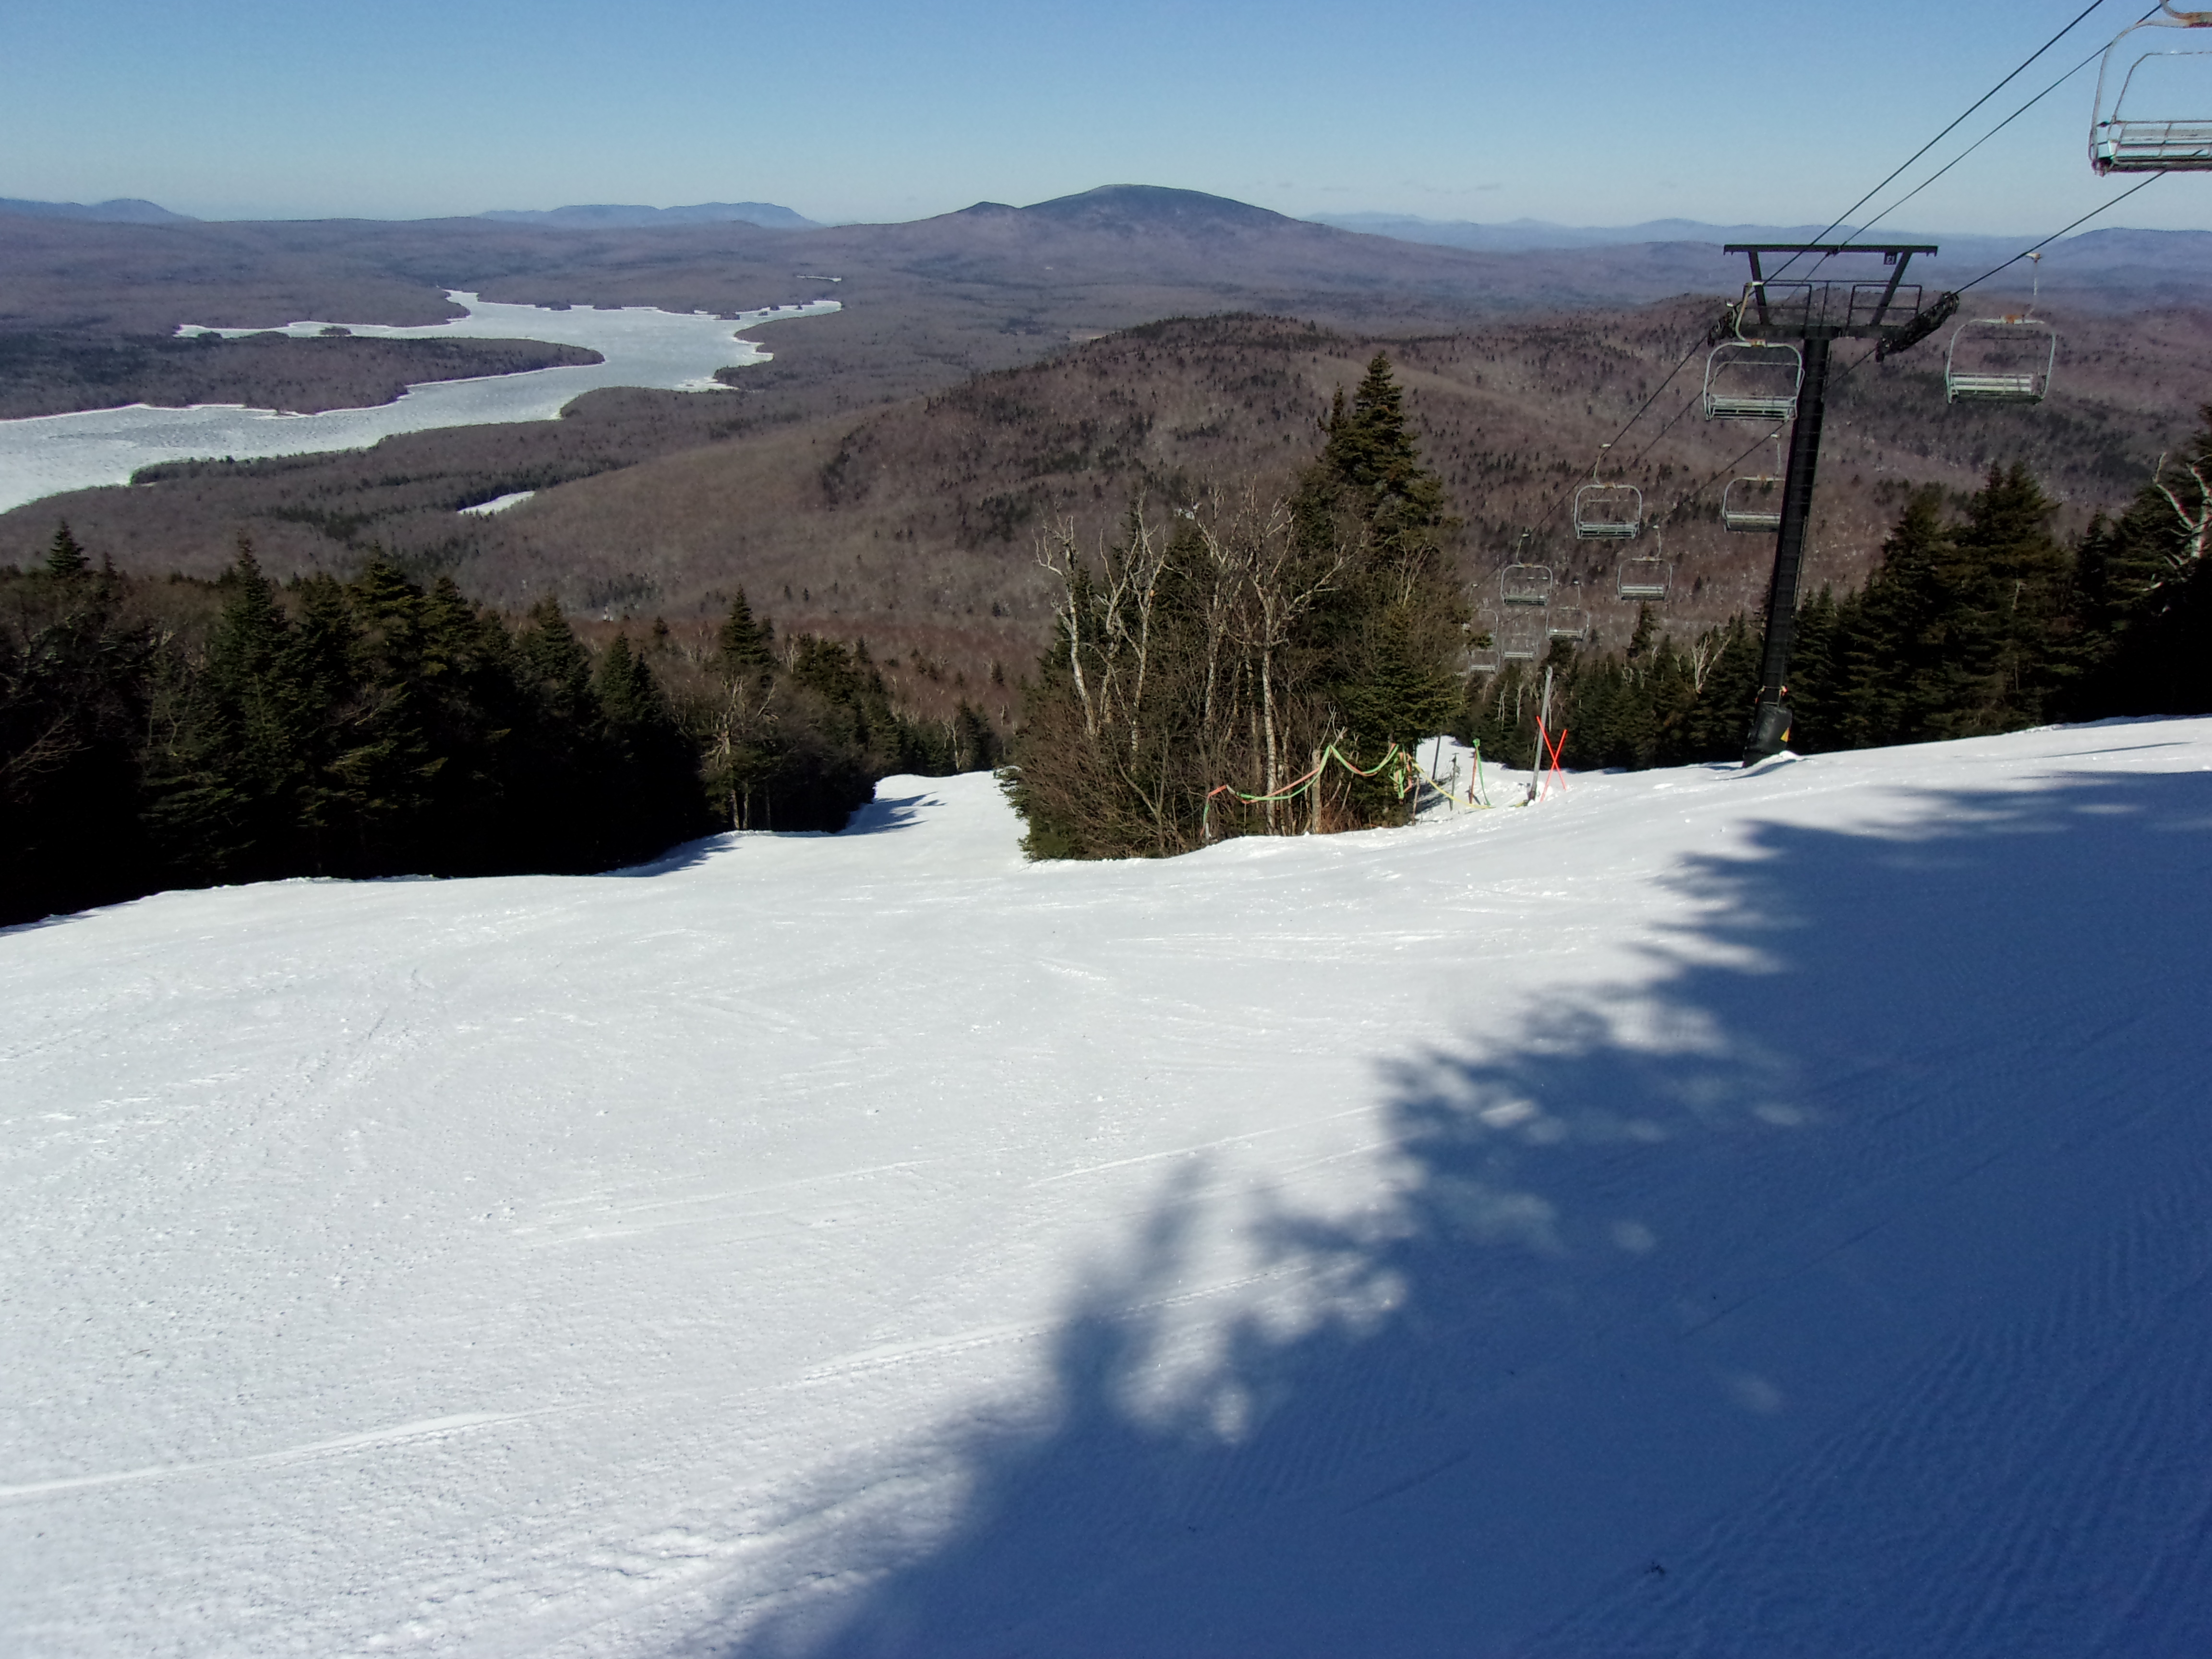
Not many folks out here.

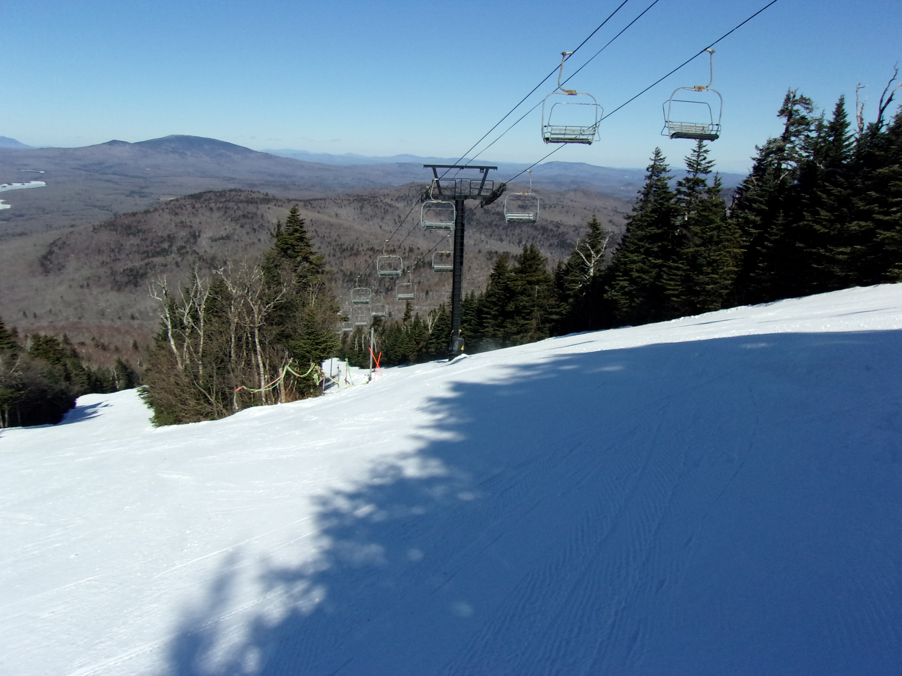
Lifts aren’t busy.
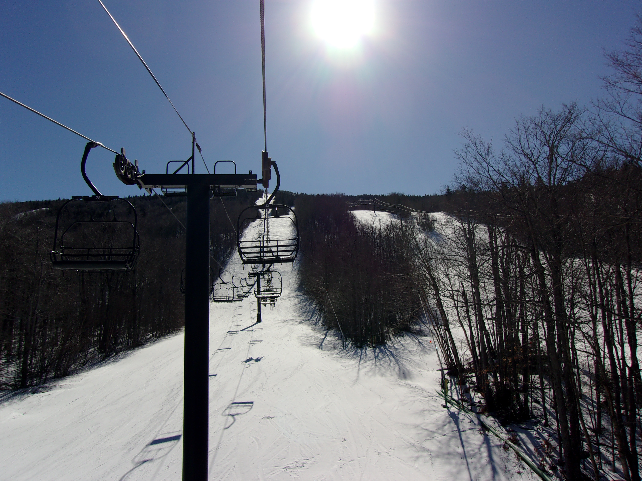
Shot from the north face lift.
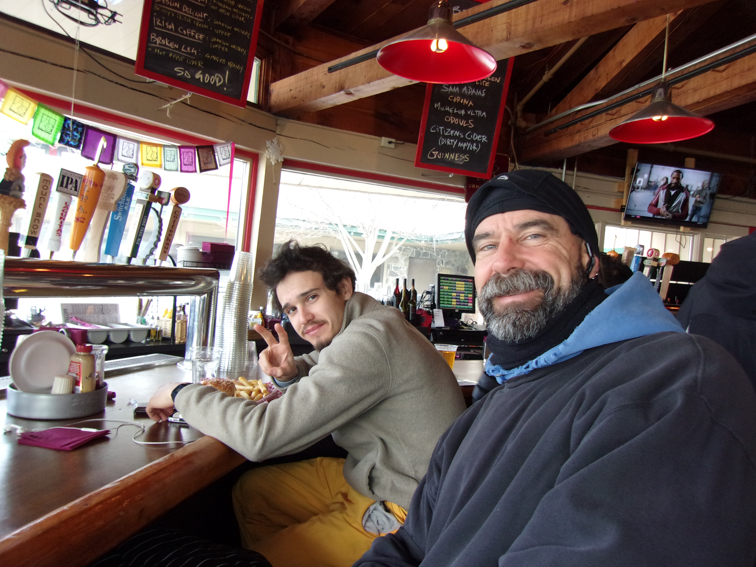
Jim & Andrew stop for lunch.
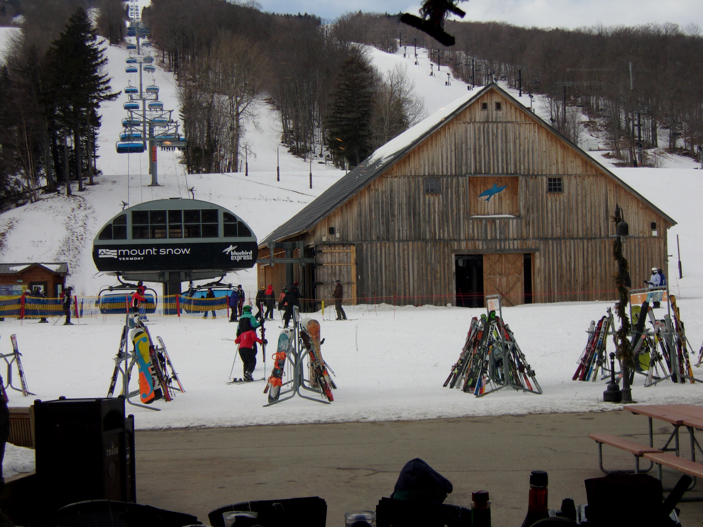
Bluebird Express bubble lift & barn.
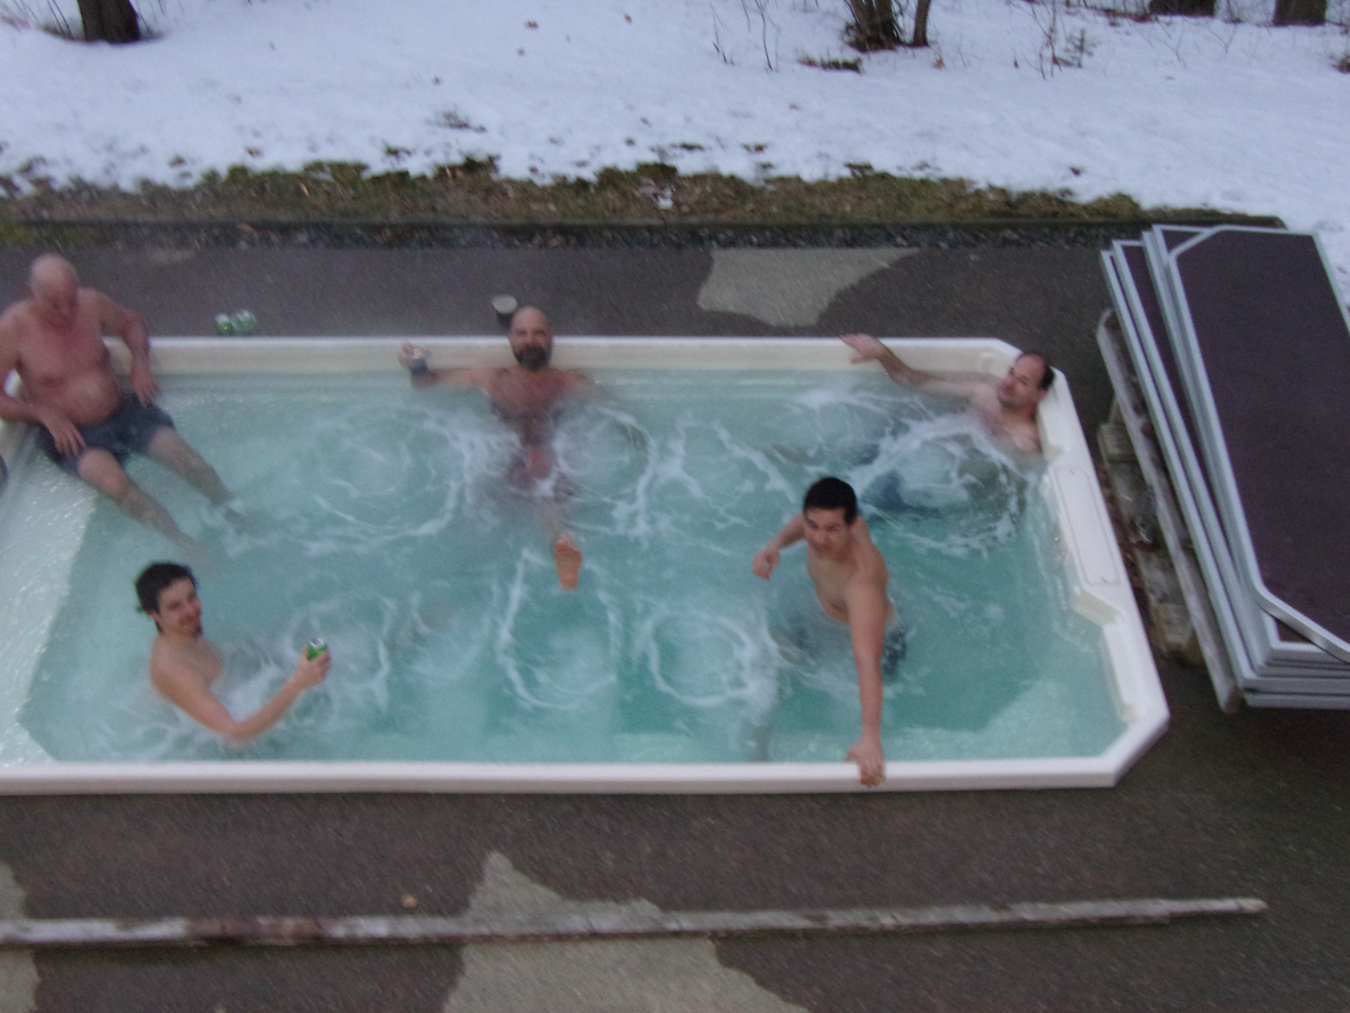
Part of the gang relaxing in the hot tub.
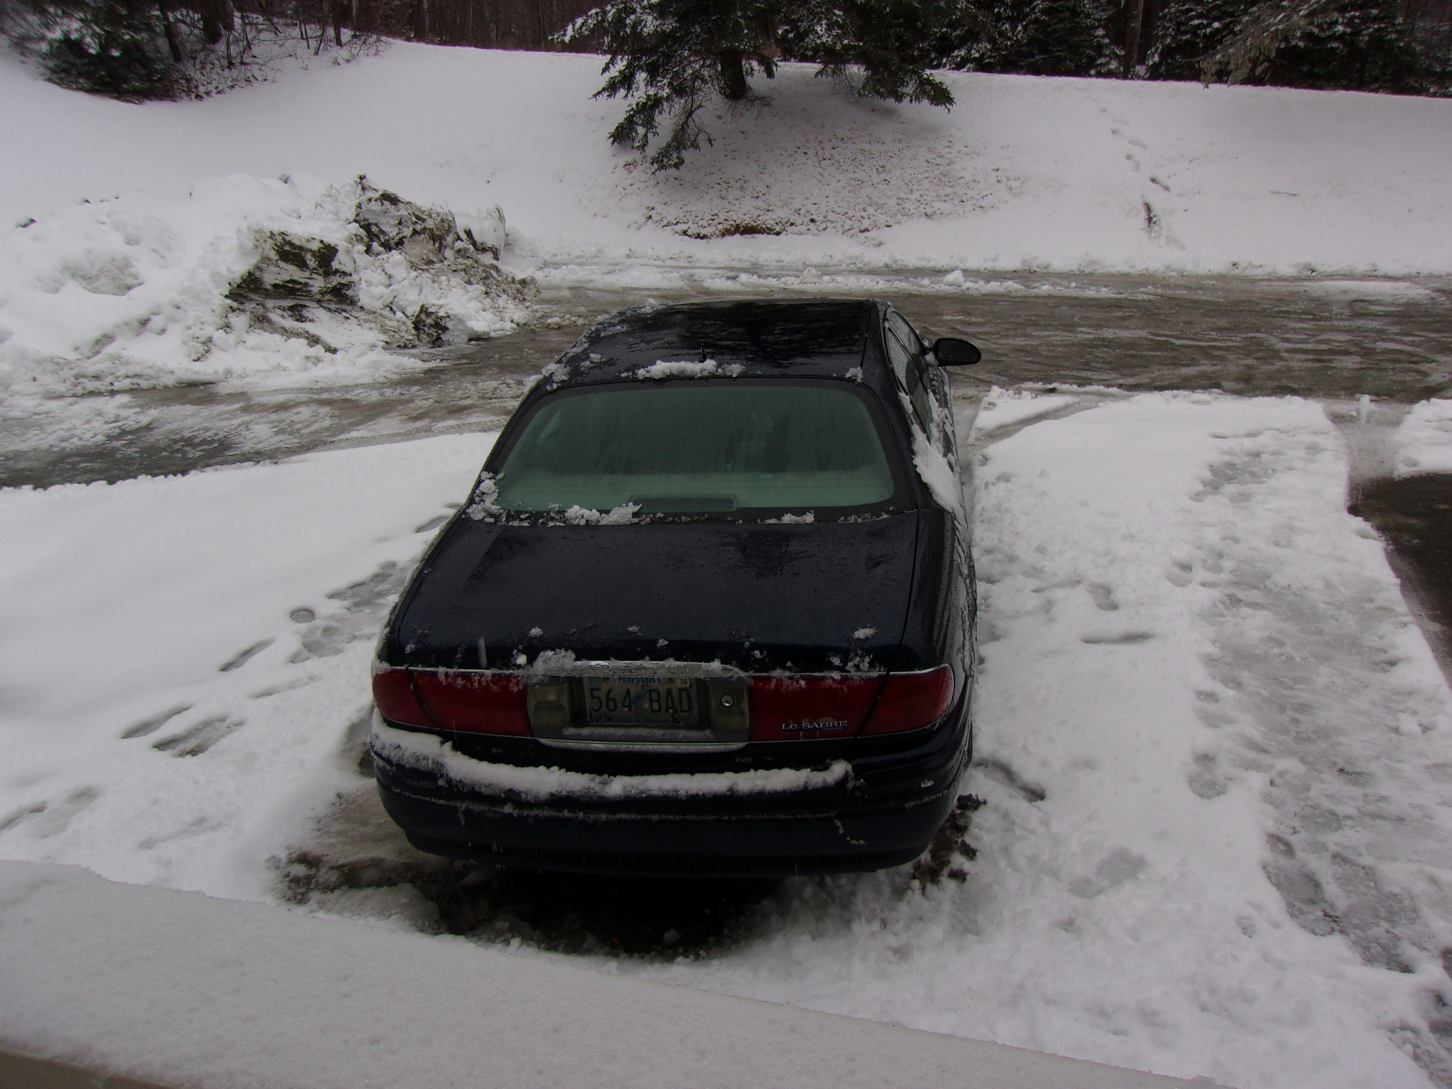
A wet morning at the lodge.
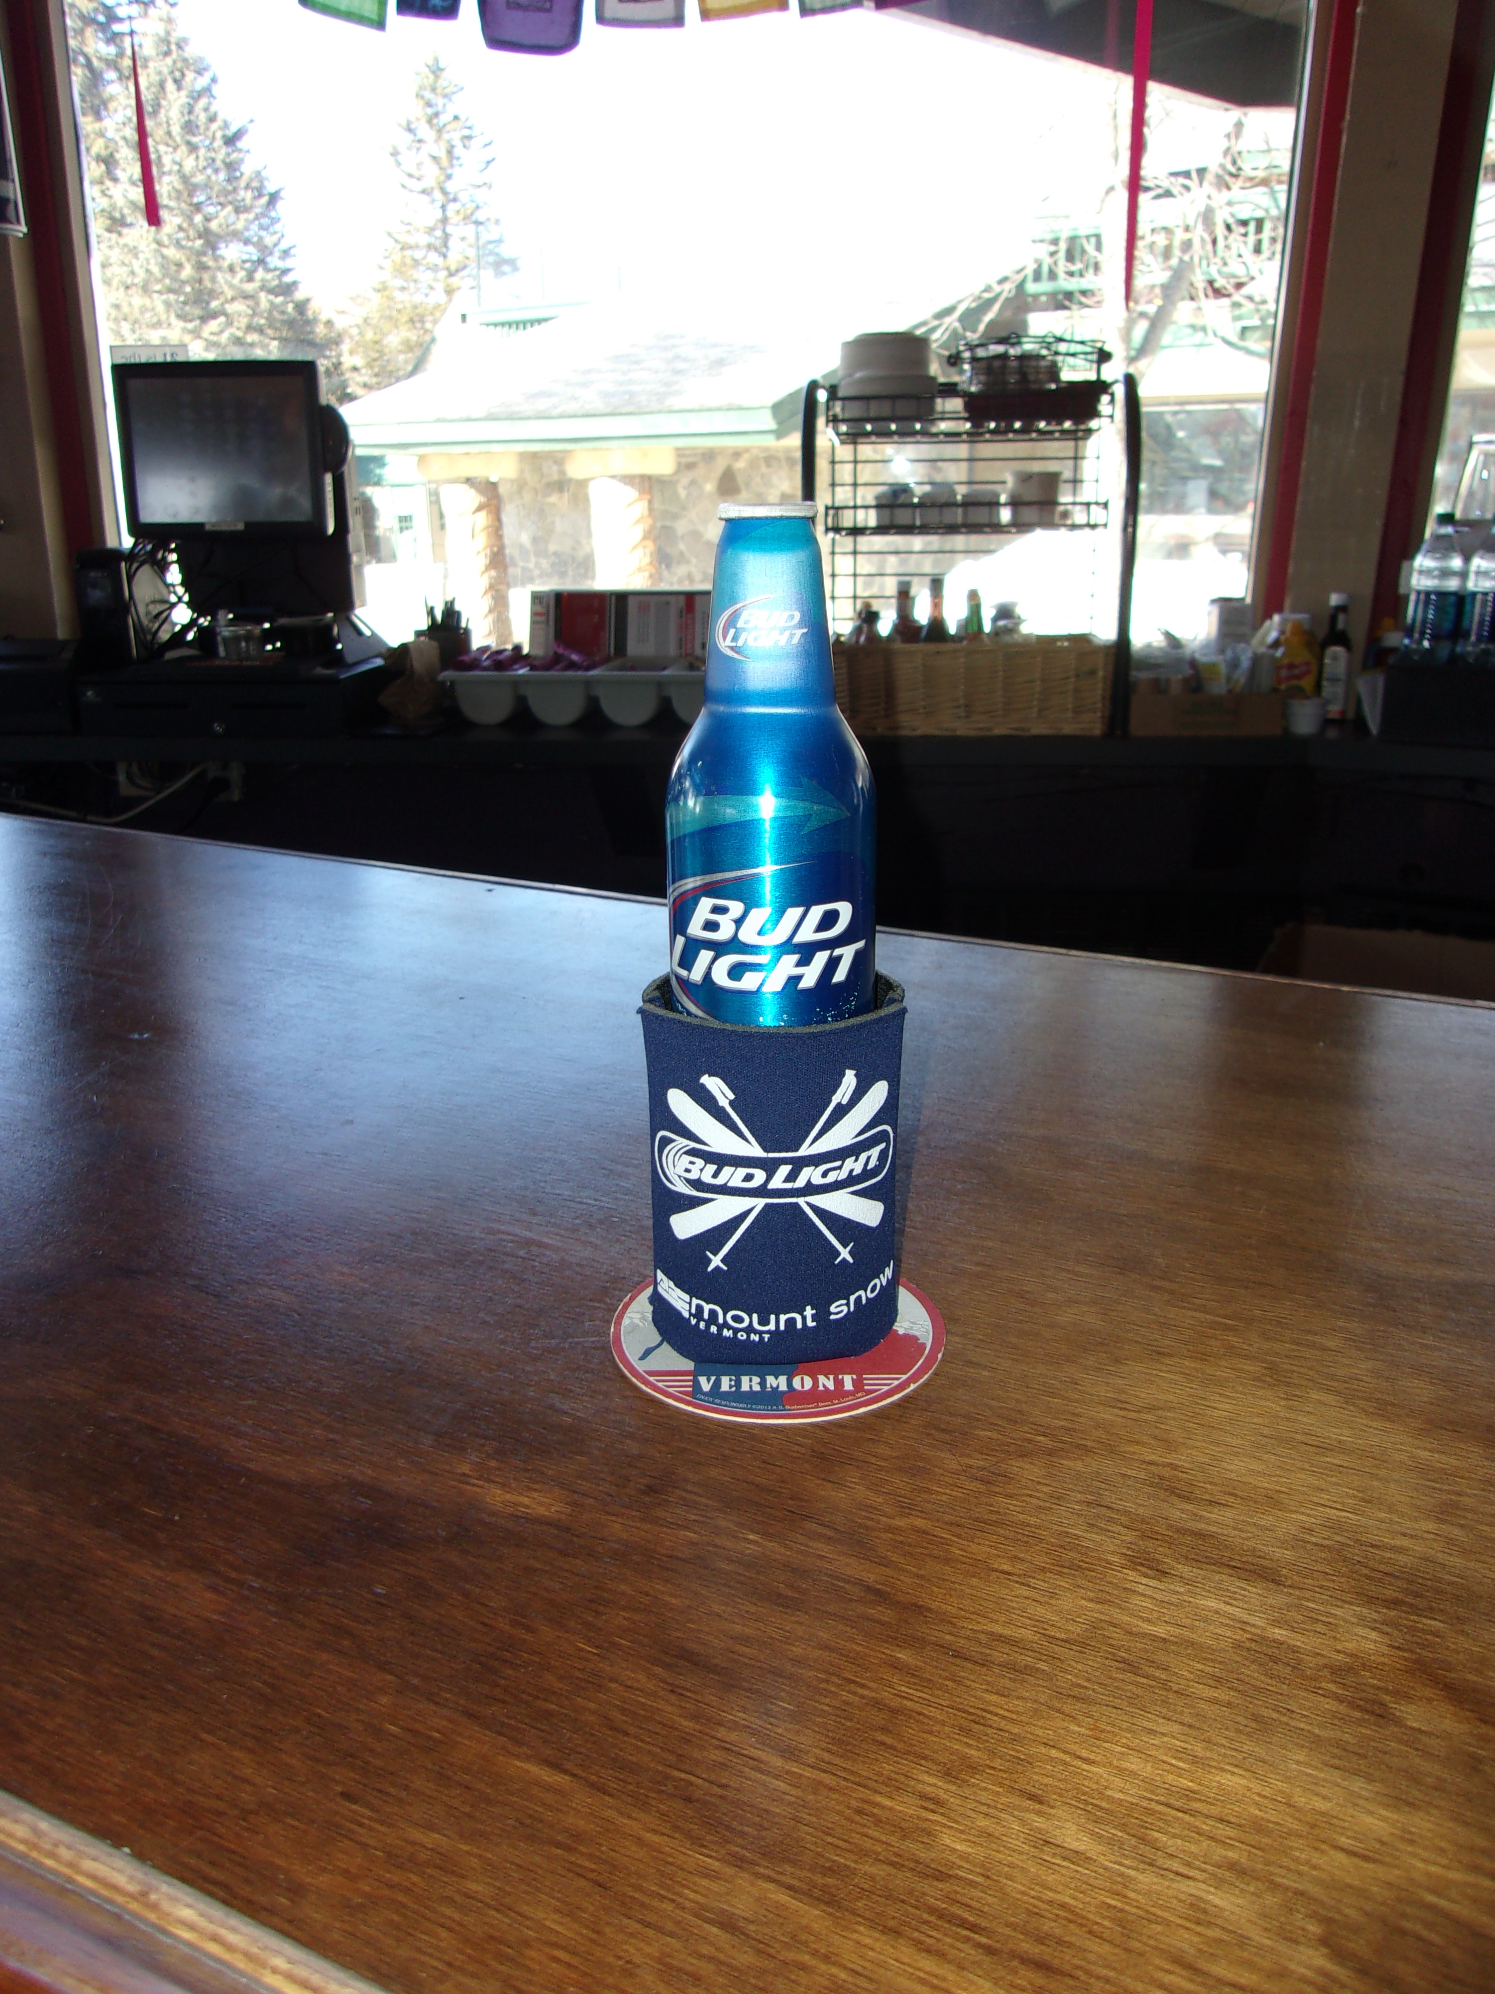
That’s a ski beer!

I had a good time & hope you did too.

This trip report can still be modified. If you’ve got some good pics you’d like to include, PLEASE send them to me with a caption.
Remember next year’s trip will be the same week so be sure to plan on it and another great time. And remember to RSVP early to get a room at the Mountaineer.

Ski ya, Mike

