Mt. Snow VT Trip February 26th – March 3rd, 2017
The Mt Snow Trip was a success with only11 participants. Of these, there was a mix of first timers and regulars who all had a good time. On a base of about 1.5 feet the conditions were ok for the 1st two days. Wednesday we got rain. Thursday the wind was brutal & for a lot of the day only 1 short lift was open. Friday it was cold again & the wind had called down. Overall these weren’t the worst conditions I’ve ever seen at Mt. Snow only because of last year. Some of our group skied all 5 days. Our stay at the Mountaineer Lodge featured good food, a large hot tub, a warm atmosphere and of course a couple+ wine & cheese parties with some new and old friends.
This affordable trip has always delivered good skiing and is a particularly good value for families. Now for the pictures which I hope participants send me more:
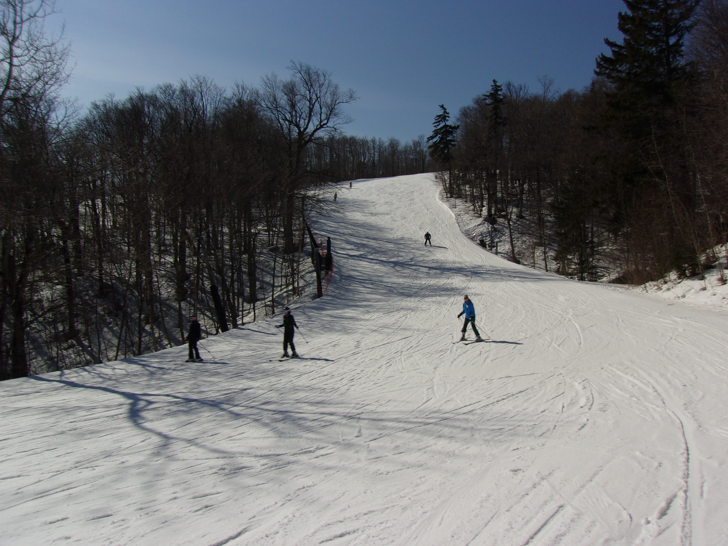
Monday, pretty nice.
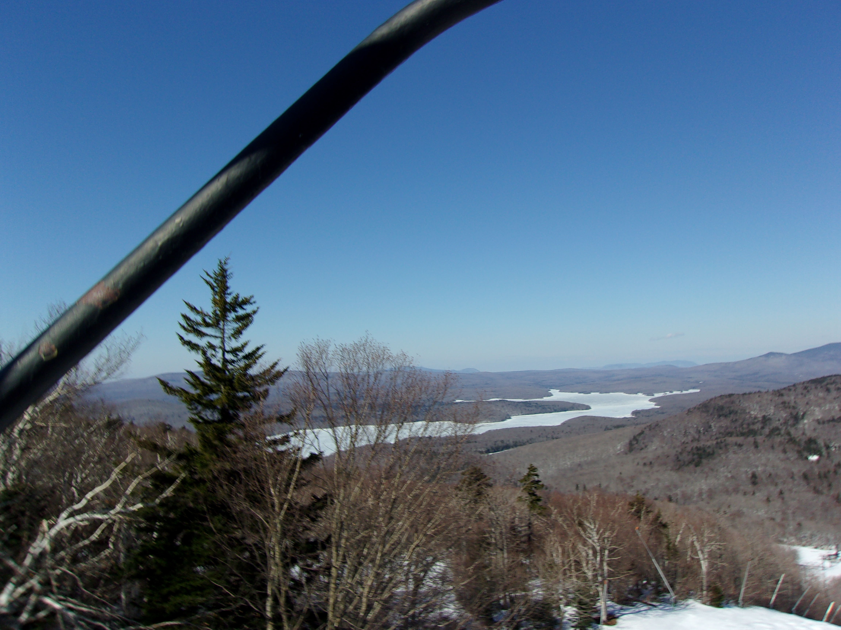
The reservoir from the north face lift.
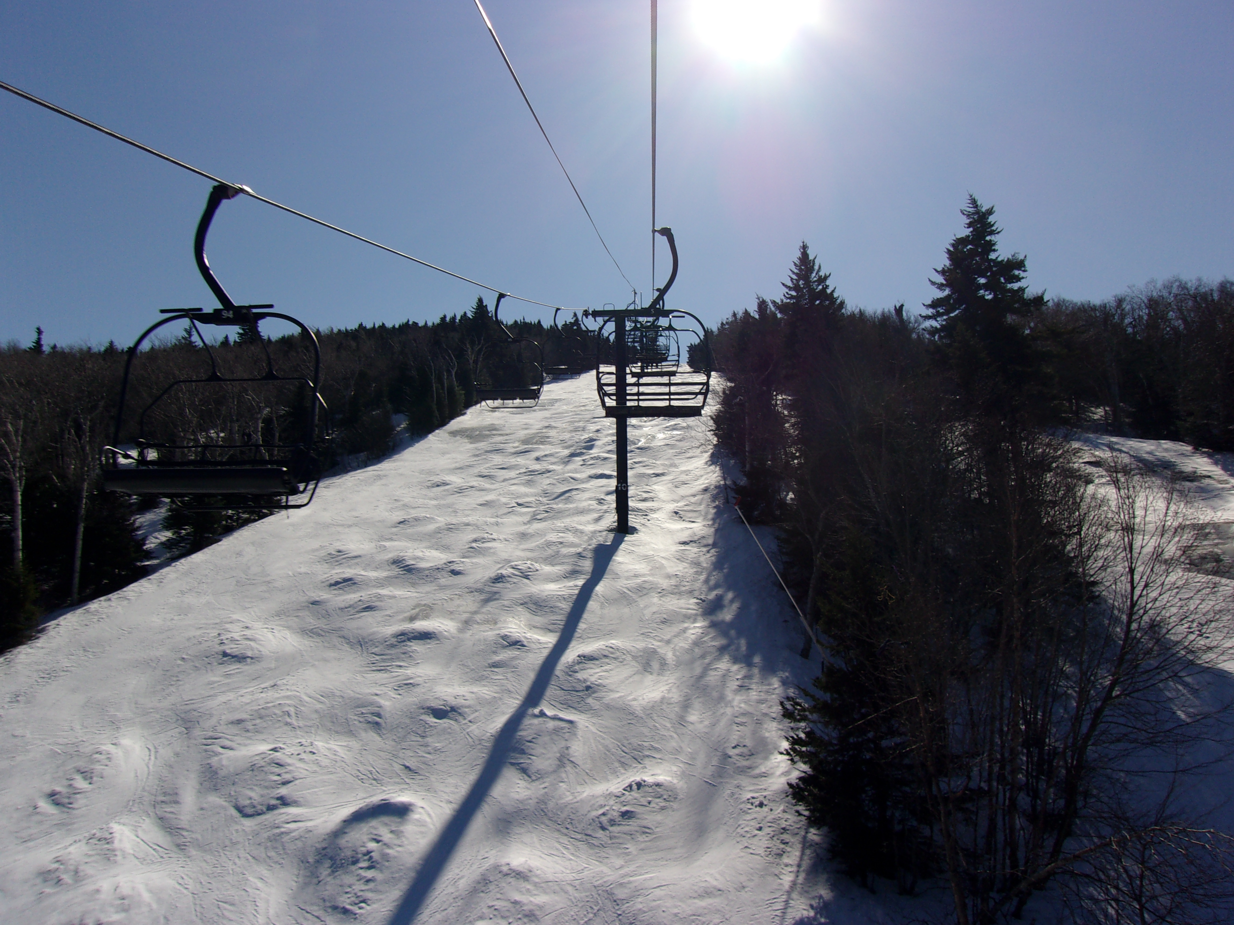
Bumps on the north face.

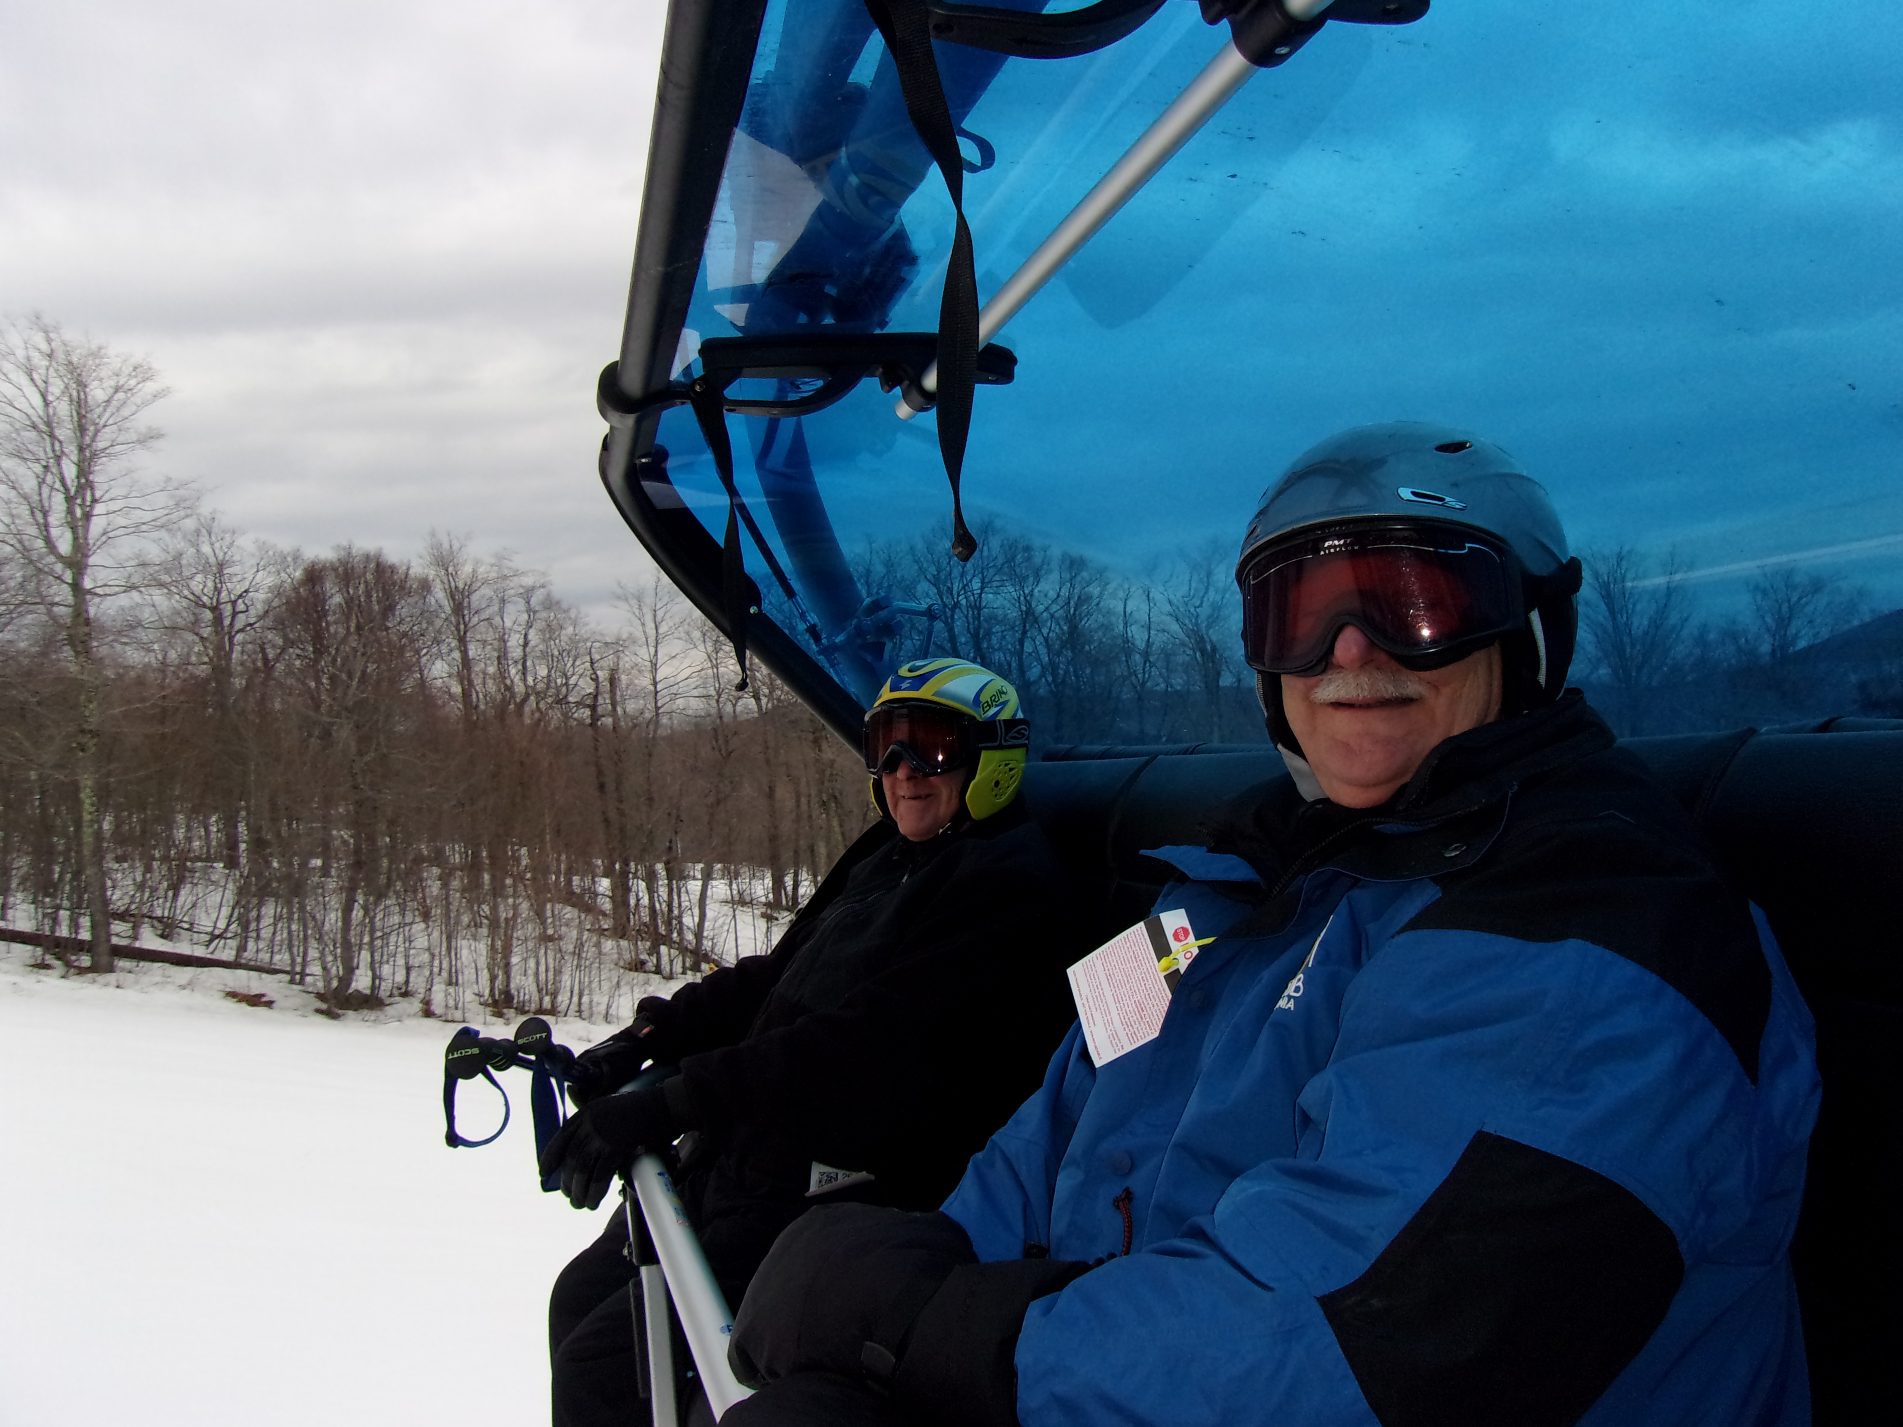
Floyd & Danny on the bubble lift.
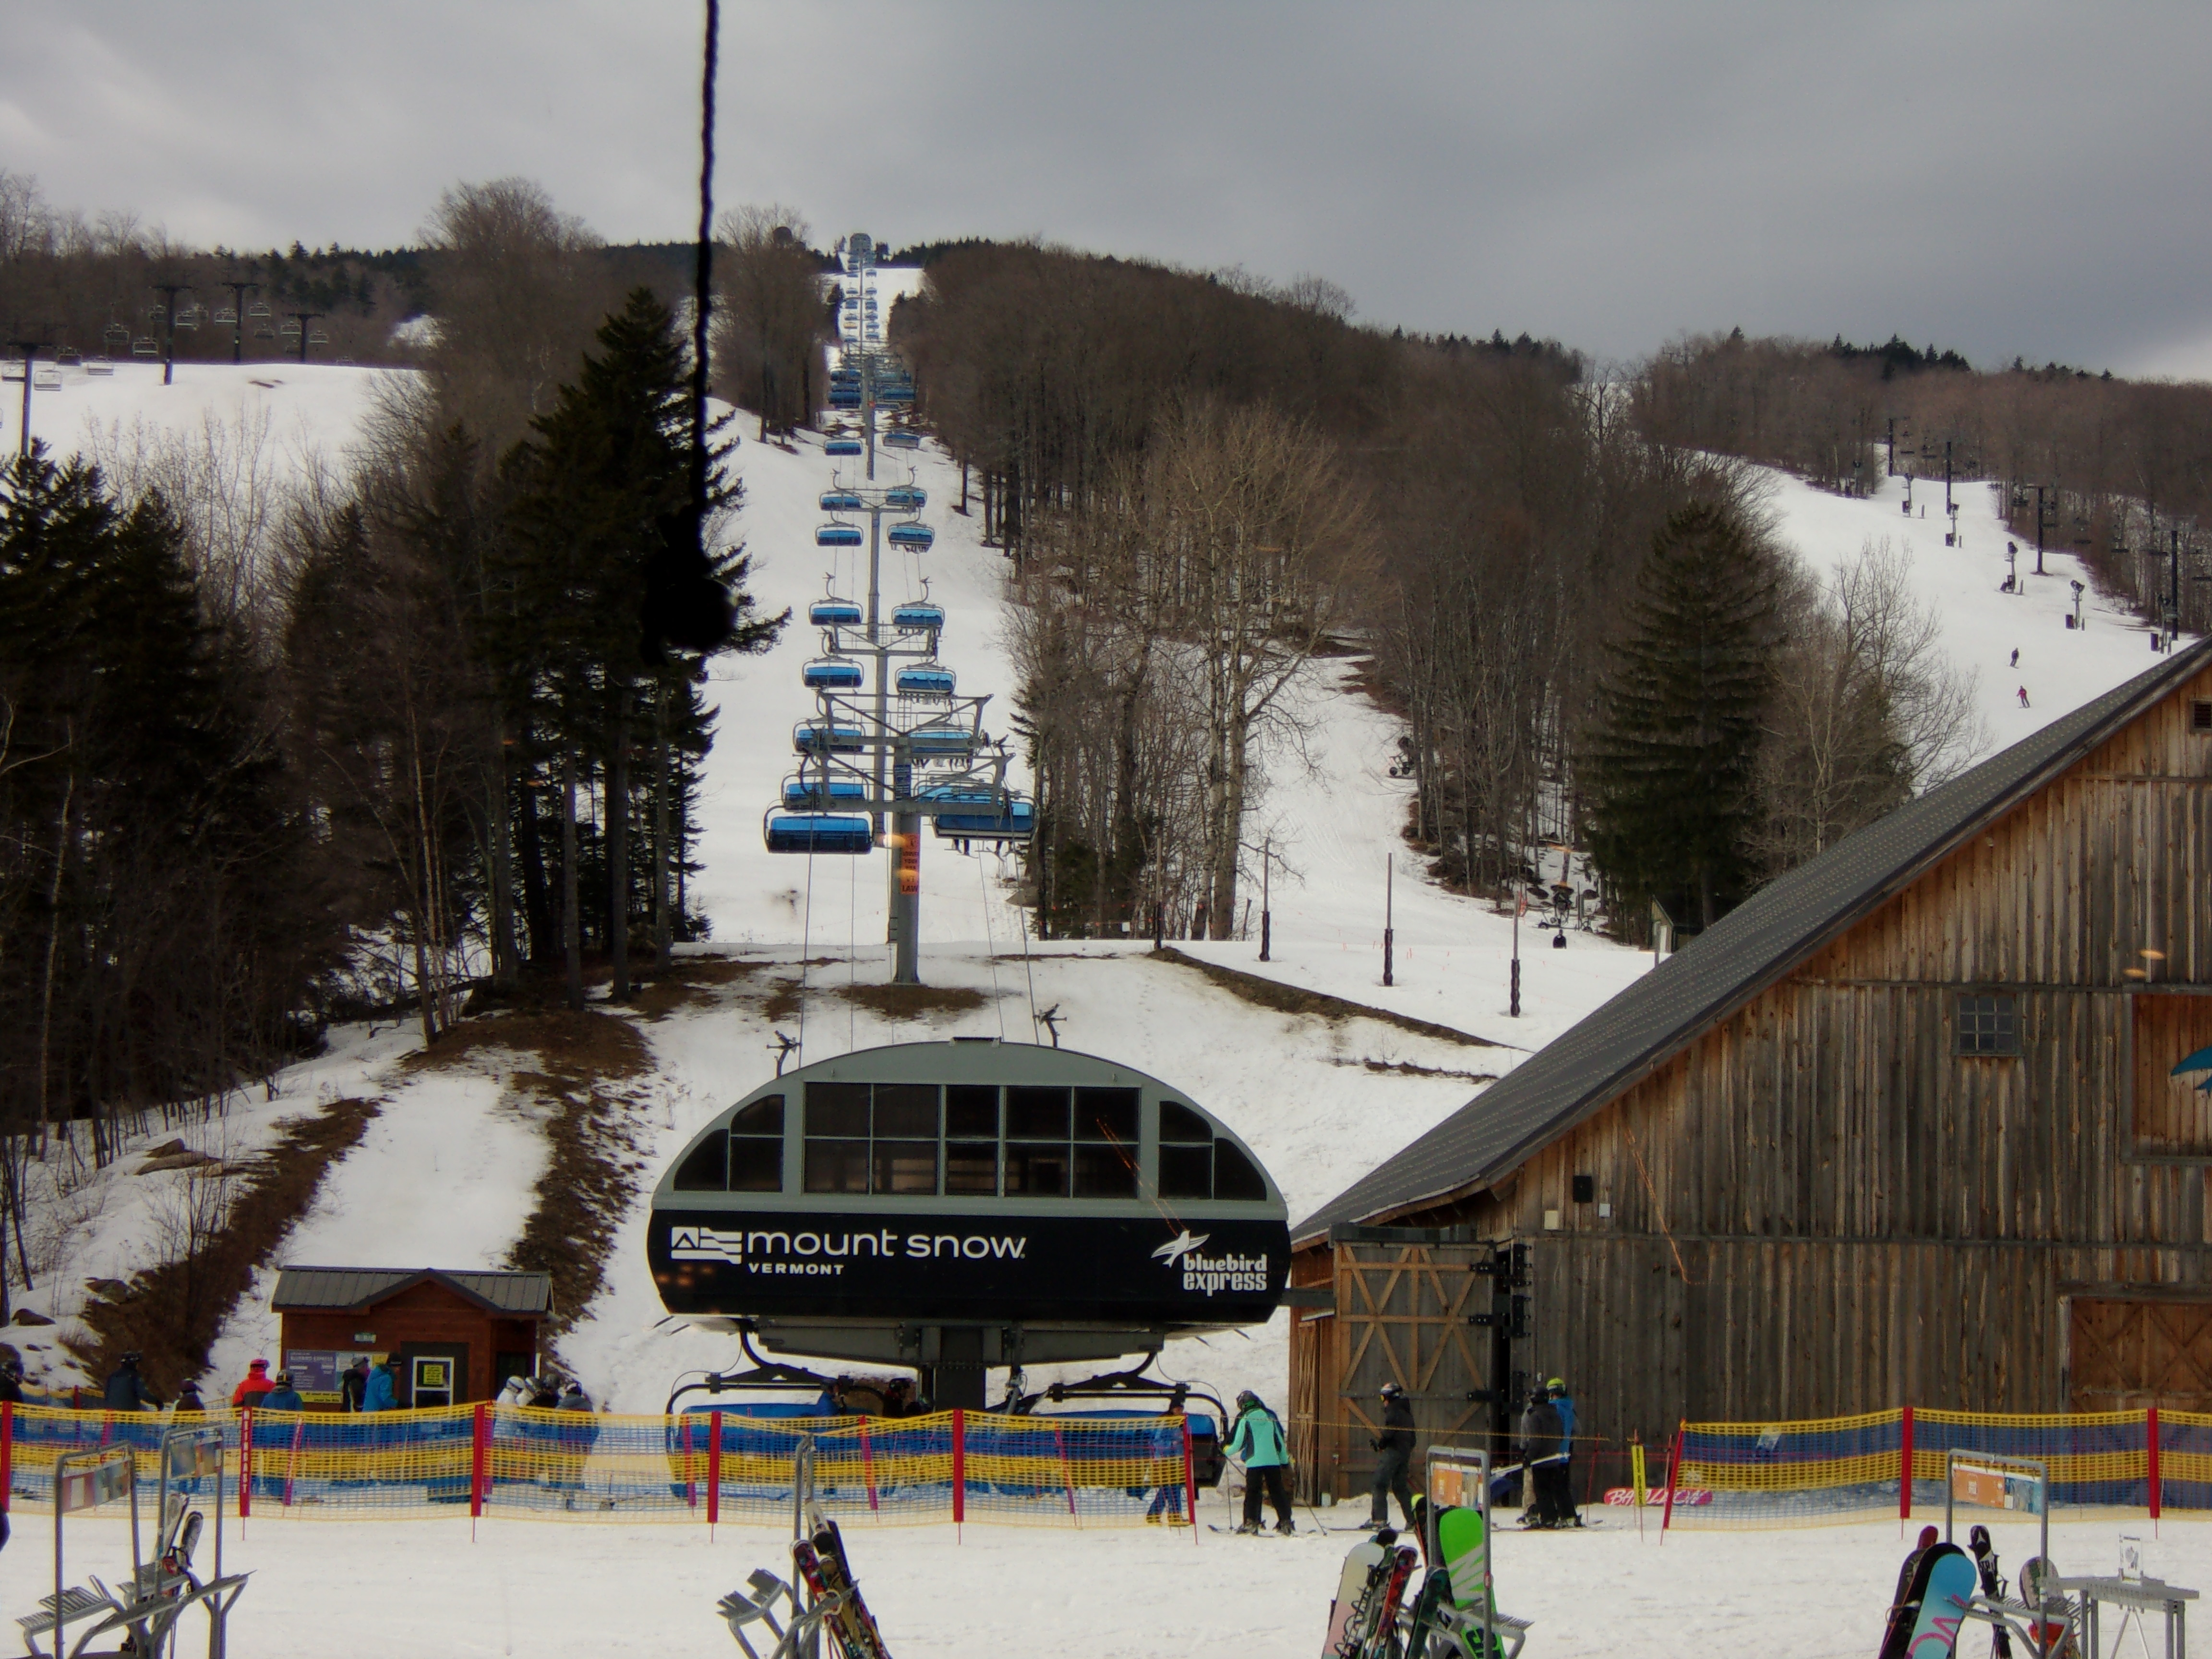
Bluebird Express from the main base.
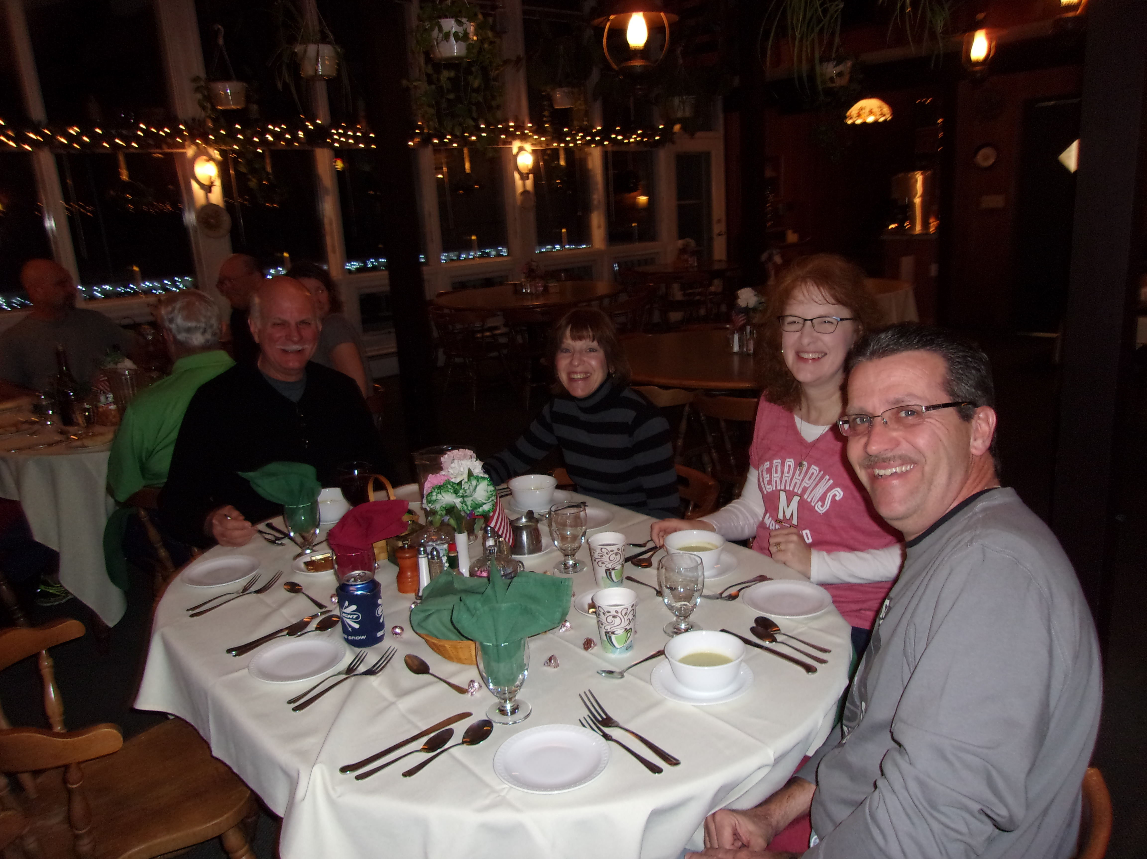
At dinner (from the left) with Tom H, Margie, Terri & Jim.
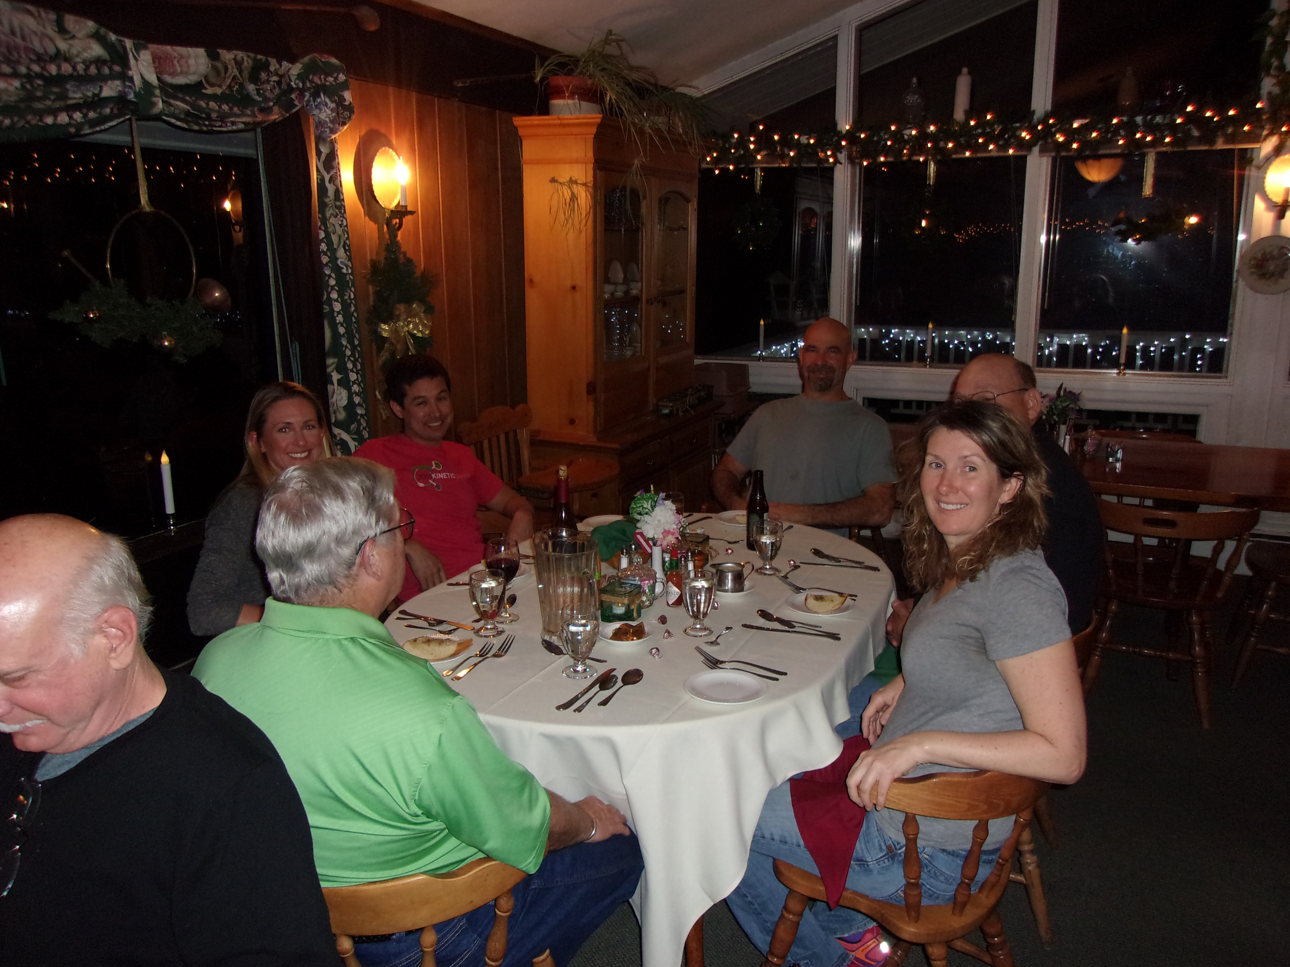
At dinner (from the left people’s faces) Anna & Theo, Jim & Candy.
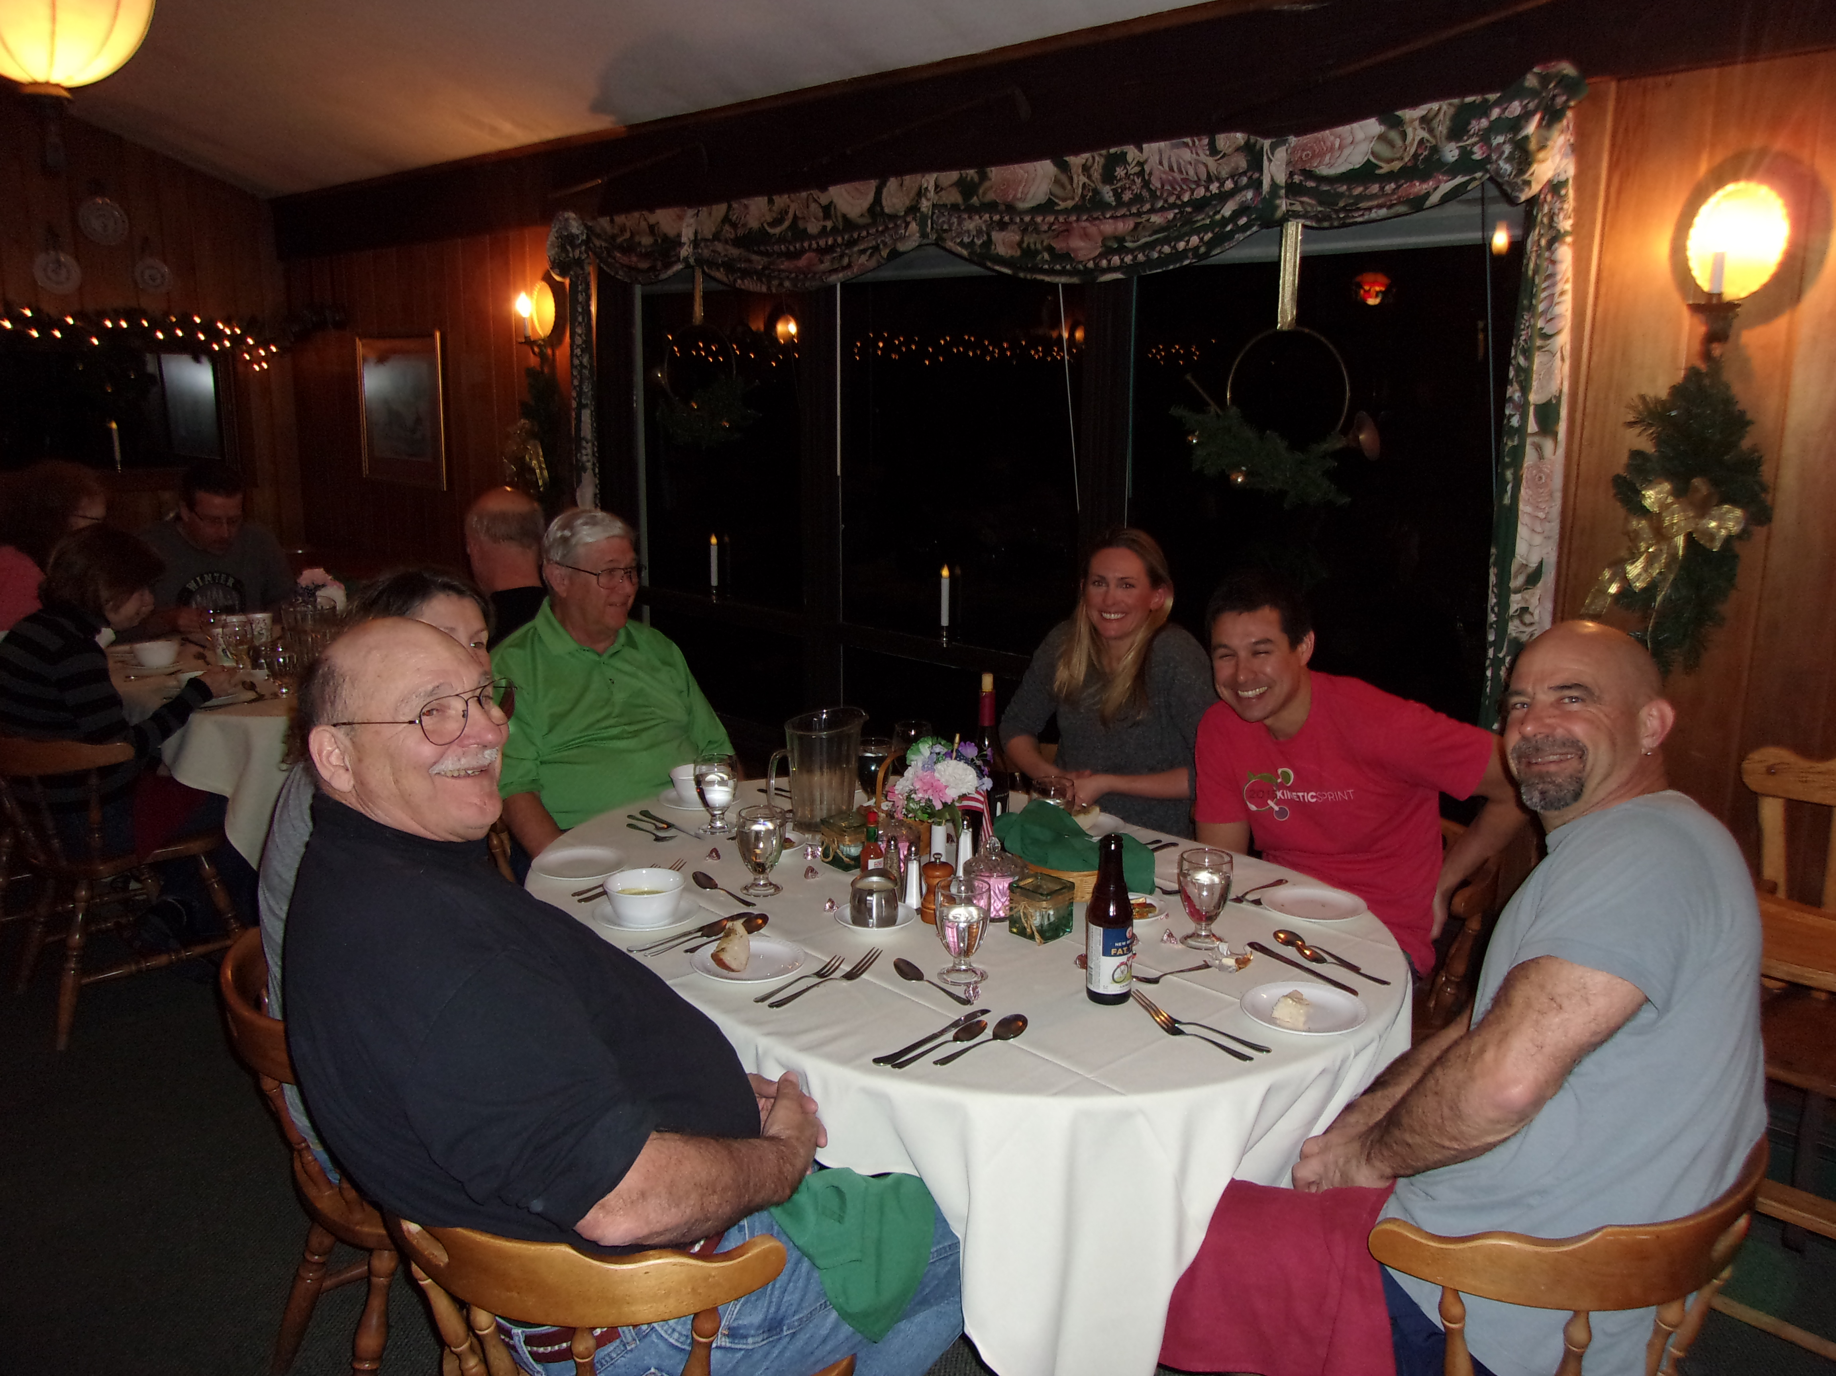
At dinner (from the left people’s faces; the rest of them). Danny, Anna &Theo, Jim, Floyd.
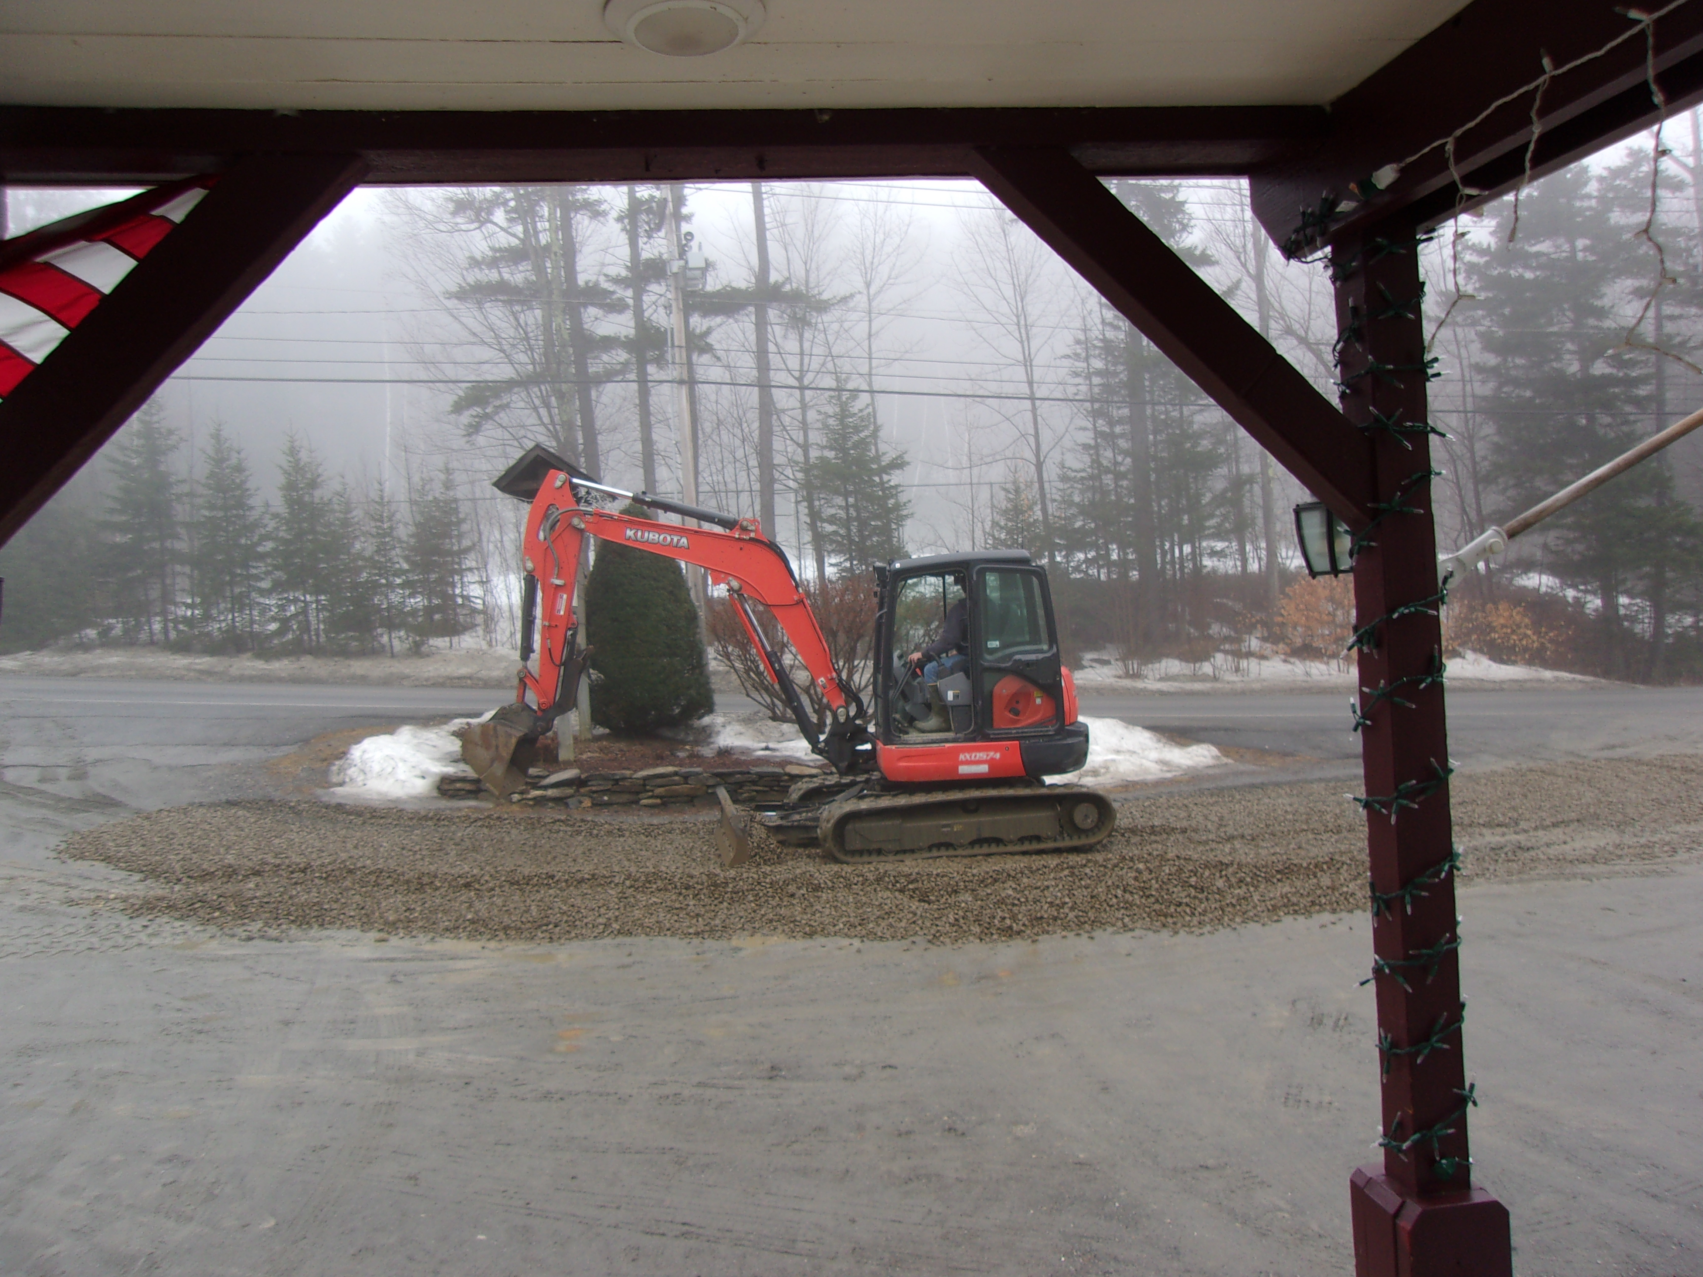
A little pot hole repair in front of the Mountaineer Wednesday morning.
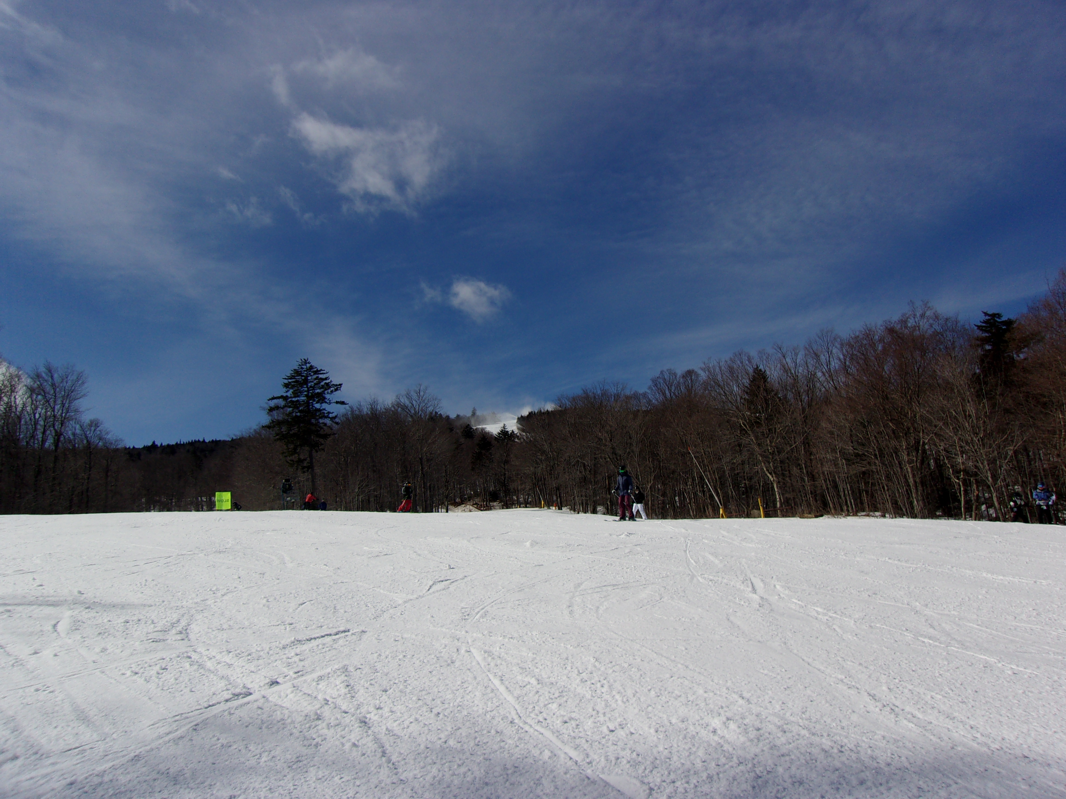
Look hard & see them making snow Friday at the top of the mountain.

I had a good time & hope you did too.

This trip report can still be modified. If you’ve got some good pics you’d like to include, PLEASE send them to me with a caption.
Remember next year’s trip will be the same week so be sure to plan on it and another great time. And remember to RSVP early to get a room at the Mountaineer.

Ski ya, Mike

