Mt. Snow VT Trip February 23rd – 28th, 2020
The Mt Snow Trip was a success with 38 participants. Of these, there was a mix of first timers and regulars who all had a good time. On a base of 12” to 18” and started as packed powder & machine groomed. Then Wednesday the wet stuff moved in. Thursday morning we’d gotten several inches of snow and it was very windy so only a couple of low lifts were open to start; then the Canyon lift was halted... Friday was a great day of skiing!
Our stay at the Mountaineer Lodge featured good food, a large hot tub, a warm atmosphere and of course a couple+ wine & cheese parties with some new and old friends.
This affordable trip has always delivered good skiing and is a particularly good value for families. Now for the pictures which I hope participants send me more and/or any comments:
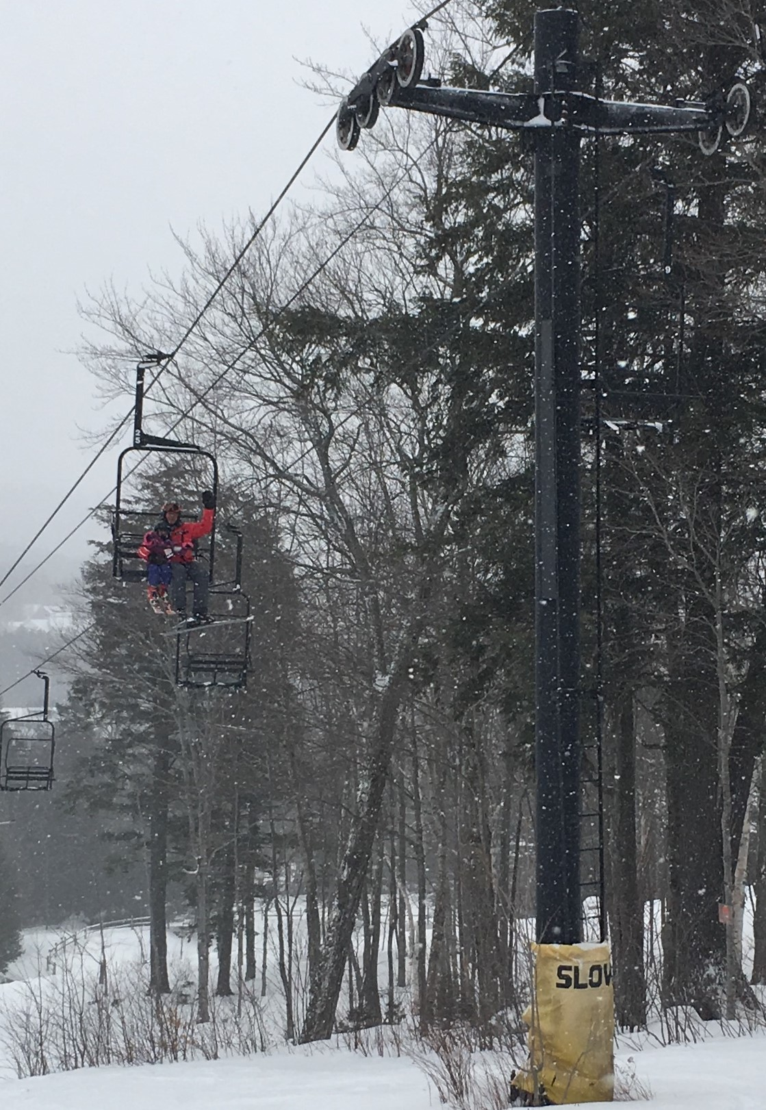
Headed up the lift.
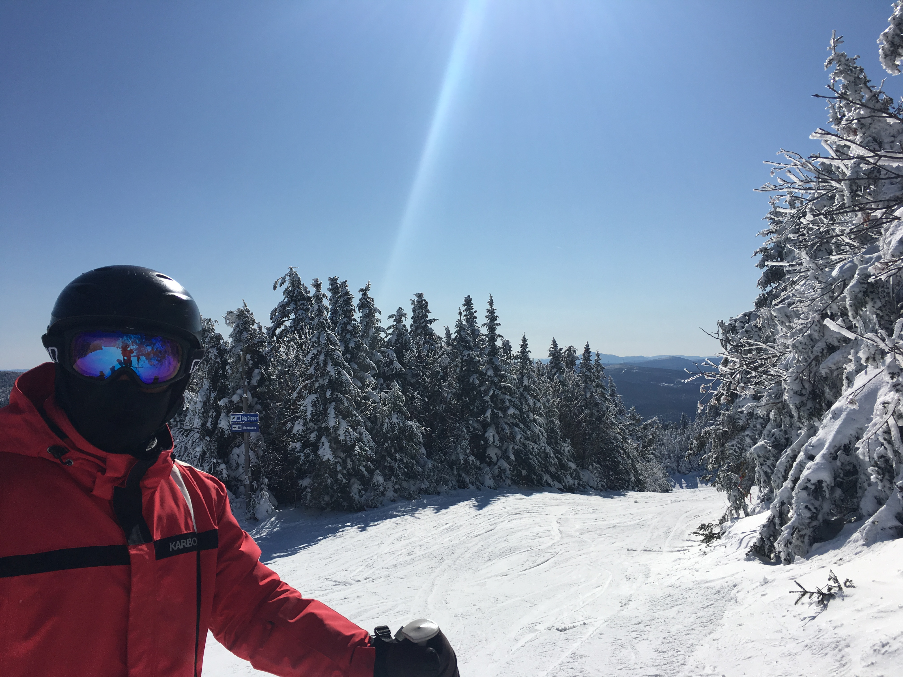
Up on the hill.

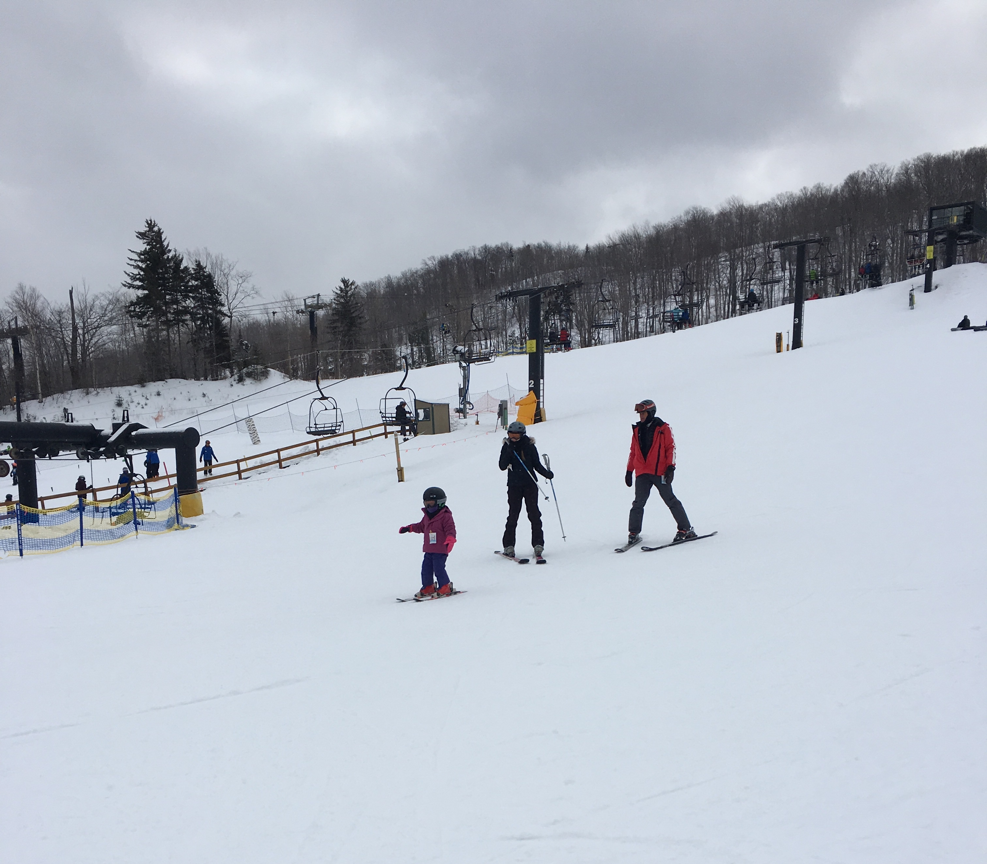
Tom with Anna & baby Jane.
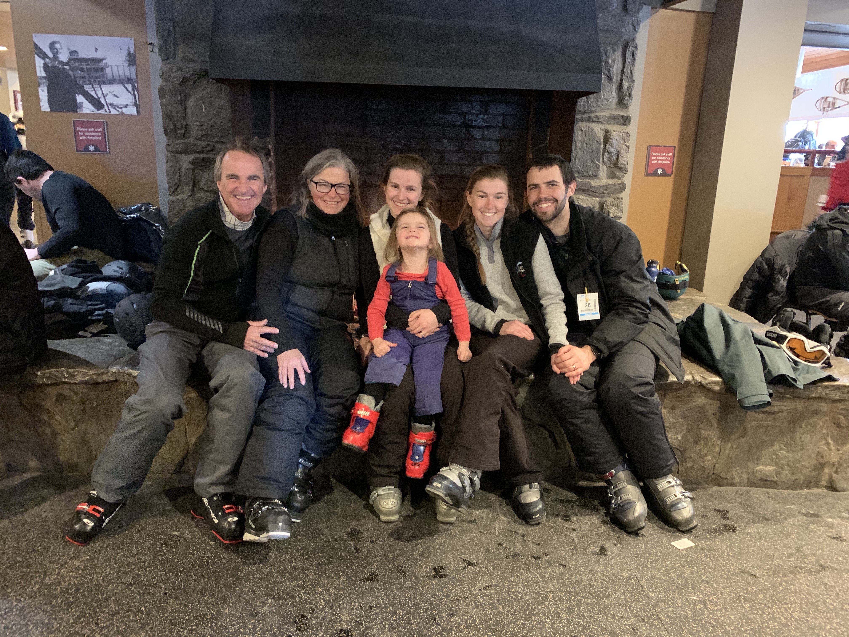
Taking a break at the Base Lodge, Tom, Marla, Anna & Jane, Emily & Raphael.
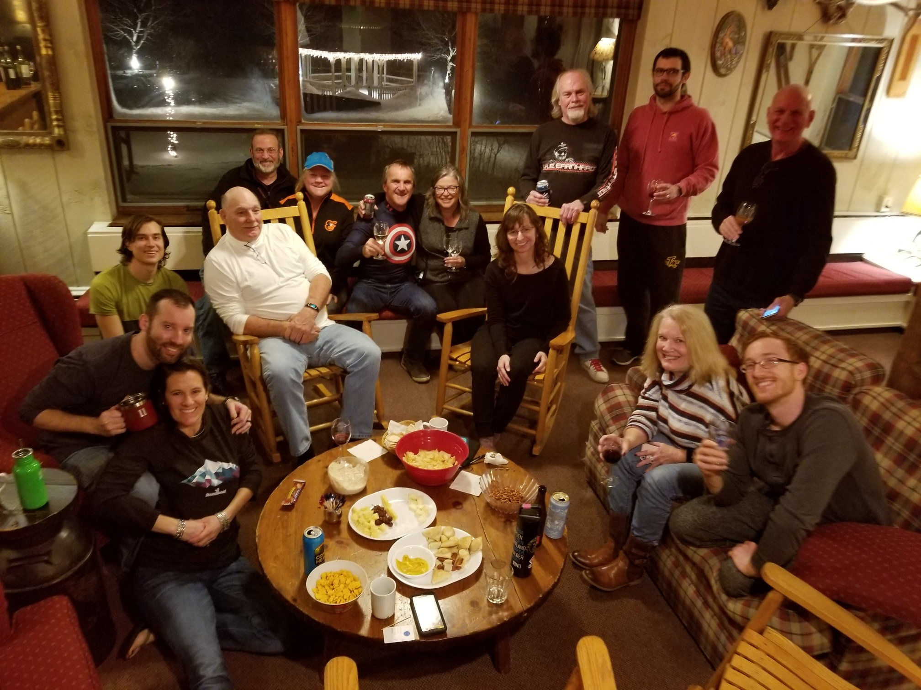
Some shots of a wine & cheese party.
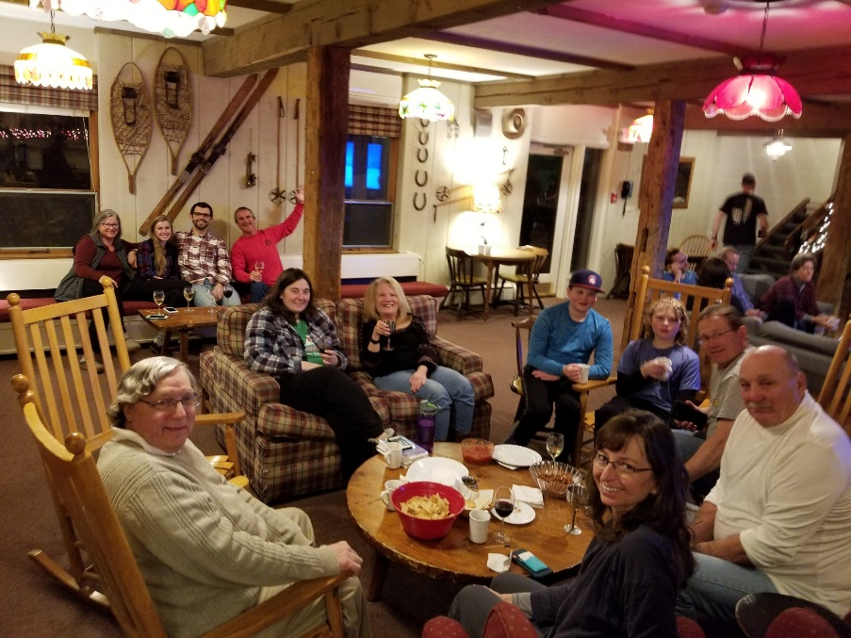
Another one.

In front of the fireplace.
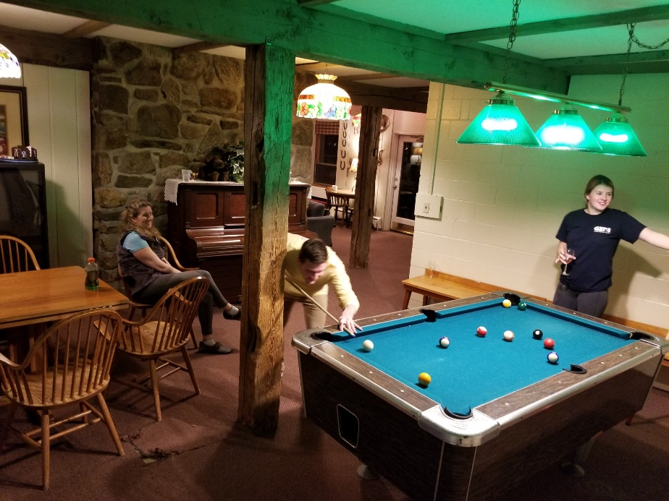
Behind the fireplace is the game room.
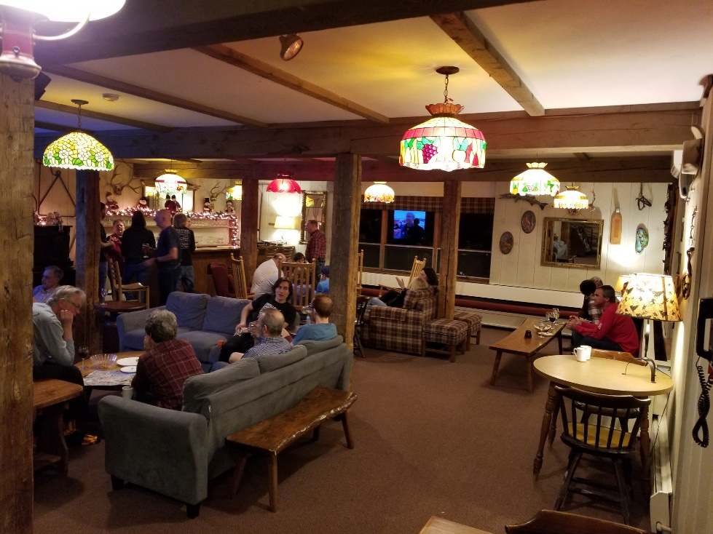
And back.
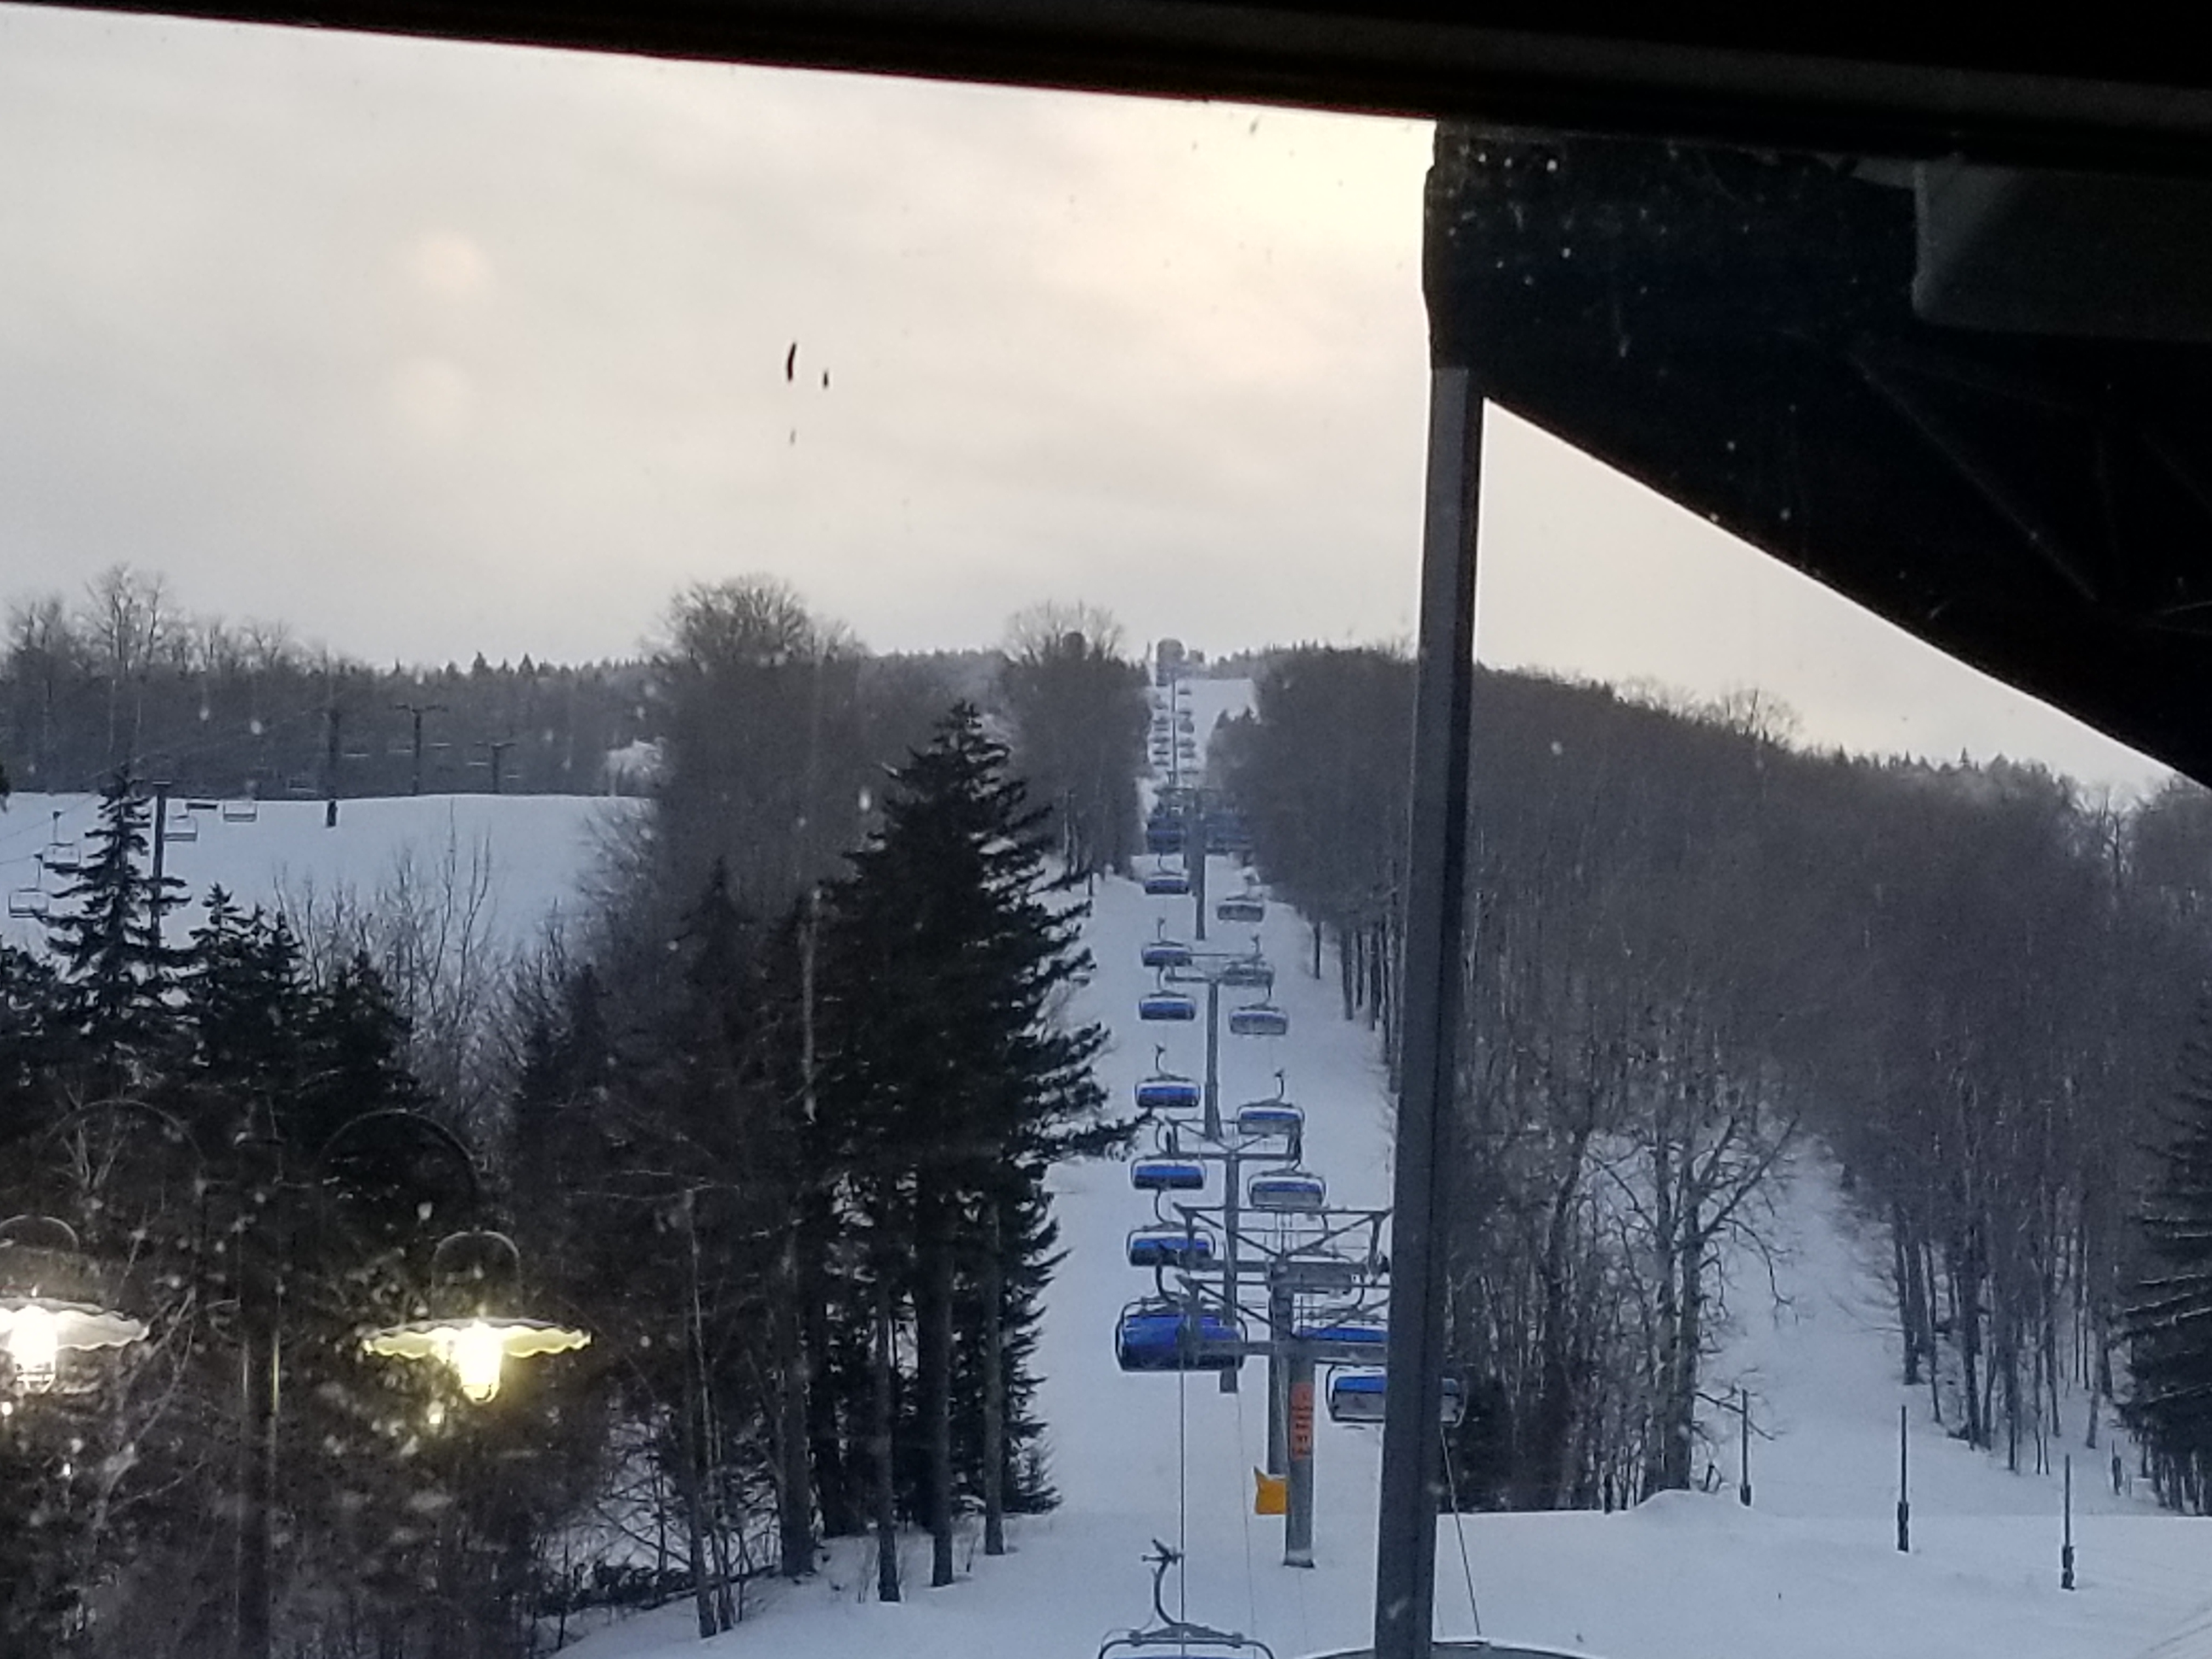
Shot from at the bottom of Bluebird.
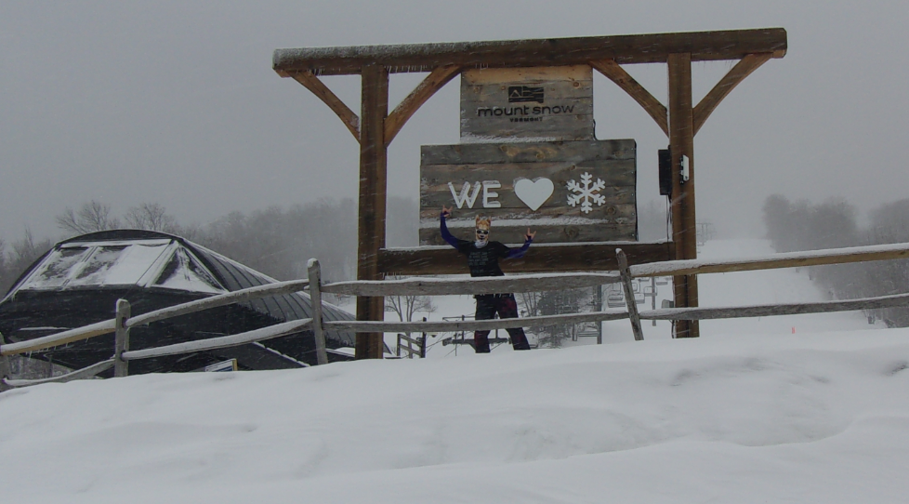
Cat Woman loves the snow.

I had a good time & hope you did too.

This trip report can still be modified. If you’ve got some good pics you’d like to include, PLEASE send them to me with a caption.
Remember next year’s trip will be the same week so be sure to plan on it and another great time. And remember to RSVP early to get a room at the Mountaineer.

Ski ya, Mike

