NASA GODDARD SKI CLUB TRIP
to PAGANELLA and FLORENCE, ITALY

February 25 to March 7, 2017

by Harvey Walden, Trip Leader
Photos by Steve Slojkowski

We departed Ronald Reagan Washington National Airport on the afternoon of Saturday, February 25th bound for Milan, Italy on American Airlines with an improbable stop on route in Miami. We had been told by our tour operator that we were only the second American ski club to visit this little-known Italian ski resort in the Dolomites known as “northern Italy’s best kept secret.” There were ten of us on the flight, although we were to meet up in Italy with three others in the group who had arranged their own flights, with two coming from Colorado. We arrived at Milan’s Malpensa Airport Sunday morning. After some initial confusion about meeting the three other trip members, we boarded a chartered bus for the approximately three-hour ride to the small mountain town of Andalo at an elevation of 1050 meters, with a stop on the way for lunch. We arrived in late afternoon at the three-star Hotel Negresco, where we were to spend the next seven nights with half-board, that is, all breakfasts and dinners provided on-site. Before dinner, we enjoyed drinks and had a briefing by Agnese and Marco on the local arrangements and attractions; they were to be with our group for the entire week. A free bus was available from the hotel’s garden gate to the slopes daily, although the distance was short enough to walk, especially since we were able to leave our ski equipment at a shop at the base of the gondola. We arranged ski equipment rentals that first day for the week.

On Monday, we met for an Italian lunch catered by Gigi on the mountain (non-skiers arrived by gondola) at La Roda restaurant at the 2125-meter summit of Cima Paganella. This vantage point offered a magnificent view of the peaks of the Dolomites. The lunch had been re-scheduled from Tuesday because of the big snowstorm that was expected then (we were not disappointed). Paganella, whose motto is “my fun ski area,” is relatively compact and easy to navigate, with primarily red (intermediate) and some blue (beginner) runs. Agnese and Marco were kind enough to offer ski tours for our group.

On Tuesday, the day of the snowstorm, our group enjoyed an Italian happy hour at the first gondola stop at Rifugio Dosson at 1480 meters. All day Wednesday and Thursday morning were ski days. Wednesday evening, most of our group enjoyed the “Dancing Waters with Fireworks” at the Piazza Paganella in Andalo that featured a combination of water, fire, and music at a free public outdoor exhibition.

Thursday afternoon a chartered bus took our group on a quick 20-minute trip from Andalo to visit two very different wineries. First was the Mezzacorona Winery, a very large scale operation where we had an extensive formal guided tour of the facility followed by a wine tasting. The architecture was unique and the facilities immaculate in the off-season. Then we visited the family-operated and much smaller Francesco Moser Winery. Here the tour of the vineyards was much more informal and accompanied by the family’s very friendly mountain dogs before another tasting. Francesco Moser is a famous retired Italian cyclist, and his winery included a small museum devoted to his bicycles, cycling paraphernalia, and trophies. The younger generation of Mosers now adds to the winemaking tradition. After the two winery tours, we returned to Andalo by bus in time for our usual excellent dinner at the hotel.

On Friday, we enjoyed morning skiing again. In the afternoon, we travelled a half hour by bus to the nearby town of Trento, from which the surrounding Trentino region derives its name. We had a brief walking tour with our guide Agnese and then were free to visit and shop at our leisure. Major points of interest were the Duomo, the Cathedral of San Vigilio, and the Castle of Buonconsiglio. We returned to Andalo for a gala dinner with music and dancing at the restaurant Dosson at the first gondola stop on the mountain.

On Saturday, we left the hotel for a full-day trip to Lake Garda, about an hour distant. We arrived in Riva del Garda and there boarded a motor yacht named “Speedy” for a tour of the lake for about two and a half hours. The boat tour was a last-minute bonus arranged by Agnese at the group’s request. The boat cruise followed the western coast of the lake, passed in front of the Ponale waterfall and continued on to the town of Limone, a fishing village with lemon terraces. At Limone, we stopped for sightseeing and shopping and then returned to Riva del Garde. Due to the onset of heavy rain, we departed a bit earlier than expected for Andalo and enjoyed our final dinner at the Hotel Negresco.

We had our final breakfast at the hotel Sunday morning and then left by chartered bus for Florence, a trip south of about three and a half hours. Before entering Florence, our bus driver had to stop at a remote outpost called “the checkpoint” under the elevated highway in order to arrange a permit to allow the bus to enter and park downtown at our hotel. We then checked in at our four-star hotel, the Adler Cavalieri, on the Via della Scala in the historical center of Florence near the Santa Maria railway station. We stayed two nights with an unscheduled itinerary. Our group was able to visit the Duomo, the Ponte Vecchio, the Piazza Pitti, Santa Croce, and many other points of interest within walking distance of our hotel.

We departed Florence very early Tuesday morning with breakfast to go in boxes on the bus to make our 10 am flight departure from Milan’s Malpensa. The return flight connected at Kennedy Airport in New York. Given the combination of the plane’s lengthy taxiing on the tarmac, passport control, immigration forms, Customs, picking up baggage and then rechecking it, passing through security, and finding the proper gate at the far end of the terminal, only two in our group managed to make the connecting flight to Washington. Fortunately, American Airlines was able to book all our remaining passengers on other flights to the same or nearby Washington area airports without losing their luggage, so all returned in good spirits after a wonderful week in Italy.

Heading down the slopes at Paganella

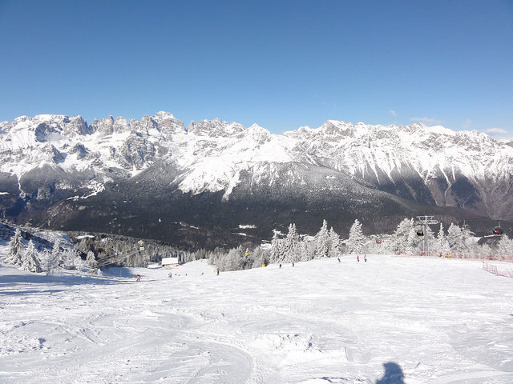

View from the top toward Lake Garda

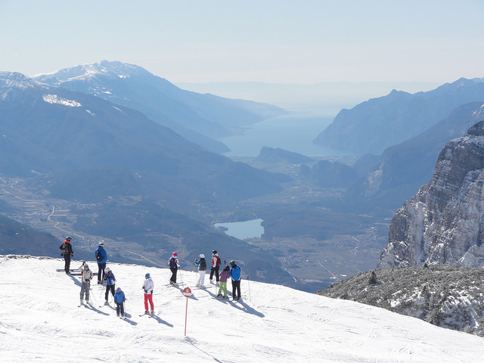
Dining at La Roda Restaurant near the summit

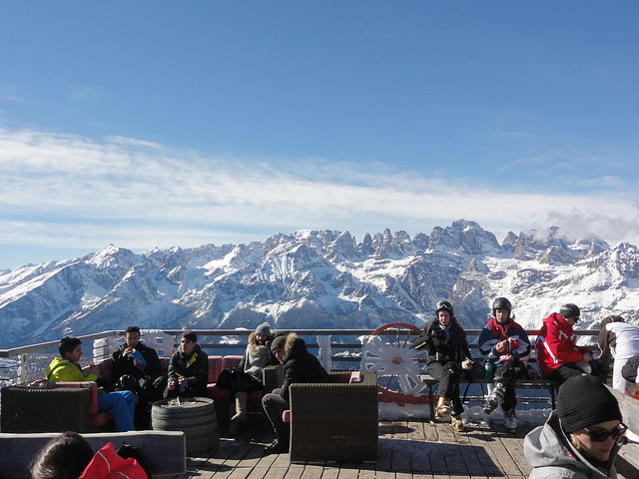

Side trails at Paganella

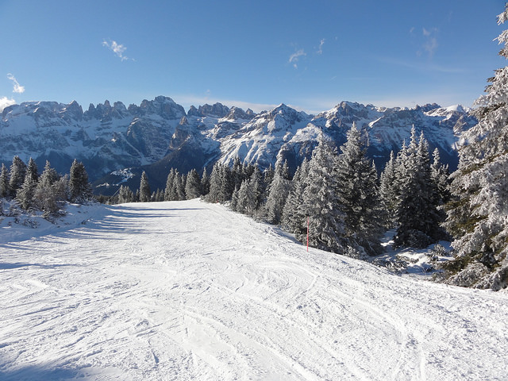

Coming into the harbor at Limone on Lake Garda

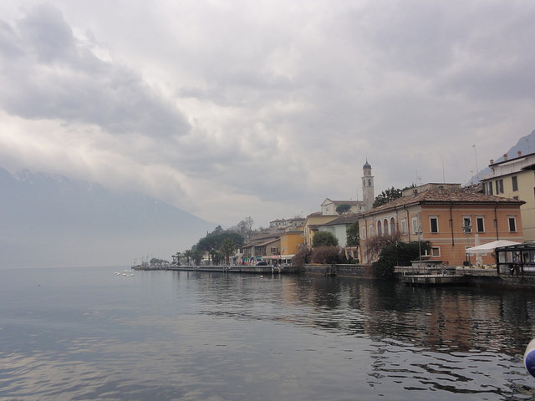

Florence as seen from the Plaza Michelangelo

