Print Resolution and Aspect Ratios

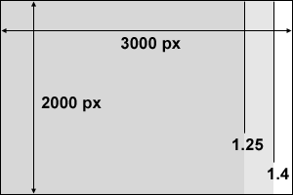

To find the actual image dimensions of your file, look into the file Properties/Details in your photo editor or organizer software (e.g., Windows Explorer, Photo Viewer, iPhoto and Photoshop all give this information). The initial image dimensions will vary from camera to camera. If you crop the image, these dimensions will get smaller.

Example
Image size as shot: 2000px x 3000px = 6 MP (mega-pixels, not mega-bytes)
Aspect ratio: 3000/2000 = 1.5

Typical print sizes and their aspect ratios and print resolutions:

Print Size Aspect Ratio Example Width Print Resolution
4” x 6” 1.5 3000 px wide 3000/6 = 500 dpi
5” x 7” 1.4 only 2800 px wide 2800/7 = 400 dpi
8” x 10” 1.25 only 2500 px wide 2500/10 = 250 dpi
16” x 20” 1.25 only 2500 px wide 2500/20 = 125 dpi

If your initial image has an aspect ratio different than the print size aspect ratio, you will need to crop it to fit (or print some white space and trim). Most cropping tools have a way to set the aspect ratio. If you have a specific printing purpose in mind ahead of time, try to keep in mind the aspect ratio of the print and the image, and match them as best you can.

16” x 20” is the size of our Photo Club Exhibit in Building 1. If you’re shooting less than 3.2 MP (mega-pixels), you probably don’t have enough resolution to print at this size. That’s 100 dpi, about the minimum we want to display. After that, things get fuzzy and jagged.

Our Flickr account allows unlimited file size uploads, so there is no need to upload a reduced resolution image, unless you have a very slow network connection.

