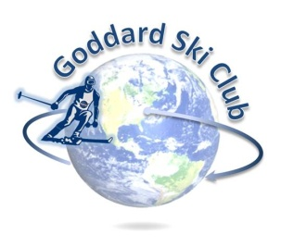
Killington Trip Report
Thursday, January 7 – Sunday, January 10, 2016

Location: Killington Ski Resort, Vermont
Participants: 21 Adults
Trip Leader: Matt Ekinci (matthewekinci@gmail.com)
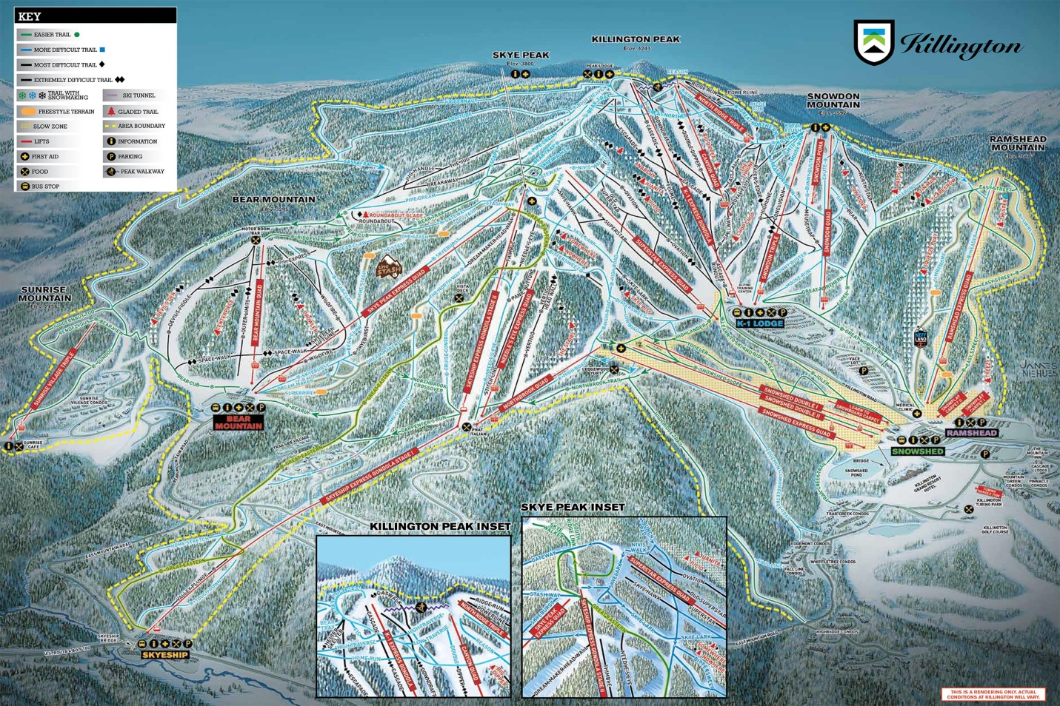

Lodging: Killington Mountain Lodge (http://killingtonmountainlodge.com/)
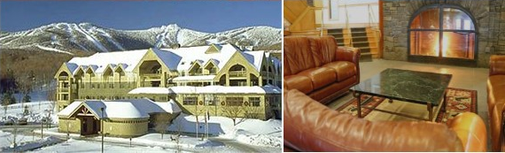
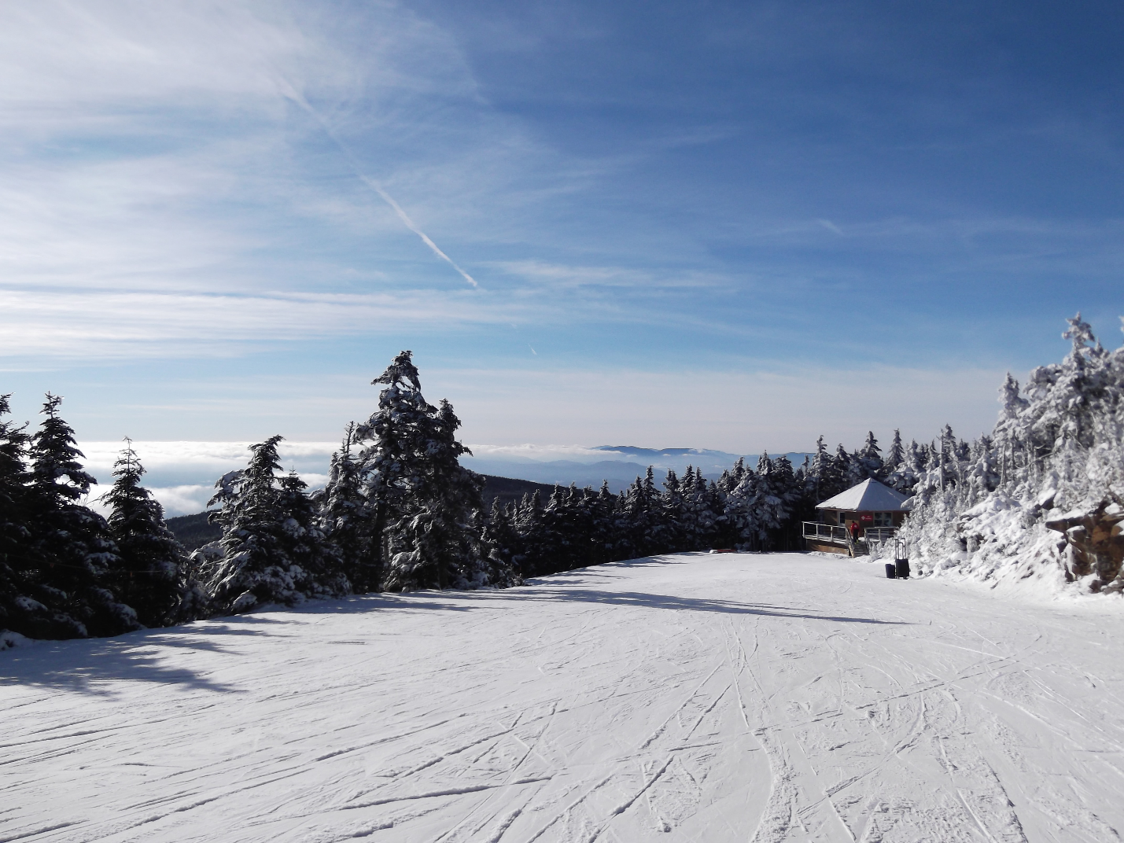

Worries ran high this year with the abnormally warm start to the winter season on the East Coast, as a week before the trip was scheduled to start Killington had weather in the 50s and less than 10 runs open. Luckily the week leading up to the trip brought below freezing temperatures that let the mountain’s snow guns start cranking 24/7. While the mountain was still running with only ~50 trails open for the weekend, that was still the most on the East Coast at the time and more than most of us had been hoping for given the weather to that point.
Friday broke as a beautiful blue-bird day that gradually gave way to overcast skies and wind as the afternoon wore on. As mentioned, the mountain wasn’t running particularly open, but the trails that were were generally in good shape, though the funnel effect of some trail closures led to high-traffic areas being either fairly scraped off or moguled up by the mid-afternoon.
This year marked the club’s first stay at the Killington Mountain Lodge after three years at the Cascades Lodge, and after a long day of skiing and snowboarding on Friday, we took advantage of the improved amenities by relaxing in their large outdoor hot tub before meeting up for a catered apres ski party in the hotel bar area. The food, drinks, and lounge area were all great, and though there were a few bumps in the road over the course of the weekend related to the total overhaul the hotel had been undergoing since the previous spring, the property in general was a noticeable step up over the Cascades Lodge and the feedback I received was very encouraging of staying there again on future trips.
Saturday as a ski day was much the same as Friday, simply with the addition of the typical weekend traffic on the slopes. A few more slopes were open, but high-traffic areas again became a problem as the day went on.
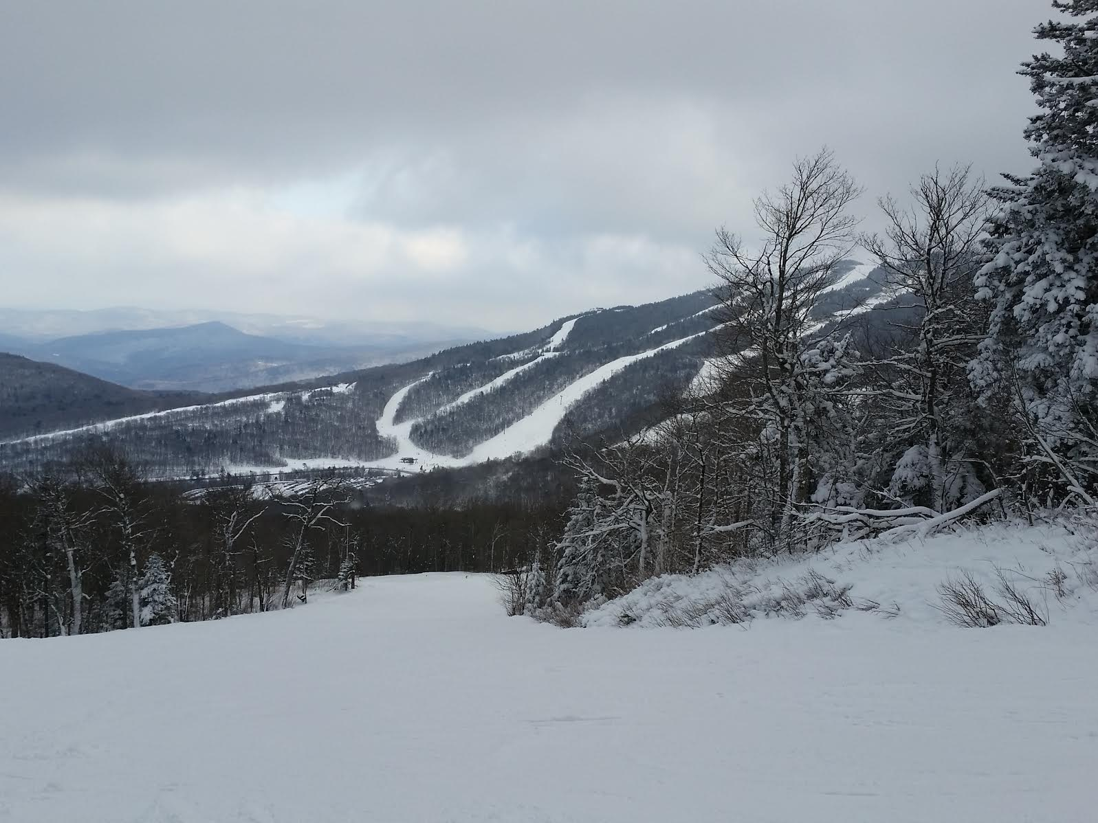
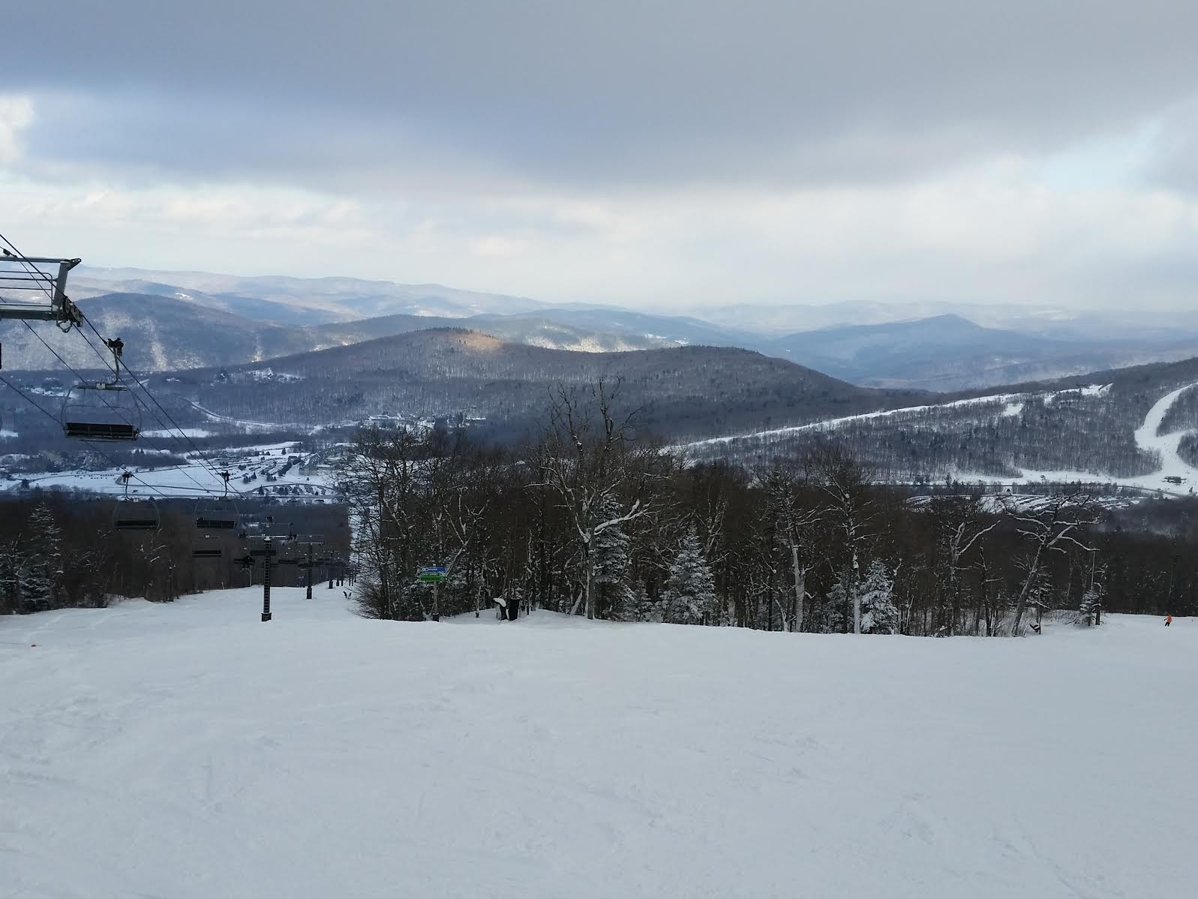
Unfortunately the Sunday forecast guaranteed the return of the unseasonably warm weather that had been threatening to undo the entire trip to start with, with heavy rain on top of it. As such, most people on the trip made plans to take advantage of Killington’s exchange policy to cash their last day of lift tickets for future vouchers, and to make a good night of Saturday. For the second year in a row a large group of us headed out to Outback Pizza for dinner and drinks, with significantly less travel drama this year as the restaurant was just a few minutes’ walk from the hotel. After dinner, most of that group retreated back to the lodge area of the hotel and enjoyed the rest of the night with drinks, card games, pool, giant Jenga, and extra hot tub time.

