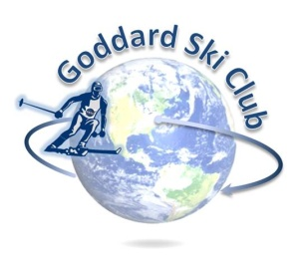
Killington Trip Report
Thursday, January 5 – Sunday, January 8, 2017

Location: Killington Ski Resort, Vermont
Participants: 21 Adults, 2 Teenagers
Trip Leader: Matt Ekinci (matthewekinci@gmail.com)
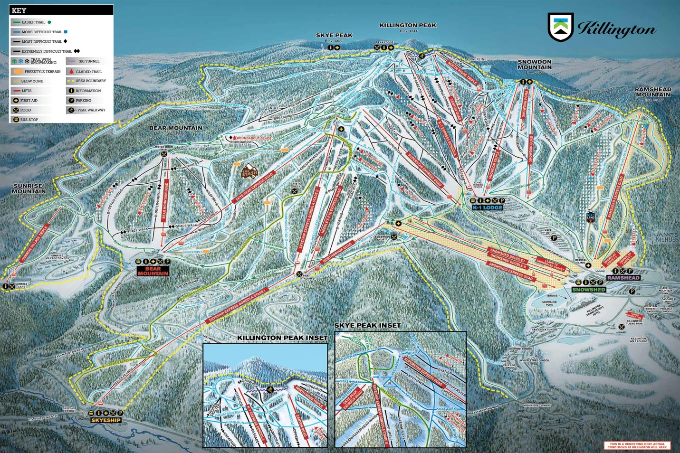

Lodging: Killington Mountain Lodge (http://killingtonmountainlodge.com/)
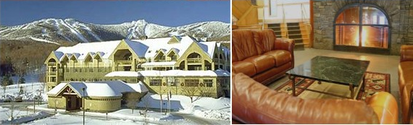

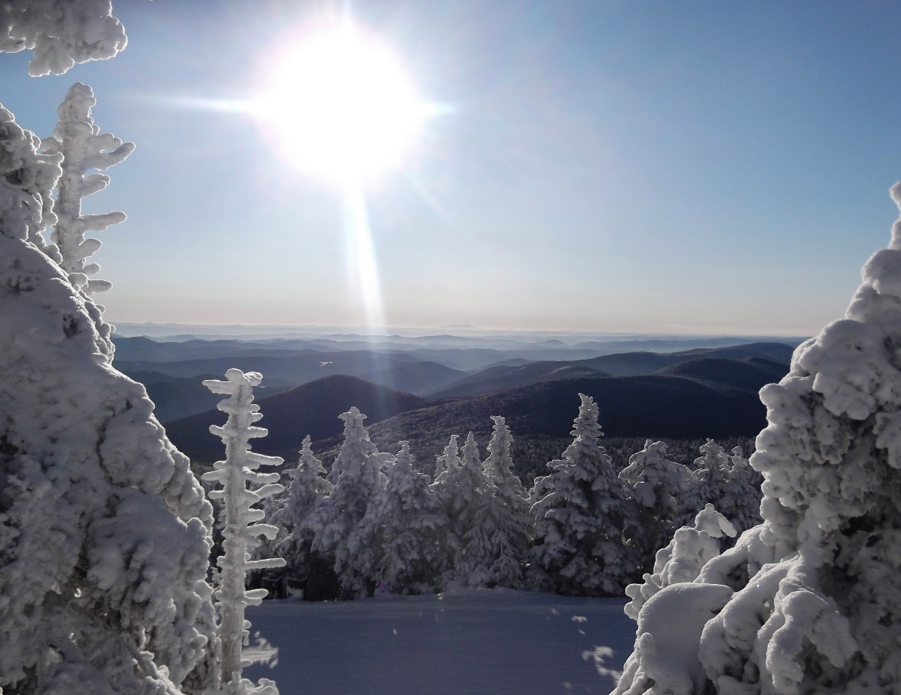
The club returned to Killington Mountain Lodge for the second time this year. Having completed the renovations they’d started the year prior, KML was even more pleasant than last year and will certainly be a place we continue to come back to in the future. While not the largest Killington trip we’ve run in terms of attendance, this year certainly had the highest demand for the available rooms and those that got their applications in early were well-rewarded – those that drove up a day early even more so. Several inches of snow fell Wednesday during the day into the wee hours Thursday morning, leading to ropes being dropped on rarely-accessible terrain on both Killington and Skye Peaks. Thursday morning brought bright sunshine, giving everyone a great little powdery bluebird morning before clouds set in in the afternoon.
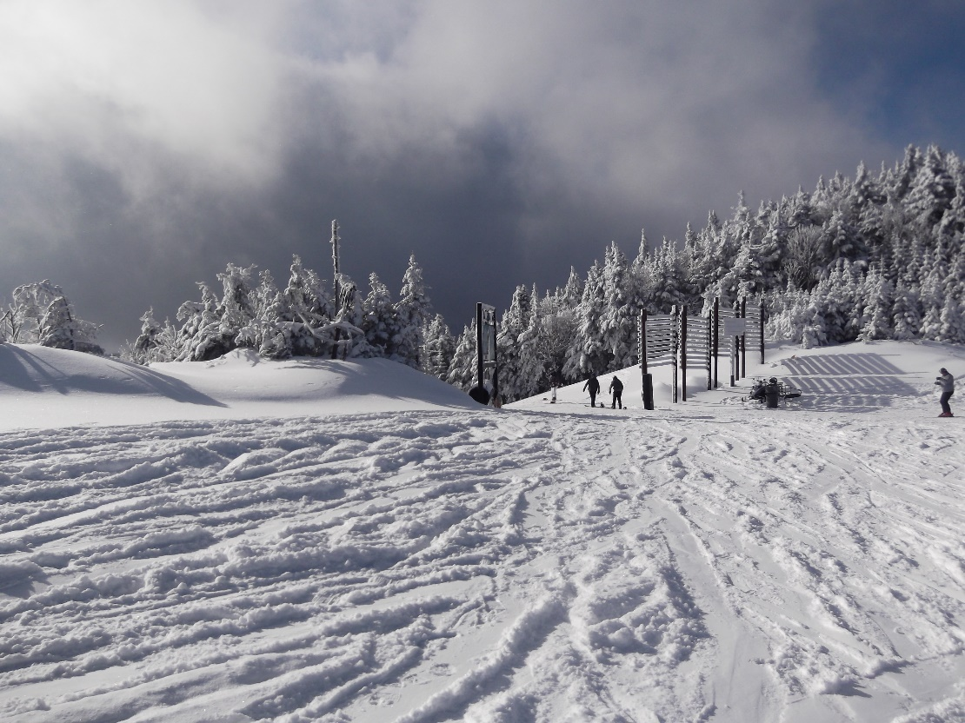
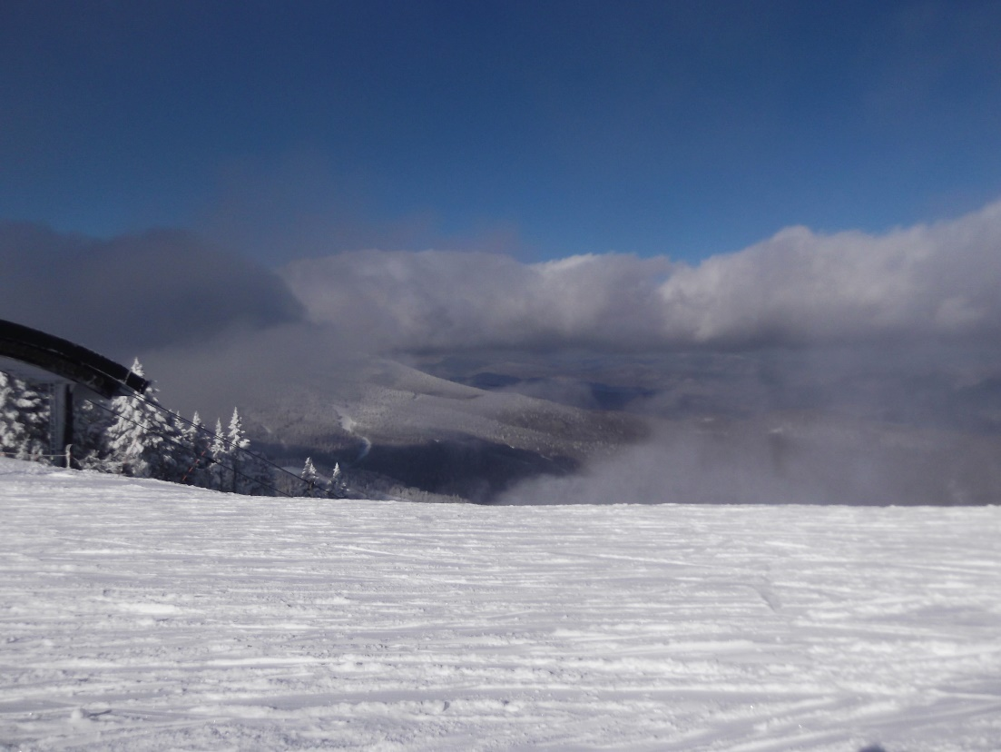
Friday night we gathered for happy hour at Outback Pizza, just a short walk down the road from KML. The club provided appetizers and drinks, and we had a great turn out with almost everyone on the trip stopping by (making it a convenient time to distribute our new club logo knit hats!). It was a great chance for everyone to socialize and get to know new people on the trip, and most of us ended up hanging around for a few hours and ordering dinner here as well.
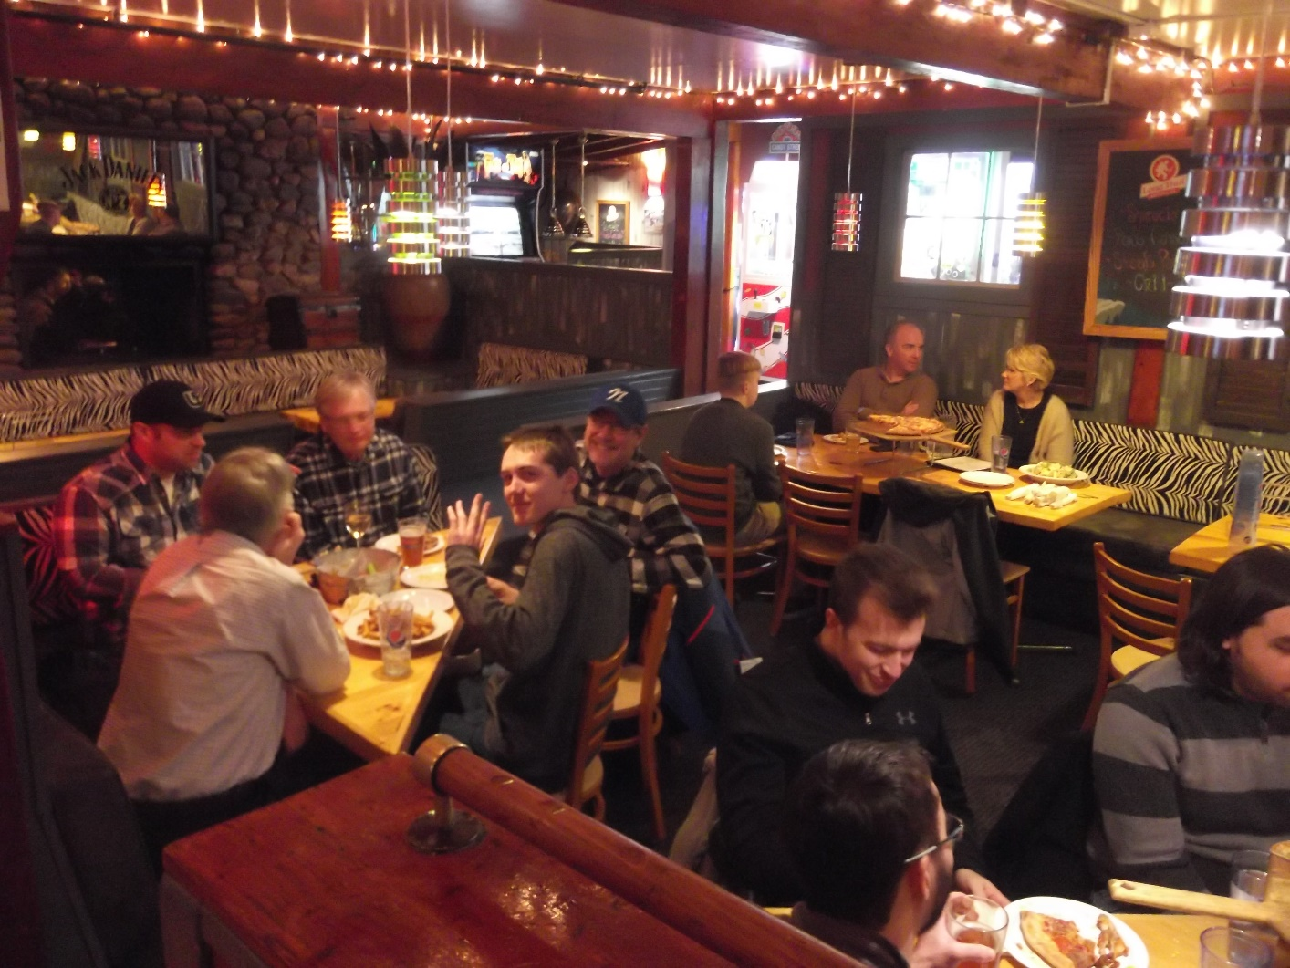
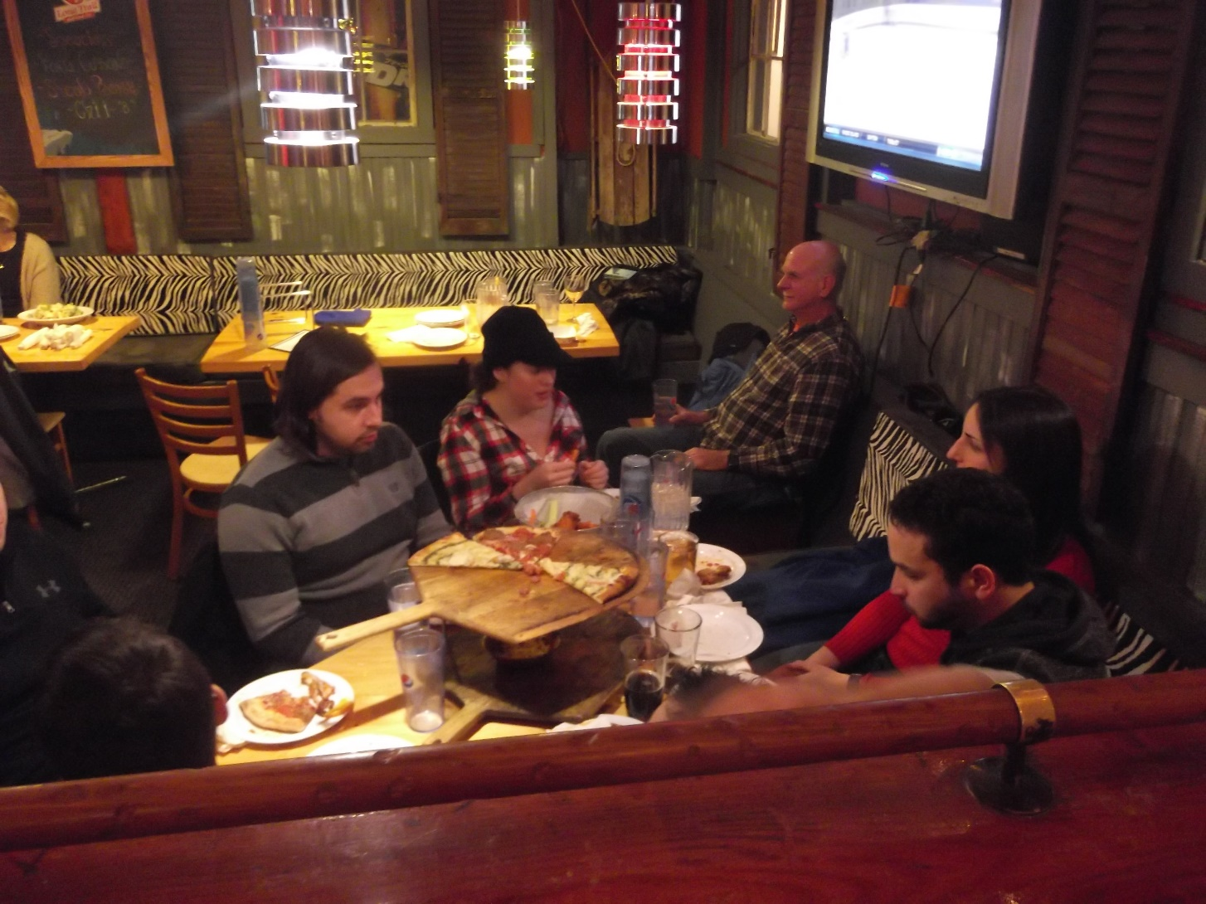

The remaining days of the trip plowed on in much the same fashion. We enjoyed cold but largely clear days with scattered clouds and occasional flurries, and generally good conditions on the slopes -- being sandwiched between two holiday weekends the mountain stayed relatively low-traffic even through the weekend (typical 10:30 AM Saturday rush hour at the K1 Gondola aside), or at least seemed so due to the high number of trails open and options available. A few of us were even able to take in the lunchtime views from the K1 summit lodge, a rarity since they opened it a few years ago as long-distance visibility is often limited from the summit.
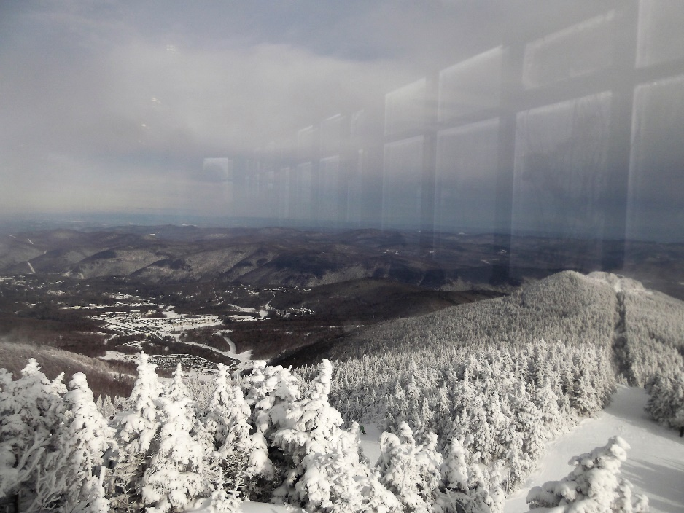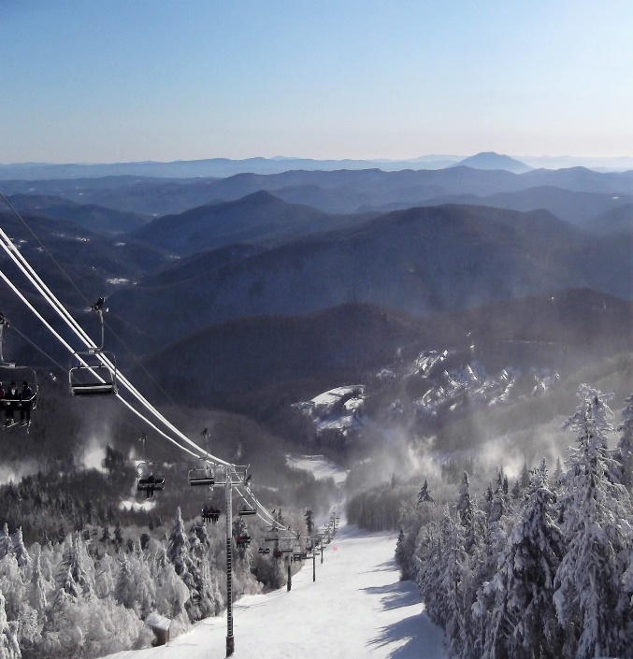
Saturday night a good portion of the group had dinner together at local standby The Wobbly Barn (something that’s becoming a bit of an annual tradition in and of itself), and every night it was easy to find attendees lazing together in KML’s fire-pit-equipped outdoor hot tub area or playing pool, giant Jenga, and other games in the lounge. All-in-all it was probably the best series of days we’ve had on this trip to date, and we can’t wait to get everyone back next year!
