Mt. Snow VT Trip February 24th – March 1st, 2013
The Mt Snow Trip was another success with 32 participants including 4 children, 5 young adults and 23 adults. Of these, there was a mix of first timers and regulars who all had a good time. On a base of about 3 feet Mt. Snow received about an inch to two the 1st night we were there and then snowed Wed a foot to a foot & ½ depending where on the mountain you checked. The conditions were all good; started packed powder w/sun to the same w/clouds to snow/deep snow. Temperatures stayed in a good ski zone with some wind on Wednesday and overall we had good conditions. Our stay at the Mountaineer Lodge featured good food, a large hot tub, a warm atmosphere and of course a couple+ wine & cheese parties with some new and old friends. This affordable trip has always delivered good skiing and is a particularly good value for families. Now for the pictures which I hope participants send me more:
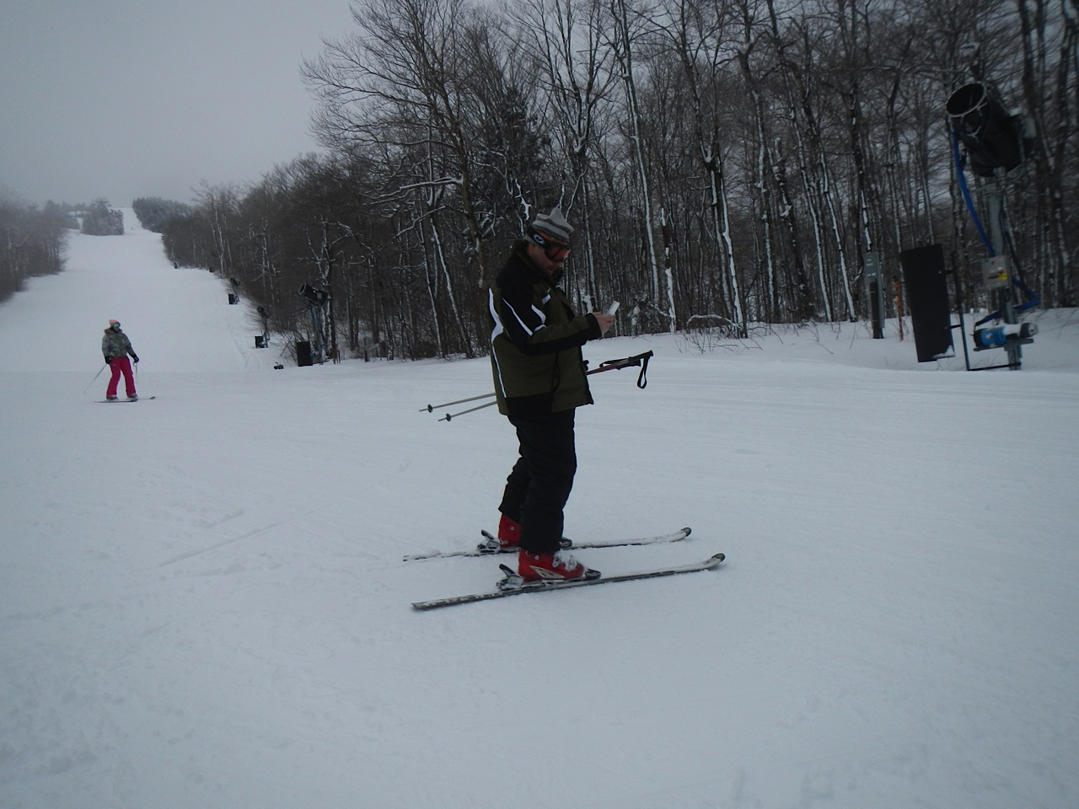
Checking the trail map.
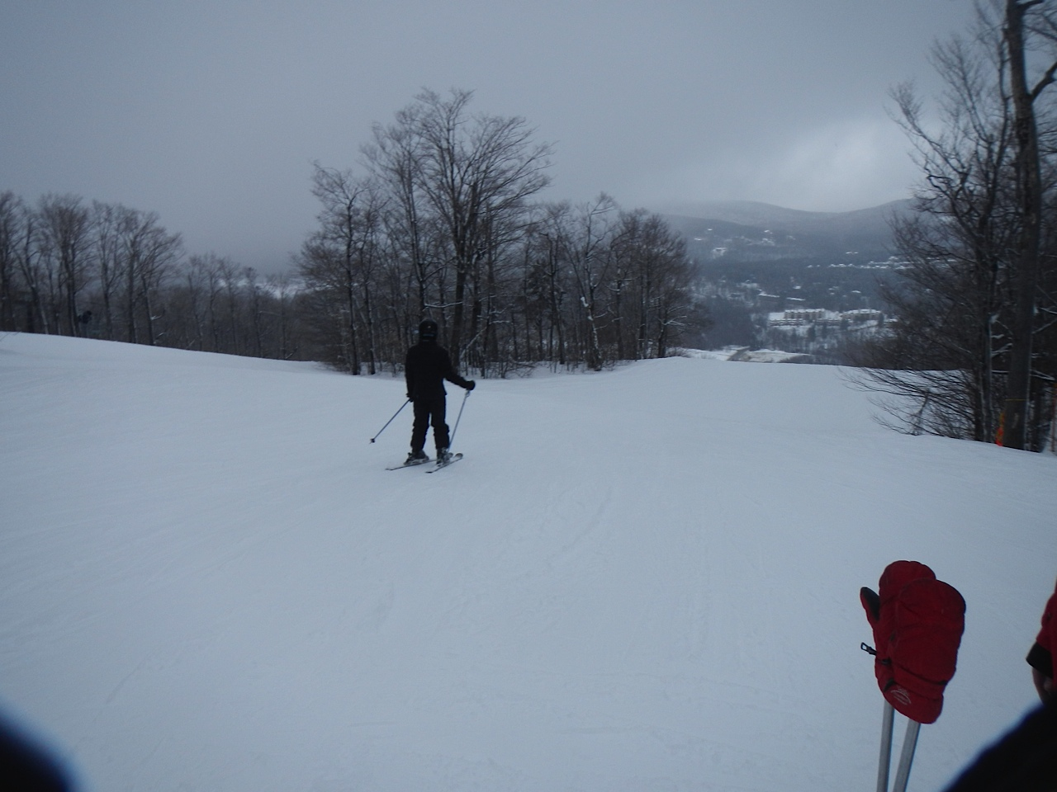
A little overcast
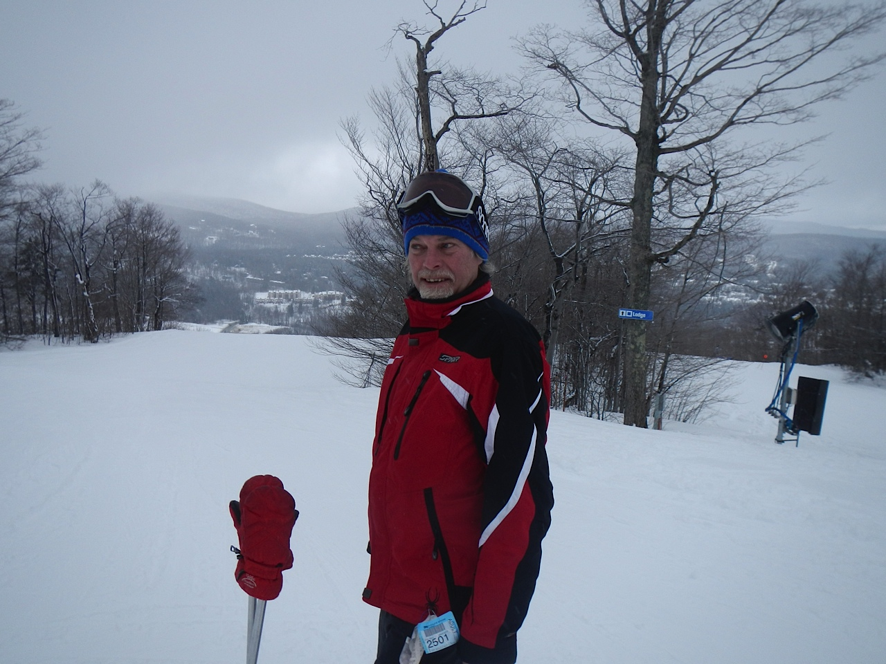
Do you hear that?
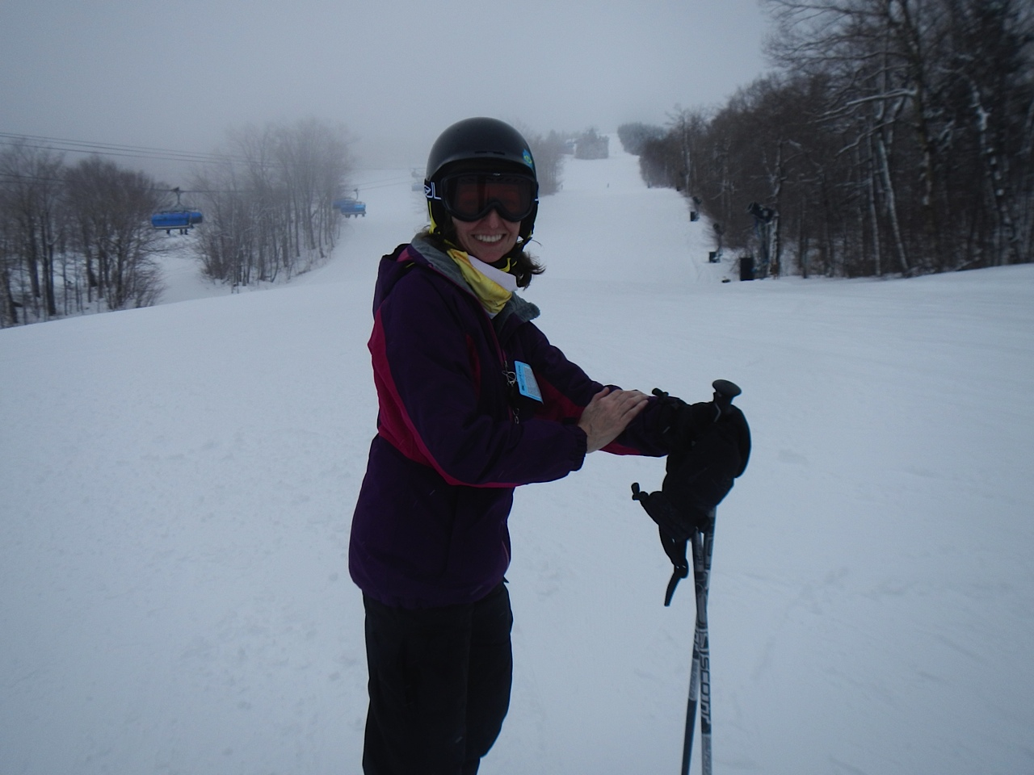
Susan happy to be out here!

I had a great time & hope you did too.

This trip report can still be modified. If you’ve got some good pics you’d like to include, PLEASE send them to me with a caption.
Remember next year’s trip will be the same week so be sure to plan on it and another great time. And remember to RSVP early to get a room at the Mountaineer.
Ski ya, Mike

