Mt. Snow VT Trip February 23rd – 28th, 2014
The Mt Snow Trip was another success with 36 participants including 1 child. Of these, there was a mix of first timers and regulars who all had a good time. On a base of about 3 feet Mt. Snow received snow just about every day we were there; once for a straight 24 hours. Six inches one day eight another… The conditions were ok to good. Temperatures stayed colder than past years but that’s better than hot. Our stay at the Mountaineer Lodge featured good food, a large hot tub, a warm atmosphere and of course a couple+ wine & cheese parties with some new and old friends. The three young-guns (Chris Brad and Trevor) tried their luck at the Thursday Night Snow Barn Raffle, and cleaned house! They could barely carry back all of their new gear!!
This affordable trip has always delivered good skiing and is a particularly good value for families. Now for the pictures which I hope participants send me more:
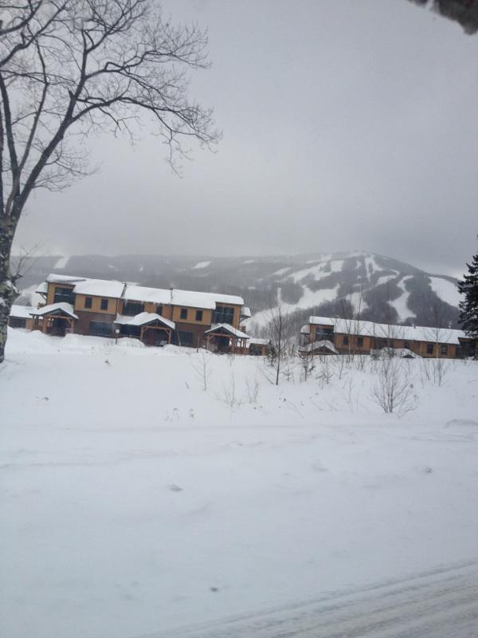
A shot from the Moover.
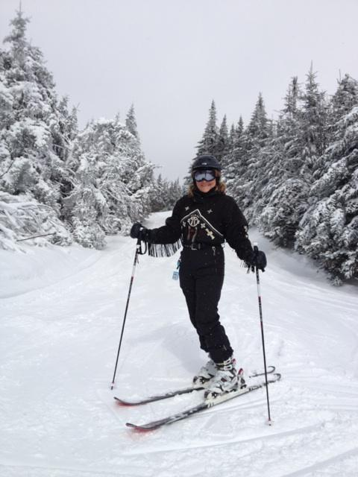
Sharon on the slopes.
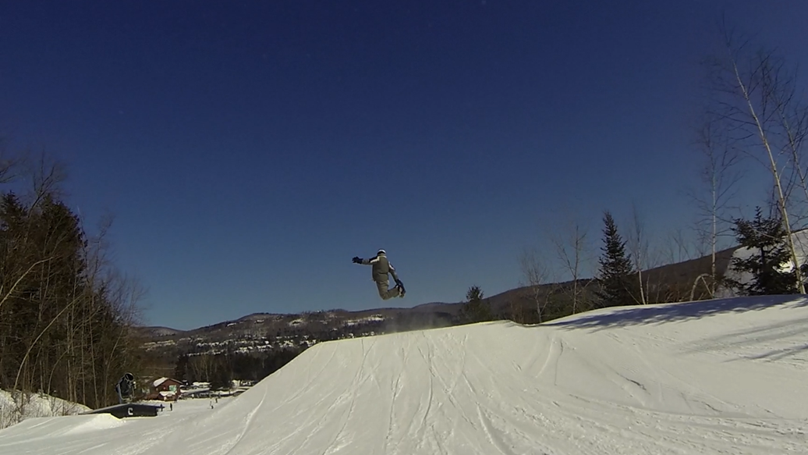
Jim in the air.

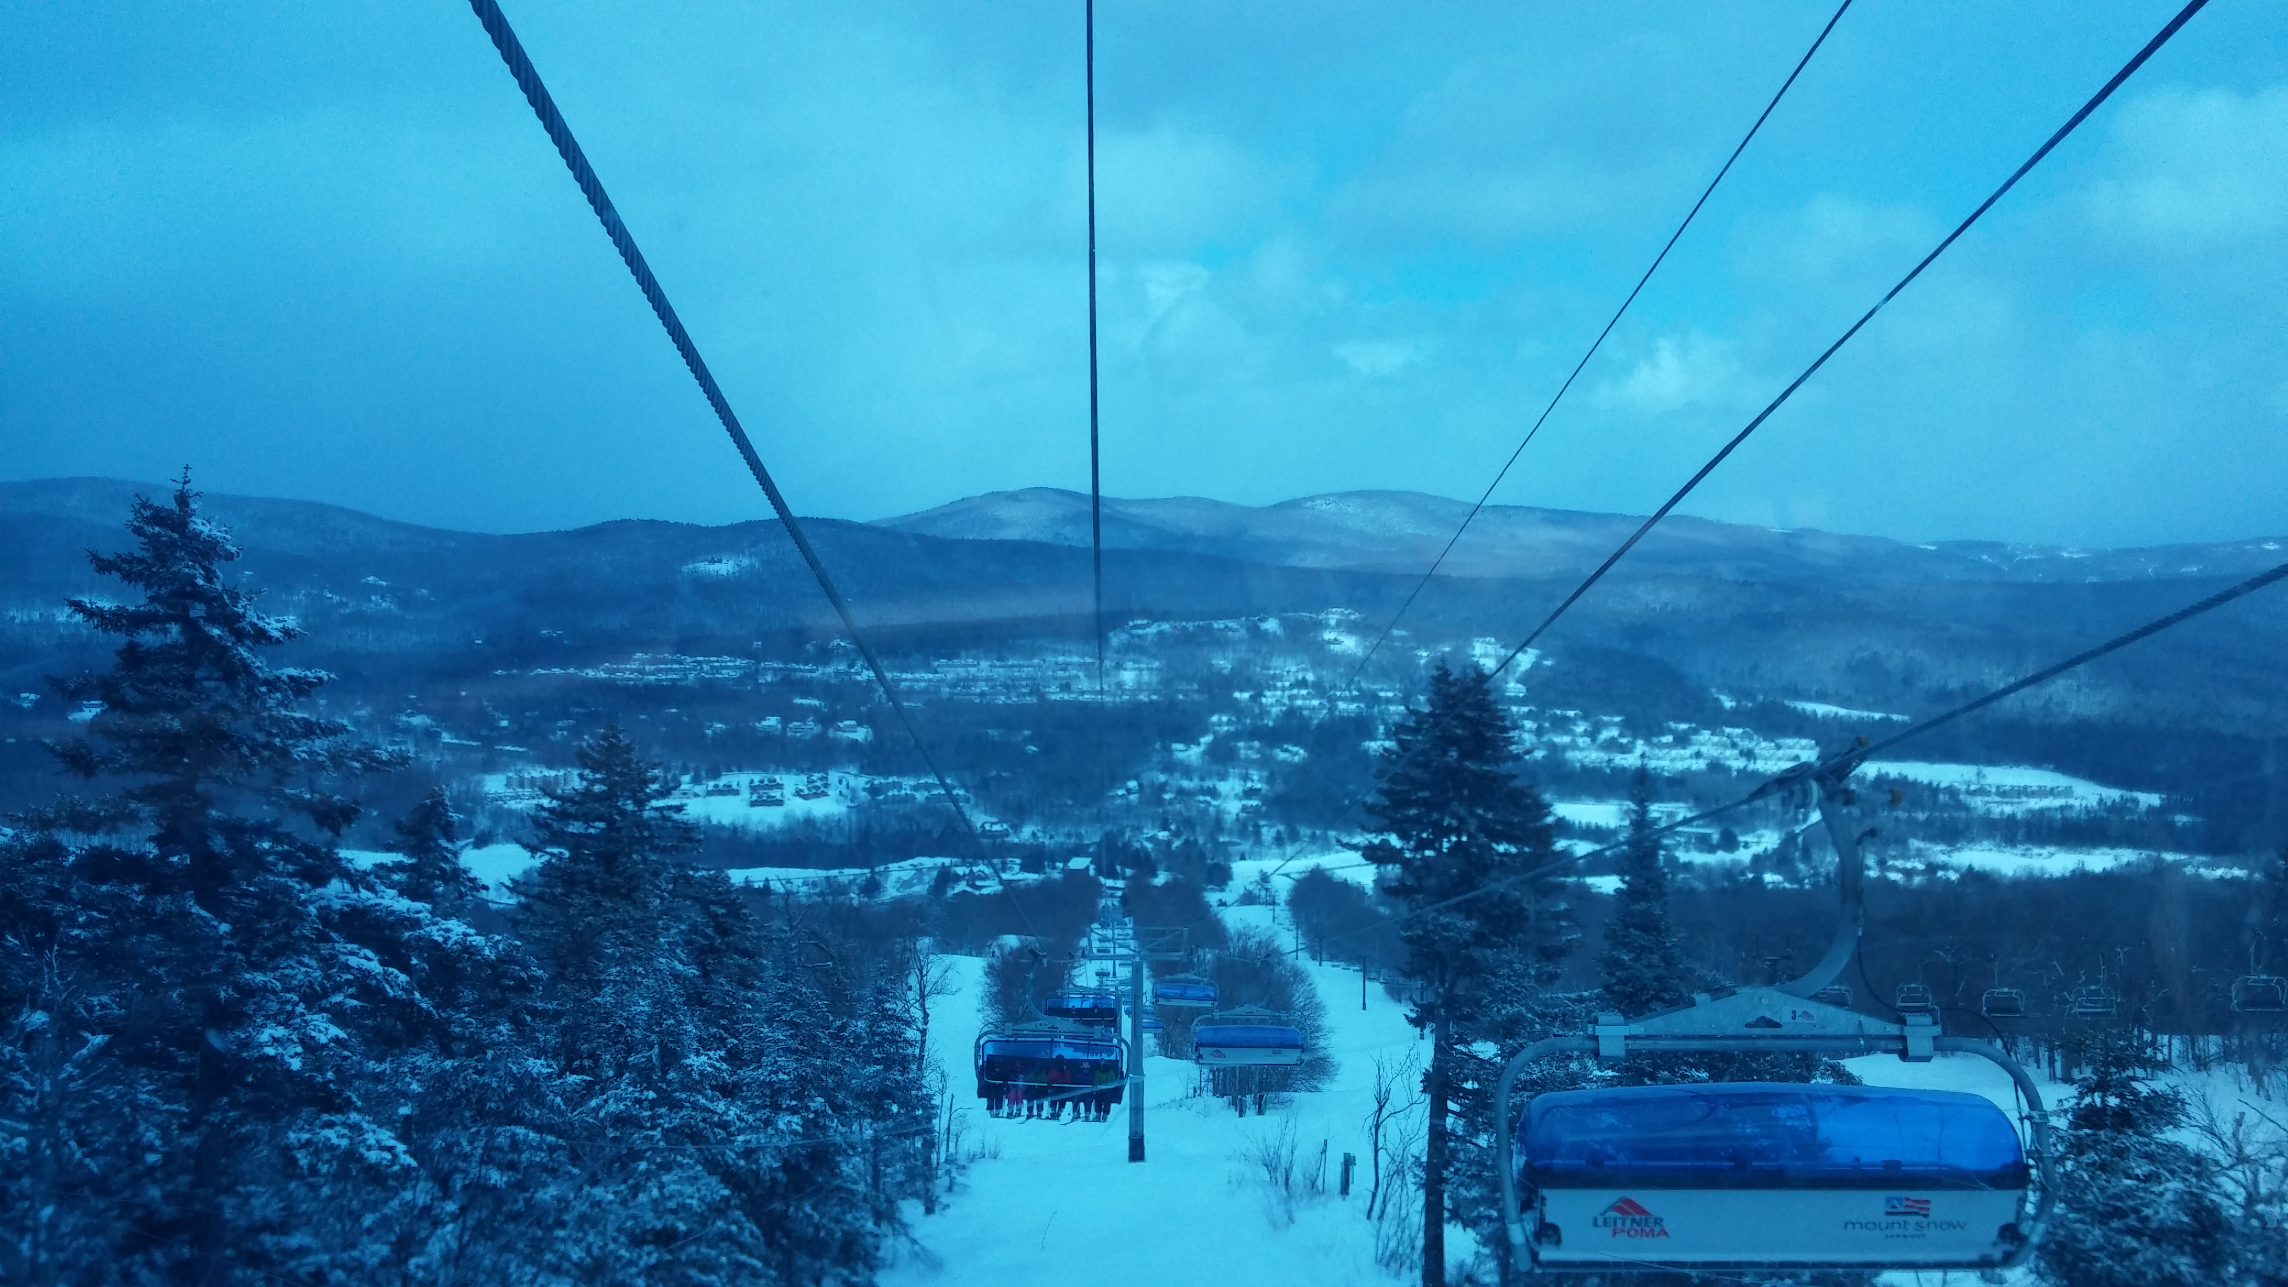
A shot from the bubble chair.
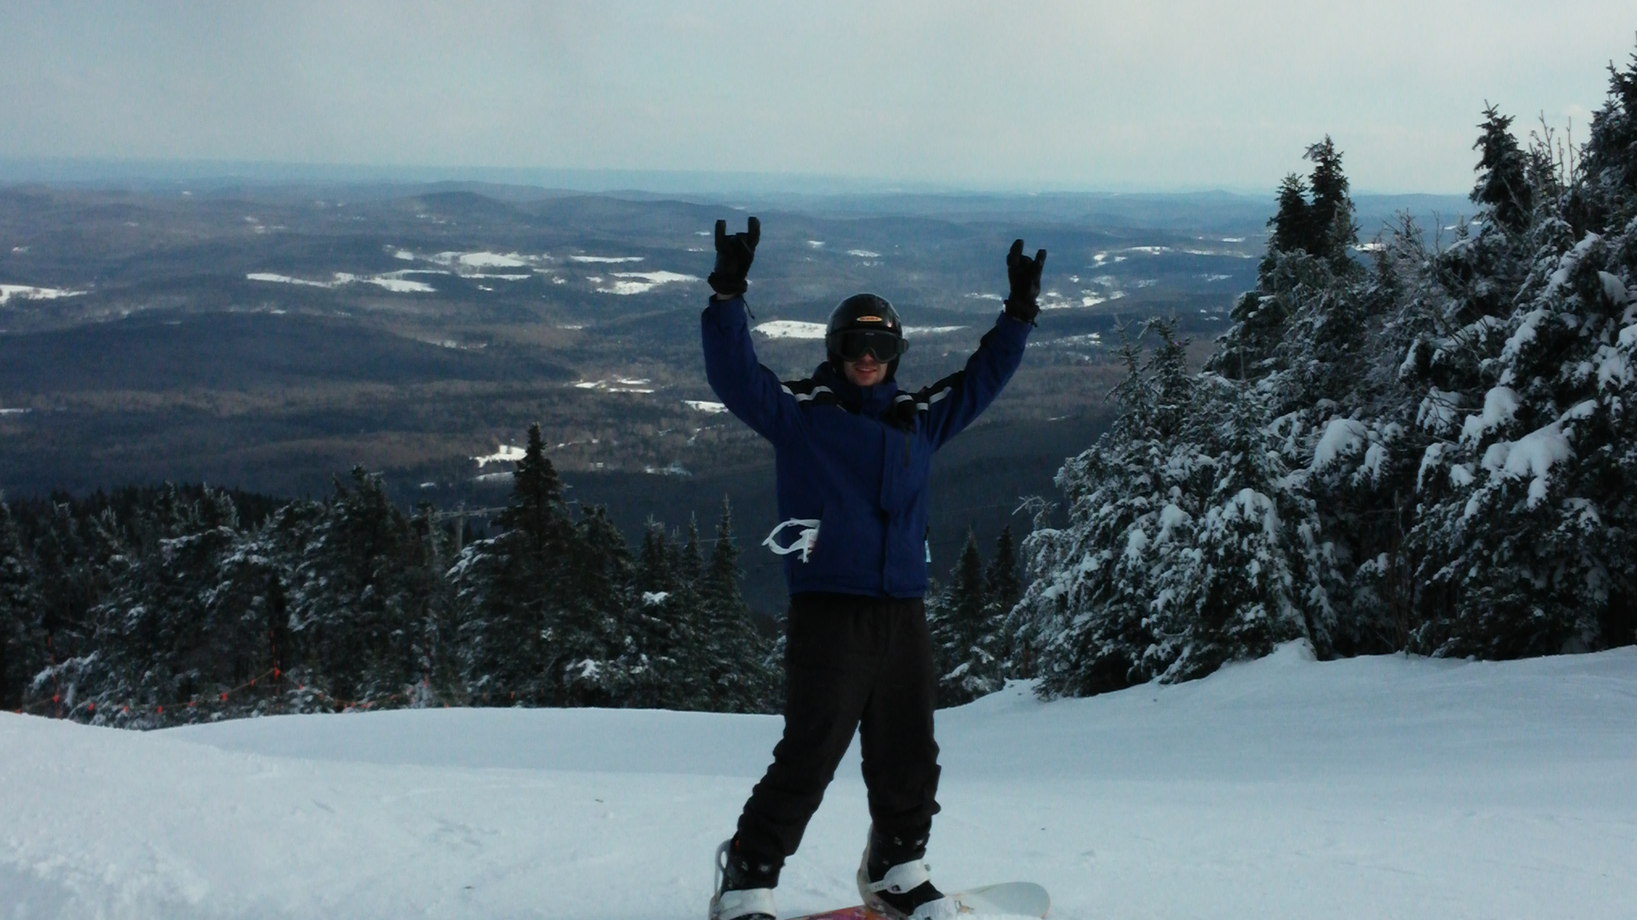
Nice shot from the top.
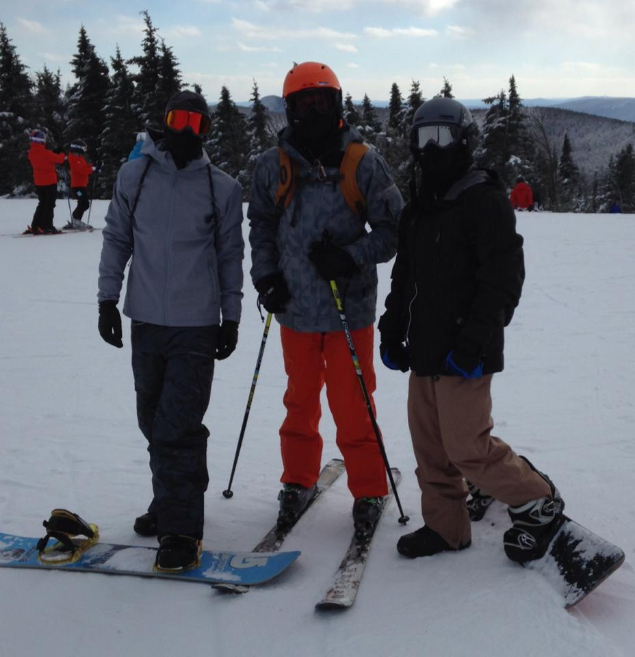
Trevor, Chris & Brad ready to go.
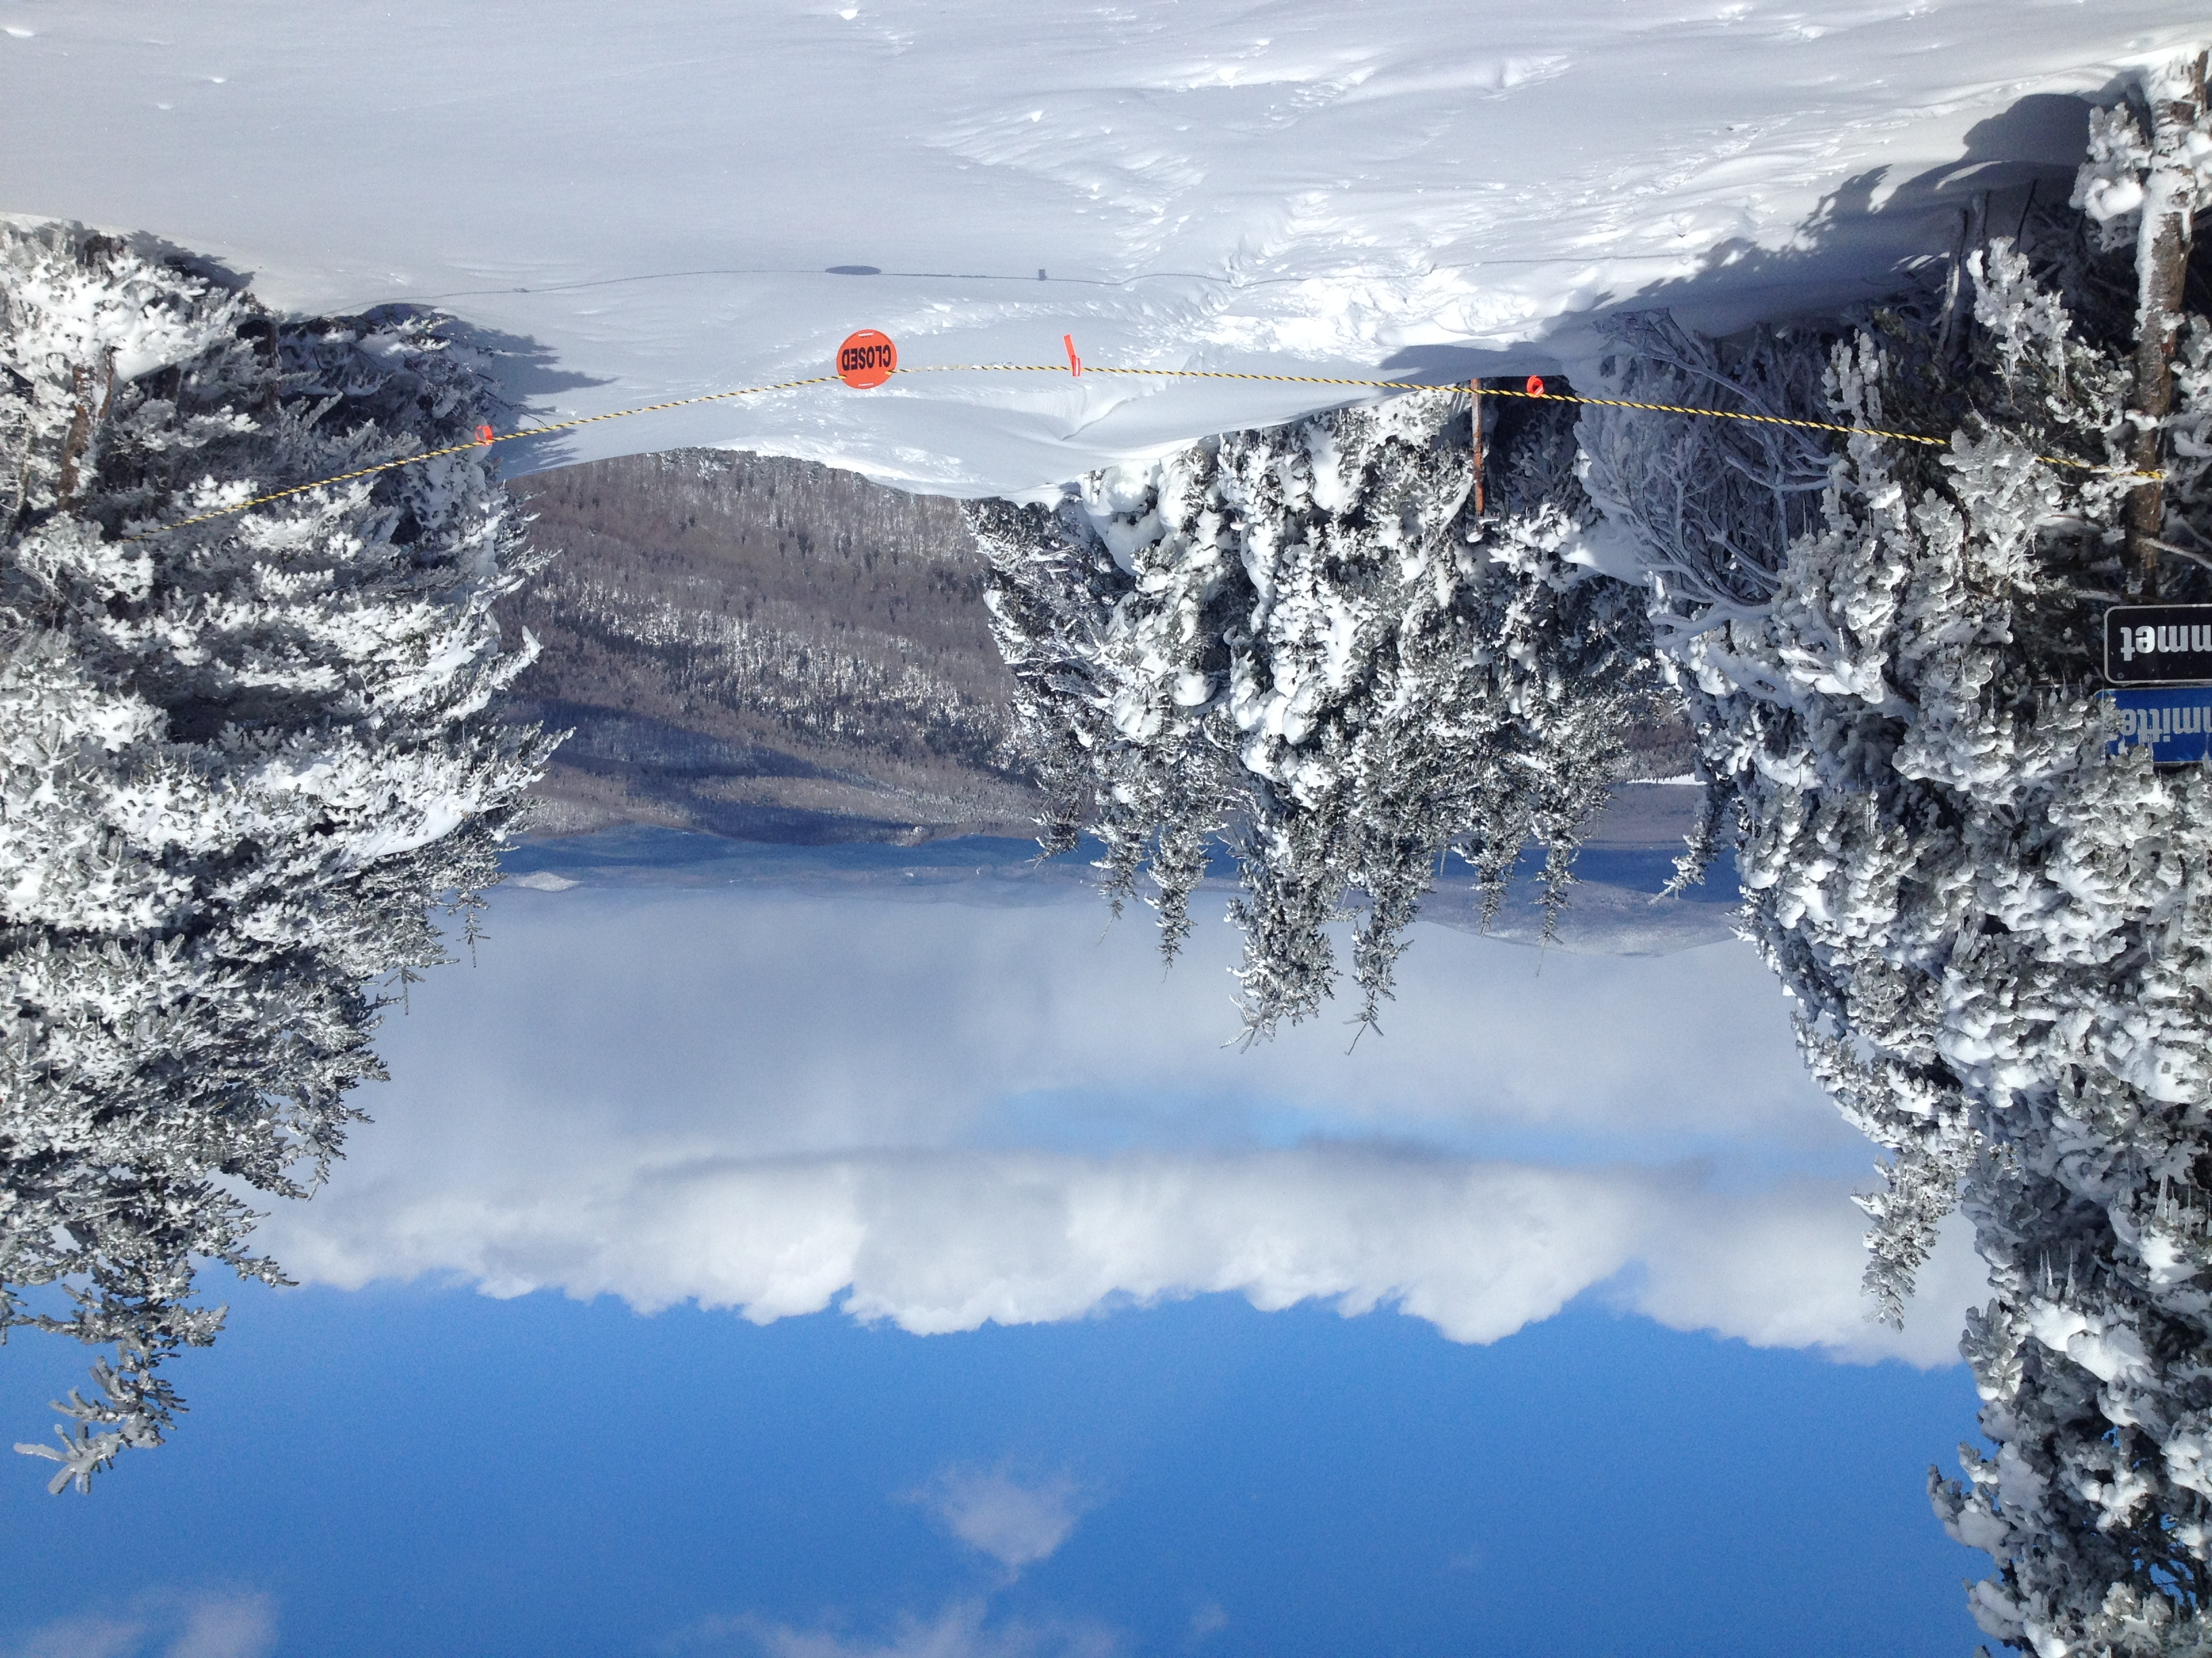
After a 24 hour snow.
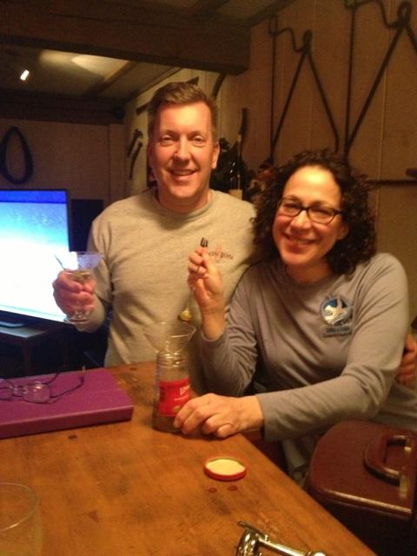
Martini time w/ Rob & Linda.
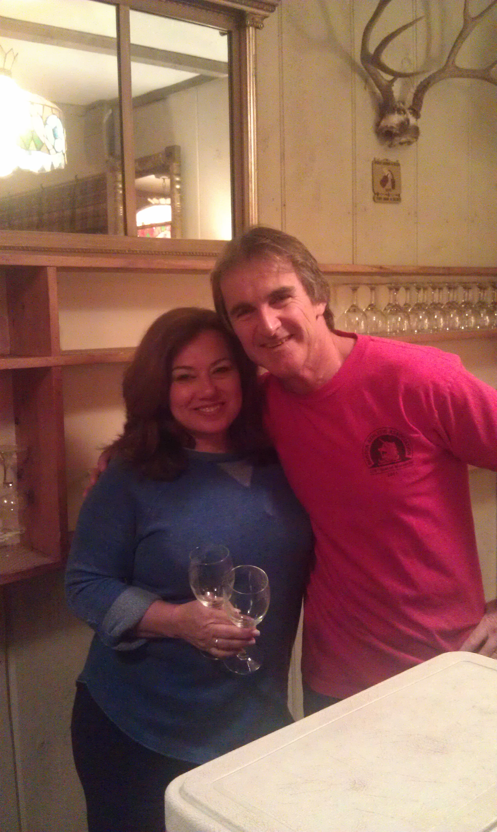
Wine & cheese w/ Carol & Tom.
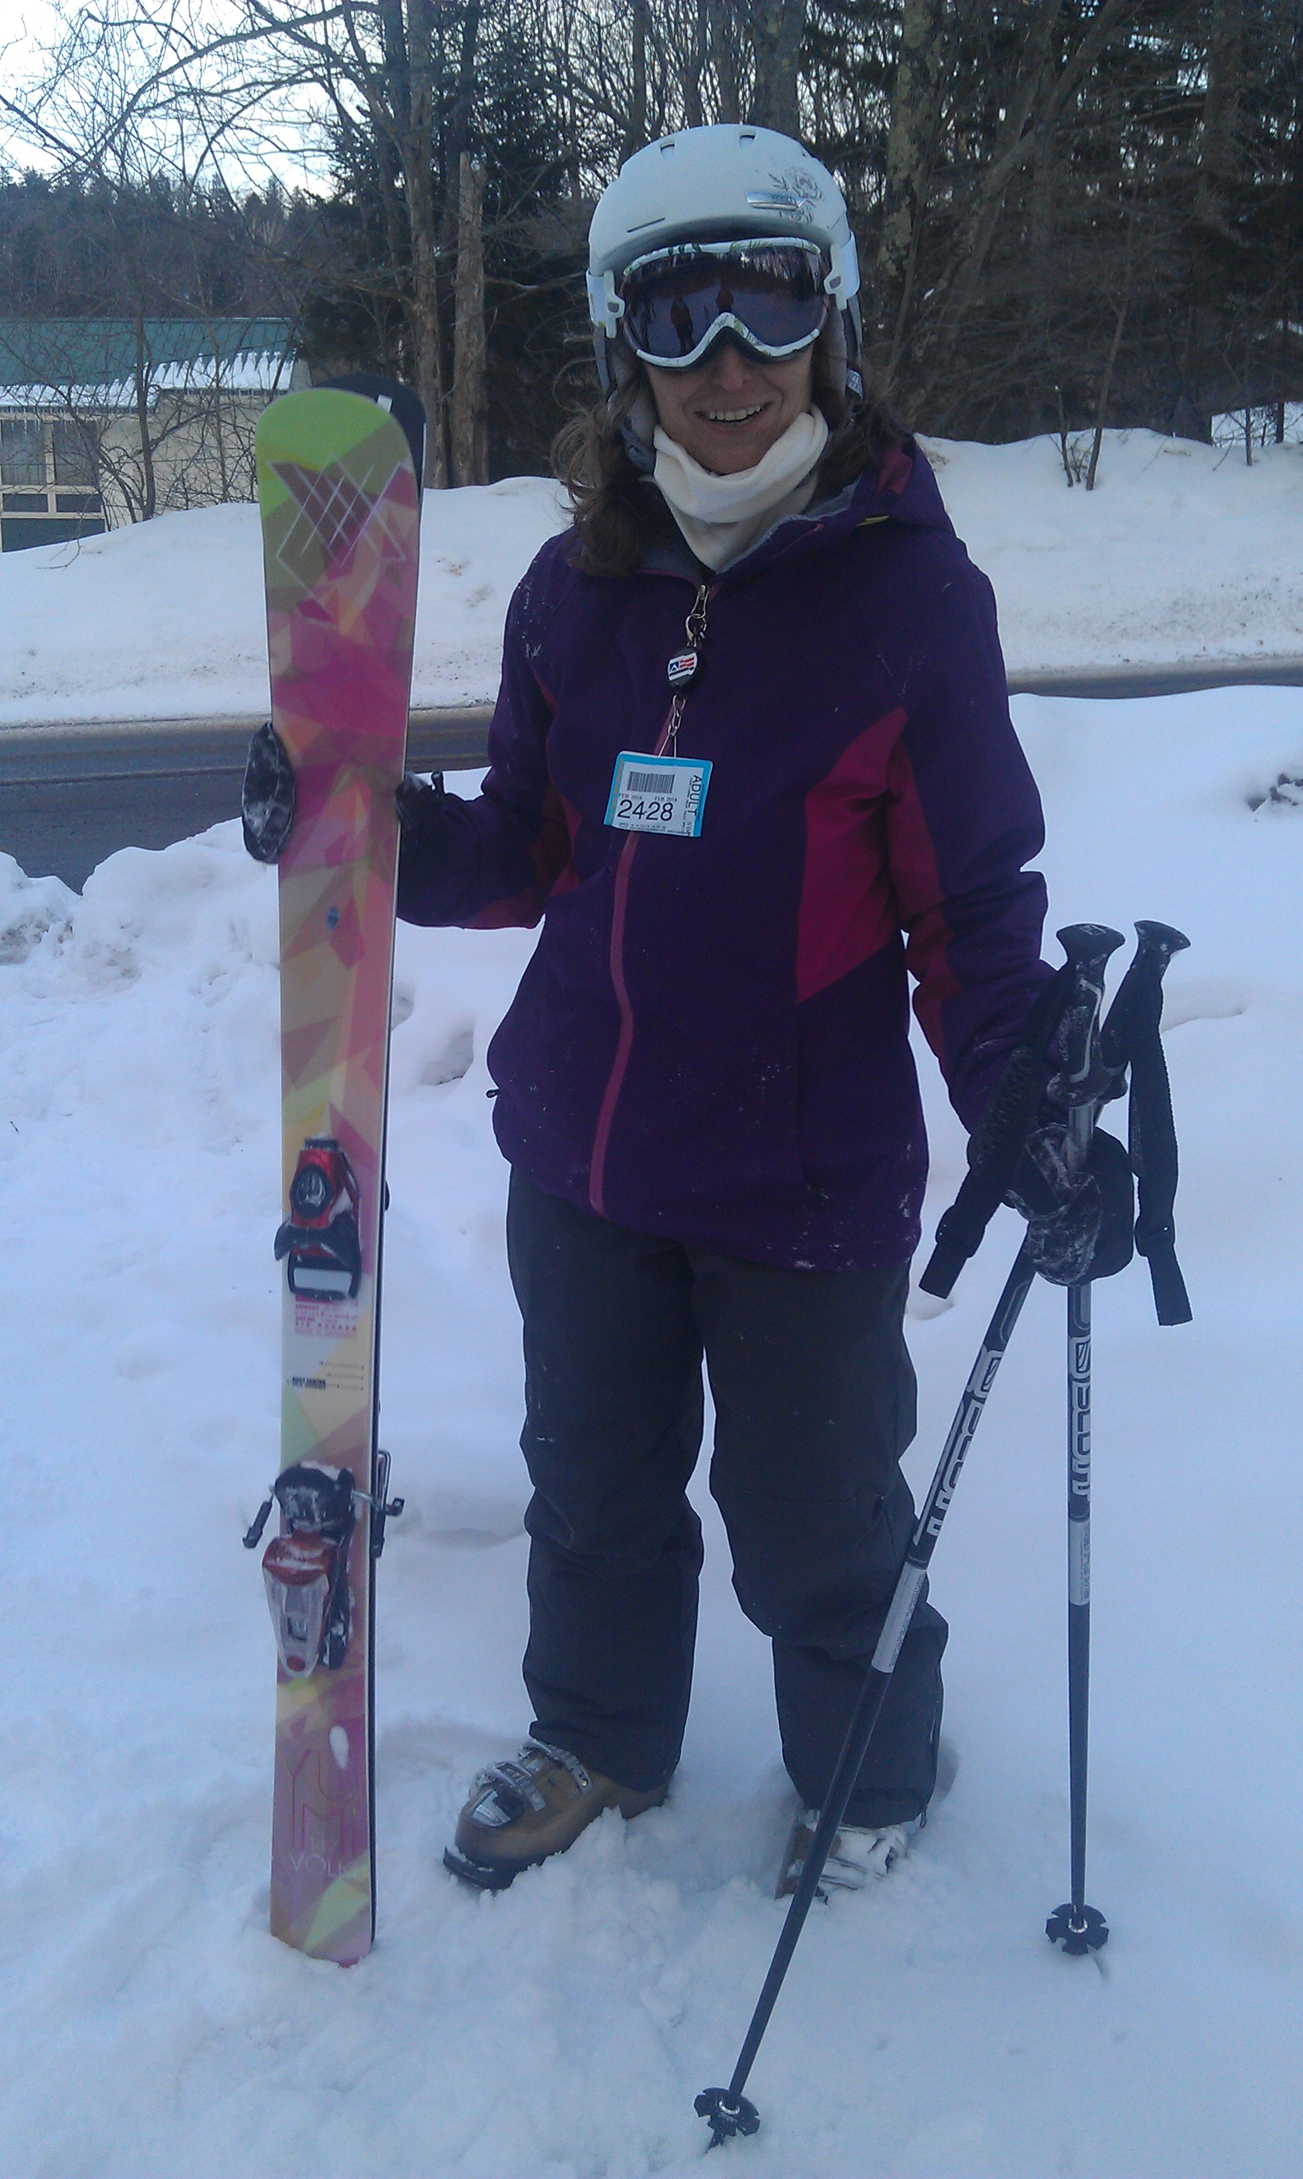
Susan’s new skis. Yes, pink is fine!
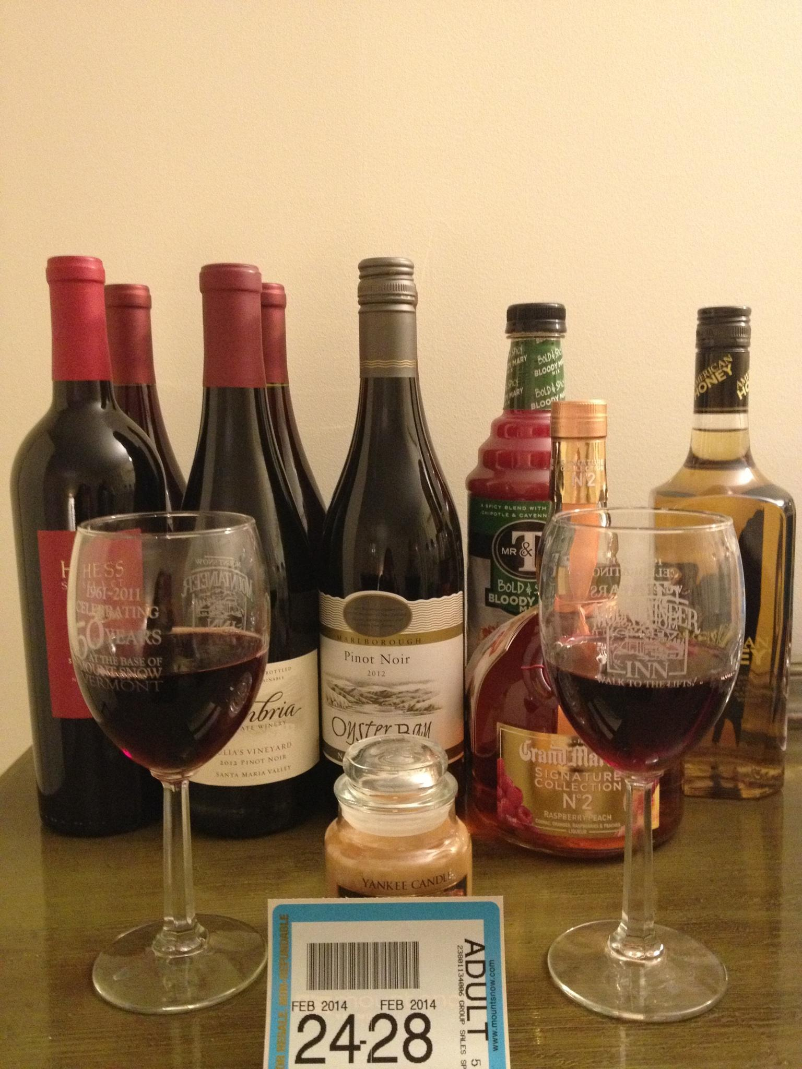
A well-stocked skier’s room.
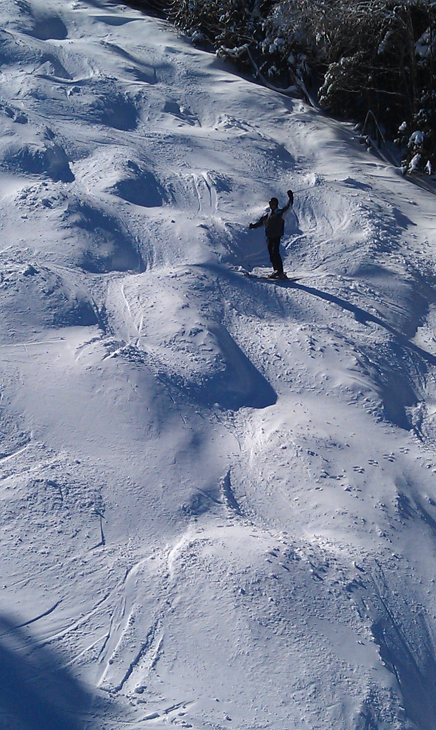
Tom on the bumps; taken from the lift.
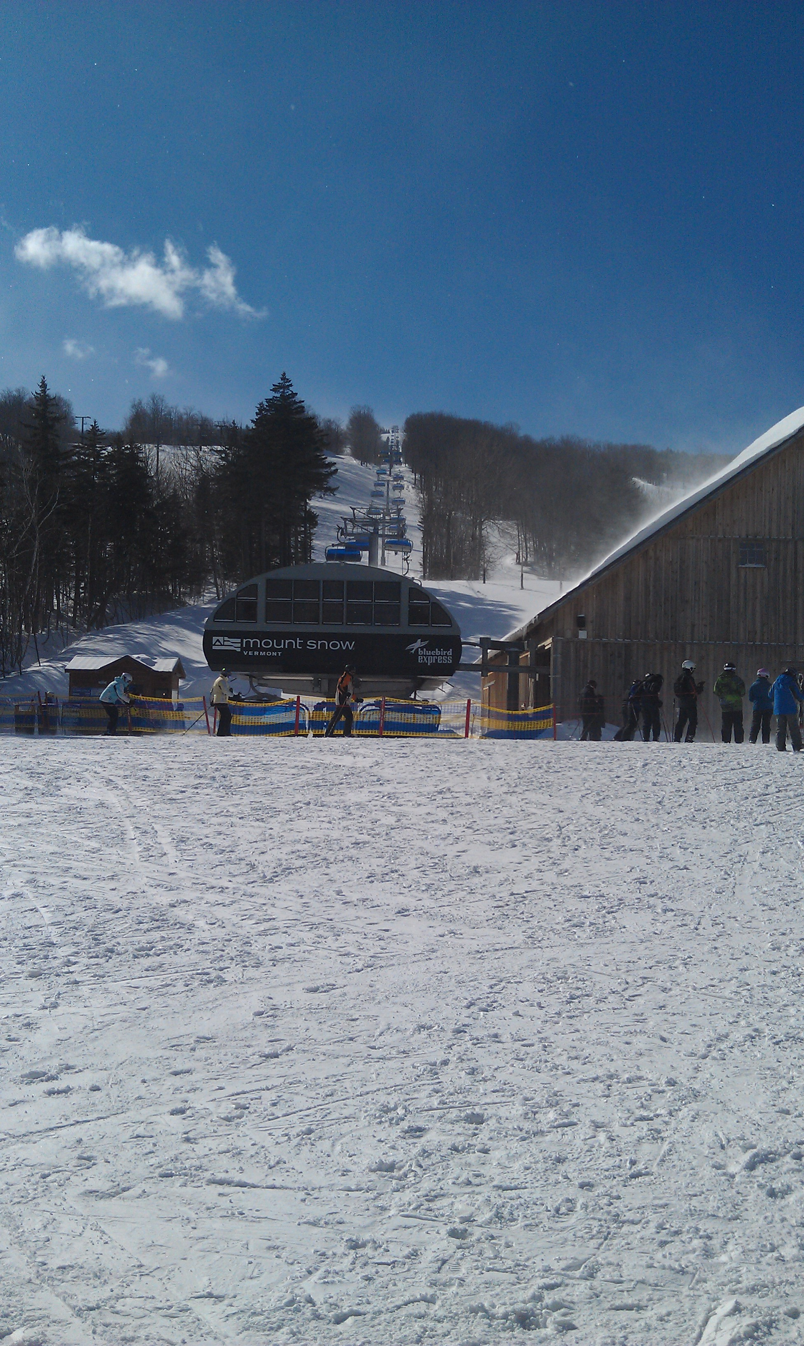
Bubble chair lift from the base.

Mike & Sharon @ the base lodge/bar.
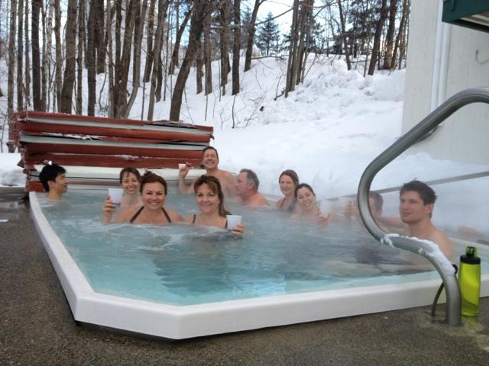
Everybody is relaxing after a great ski day!

I had a great time & hope you did too.

This trip report can still be modified. If you’ve got some good pics you’d like to include, PLEASE send them to me with a caption.
Remember next year’s trip will be the same week so be sure to plan on it and another great time. And remember to RSVP early to get a room at the Mountaineer.
Ski ya, Mike

