Mt. Snow VT Trip February 24th – March 1st, 2019
The Mt Snow Trip was a success with 29 participants. Of these, there was a mix of first timers and regulars who all had a good time. On a base of 24” to 32” the conditions varied. Rain then sleet was the Sunday road trip. Then it got very windy so Monday only a couple of low lifts were open so I did one & done. Tuesday not as windy but cold. Wednesday still pretty icy and started getting a little very light/fluffy snow. Thursday it warmed up some and conditions were very good; the 6”-8” from the night before helped. Friday it was perfect. Our stay at the Mountaineer Lodge featured good food, a large hot tub, a warm atmosphere and of course a couple+ wine & cheese parties with some new and old friends.
This affordable trip has always delivered good skiing and is a particularly good value for families. Now for the pictures which I hope participants send me more and/or any comments:
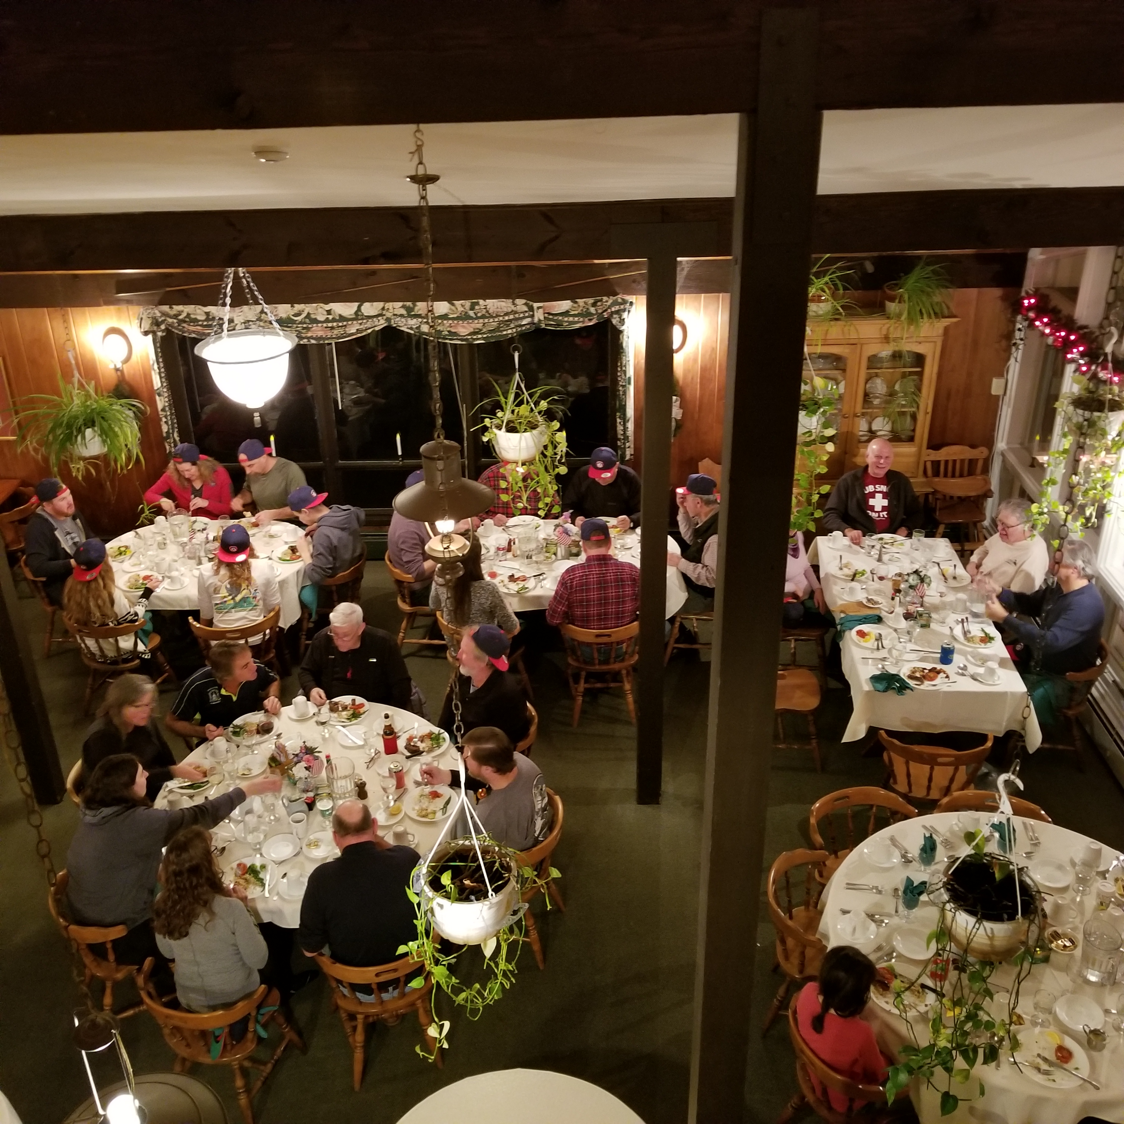
Picture of the group for dinner.
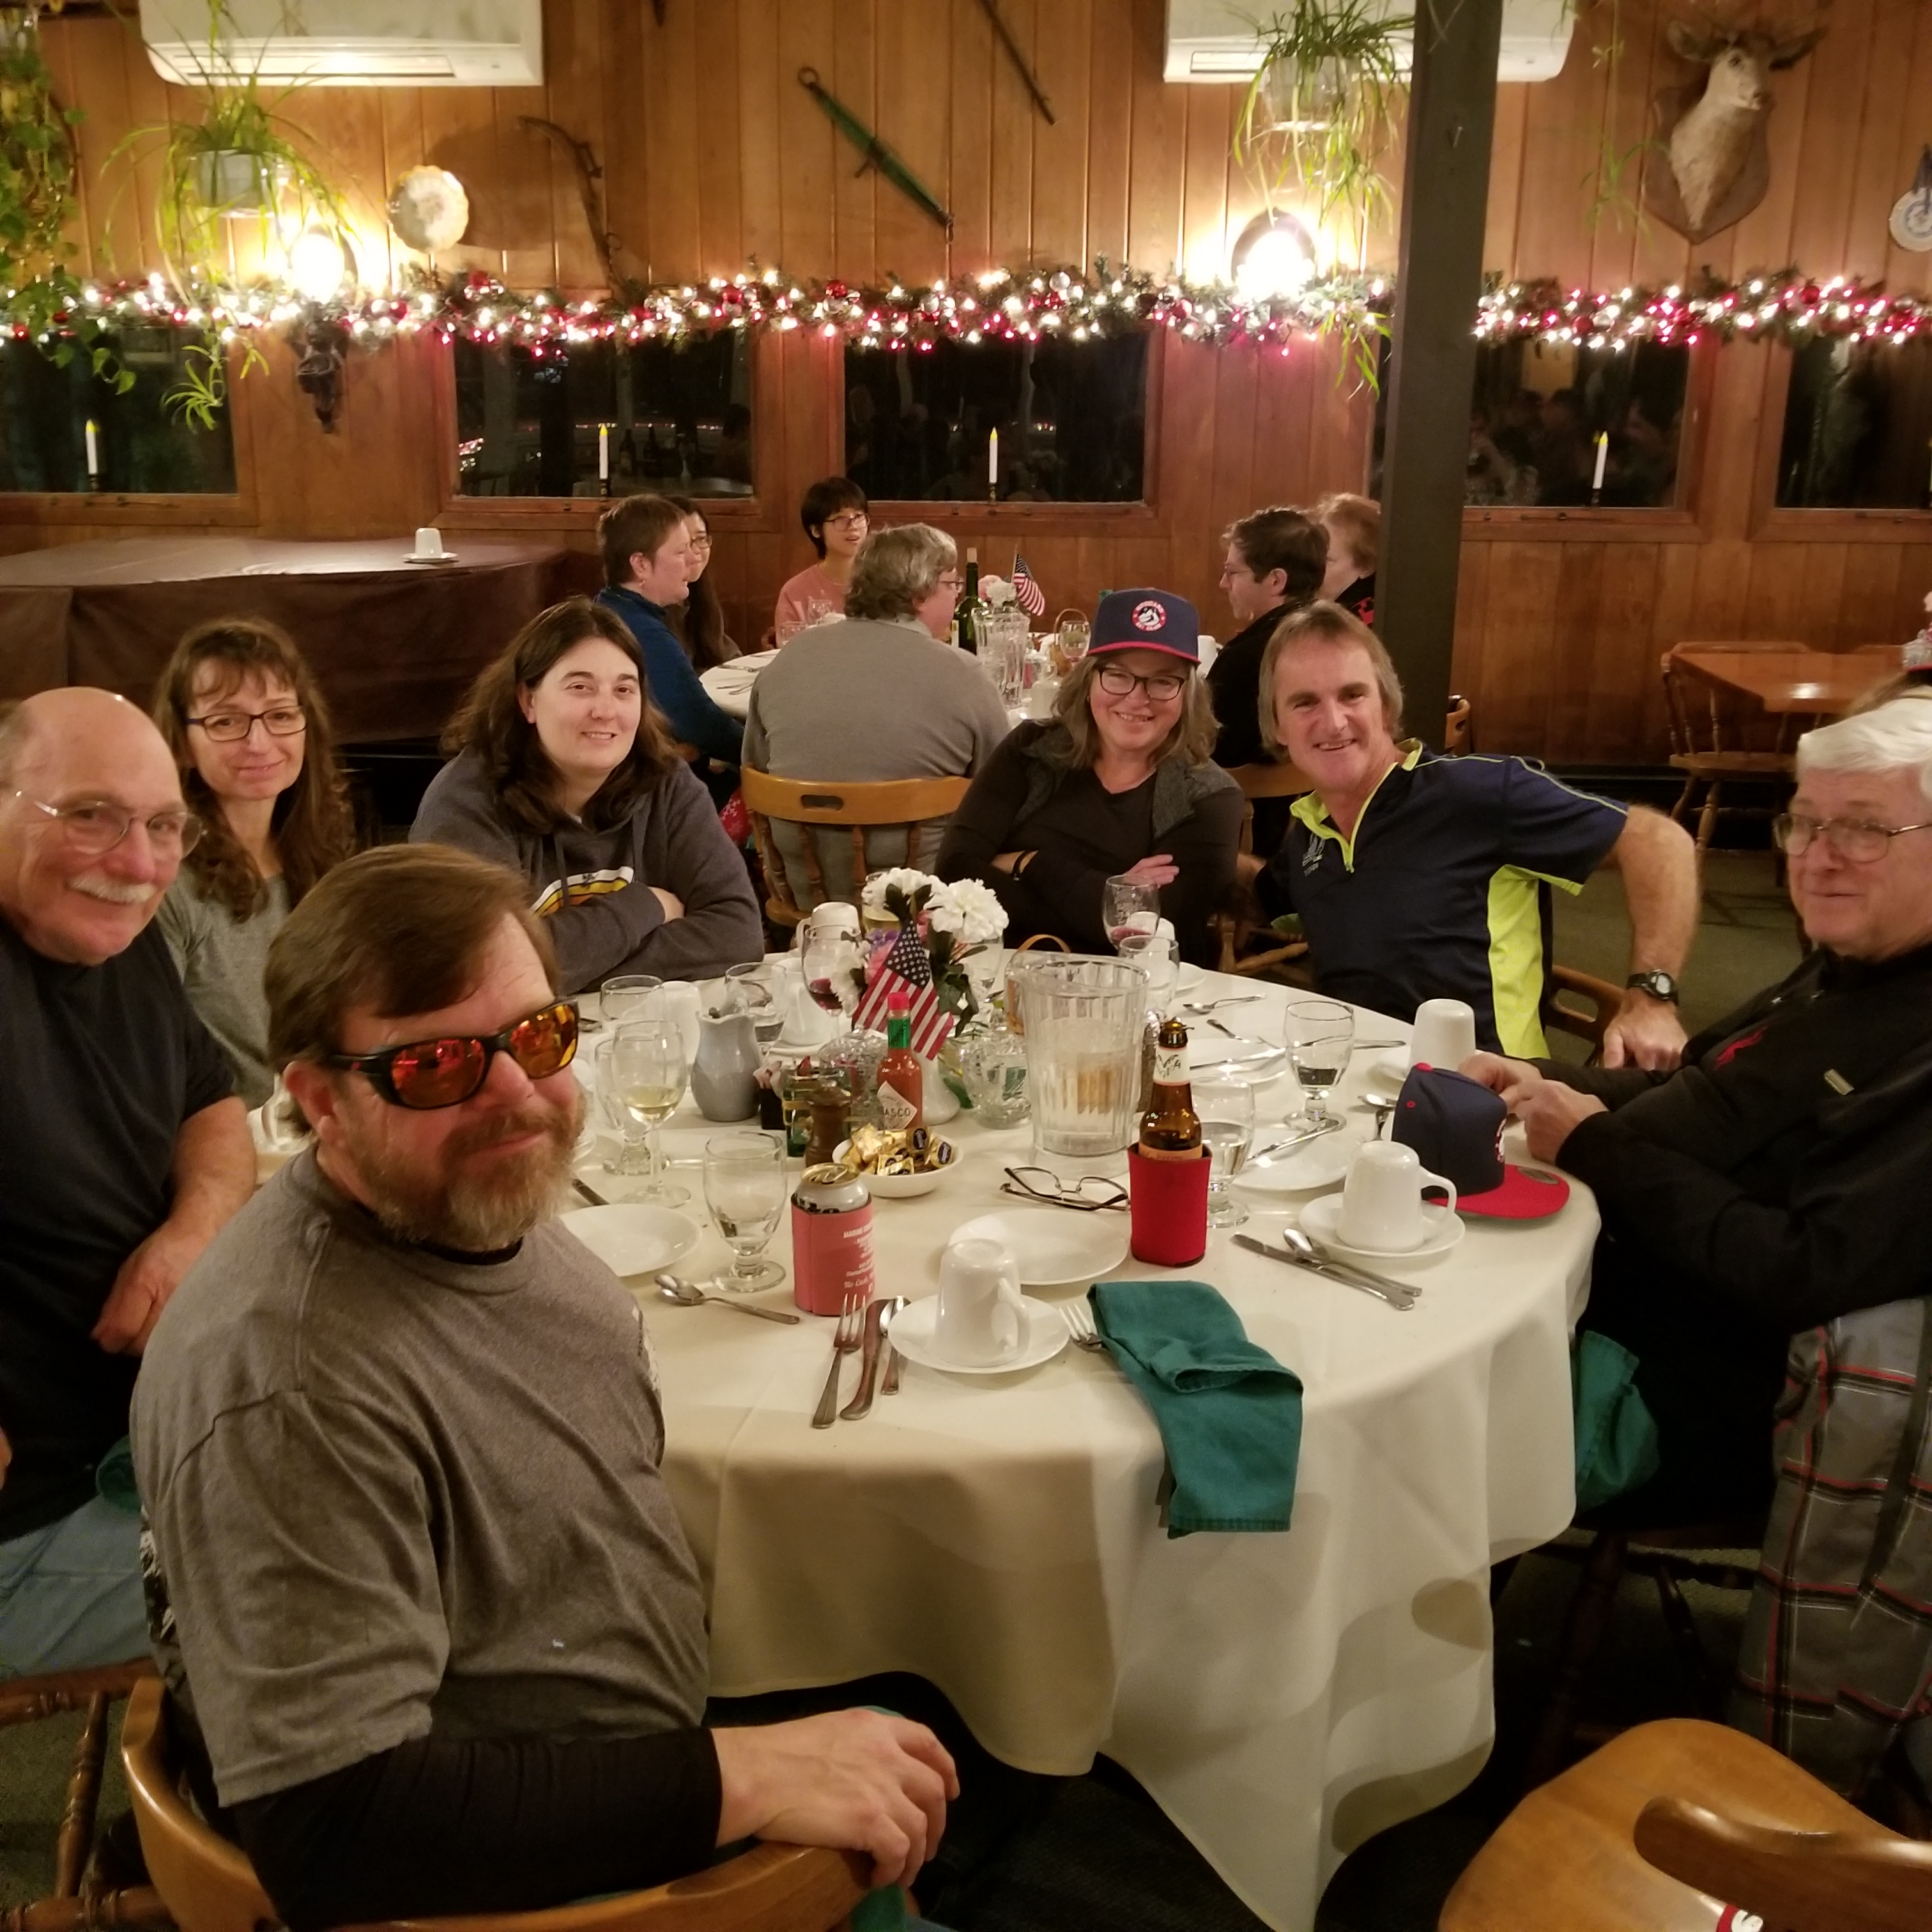
Dinner with Kevin, Floyd, Susan, Lauren, Marla, Tom & Danny.
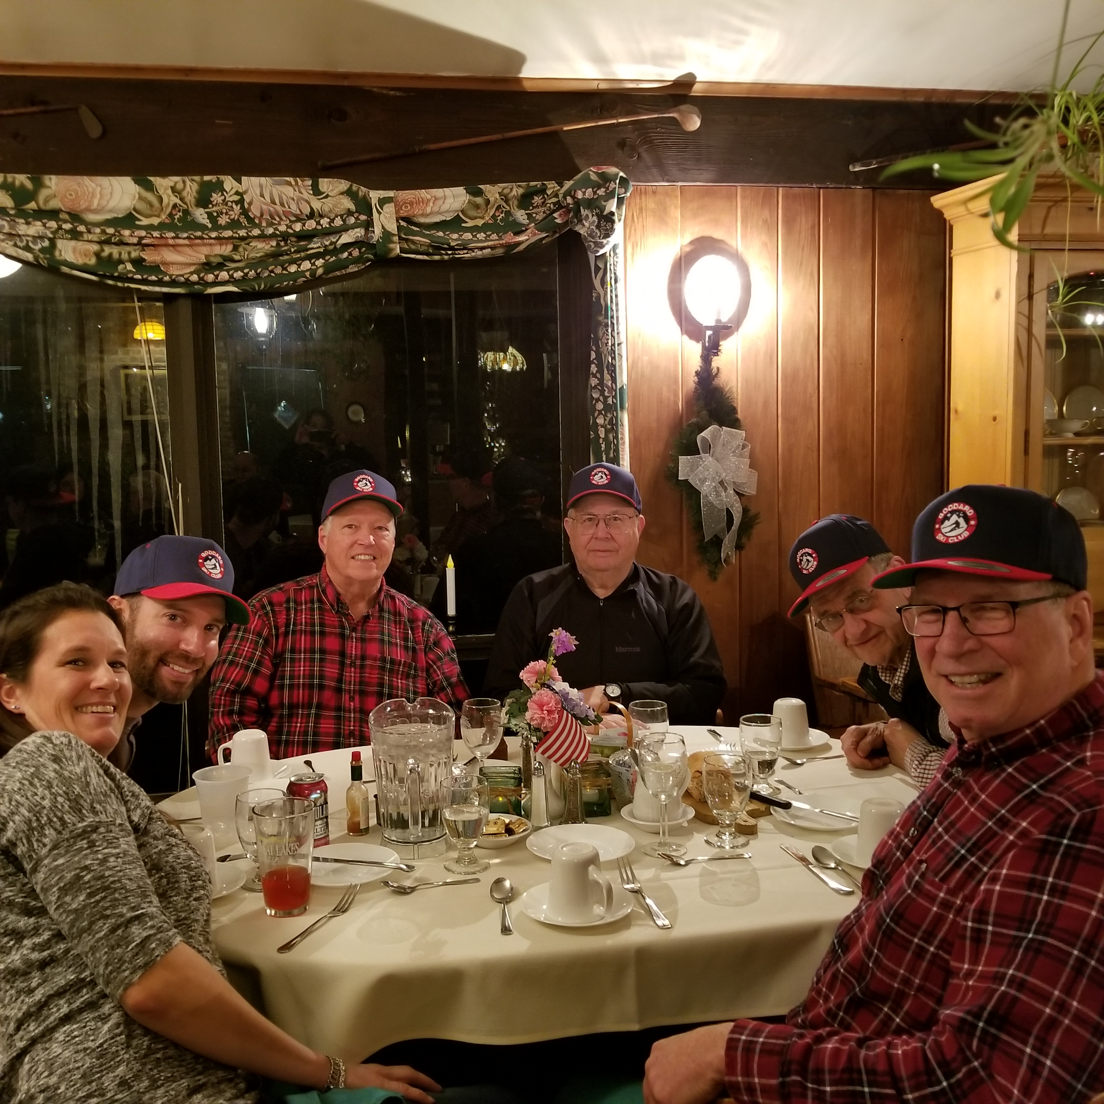
Jennifer, Bill, Mike, John, Tom & Don.
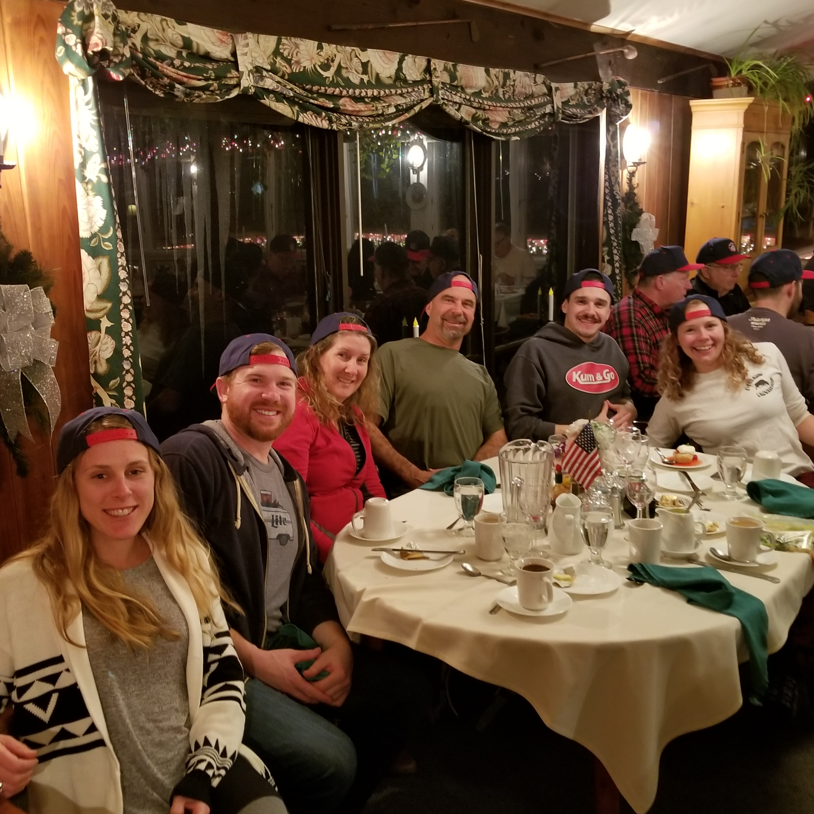
Erika, Chris, Candy, Jim, Andrew & Megan.
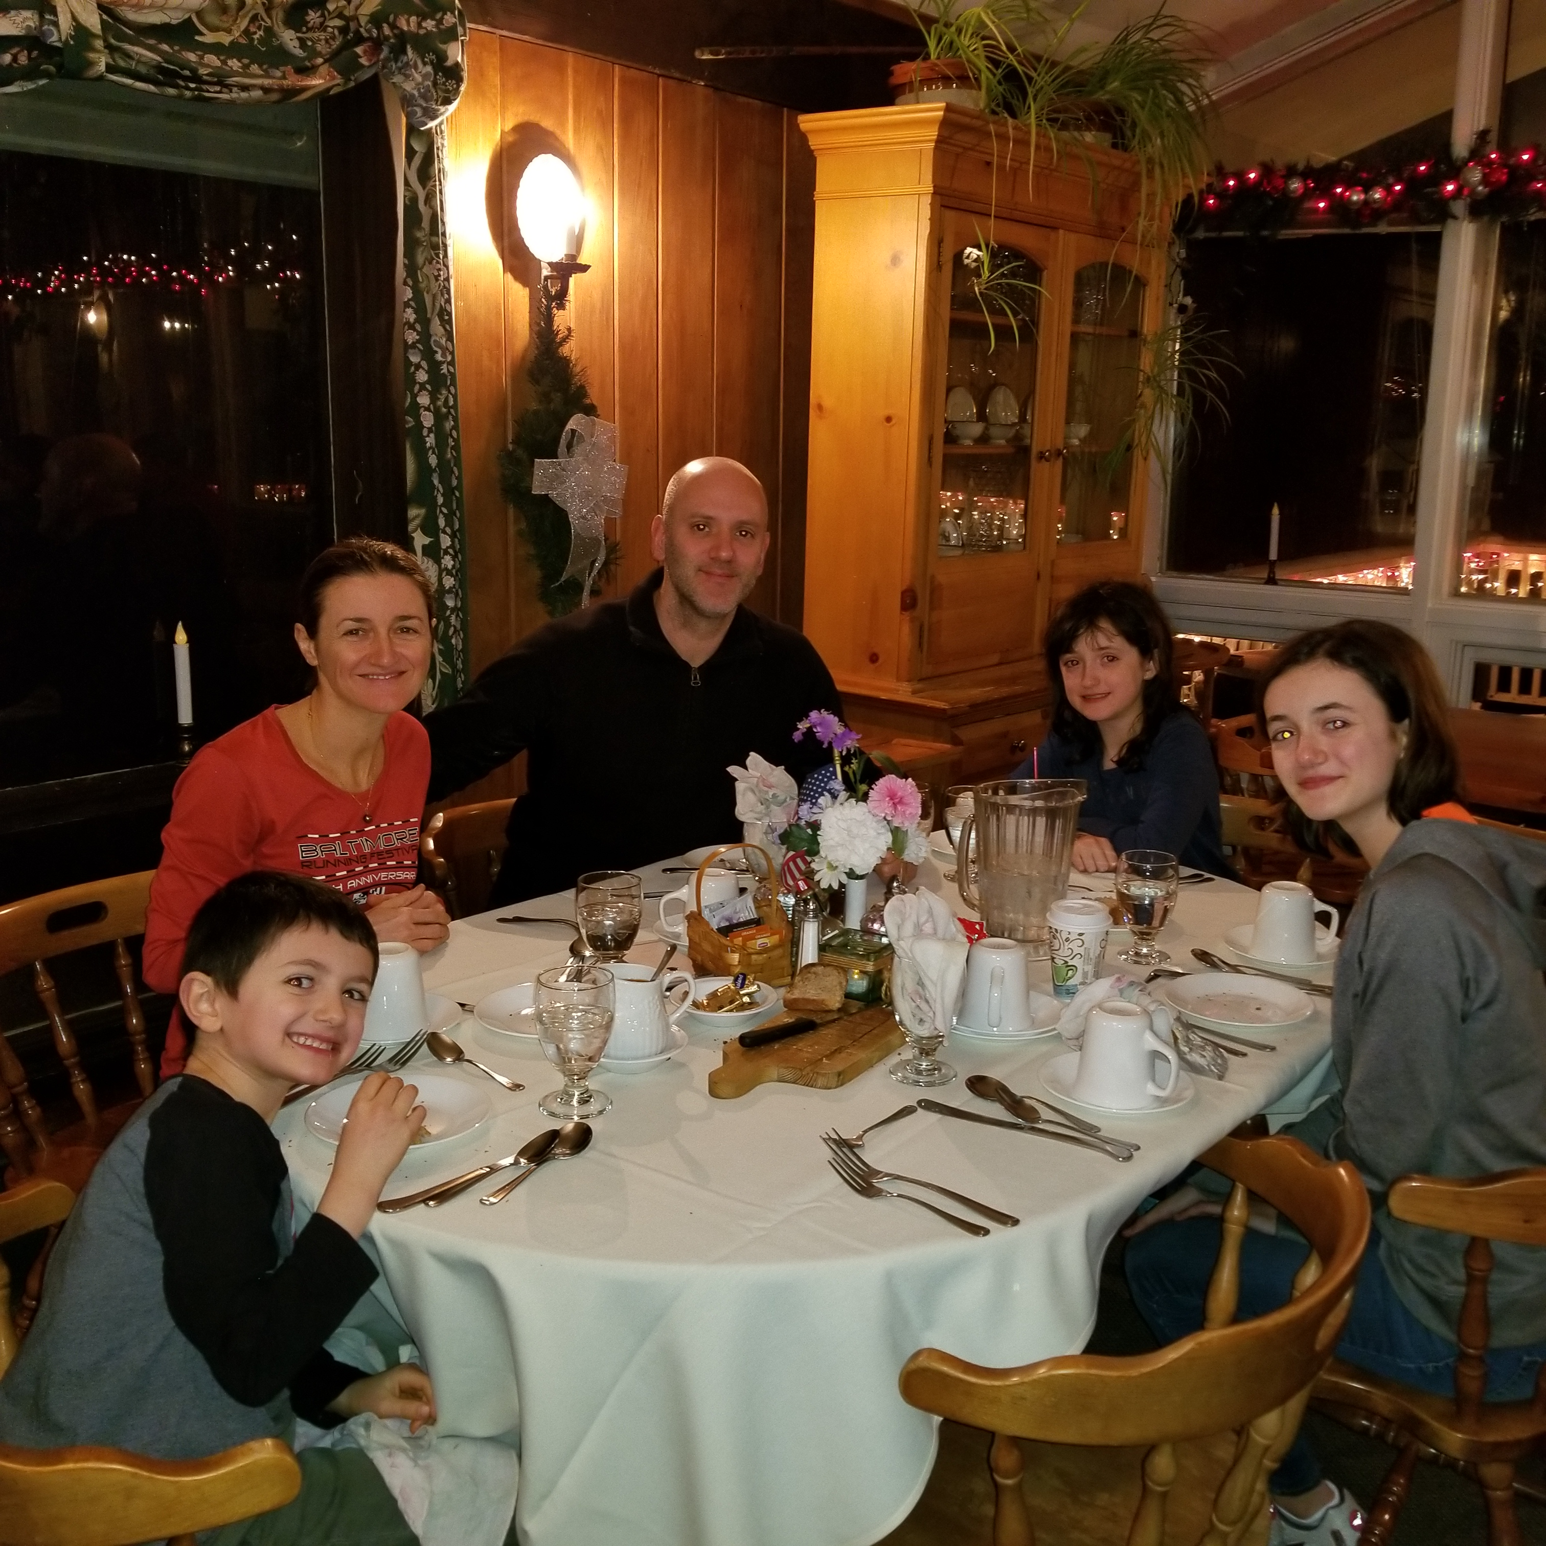
Lue, Laurie, Thomas, Juliette and Mila
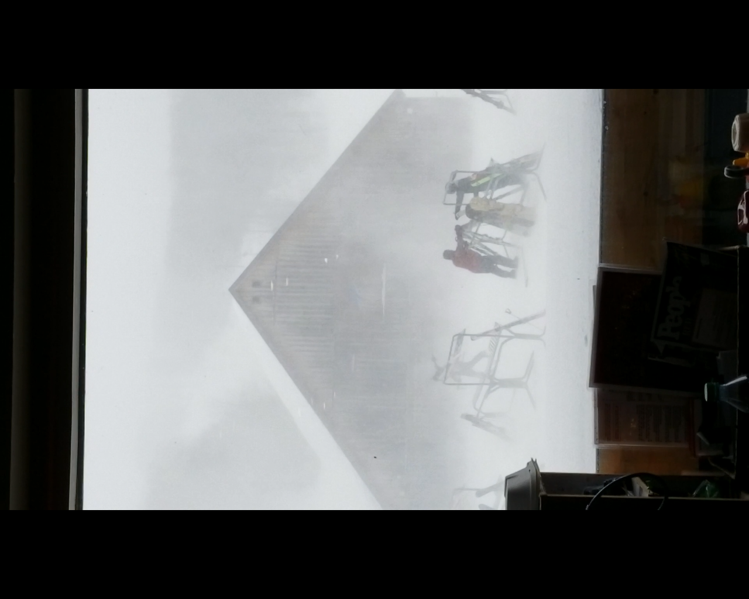
A shot Monday of the wind blowing snow around from inside Cuzzins restaurant.
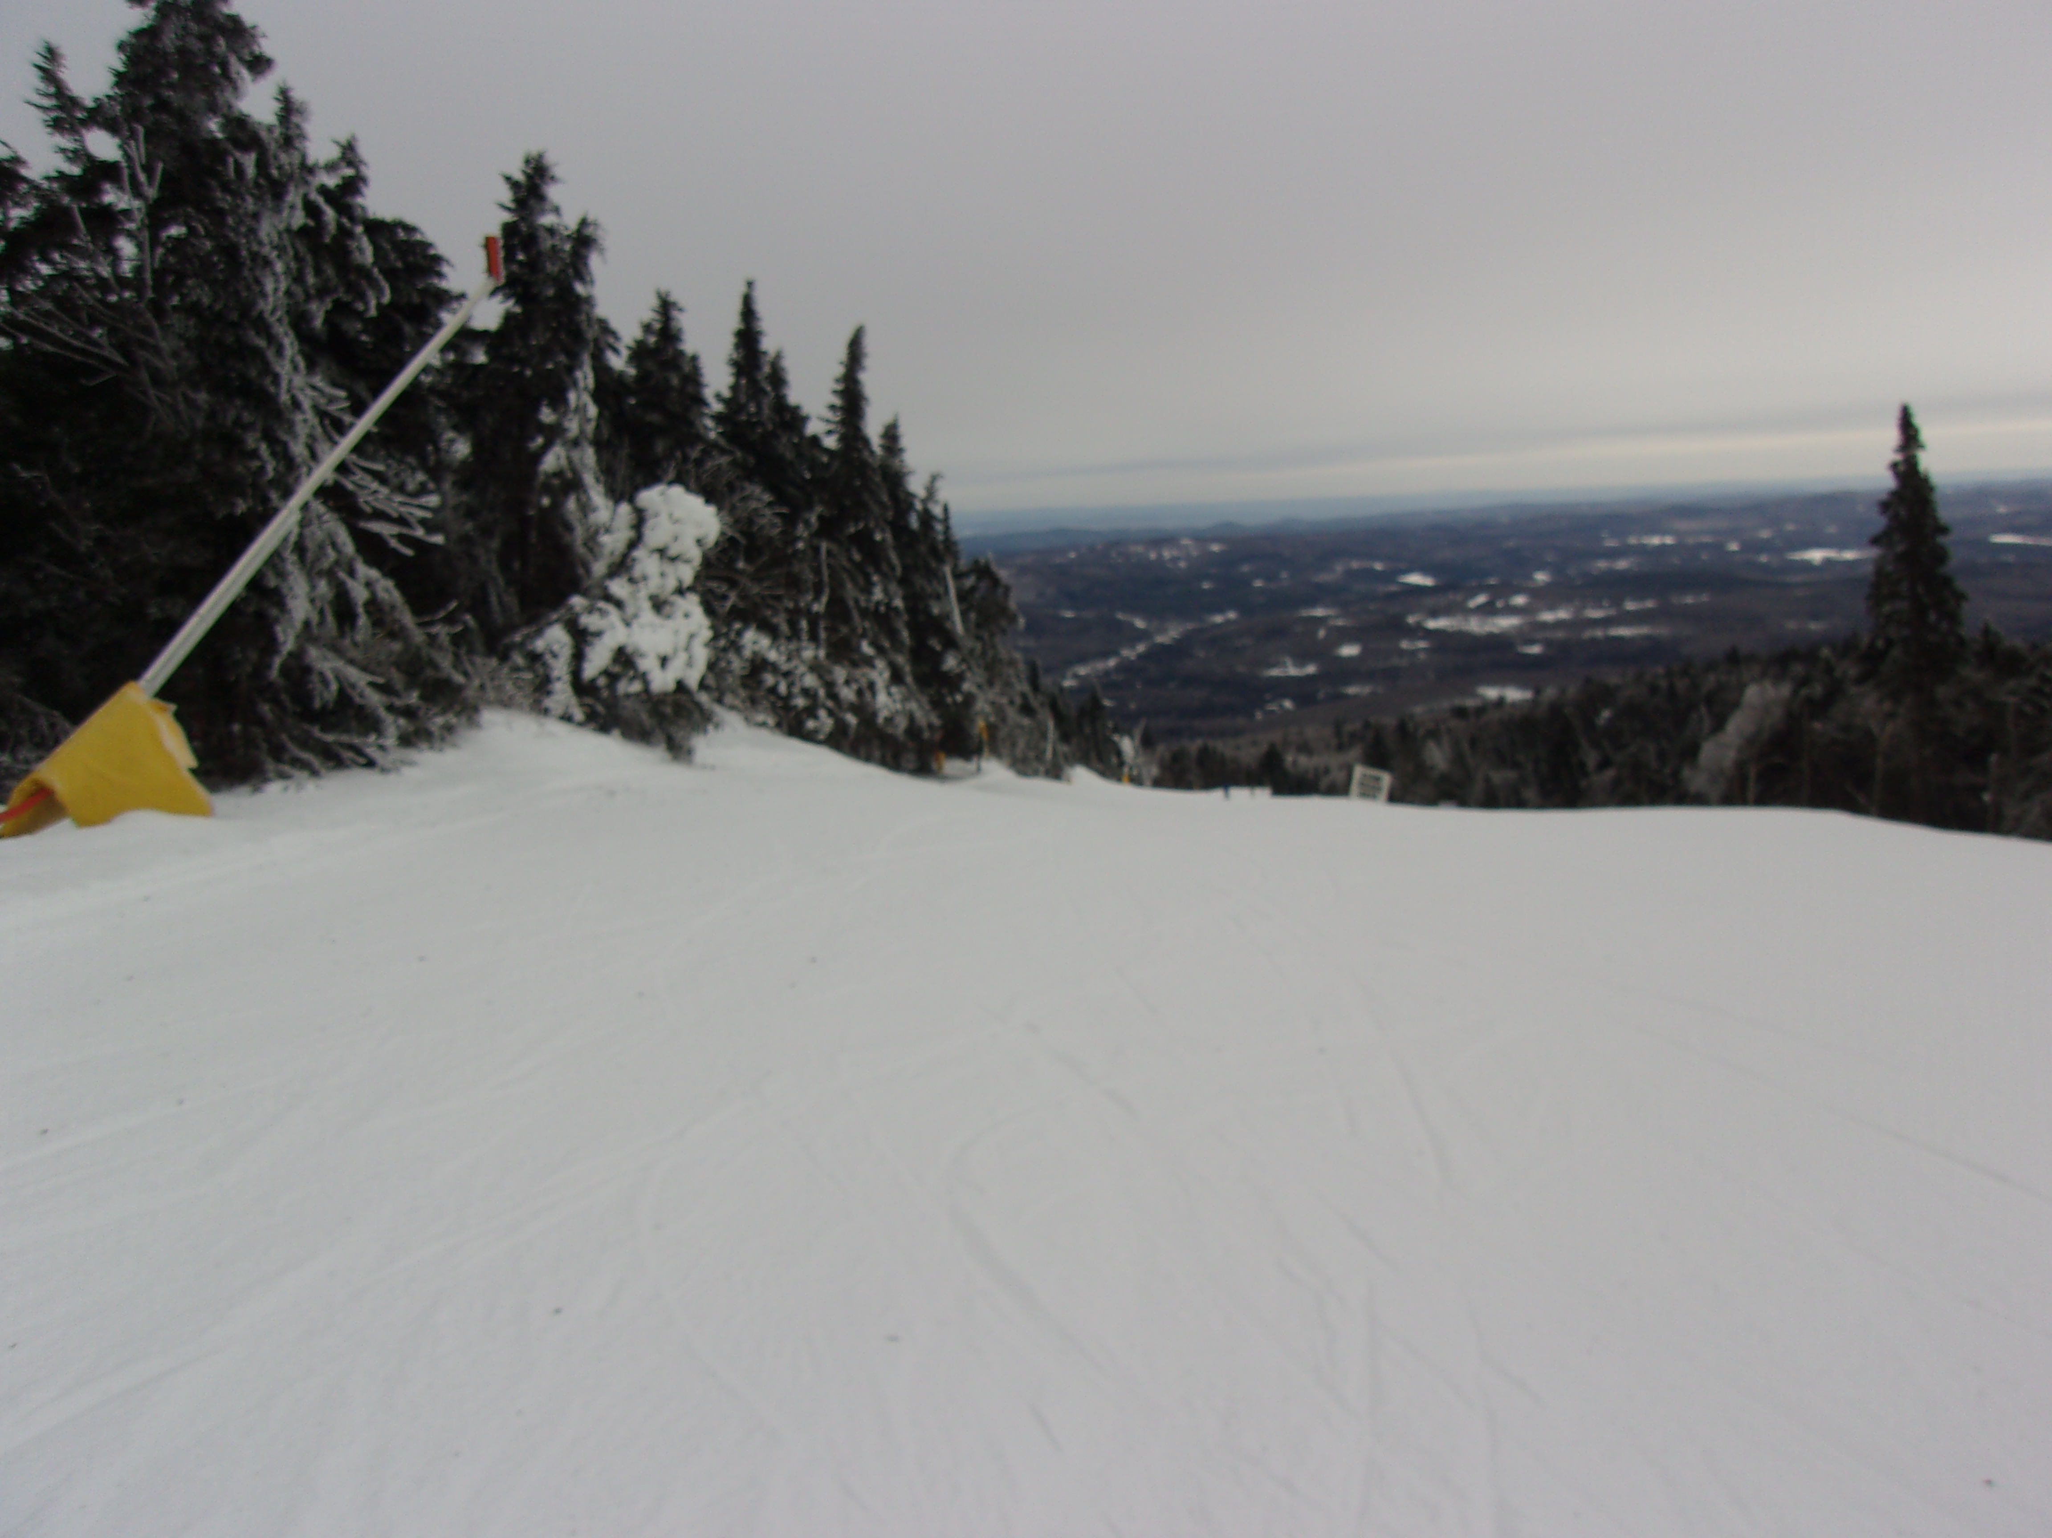
At least it wasn’t that windy all week.
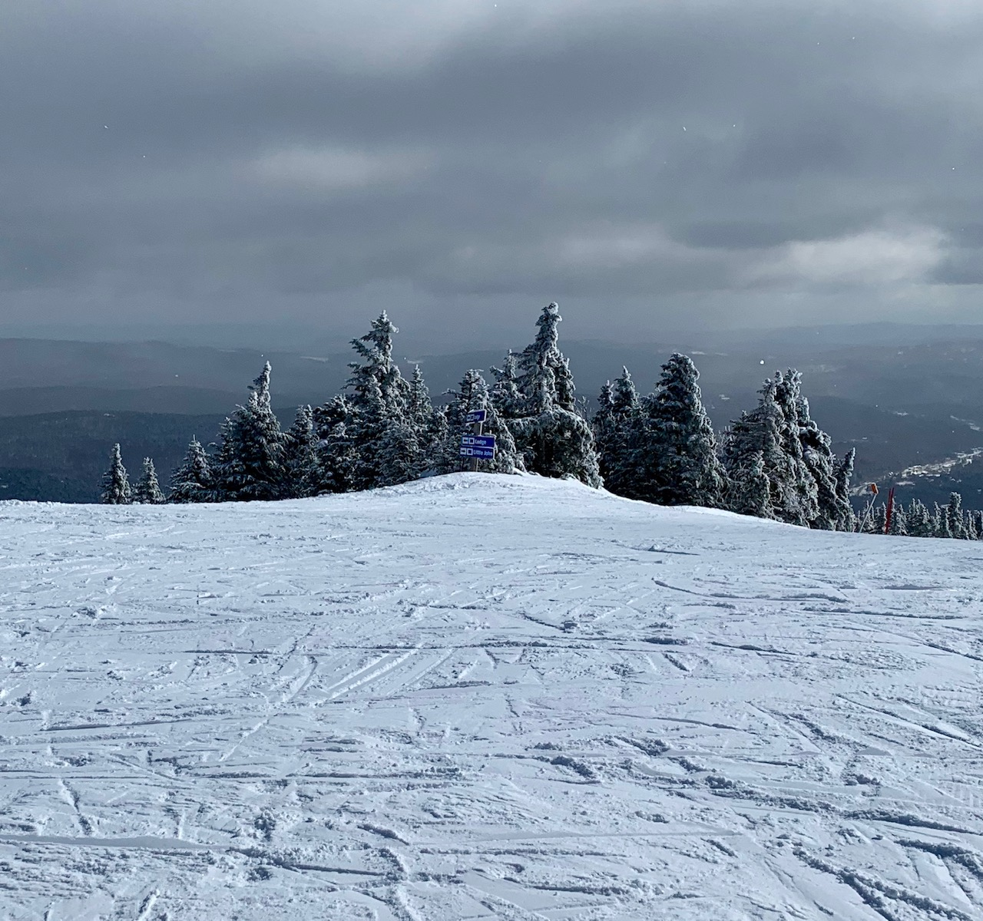
Shot from the top; ski time.
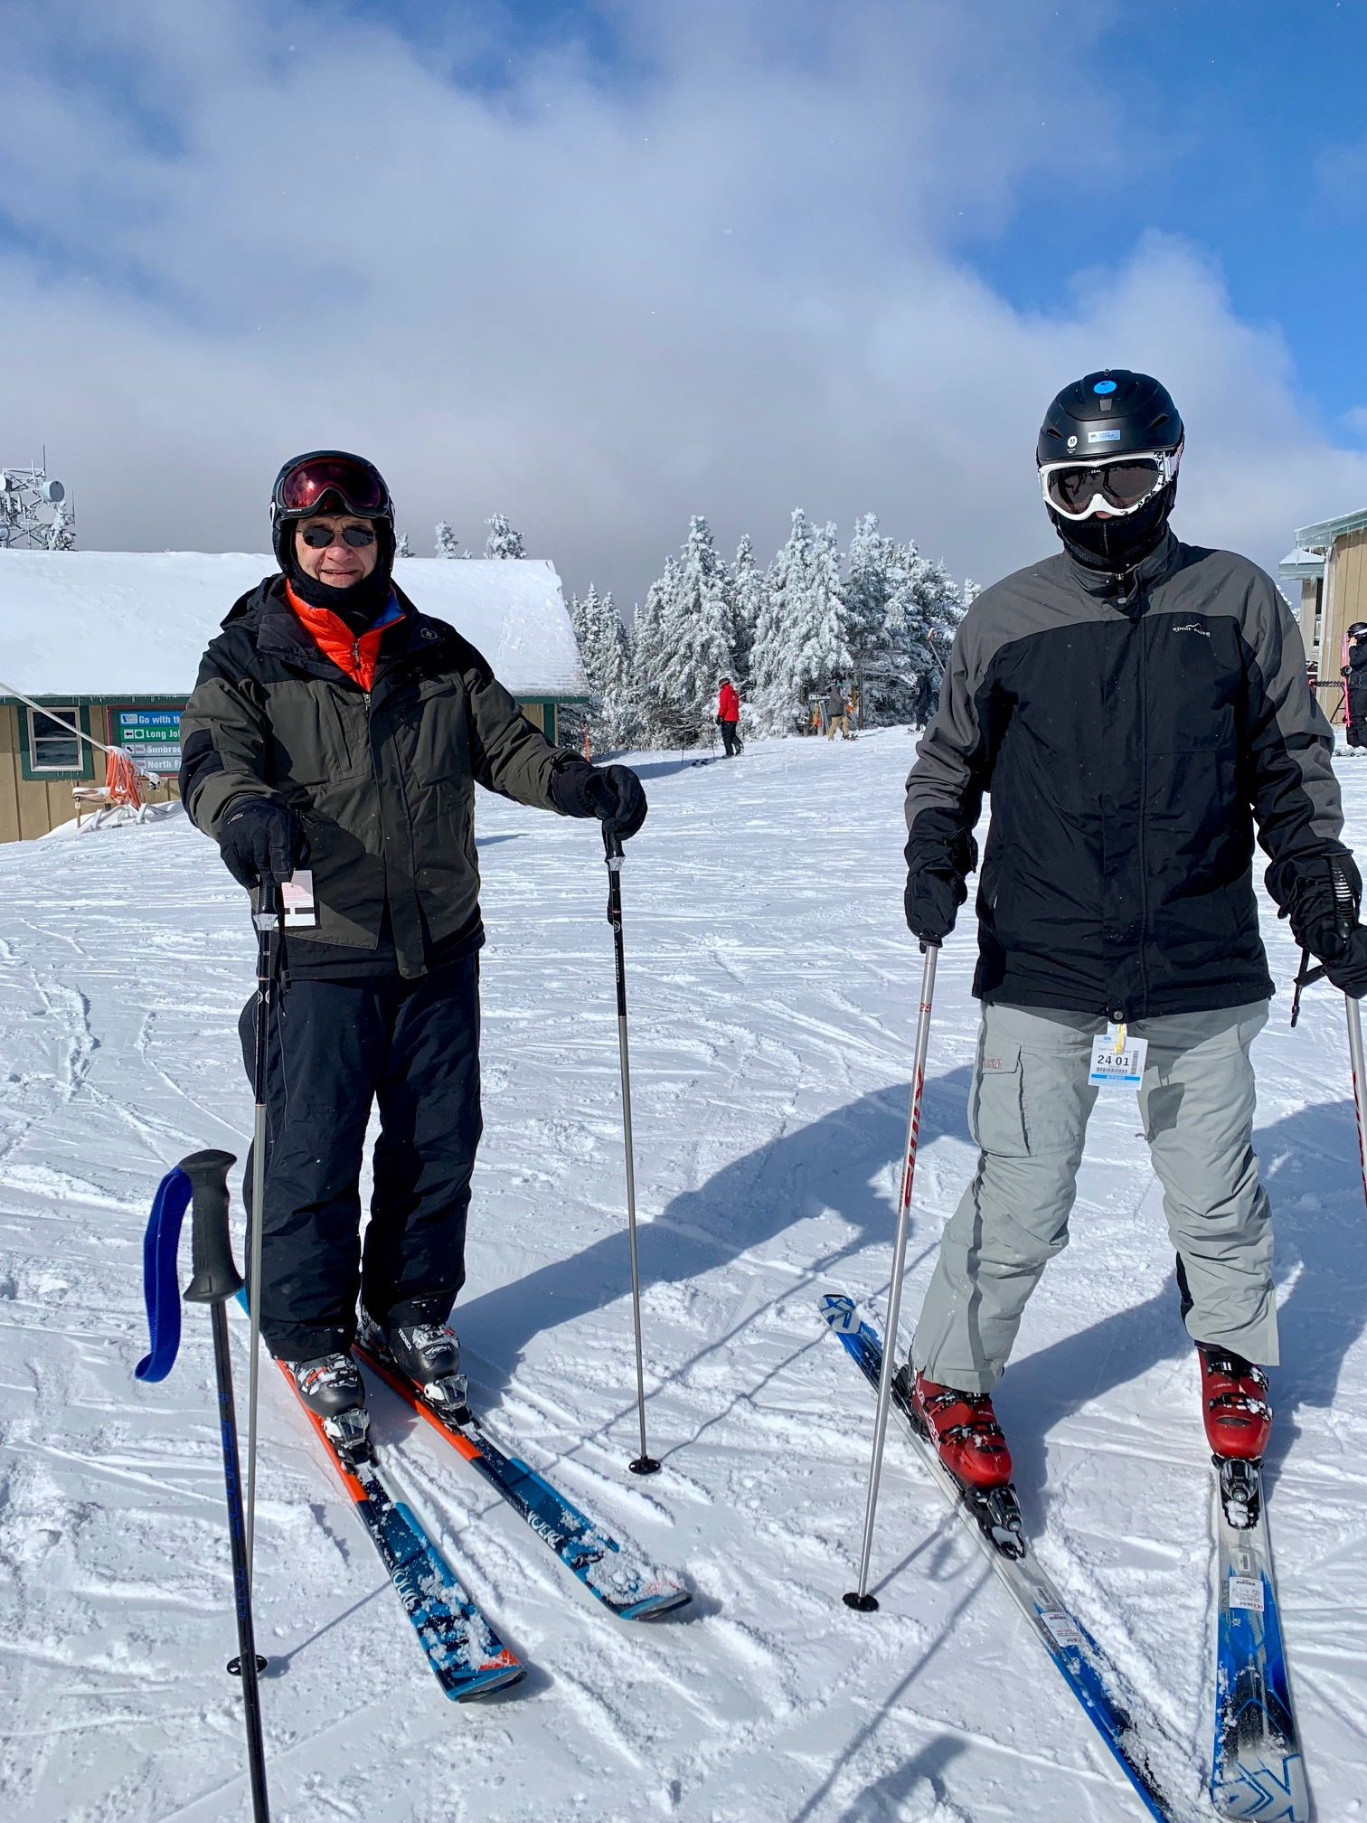
Off you go.
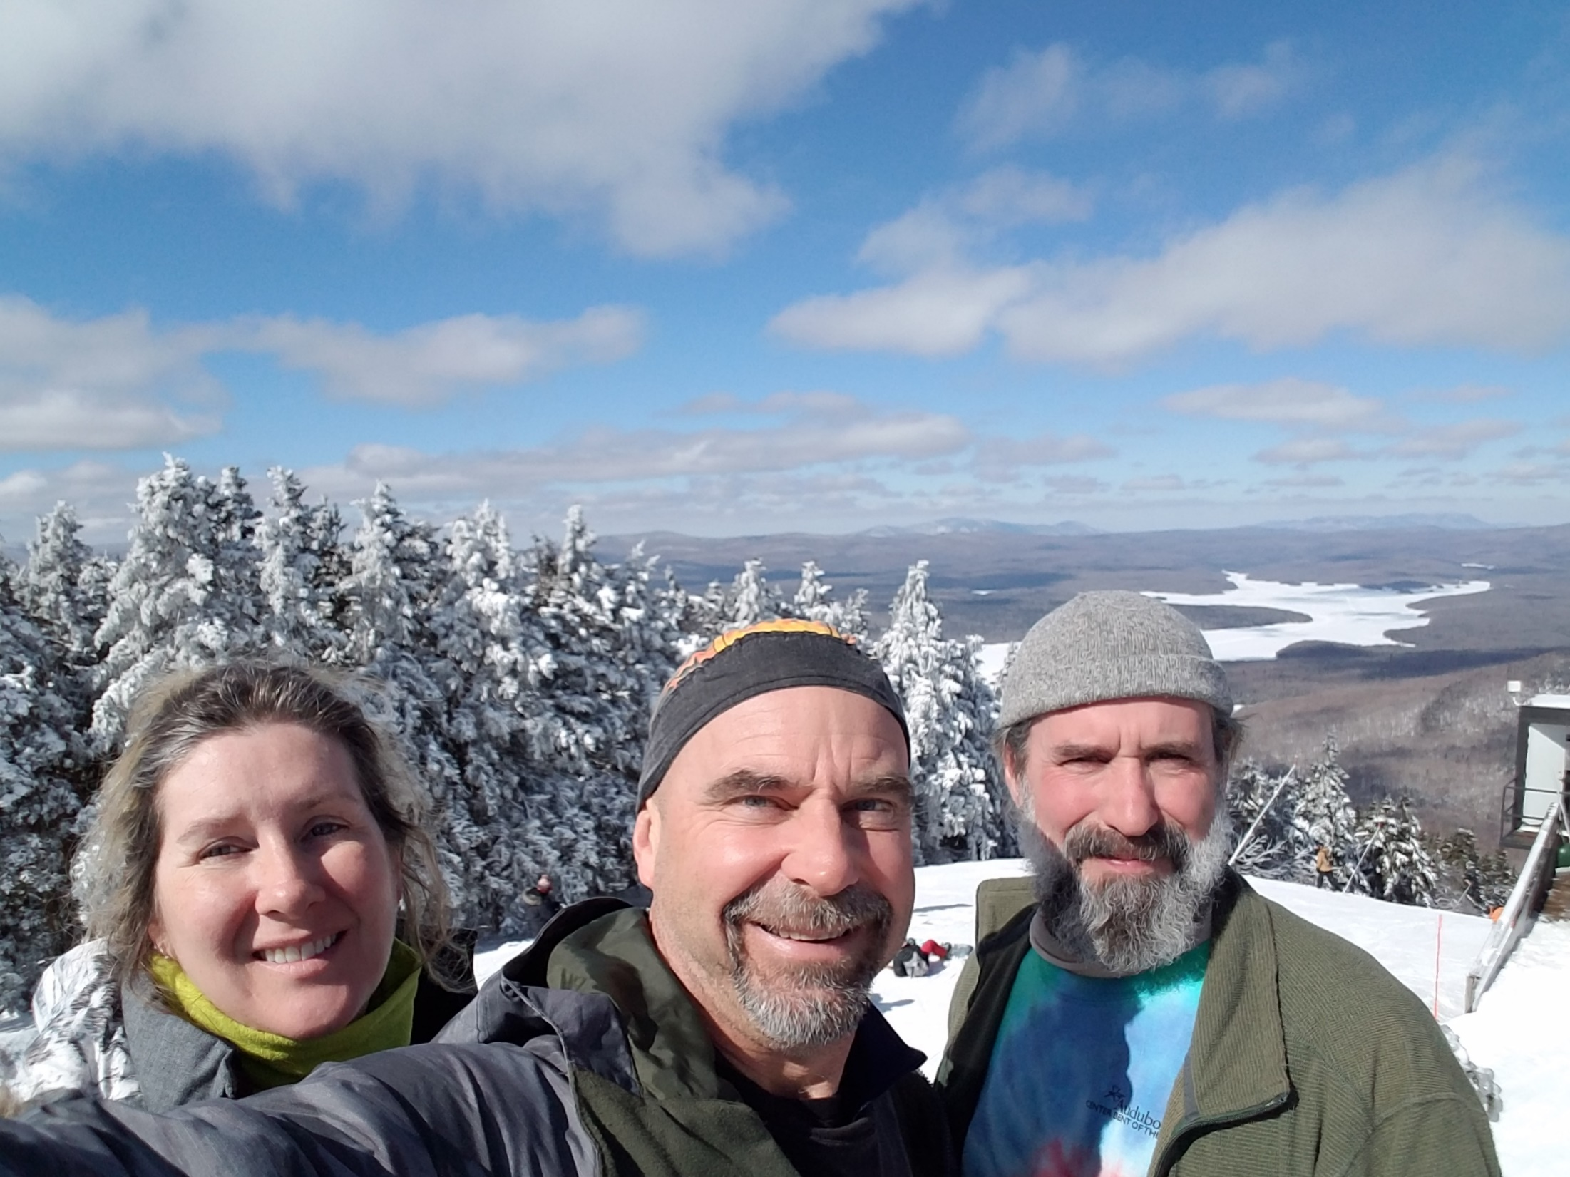
Candy, Jim, and Brad at Mt Snow – Summit
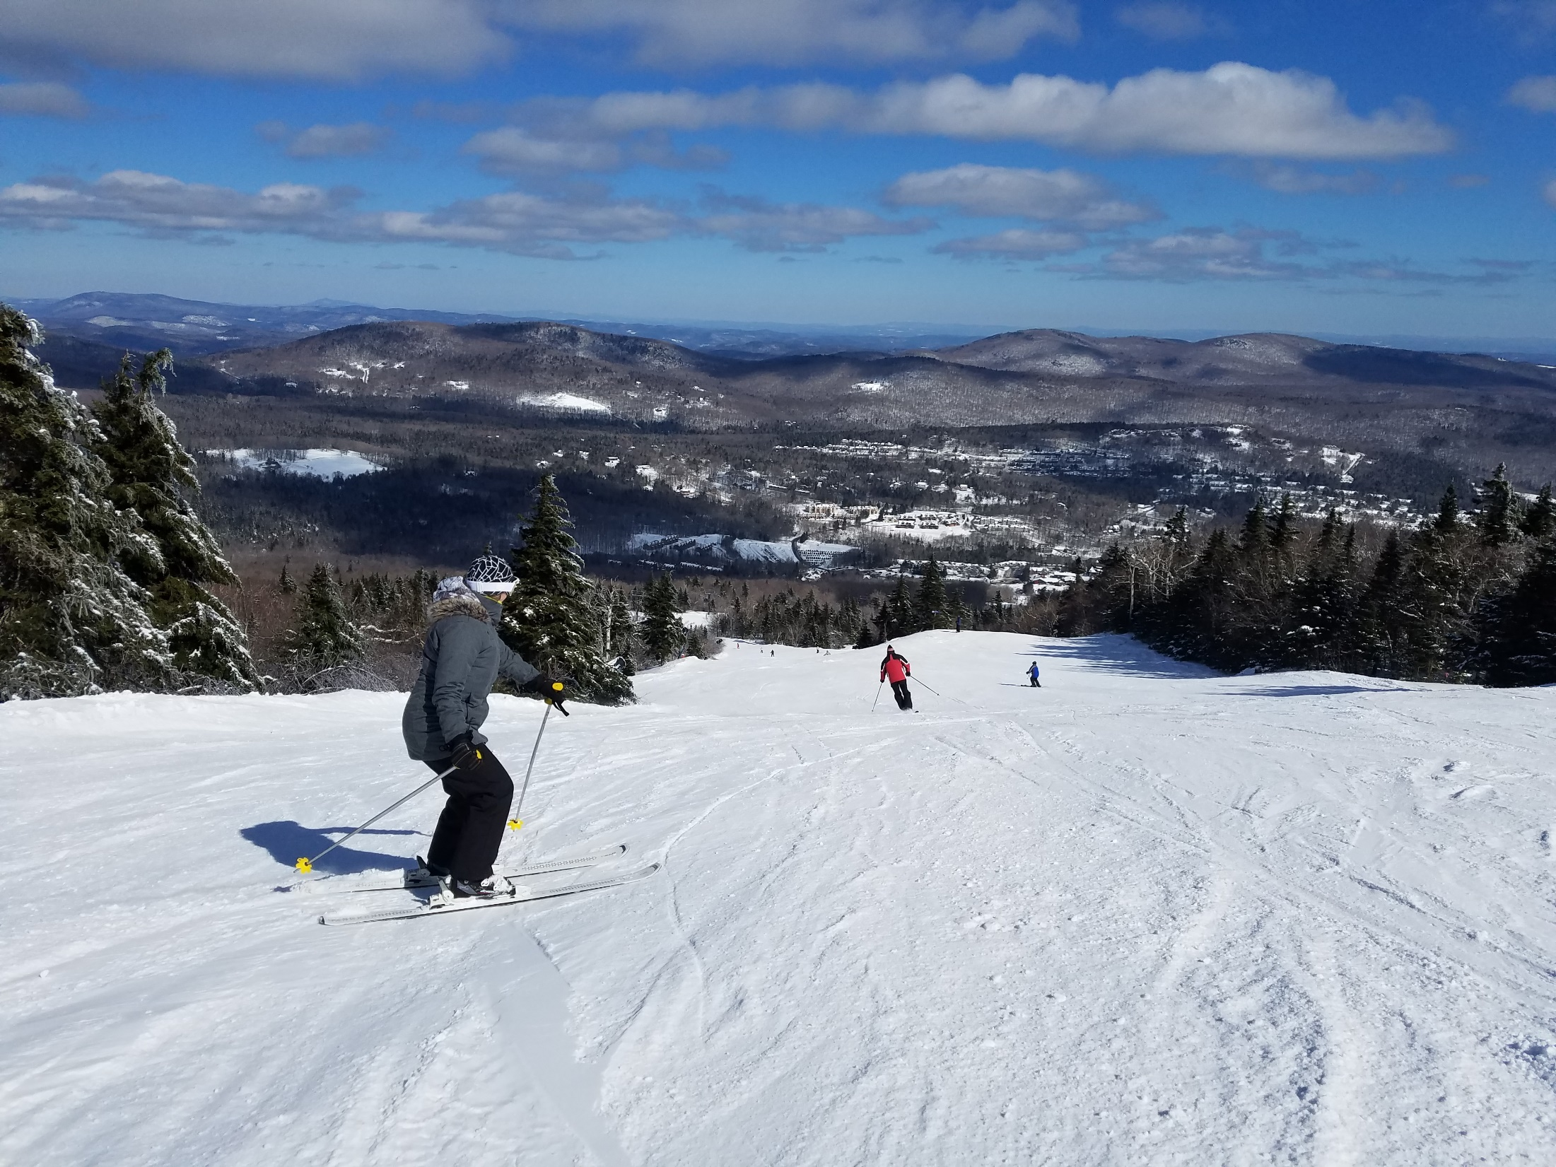
Candy showing good form at Mt Snow – left of the Blue Bubble
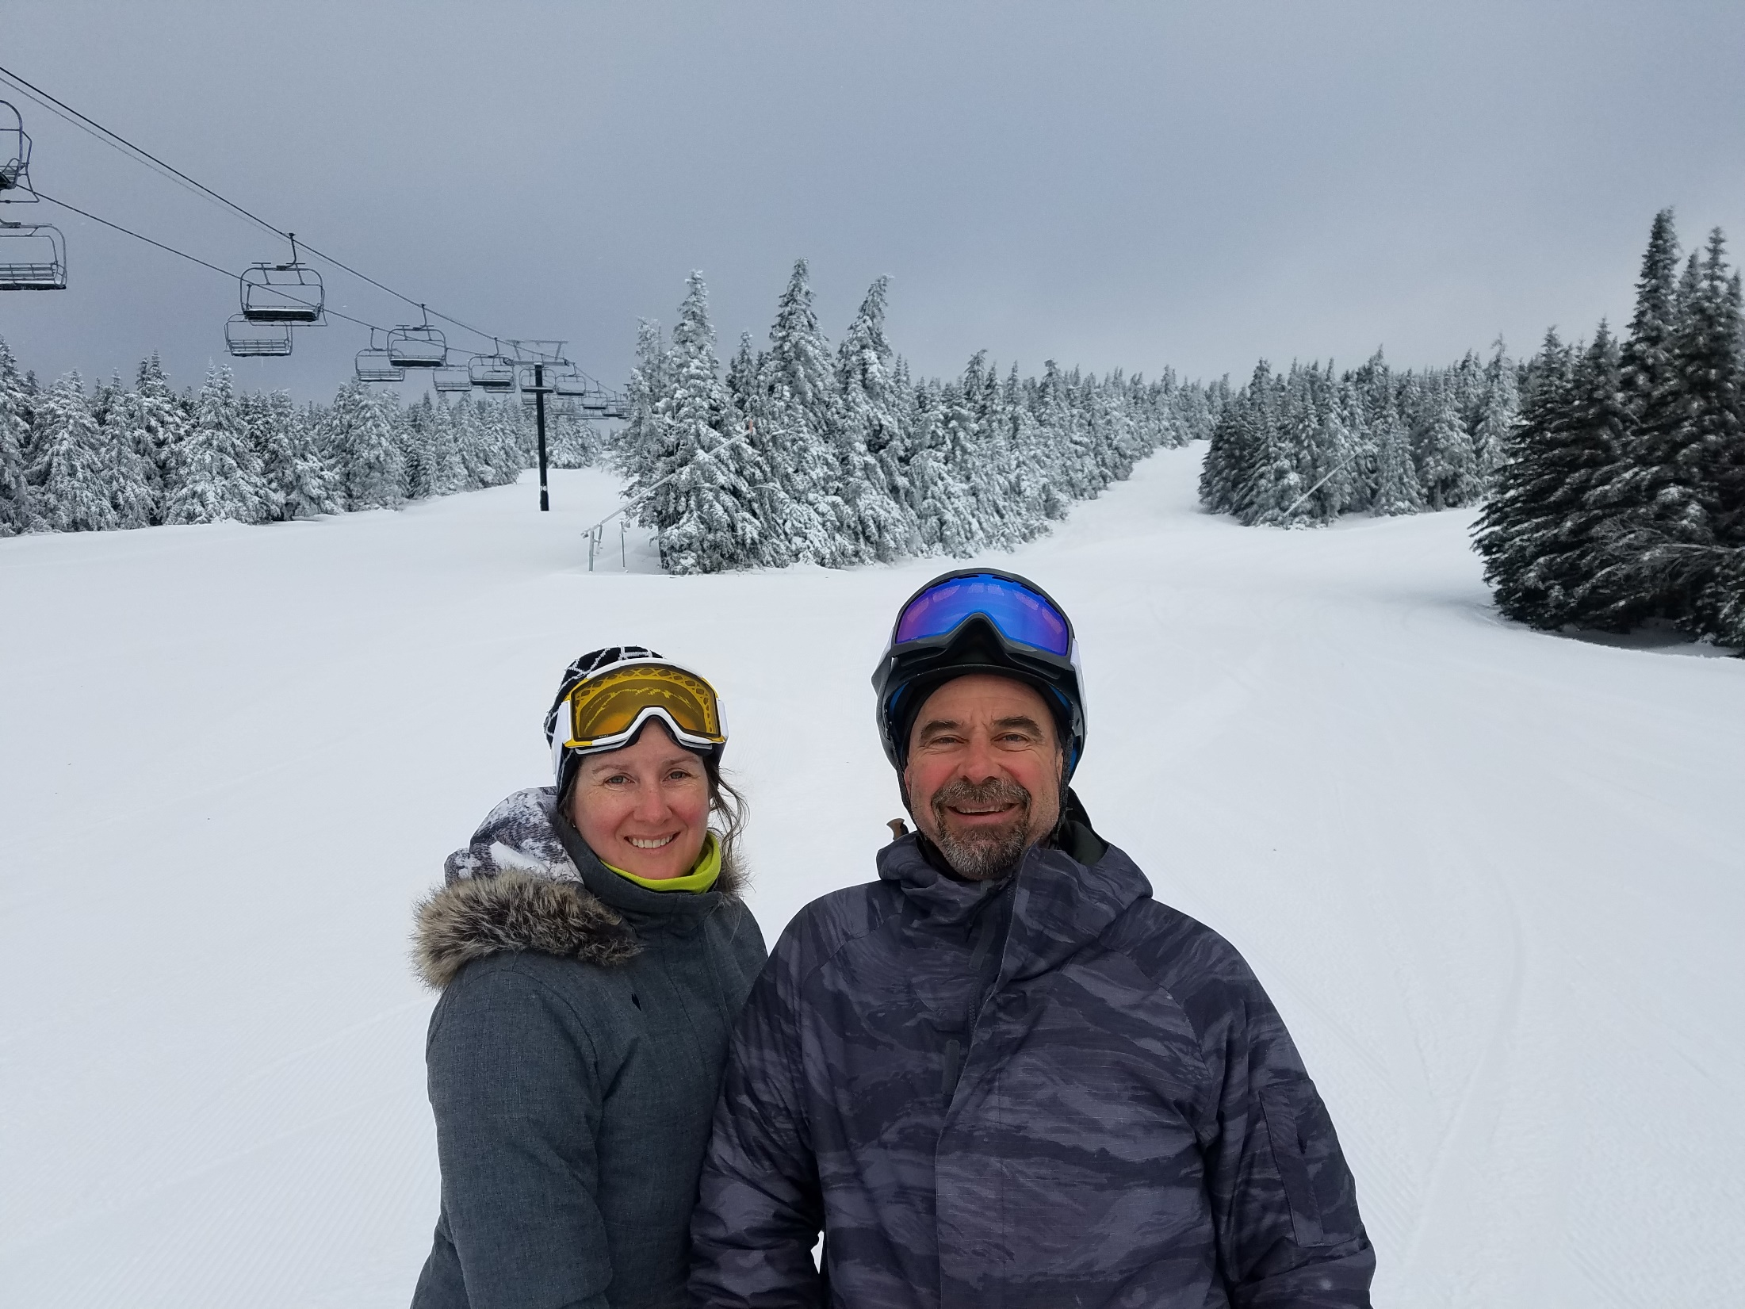
Candy and Jim in the pow at Mt Snow – Sunbrook Area
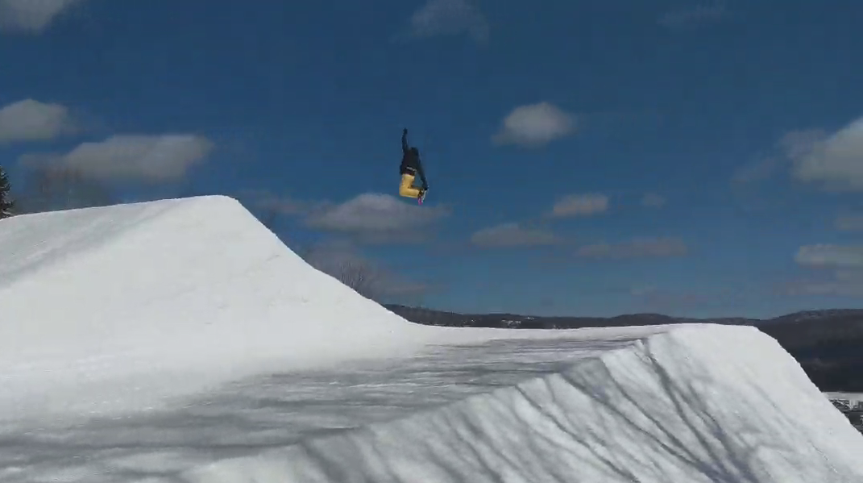
Andrew Pontius going large – Inferno XL area at Mt Snow
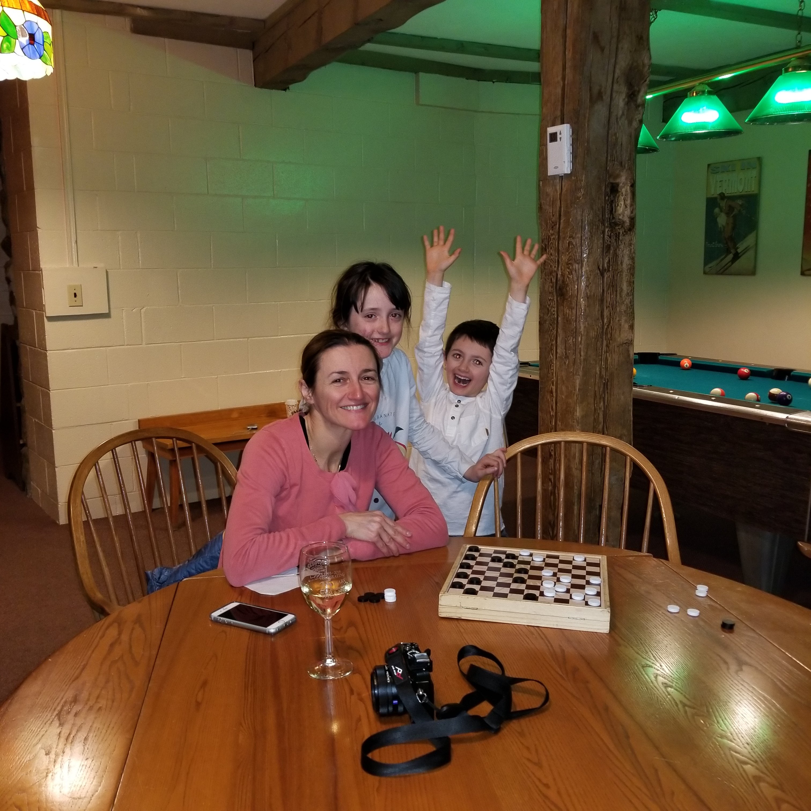
Game Time!
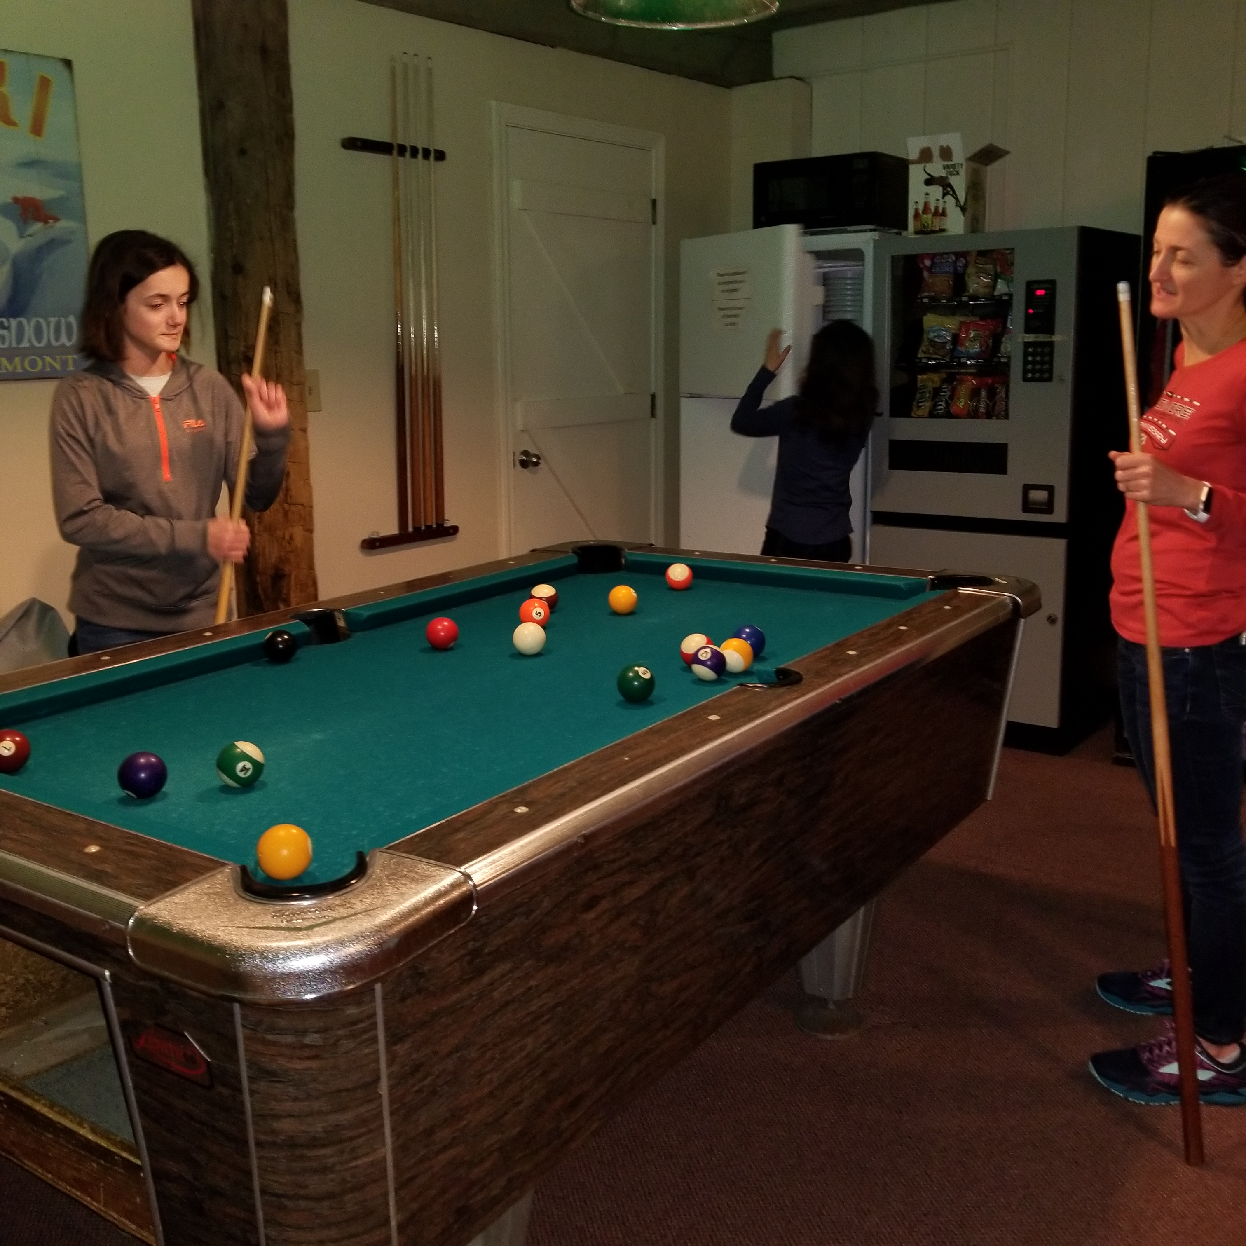
Pool hustlers.
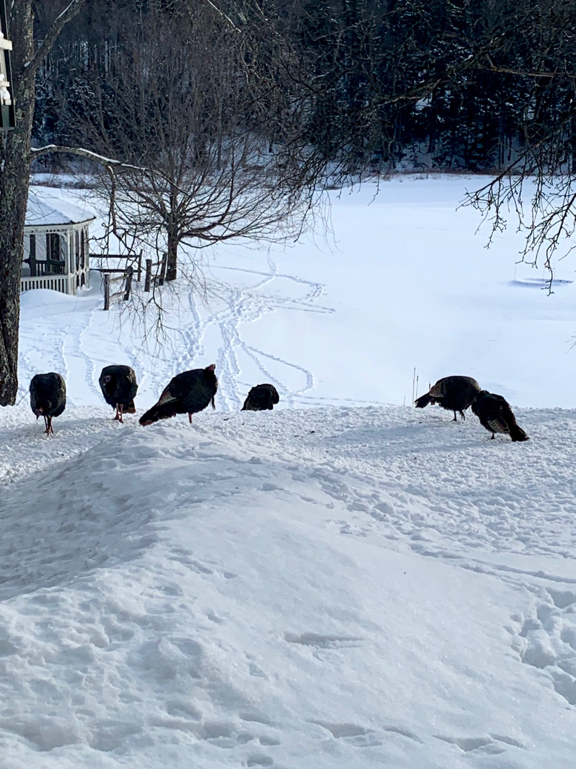
A few new residents at the Mountaineer.
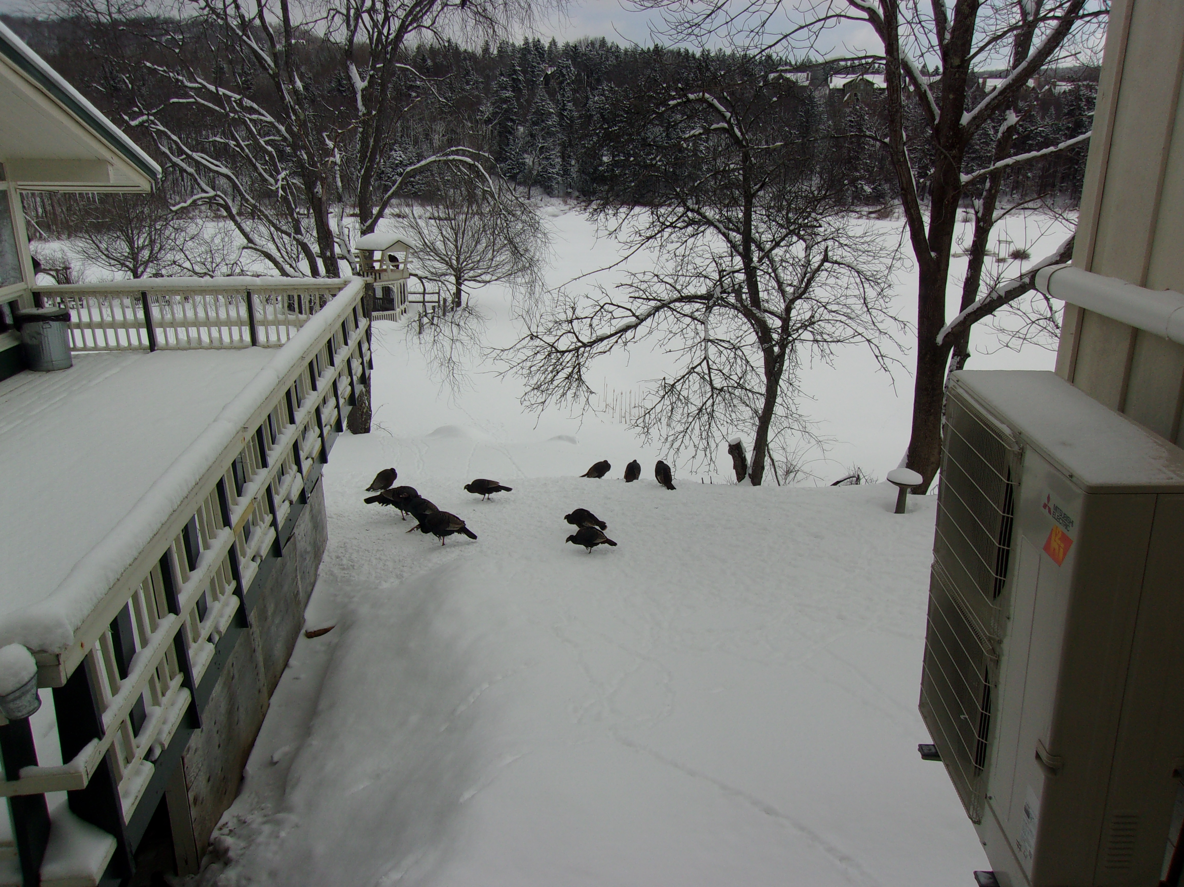
There was a bunch of them. Gobble Gobble.
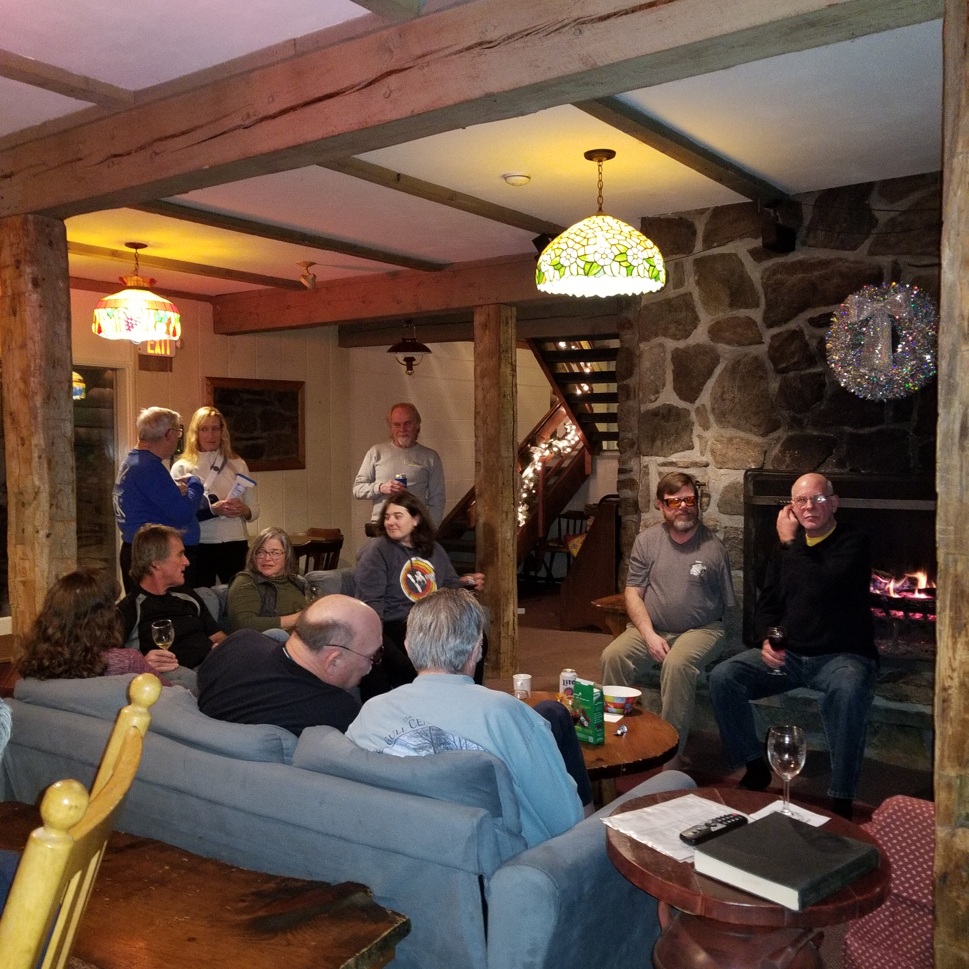
Wine & cheese party.

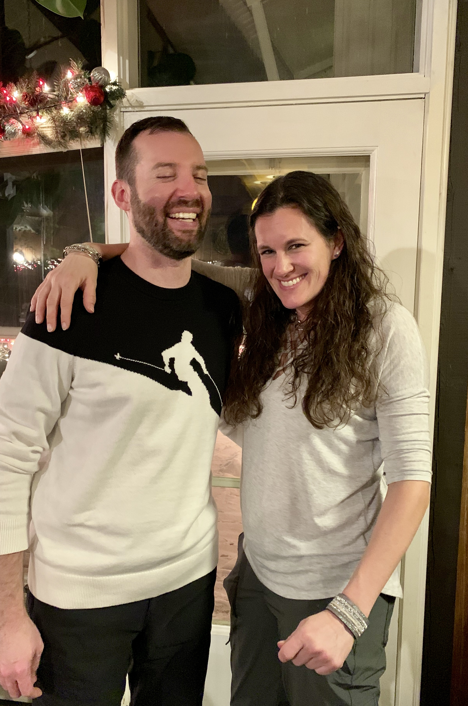
Bill & Jennifer in vacation mode.
I had a good time & hope you did too.

This trip report can still be modified. If you’ve got some good pics you’d like to include, PLEASE send them to me with a caption.
Remember next year’s trip will be the same week so be sure to plan on it and another great time. And remember to RSVP early to get a room at the Mountaineer.

Ski ya, Mike

