GODDARD SKI CLUB trip to CORTINA and VENICE, ITALY
Friday, March 23 to Monday, April 2, 2012

Report by Harvey Walden, Trip Leader

Friday afternoon, March 23, a select group of 5 skiers and 4 tourists (one would-be skier) in the NASA Goddard Ski Club departed Washington Dulles Airport on an Air France flight to Venice via Paris. Upon arrival at Paris’ Charles De Gaulle Airport, we transferred terminals, requiring an unusually long walk, to catch our connecting flight. At Venice’s Marco Polo Airport, our group boarded a chartered bus for the approximately two-hour ride to Cortina. Two drivers in succession were needed, with a rest stop en route to switch, as the first driver had exceeded his quota of hours for the day. The mountainous route with its frequent hairpin turns proved unsettling for at least one in our group. We arrived about noon local time and checked into the three-star Hotel Olimpia, located in the town center across from the post office and convenient to everything. We had lunch and then later attended an orientation meeting with our very lively hotel manager, Roberta, to discuss skiing and touring possibilities. Afterwards, several of us went to a nearby ski shop to arrange rental equipment. Then we explored Cortina and enjoyed dinner on our own.

The following six days, Sunday through Friday, we had a buffet breakfast at our hotel each morning and then split into skiing and touring groups. We went skiing at the Falzarego – Lagazuoi area by riding the free bus (Sunday’s was the last one of the ski season) from Cortina to Bai De’Dones near Cinque Torri (a rock formation known as the Five Towers). Other days we skied the Faloria and Cristallo areas, which were accessible by the Mandres and Faloria cable cars, a short walk from our hotel. Another possibility was to ride the municipal bus in Cortina to the Freccia Nel Cielo cable car near Cortina’s Olympic Stadium to Col Druscie and onward to Tofana and Ra Valles. Most of these areas had fine snow cover on the red and black runs, but the blue (beginner) runs at lower elevations tended to have marginal conditions or no snow at all. Some in our group tried completing the ambitious 42-kilometer Sellaronda circuit tour outside Cortina Valley by joining up with some Japanese tourists at our hotel who had rented a van for this purpose. The Sellaronda was possible, despite the lack of snow for the horse-drawn rope tow portion.

Some of our touring members rode the Mandres and Faloria cable cars directly from town for the fabulous views of the Dolomites. On Tuesday, a threesome pre-arranged a car and driver for a tour to Innsbruck, Austria. On two days during the week, an open-air market was held in Cortina near the bus station. Other attractions were visits to the three museums in Cortina: one of modern art, an ethnographic museum, and one specializing in paleontology. More active options were mountain hiking or cycling, using inexpensive rental bicycles that had just become available for the spring season bursting forth. Maps of suggested cycling routes were available at our hotel. The trail northward from Cortina past Fiames, a Nordic skiing area under better snow conditions, seemed to be the favorite. After passing over the Ponte Felizon bridge (a World War I landmark) and going through two tunnels, the trail became impassable at Ospitale, 9 kilometers from Cortina, due to snow cover. Days in Cortina were uniformly spring-like with warm temperatures and sunny with often cloudless skies. Weather conditions on the mountains for skiers were also superb.

We had dinners in groups at various restaurants in Cortina, some of which were recommended by our hotel staff. Favorites were the pizzerias La Perla and the Cinque Torri, and the Croda café. On Wednesday evening, a dinner at Ristorante Aniston was included in our tour package. We all enjoyed our pre-selected menu choice: vegetable crepes and oven shank of pork with roasted potatoes. On Friday evening, a waiter from the Aniston restaurant brought us desserts to enjoy at our hotel’s bar. In the evenings, we often strolled along the Corso Italia, the famous pedestrian-only shopping street in Cortina, checking out the high-end merchandise in the windows.

Saturday morning, we had breakfast and then checked out of Hotel Olimpia and took a 9 a.m. chartered bus to the Venice airport. There we transferred to two smaller vans for the short trip to Venice’s Piazza Le Roma, beyond which vehicles were banned. We took our luggage across a pedestrian bridge, past the railroad station to the Hotel Continental, a 10-minute walk, to check in. We had lunch and toured Venice on our own by foot or by water ferry. Following dinner, we strolled around Venice some more. After a Sunday breakfast buffet in the large dining room at the hotel, several of us took the water ferry to Piazza San Marco and bought tickets for a one-hour behind-the-scenes guided tour in English, “The Secret Passages of the Doge’s Palace”. We were able to visit the public rooms of the Doge’s Palace on our own before the tour. Afterwards, we had lunch in the Palace cafeteria. We walked around the Piazza San Marco to the Basilica San Marco, partially closed that day for Palm Sunday. We continued our walking tour of Venice, encountering an organ concert in progress at one church, and ended up at the Papadopoli Gardens. We all re-grouped at our hotel in early evening. Our final dinner was at a nearby family restaurant, where the proprietor had enticed us the previous day by promoting the features of his establishment to the passing crowds on the street in typical Venetian fashion. After dinner, several of us went on a self-guided nighttime water ferry tour of the Grand Canal to the final stop at Lido. This route took us on three ferries with 38 water stops before returning to our hotel. Monday morning, we had breakfast, packed up, and then checked out of our hotel and took a bus from Piazza Le Roma to the Venice airport. Our return Delta flight to Washington Dulles via New York’s JFK Airport was an uneventful conclusion to a wonderful trip to the Dolomites of northern Italy and the spectacular sights of Venice.

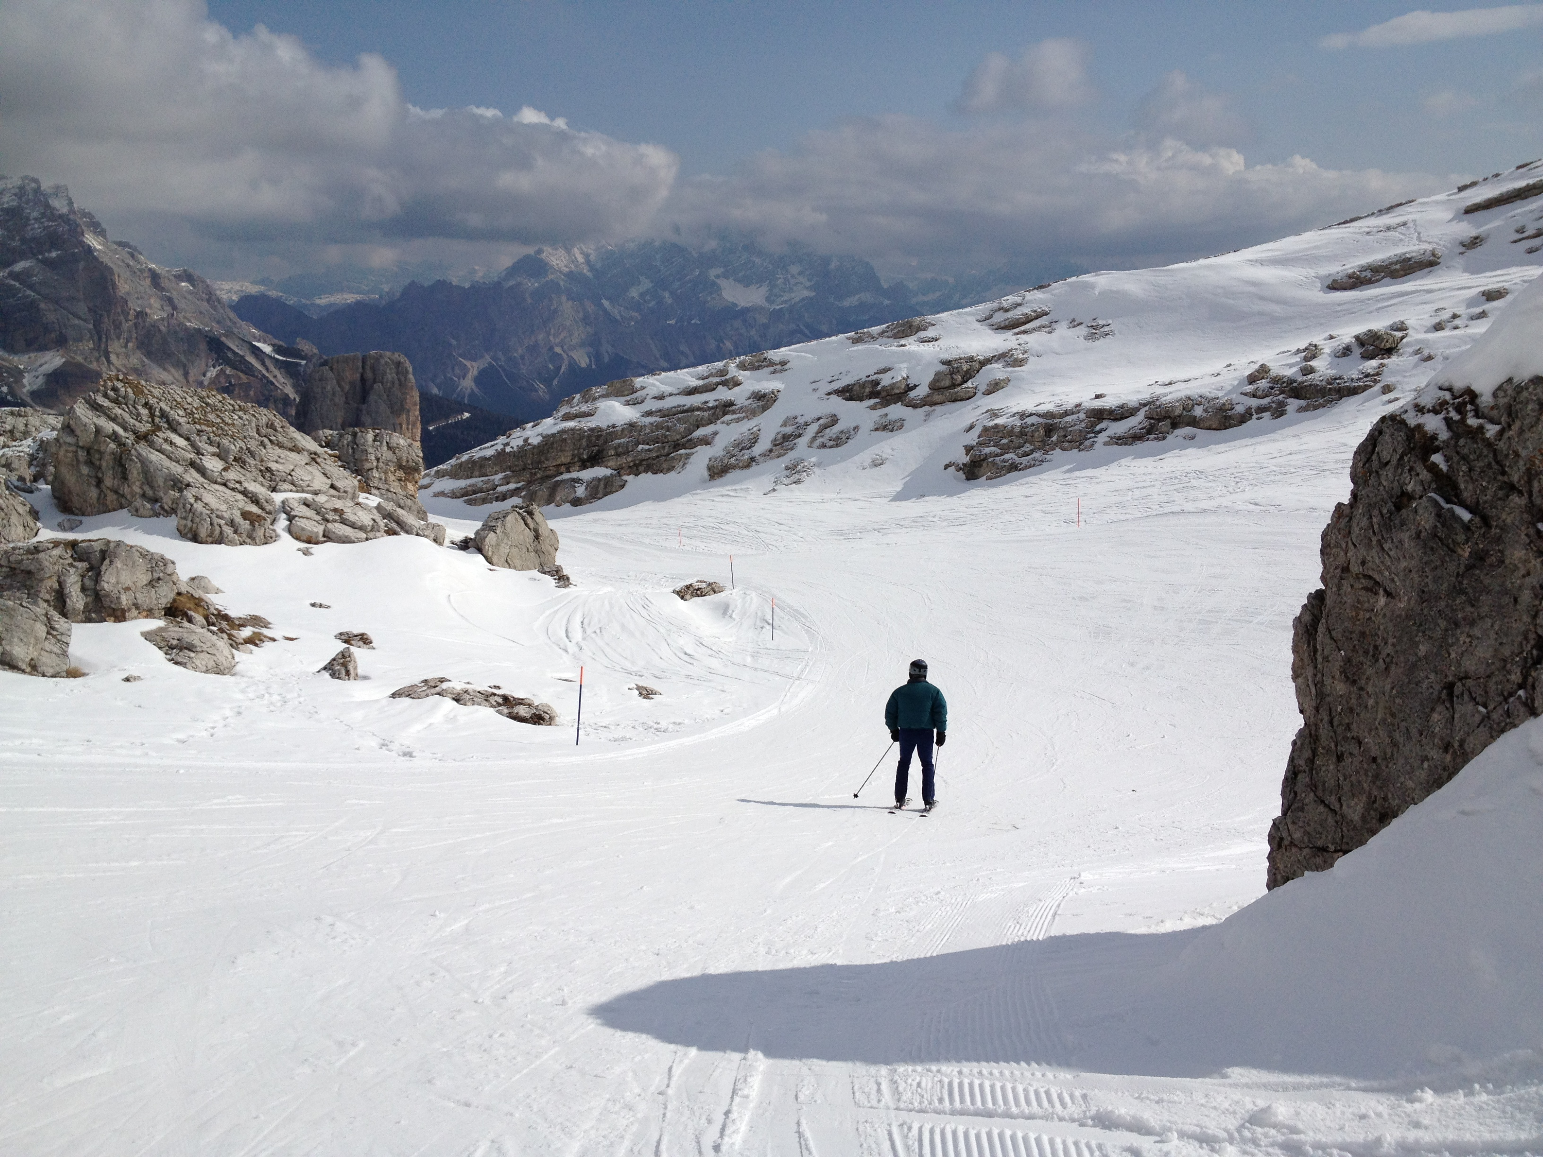
Lone skier on trail near Cinque Torri
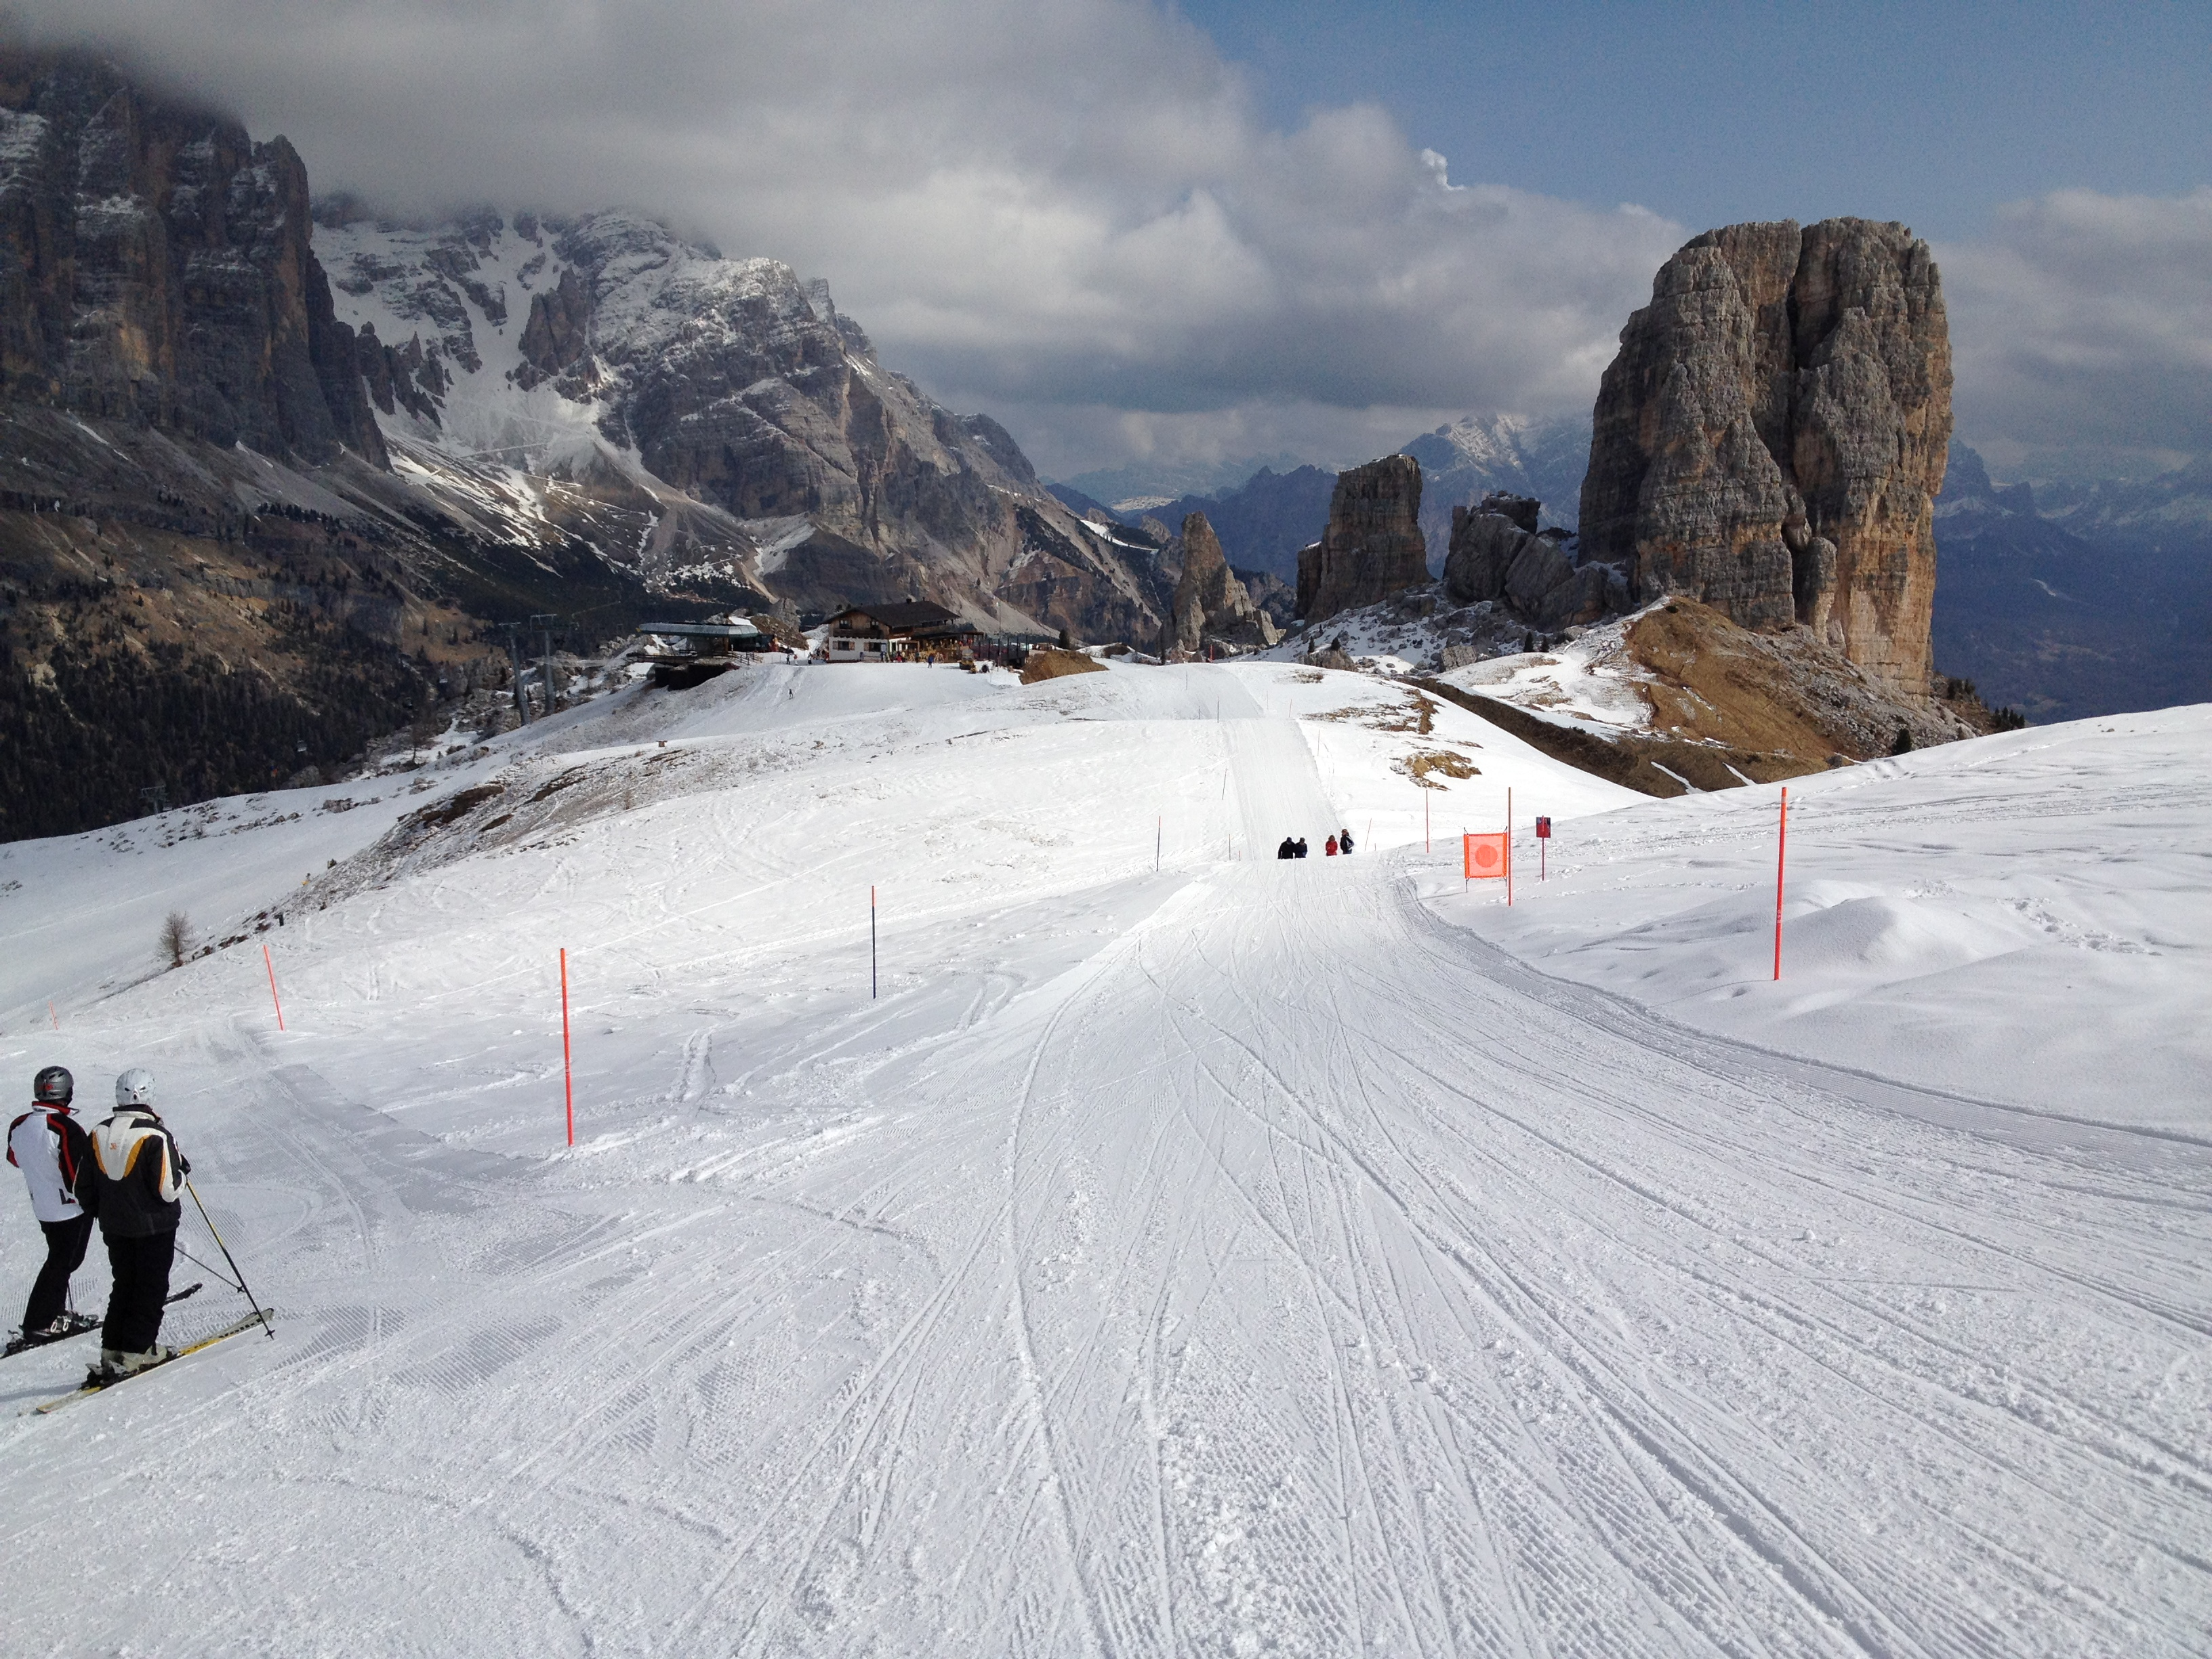
View of Cinque Torri rock formation from ski trail

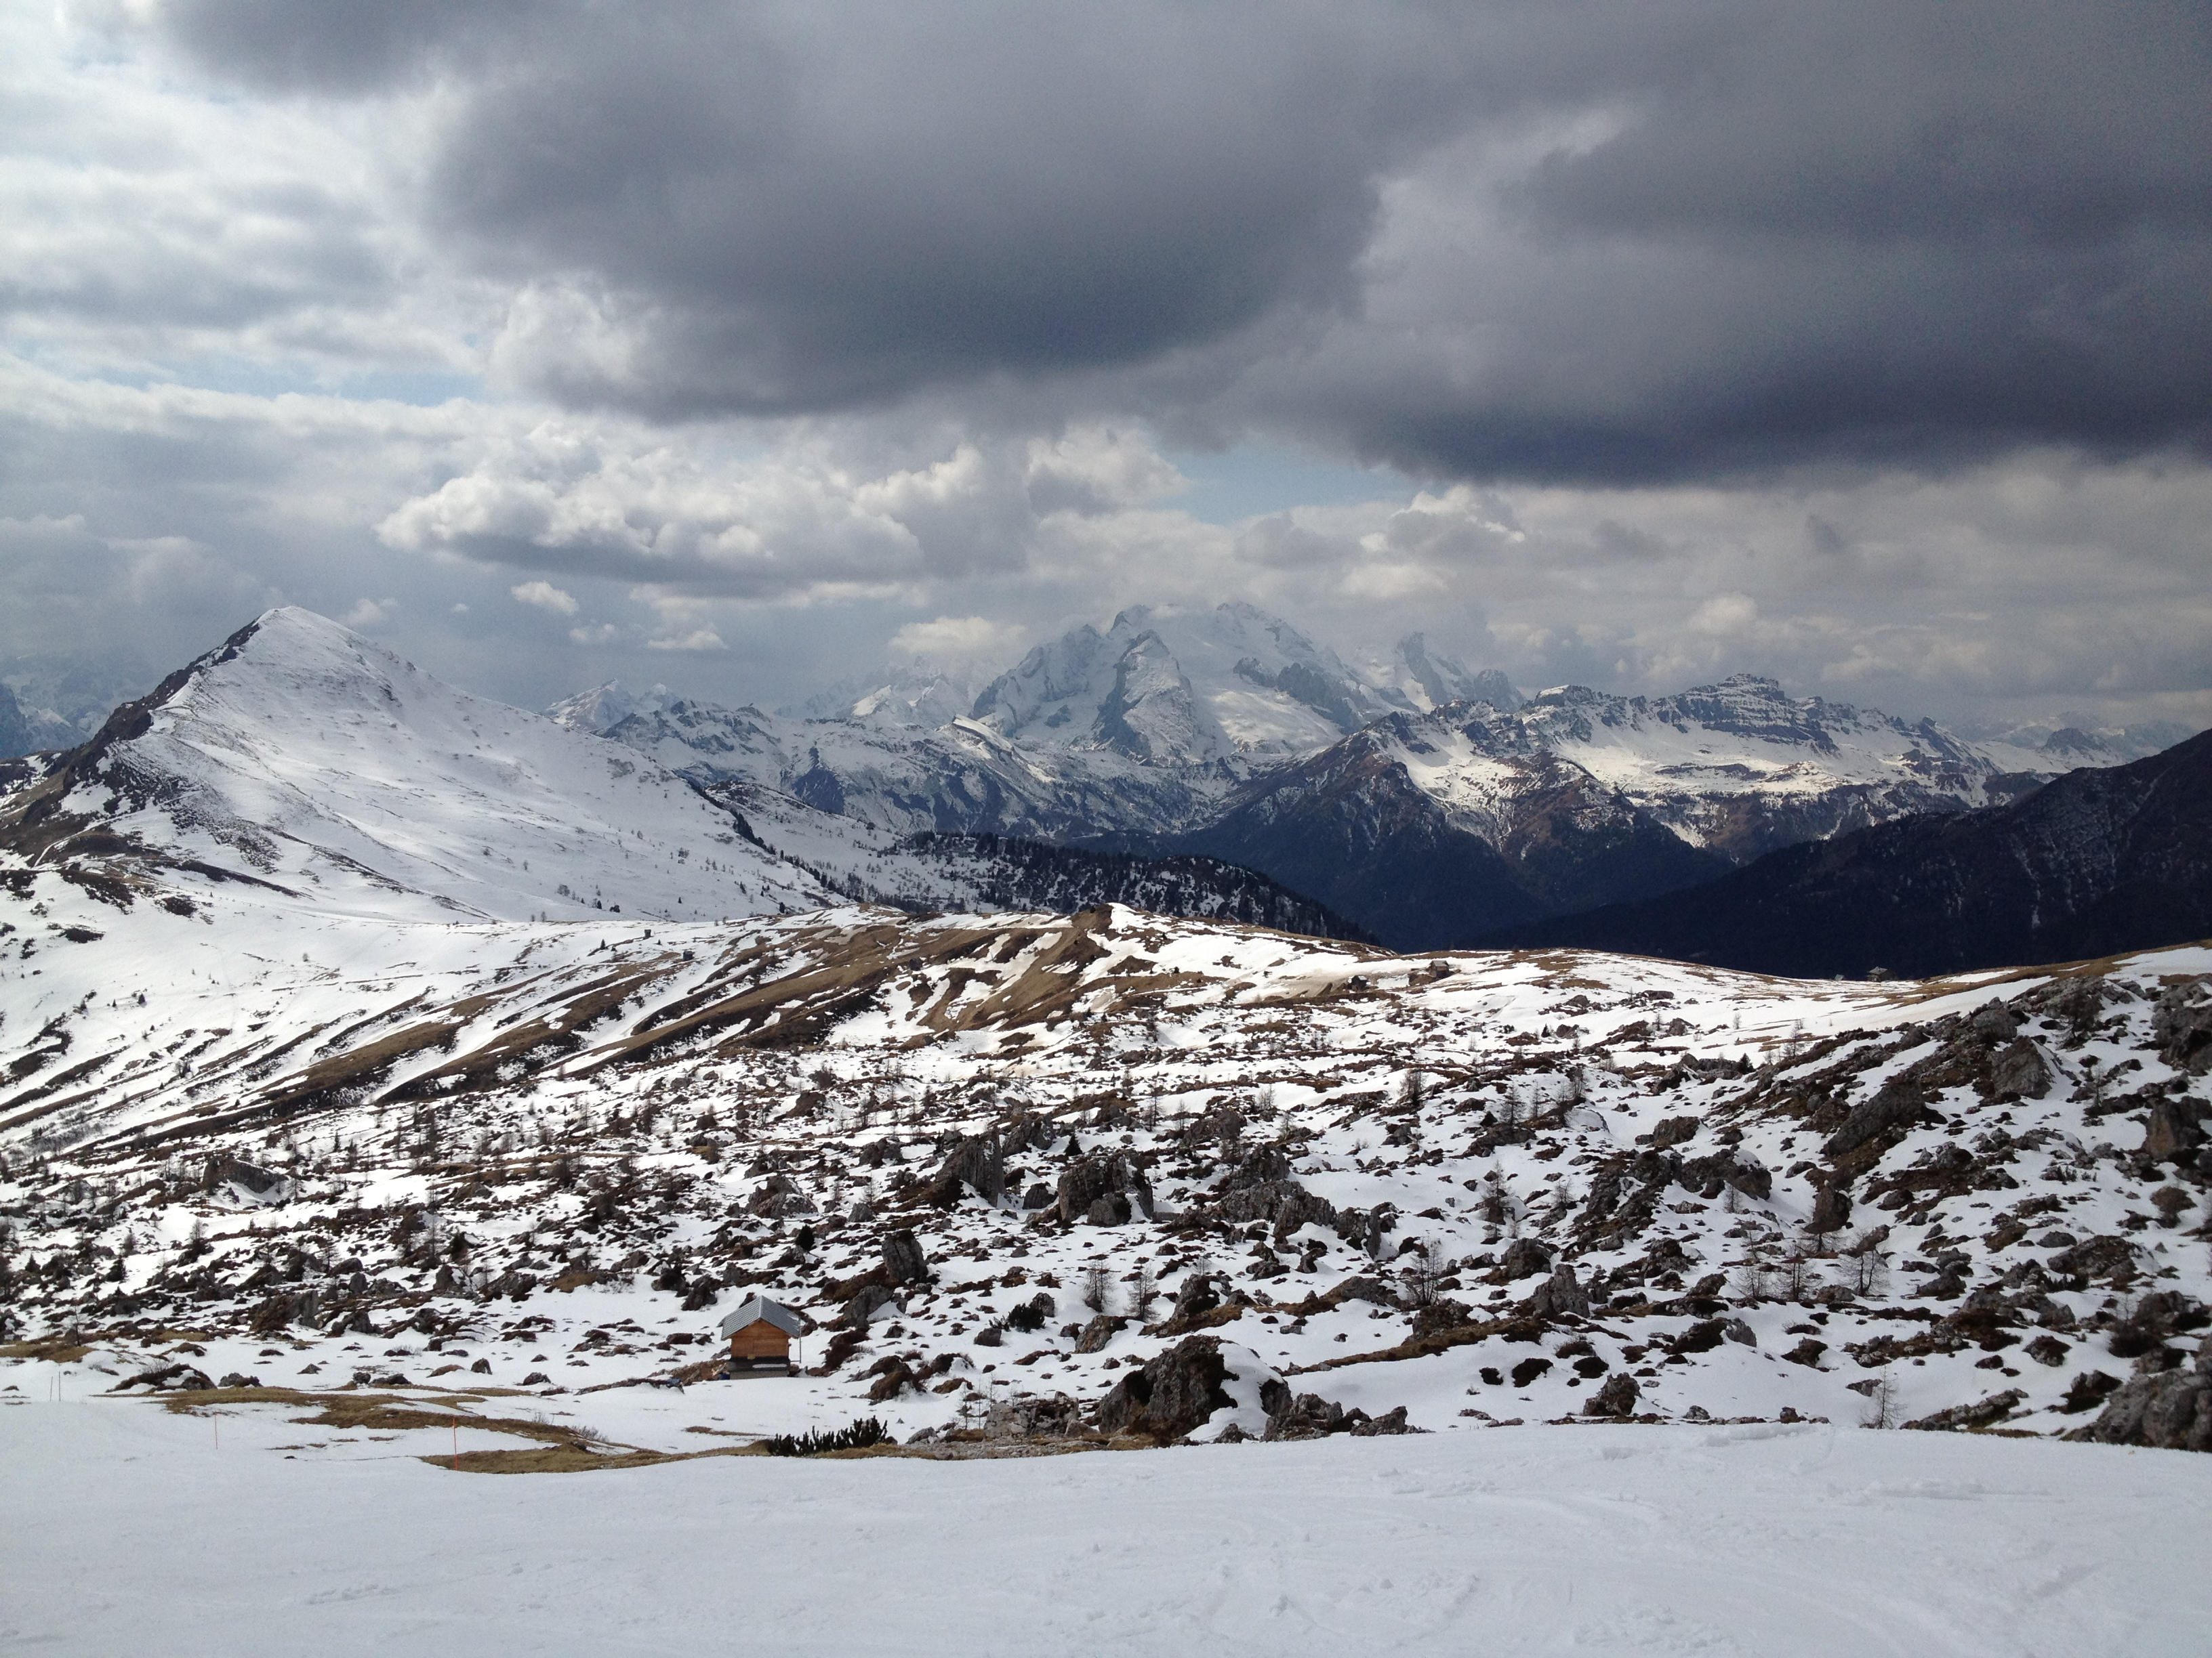
General view of the Dolomites
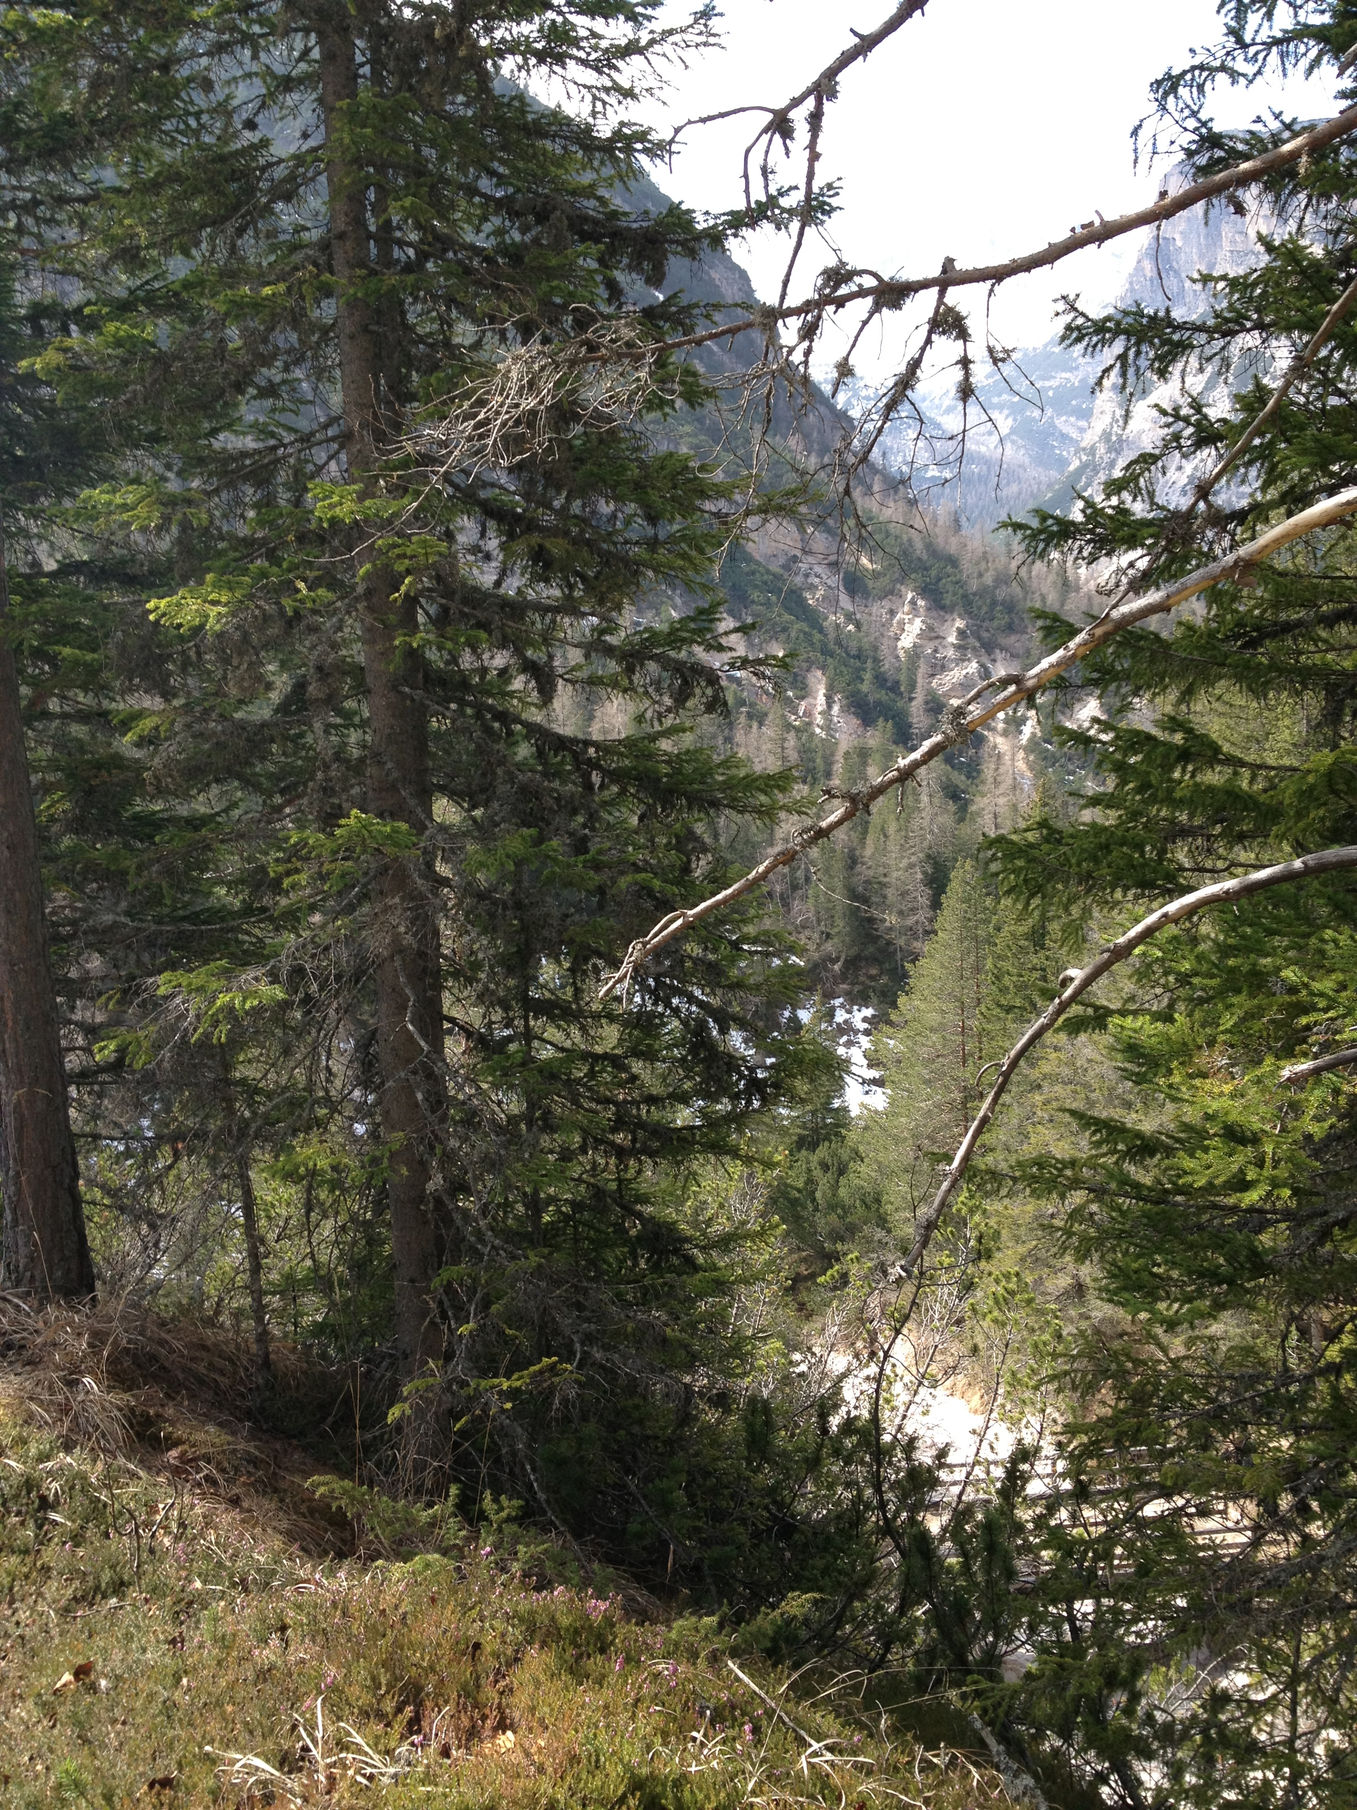
Valley view from hiking and cycling trail between Fiames and Ospitale

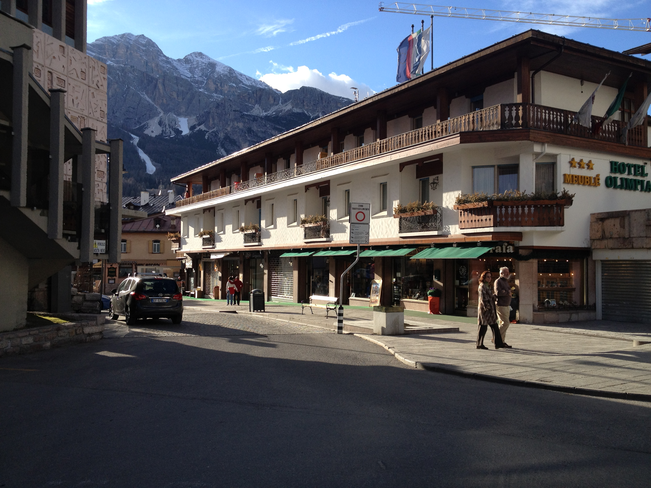

Hotel Olimpia in the center of Cortina (where we stayed)

