GODDARD SKI CLUB trip to ENGELBERG and BASEL, SWITZERLAND
Saturday, March 8 to Sunday, March 16, 2014

Report by Harvey Walden, Trip Leader
With images by Steven Slojkowski

A group of 20 intrepid NASA Goddard Ski Club members, to be later joined by another member living in France, left Washington Dulles International Airport Saturday, March 8th on a non-stop United Airlines flight to Zurich, Switzerland. We arrived early Sunday morning and immediately boarded our chartered bus at the airport terminal for the scenic ride through the central Swiss Alps to the three-star Hotel Terrace in Engelberg. Located in the German-speaking sector, the hotel has a definite old-world charm that is similar to that of the Grand Budapest Hotel in the recent movie of the same name. It is situated above the town with sweeping views of the mountains and is accessible by two consecutive tunnels and elevators buried in the steep hillside. These tunnels and elevators replace an antiquated funicular cable railway from years past that remains as an immobile historical oddity on the hill.

After checking in at the hotel, at noon we were treated to refreshing drinks and a welcome orientation talk by a member of the hotel staff to acquaint us with the skiing and touring possibilities. In the afternoon, some of us who chose the rental option for our ski equipment made arrangements at nearby winter sports shops. That first evening in Switzerland, we gathered in the cavernous dining rooms with high ceilings and reserved tables. Our tables were marked by a somewhat enigmatic sign that identified our group. Nonetheless, the dinner, as all dinners to come later in the week, offered an all-you-can-eat buffet spread of numerous salads, soups, breads, main entrees, vegetables, and desserts, all of which were delicious. To accompany the dinners, we were treated to all the wine and beer one chose to order from the ever so polite wait staff.

For the next five days, Monday through Friday, we had delicious all-you-can-eat buffet breakfasts in the same hotel dining room each morning. We then separated into skiing and touring groups. We used the elevators and tunnels to descend from our hotel into town, crossed the small Kurpark to the main street opposite the Ramada Hotel Regina Titlis where our free shuttle bus picked us up for the short ride to the slopes. The touring group had access to the Bahnhof (rail station) by walking just a bit farther down the street. This late in the winter season, the better snow was found in the Titlis area (summit at 3239 meters), the Jochstock (elevation 2564 m) and lower down at the Trubsee area. The Titlis Rotair, the world’s first rotating cable gondola, ascended to the summit of Klein Titlis at 3028 meters elevation with a full 360-degree slow spin during a five minute ride. Its spectacular view was available to sightseers as well as skiers. Non-skiers in our group participated in a variety of activities on the mountain during the week, including snowshoeing along the winter hiking trails and snow tubing, sledging (sledding, in American parlance), and snow bicycling. At Mount Titlis, the swaying Titlis cliff walk, Europe’s highest suspension bridge, hangs suspended by steel cables 500 meters above the crevasses. It required strong nerves to cross, but nevertheless, several in our group gave it a try. For further exploration, there was the Glacier Cave, a 150-meter long blue ice corridor 20 meters below the surface of the Titlis glacier. On the mountainside near the Trubsee stood the Igloo Village with its hotel made entirely of ice, a delightful Ice Bar, and outdoor bean bags for sunbathing on the slopes.

At midweek, several in our group took the train from Engelberg to the nearby town of Lucerne (Luzern). We explored the Chapel Bridge (built in 1333) with its gable paintings, the Musegg Wall and its nine towers that were part of the ring wall that protected the city, and the famous lion monument. The dying lion of Lucerne is carved into natural rock and was created in 1820-1821 to commemorate the Swiss heroes who gave their lives at the Tuileries in Paris during the French Revolution in 1792. We were easily able to return to Engelberg in time for our gourmet dinner.

Although we had no new snow during the week, snow cover on the Trubsee, Stand, and Jochpass area slopes was excellent and offered a wide variety of blue, red, and black runs for skiing and snowboarding. The weather was fairly mild with generally clear skies and repeated days of unprecedented Swiss sunshine. This encouraged outdoor lunches at various mountainside restaurants. On Saturday, March 15th, we packed up and loaded our chartered bus after some initial confusion with another group, from our hotel, which attempted, unwittingly, to commandeer our bus. We departed Engelberg for a two-hour trip to Basel and an overnight sightseeing visit. We stayed one night at the modern four-star Hotel Metropol, centrally located in Basel, and a decided contrast to our traditional hotel in Engelberg. The Old Town of Basel with its historic Market Square, buildings from the 15th century, restaurants and pubs, and boutiques and shops, was within an easy walk. We also had access to free rides on the city’s trams through our hotel’s mobility ticket. These ramblings afforded a view of the Rhine River with its promenades and the Munster Cathedral, a key landmark of the city. Dinner that evening was on our own in small subgroups at various favorite restaurants. The next morning, we had a specially arranged early breakfast on the 8th floor of our hotel before departing for the Zurich airport. The return planned nonstop flight offered a surprise when we were diverted to Boston due to possible mechanical difficulties. This delayed our arrival at Washington Dulles by several hours for which United Airlines later offered a choice of amenities in compensation. However, the overall adventure and beauty of our trip to the Swiss Alps was undimmed.

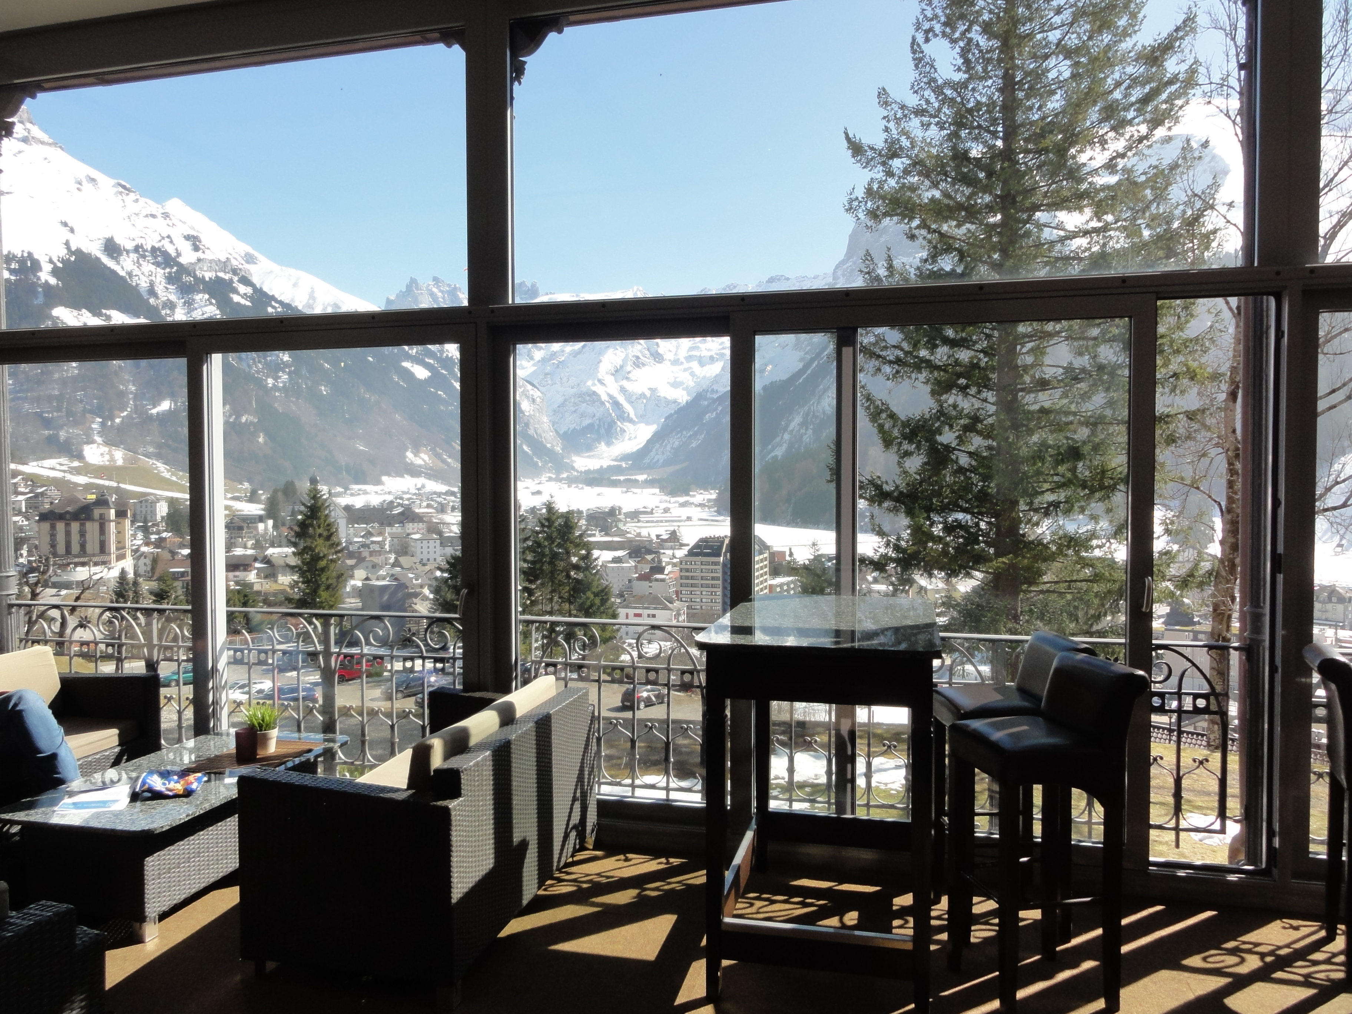

Town of Engelberg as seen from Hotel Terrace lobby
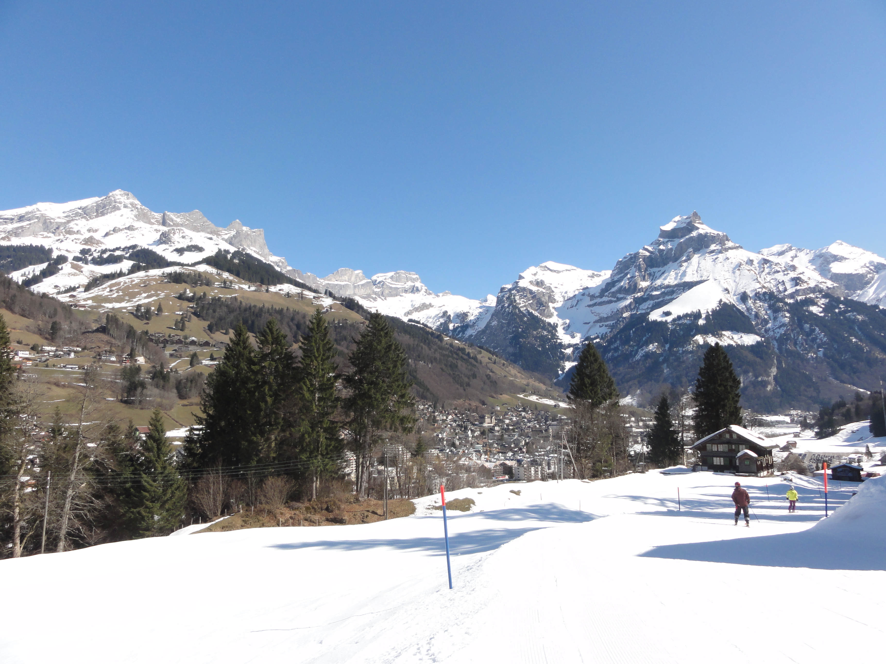
Ski slope overlooking Engelberg

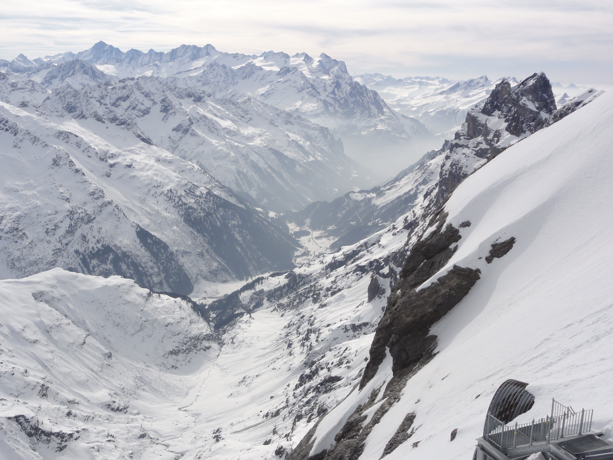
View from Titlis Cliff Walk
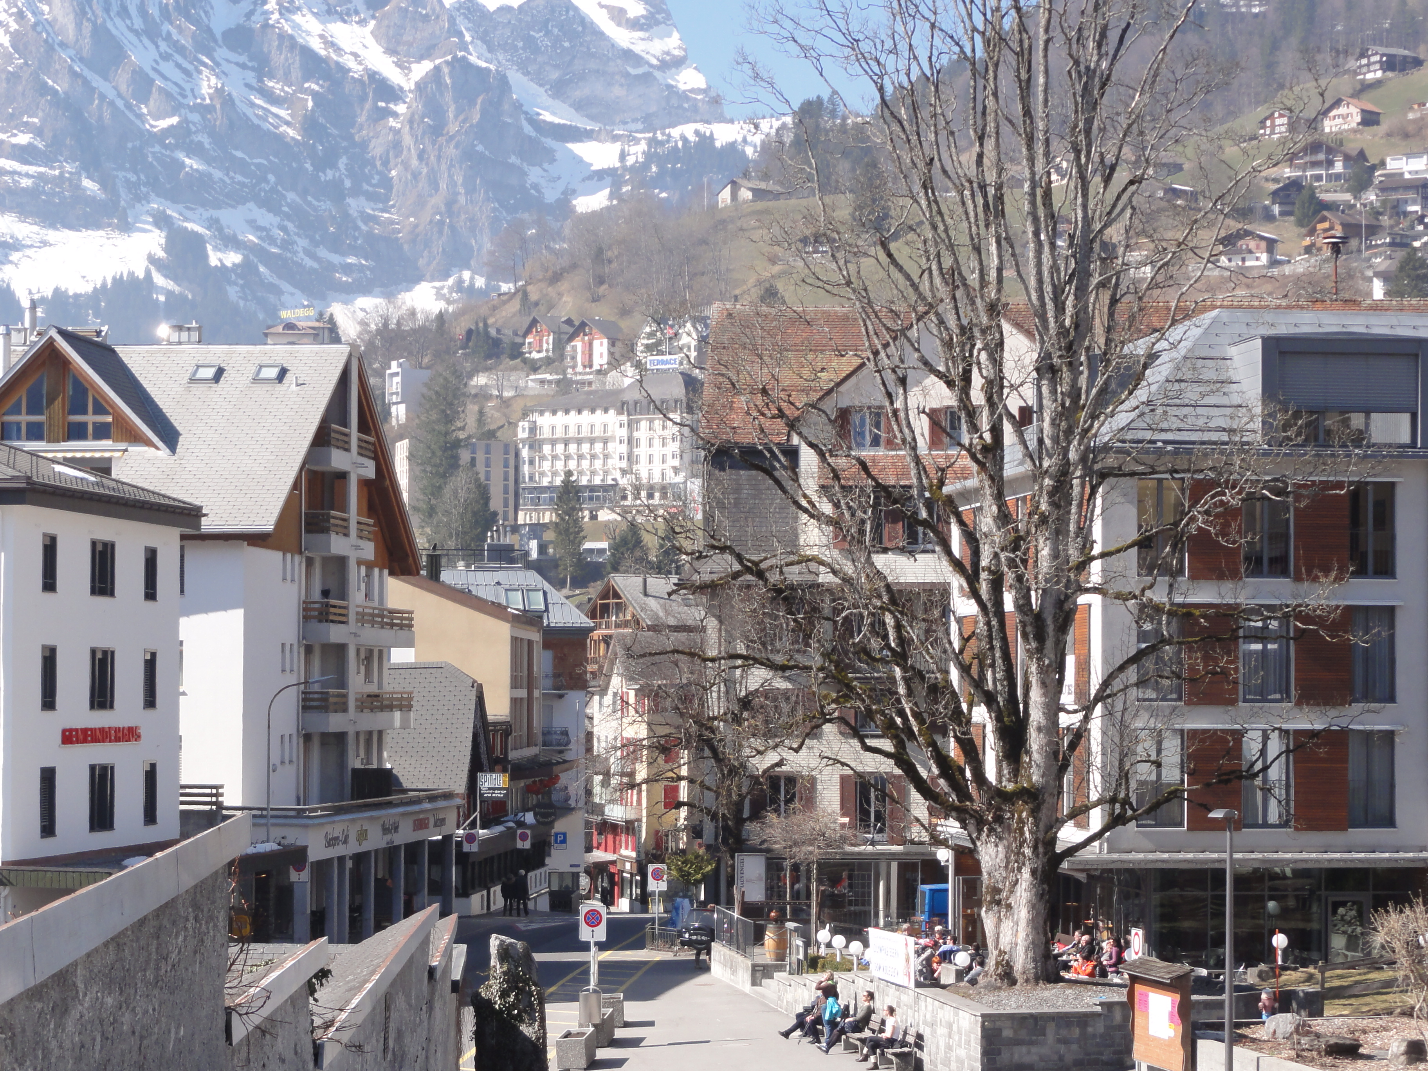
Engelberg street scene with Hotel Terrace visible on hillside (center rear)
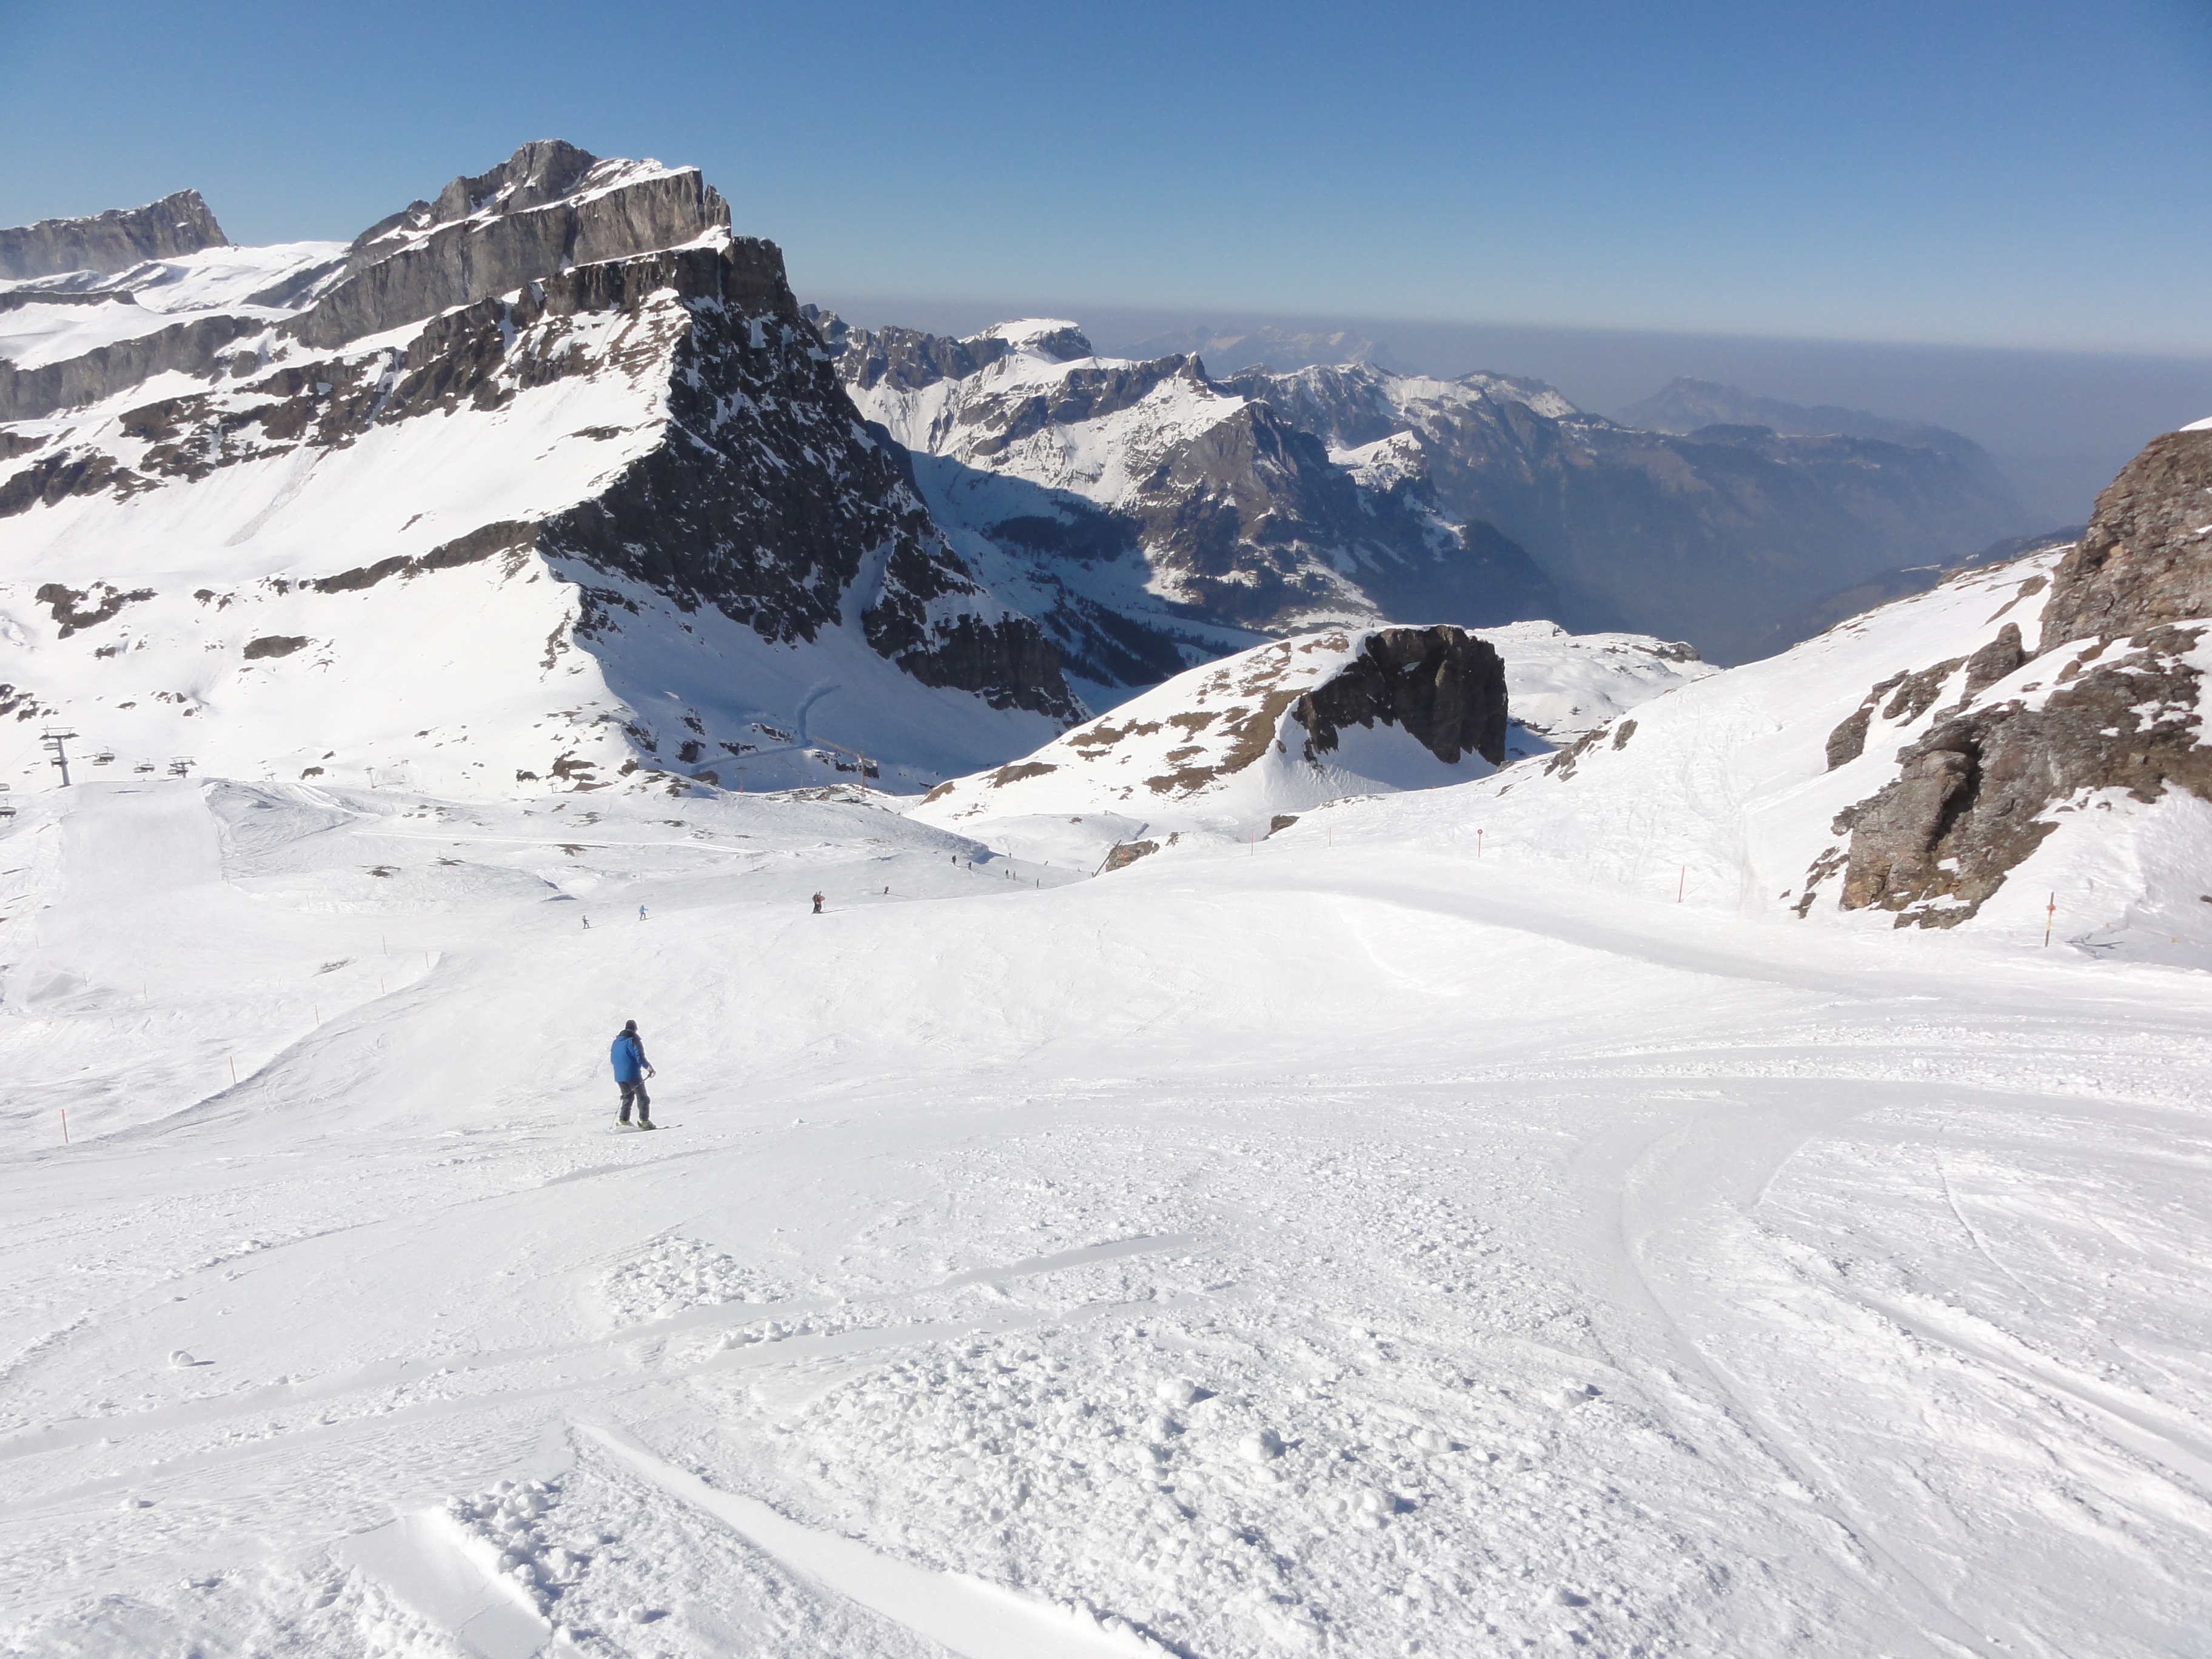
Lone skier on ski slopes
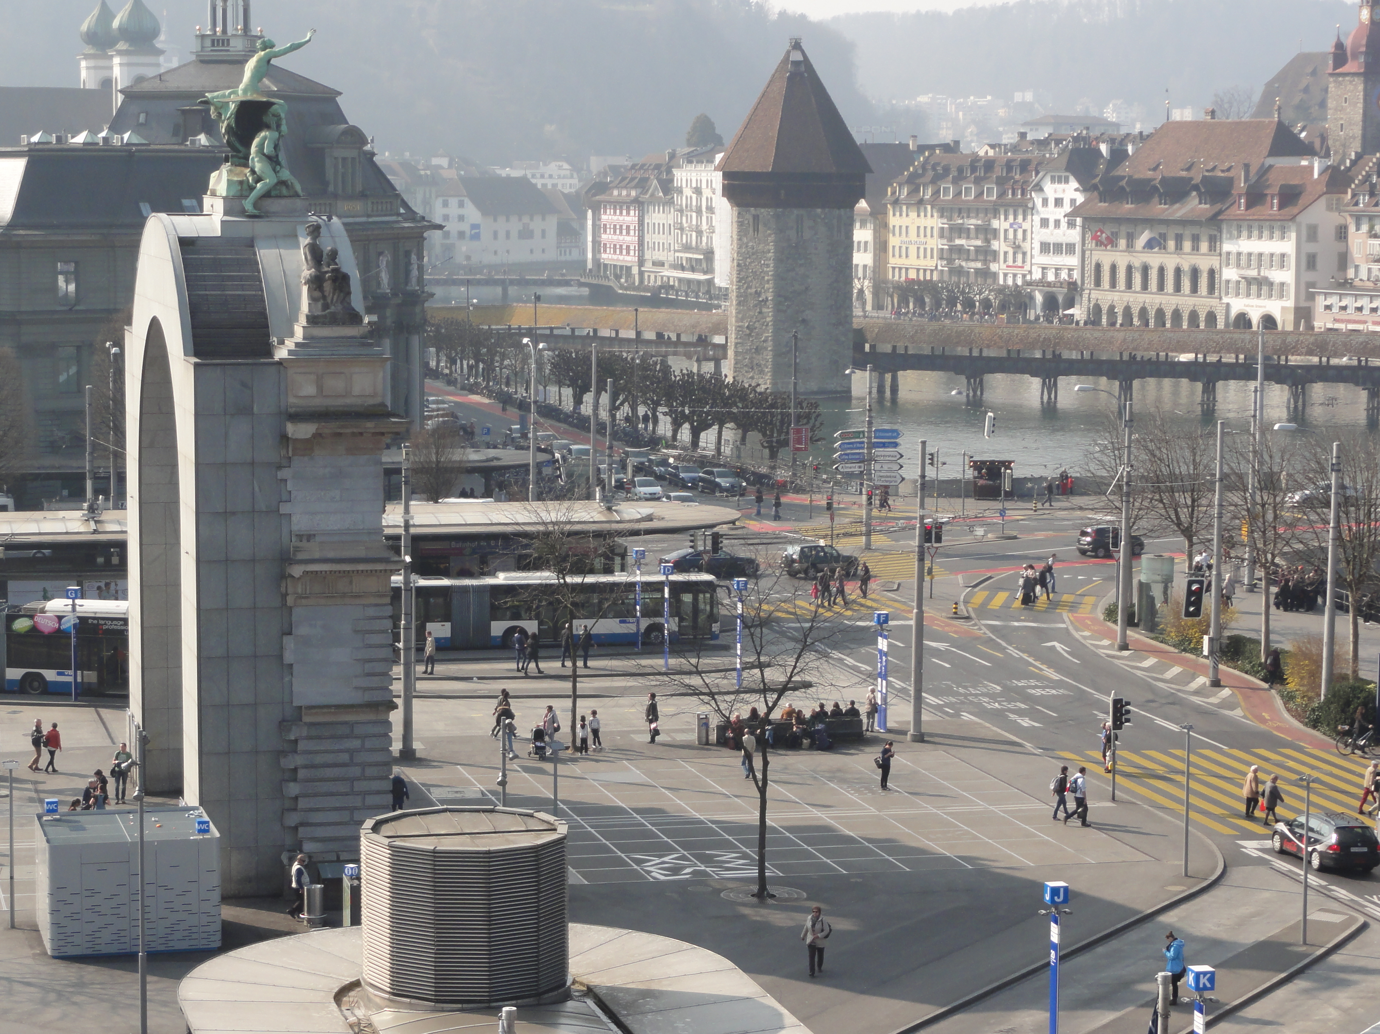
Town of Lucerne with Chapel Bridge
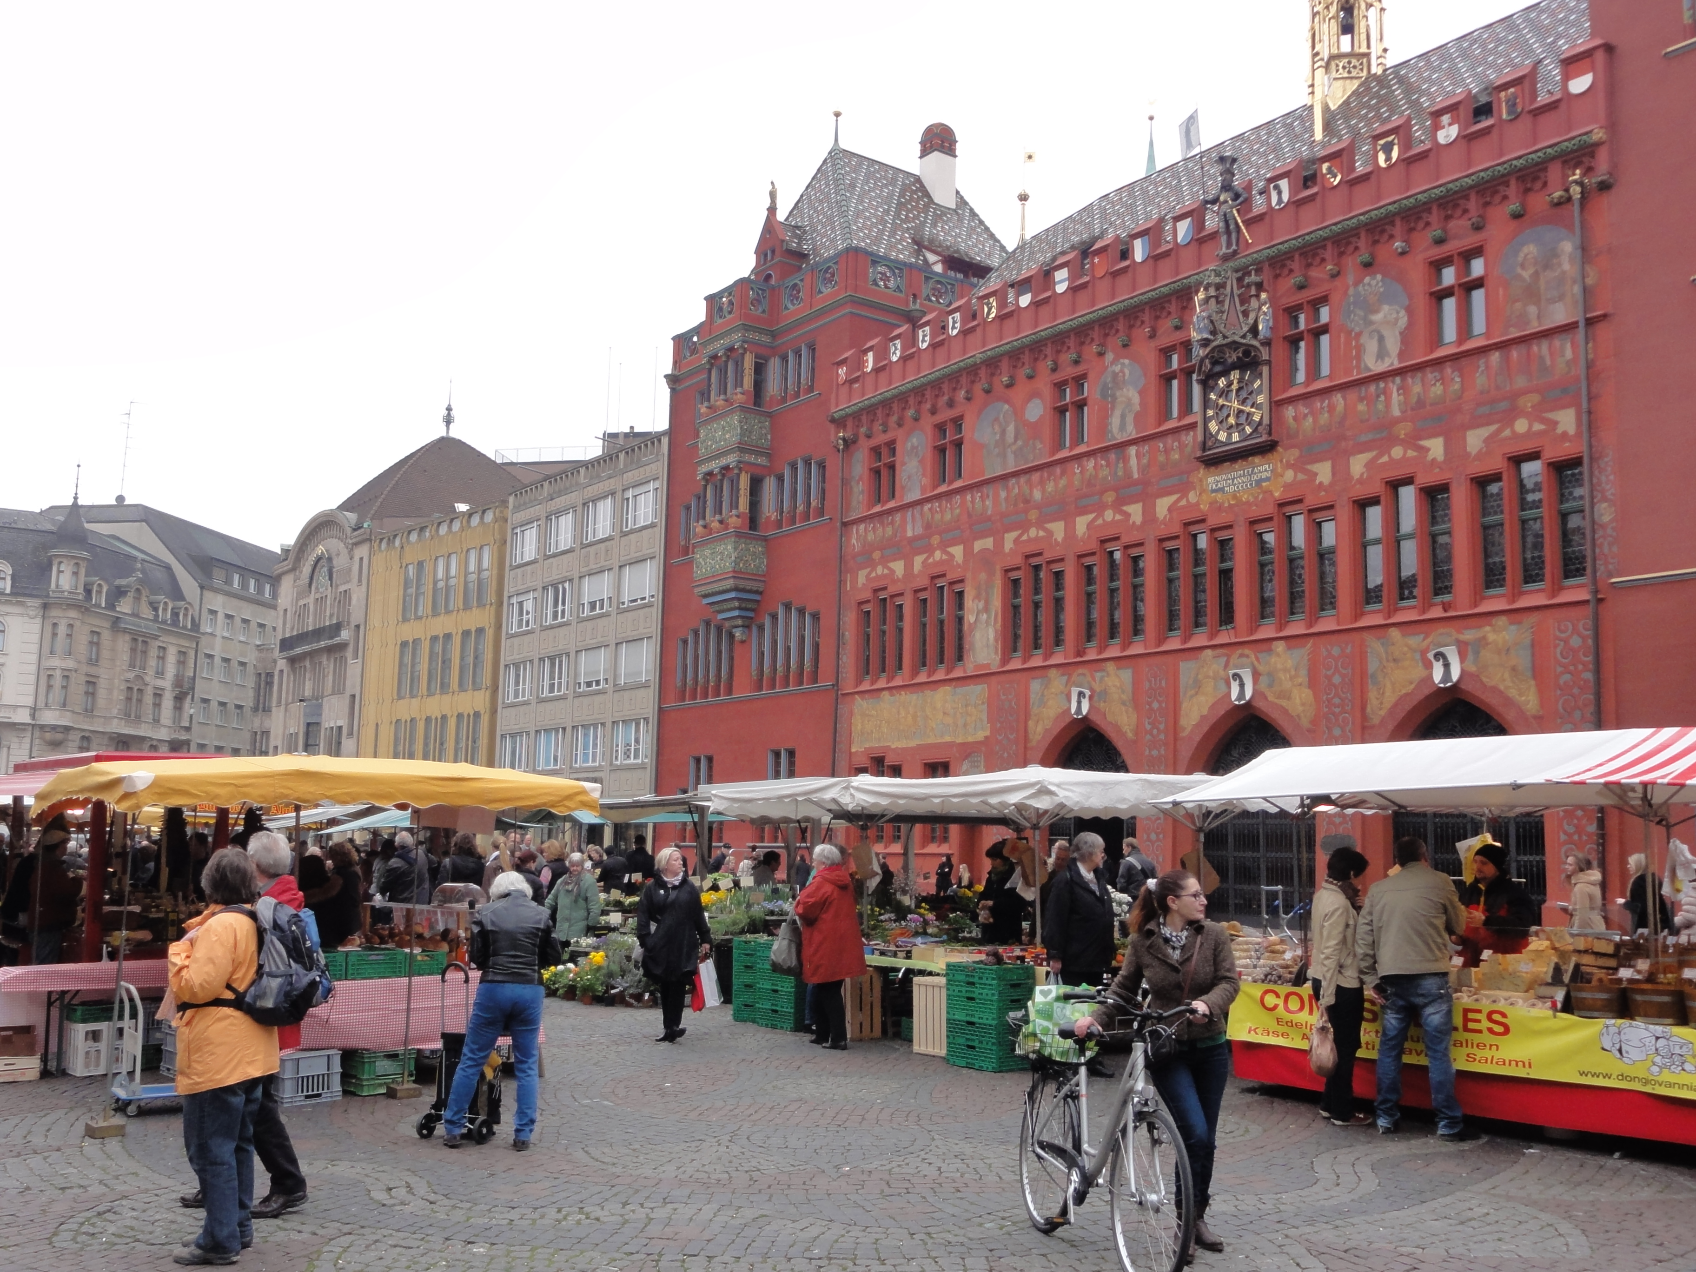
Market Day at Basel's City Hall

